10 Minutes



PART 1
Each student interacts with the teacher answering some personal questions.

PART 2
Students interact with each other. Students ask and answer questions using prompt material.

STUDENT A
Here’s some information about an art gallery. Look at this information and answer your partner’s questions.

ART GALLERY AND MUSEUM



A vast collection of paintings and sculptures firearms
and medieval swords

FREE ENTRANCE

Monday – Saturday

9.00 am – 6 pm

Kelvingrove in Glasgow Scotland

STUDENT A
You don’t know anything about this school trip. So ask student B some questions about it. Use these words to help you.

SCHOOL TRIP

• where / go?


• day?

• travel / train?

• what / see?

• come back / ?

(Adapted from: Cambridge Tests)

Swoosh · 8.˚ ano Evaluation tests




10 Minutes

PART 1
Each student interacts with the teacher answering some personal questions.

PART 2
Students interact with each other. Students ask and answer questions using prompt material.

STUDENT B
You don’t know anything about this art gallery. So ask student A some questions about it. Use these words to help you.

ART GALLERY AND MUSEUM

• where?
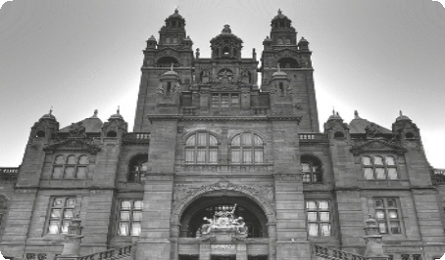

• what?

• close / ?

• open / Sunday?

• cost / £?

STUDENT B
Here’s some information about a school trip. Look at this information and answer your partner’s questions.



TRIP TO THE SCIENCE CENTRE

Science Mall, the IMAX cinema and Glasgow Tower

Get bus in front of the post office: Friday

Leave 9.30 am / Return 4.00 pm



Don’t forget

Bring camera and notebooks
SW8TF © Porto Editora

(Adapted from: Cambridge Tests)

