Name |  | No. | Class
Date | Mark | Teacher
Listening
Progress Test A

 Listen to five teenagers talking about their favourite free time activity. Match each teenager with their free time activity. There are three extra options.
A
Alice | 1 | • |  | • | a | collecting cans
Chris | 2 | • |  | • | b | watching series
Kate | 3 | • |  | • | c | backpacking
James | 4 | • |  | • | d | cooking
Alex | 5 | • |  | • | e | waterskiing
 |  |  |  | • | f | mountain biking
 |  |  |  | • | g | hiking
 |  |  |  | • | h | going to concerts

Listen to the biography of an e-sports champion. Complete with the correct information.
B
E-sports champion: Juno “ShadowBall” Vernon
1. Birthplace: Seoul,
2. Age he first started playing:
3. Name fans call him: the ___________________ player
4. Hours spent training (per day):
5. Best part: meeting his _________________ and inspiring young _______________
6. Free time activities: reading ________________ and playing __________________

Reading
Progress Test A

Name |  | No. | Class
Date | Mark | Teacher

Read the text.

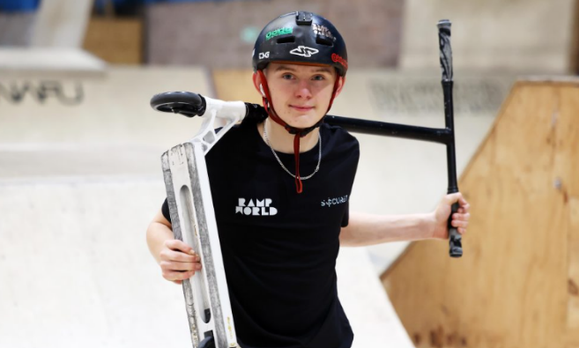
Josh Popham: a Scootering Success
Josh Popham is getting ready for the biggest year of his career. The Welsh 16-year-old won a prize at the UK’s national scootering championship, Scoot GB, in October 2024. Now he is getting ready for some of the most important events on the scootering competition circuit.
5

10

15

20

Josh’s love for scooters began when he was eight, after a trip to a local skate park. “I remember my parents brought me to RampWorld, in Cardiff, and I just loved it immediately” he said. However, it was not until Josh was 12 that he started taking the sport more seriously. He began competing at a professional level in the last two years, winning medals such as second place in the Welsh scootering finals last year. Josh believes scootering requires a combination of technical skill and performance to be successful.
Like most athletes, Josh has a huge support system behind him. His dad Philip Popham initially wanted him to become a football player, but he quickly realised his son’s true passion was different. “We never imagined he’d be doing what he’s doing,” his father said.
Josh is now focusing on the international stage, where he will be competing against some of the world’s best riders. “I’ve got a sponsor now, Grit Scooters. This means I have to compete at a higher level, but I’ve got a lot to look forward to,” he said.
Apart from competing, Josh wants to make scootering his future career. He believes social media is helping sports like BMX freestyling and skateboarding grow, so it is also a good sign for the future of scootering.

www.bbc.com (adapted; accessed in August 2025)

Find synonyms for these words/definitions in paragraphs 2 and 3.
A
- took: _________________________
- at once: _________________________
- involves: _________________________
- ability: _________________________
- enormous: _________________________

Are the sentences True (T) or False (F)? Correct the false ones.
B
 | T | F
1. Josh Popham is a scooter success from Wales.
2. His passion for scootering started when he was thirteen.
3. He won two gold medals last year.
4. Josh wanted to be a footballer when he was younger.
5. His sponsor is called Grit Scooters.

Answer the questions about the text.
C
1. What happened in October 2024?

2. When did Josh start competing at a professional level?

3. Does Josh think social media is positive or negative for extreme sports? Justify with a sentence from the text.

Vocabulary and Grammar
Progress Test A

Name |  | No. | Class
Date | Mark | Teacher


Vocabulary

Read the sentences and match them to the extreme sports. There are two extra options.
A

Running on outdoor tracks in nature. | 1 | • |  | • | a | eFoil surfing
Holding a line and sliding on snow or  ice while wearing skis or a snowboard. | 2 | • |  | • | b | wing walking
Riding a biking and doing tricks. | 3 | • |  | • | c | pro scooter
Standing on an airplane while it’s flying. | 4 | • |  | • | d | BMX freestyle
Keeping your balance on a rope  between two trees. | 5 | • |  | • | e | slacklining
 |  |  |  | • | f | trail running
 |  |  |  | • | g | snowkiting

Label the photos with free time activities.
B
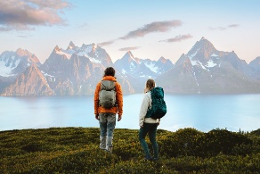 |  | 
a. ______________ | b. ______________ | c. ______________
 | 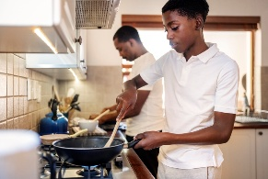 | 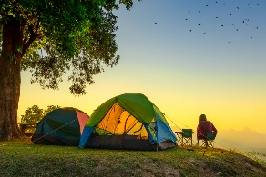
d. ______________ | e. ______________ | f. ______________

Complete the sentences with the free time activities in the box. There is one extra option.
C
going out for dinner swimming reading listening to music meeting friends
1. At weekends,___________________ helps me to relax. Being in the water is a great feeling!
2. There’s a new Italian restaurant I want to try. I really enjoy _________________________ .
3. I love __________________, especially a good novel or adventure fiction.
4. Emma enjoys __________________ at the shopping centre. They always have fun together.
Grammar

Complete the dialogue with the present simple or the present continuous.
A
Marco: 1. ______ you usually __________ (do) any extreme sports?
Joanna: Yes, I 2. __________________ (go) mountain biking every weekend.
Marco: Cool! I usually 3. __________________ (play) tennis, but right now I
4. __________________ (take) a climbing course.
Joanna: Cool! At the moment, I 5. __________________ (try) to join a new climbing group.
Marco: My brother 6. __________________ (not do) anything new now. He usually just
7. __________________ (watch) football on TV.

Complete the sentences with the past simple.
B
- Xavier ________________ (try) slacklining for the first time last week.
- I ________________ (not do) anything special last weekend.
- __________ you ___________ (win) the tournament yesterday?
- The BMX freestyling competition ________________ (be) amazing!
- Nick ________________ (not go) to the concert last night.

Write sentences in the past simple and the past continuous.
C
- Diana / fall / asleep / while / she / watch / favourite series
_________________________________________________________________
- They / swim / the lake / when / it / start / rain
_________________________________________________________________
- I / meet / Alan / while / I / run / in the forest
_________________________________________________________________
- While / mum / cook / I / read / favourite book
_________________________________________________________________

Name |  | No. | Class
Date | Mark | Teacher
Writing
Progress Test A

Write an email to a friend telling him/her your favourite free time activity. Use the information in the boxes to guide you.
A
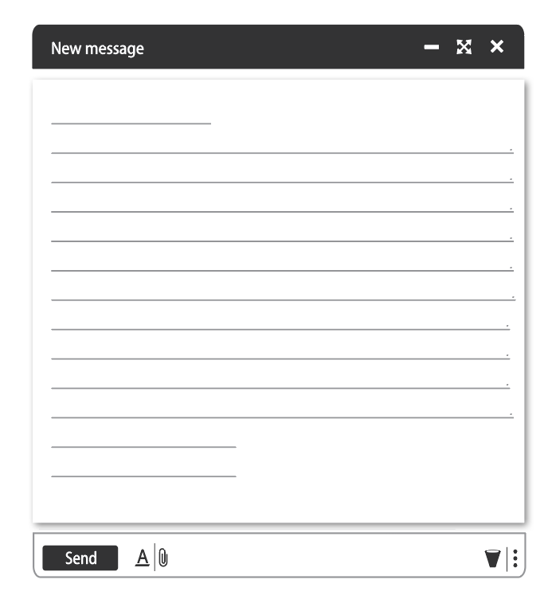
End your email
When did you last do it?

Why is this activity important to you?

What is your favourite free time activity?
When did you start it?

Greeting

