Name |  | No. | Class
Date | Mark | Teacher
Listening
Progress Test B

 Listen to five teenagers talking about their favourite free time activity. Match each teenager with their free time activity.
A
Alice | 1 | • |  | • | a | collecting cans
Chris | 2 | • |  | • | b | mountain biking
Kate | 3 | • |  | • | c | going to concerts
James | 4 | • |  | • | d | waterskiing
Alex | 5 | • |  | • | e | hiking

Listen to the biography of an e-sports champion. Circle the correct information.
B
E-sports champion: Juno “ShadowBall” Vernon
1. Birthplace: Seoul, North Korea / South Korea
2. Age he first started playing: seven / six
3. Name fans call him: the laughing / lightning player
4. Hours spent training (per day): six / five
5. Best part: meeting his fans / friends and inspiring young children / gamers
6. Free time activities: reading science fiction / fantasy and playing basketball / hockey

Reading
Progress Test B

Name |  | No. | Class
Date | Mark | Teacher

Read the text.

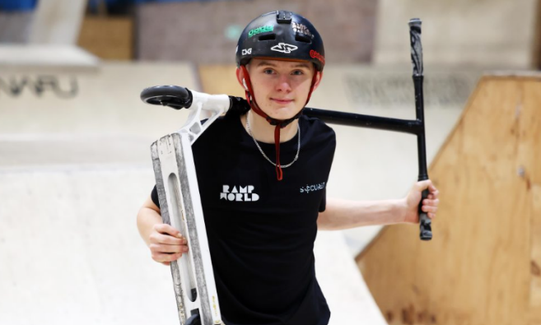
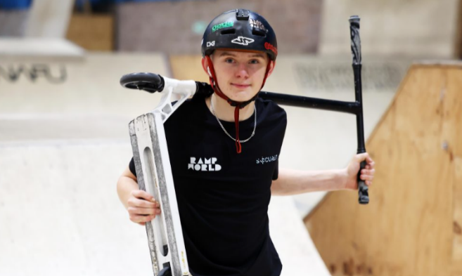
Josh Popham: a Scootering Success
Josh Popham is getting ready for the biggest year of his career. The Welsh 16-year-old won a prize at the UK’s national scootering championship, Scoot GB, in October 2024. Now he is getting ready for some of the most important events on the scootering competition circuit.
5

10

15

20

Josh’s love for scooters began when he was eight, after a trip to a local skate park. “I remember my parents brought me to RampWorld, in Cardiff, and I just loved it immediately” he said. However, it was not until Josh was 12 that he started taking the sport more seriously. He began competing at a professional level in the last two years, winning medals such as second place in the Welsh scootering finals last year. Josh believes scootering requires a combination of technical skill and performance to be successful.
Like most athletes, Josh has a huge support system behind him. His dad Philip Popham initially wanted him to become a football player, but he quickly realised his son’s true passion was different. “We never imagined he’d be doing what he’s doing,” his father said.
Josh is now focusing on the international stage, where he will be competing against some of the world’s best riders. “I’ve got a sponsor now, Grit Scooters. This means I have to compete at a higher level, but I’ve got a lot to look forward to,” he said.
Apart from competing, Josh wants to make scootering his future career. He believes social media is helping sports like BMX freestyling and skateboarding grow, so it is also a good sign for the future of scootering.

www.bbc.com (adapted; accessed in August 2025)

Match the words/expressions from the text with their synonyms.
A
brought | 1 | • |  | • | a | involves
immediately | 2 | • |  | • | b | took
requires | 3 | • |  | • | c | ability
skill | 4 | • |  | • | d | enormous
huge | 5 | • |  | • | e | at once

Are the sentences True (T) or False (F)?
B
 | T | F
1. Josh Popham is a scooter success from Wales.
2. His passion for scootering started when he was thirteen.
3. He won two gold medals last year.
4. Josh wanted to be a footballer when he was younger.
5. His sponsor is called Grit Scooters.

Answer the questions about the text.
C
1. What happened in October 2024?
In October 2024, Josh

2. When did Josh start competing at a professional level?
He __________competing at a

3. Does Josh think social media is positive or negative for extreme sports? Justify with a sentence from the text (last paragraph).
He __________ it’s______________________: “

”

Vocabulary and Grammar
Progress Test B

Name |  | No. | Class
Date | Mark | Teacher


Vocabulary

Read the sentences and match them to the extreme sports.
A

Running on outdoor tracks in nature. | 1 | • |  | • | a | wing walking
Holding a line and sliding on snow or  ice while wearing skis or a snowboard. | 2 | • |  | • | b | BMX freestyle
Riding a biking and doing tricks. | 3 | • |  | • | c | slacklining
Standing on an airplane while it’s flying. | 4 | • |  | • | d | trail running
Keeping your balance on a rope  between two trees. | 5 | • |  | • | e | snowkiting

Label the photos with free time activities.
B
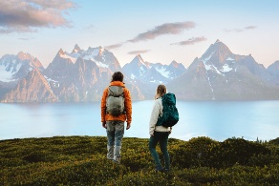 |  | 
a. b____________________ | b. g_______ t___ c________ | c. w__________ s_________
 | 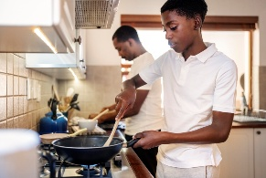 | 
d. c___________ c________ | e. c_____________________ | f. c______________________

Complete the sentences with the free time activities in the box.
C
going out for dinner swimming reading meeting friends
1. At weekends,___________________ helps me to relax. Being in the water is a great feeling!
2. There’s a new Italian restaurant I want to try. I really enjoy _________________________ .
3. I love __________________, especially a good novel or adventure fiction.
4. Emma enjoys __________________ at the shopping centre. They always have fun together.

Grammar

Choose the correct option: present simple or present continuous.
A
Marco: 1. Do you usually do / Are you usually doing any extreme sports?
Joanna: Yes, I 2. go / am going mountain biking every weekend.
Marco: Cool! I usually 3. play / am playing tennis, but right now I 4. take / am taking
a climbing course.
Joanna: Cool! At the moment, I 5. try / am trying to join a new climbing group.
Marco: My brother 6. doesn’t do / isn’t doing anything new now. He usually just
7. watches / is watching football on TV.

Choose the correct option to complete the sentences with the past simple.
B
- Xavier tries / tried slacklining for the first time last week.
- I didn’t do / don’t do anything special last weekend.
- Did you win / Have you won the tournament yesterday?
- The BMX freestyling competition were / was amazing!
- Nick doesn’t go / didn’t go to the concert last night.

Complete the sentences in the past simple and the past continuous.
C

- Diana / fall / asleep / while / she / watch / favourite series
Diana fell asleep while _______________________________________________________
- They / swim / the lake / when / it / start / rain
They were swimming in the lake when __________________________________________
- I / meet / Alan / while / I / run / in the forest
I met Alan while I ___________________________________________________________
- While / mum / cook / I / read / favourite book
While mum was cooking I ____________________________________________________

Name |  | No. | Class
Date | Mark | Teacher
Writing
Progress Test B

Write an email to a friend telling him/her your favourite free time activity. Use the information in the boxes to guide you.
A
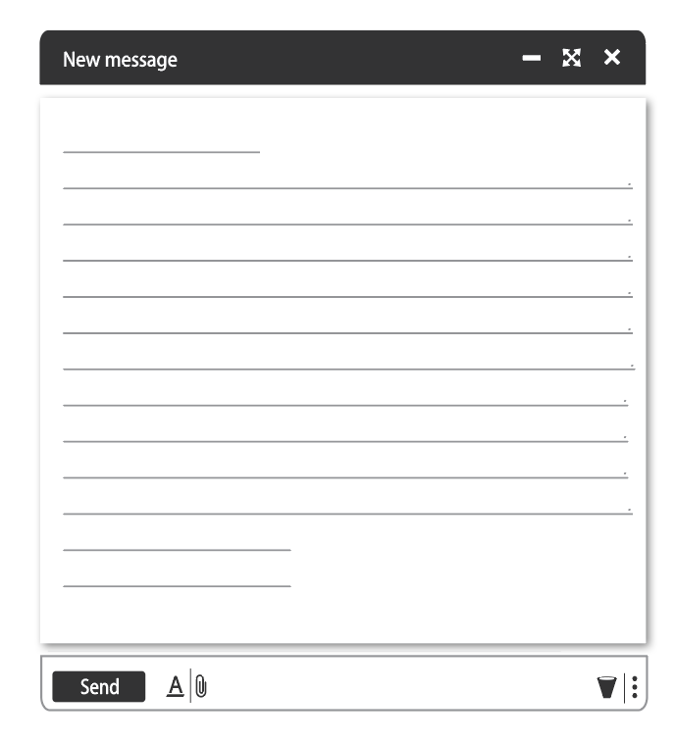
Why is this activity important to you?

When did you last do it?

Hello ,
My favourite
I started doing it when

The last time I did it was

It’s important to me because

See you soon,
End your email
What is your favourite free time activity?
When did you start it?

Greeting

