b
Unit 1 (TV shows and films; the media; new media; past simple and past continuous; present perfect or past simple; correlative conjunctions)

Minitest
Name: No.: _____ Class: _______ Date: ____/ ____/ ____
Mark: ________________ Teacher: ____________________________ Enc. Educação:
1

A. Label the following images with the names of the types of TV shows.
6 x 4% = 24%

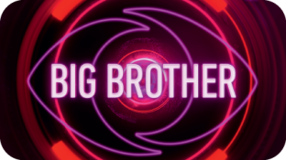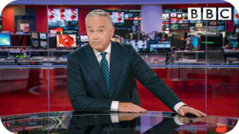
1. _______________ 2. _______________ 3. _______________
s
n
r
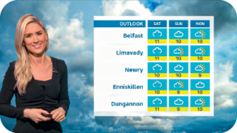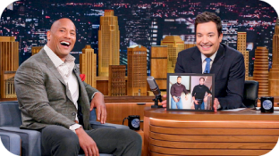
s
c
w
4. _______________ 5. ______________ 6. _______________

B. Which word doesn’t belong in the group? Circle the odd one out.
5 x 4% = 20%
1. awesome – tedious – funny – entertaining 4. e-book – novel – musical – biography
2. hilarious – mindless – weak – awful 5. edit – post – upload – website
3. fiction – comedy – thriller – plot
C. Complete the sentences with the correct forms of the past simple and past continuous.
6 x 4 = 24%
1. I ________________(watch) the film when my mum ________________ (call) me for dinner.
2. Last night I ________________ (see) a horror film. It ________________ (be) quite frightening!
3. We ____________(not leave) the show earlier because we ___________(enjoy) ourselves.
D. Write the sentences in the past simple or the present perfect.
4 x 5 = 20%
1. My grandmother / never / use / emojis /.
_______________________________________________________________ But she likes them!
2. you / ever / see / a Harry Potter film / ?
_______________________________________________________________________________
3. When / we / be / young / we / not have / internet /
_______________________________________________________________________________
4. I / not post / anything / online / since / last week / .
_______________________________________________________________________________
E. Complete the sentences with either… or, neither… nor, both… and.
3 x 4 = 12%
1. The film we saw is ___________ tedious ___________ awful. It’s actually quite entertaining!
2. We can ___________ watch a comedy ___________ a thriller. I like both types.
3. ___________ my mum ___________ my dad love watching TV series.

