b

Minitest
Name: No.: _____ Class: _______ Date: ____/ ____/ ____
Mark: ________________ Teacher: ____________________________ Enc. Educação:
5

Unit 5 (technology; computing and robotics; verbs followed by
to-infinitive or -ing form; passive – present simple and past simple)
A. Label the pictures with the words/phrases from the box.
5 x 6% = 30%

VR headset earbuds Bluetooth keyboard smartwatch laptop

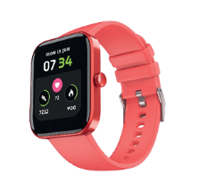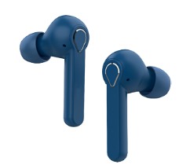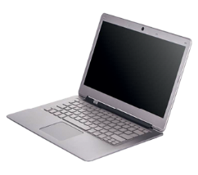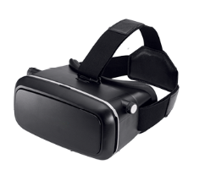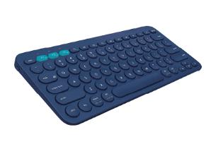
1. ___________ 2. ___________ 3. ___________ 4. ___________ 5. ___________
B. Complete the sentences with the correct words/phrases from the box.
4 x 5% = 20%
robot floor cleaner autocomplete facial recognition speech-to-text
1. I use _______________to unlock my mobile phone.
2. My parents have just bought a _______________, so I don’t need to vacuum.

3. ___________________ is very useful, especially for people who can’t move their hands.
4. He doesn’t like to use ________ because it is easier for hackers to access personal information.
5 x 6 = 30%
C. Complete the sentences with the correct forms of the past simple and past continuous.
play use listen accept buy
1. Can you afford _______________ a new phone? They are so expensive!
2. My dad considered _______________ autocomplete, but he doesn’t trust the appliance.

3. I love ____________________ video games! I really have a good time with my friends.
4. My grandad had his leg amputated, so he decided _______ the bionic leg suggested by his doctors.

5. My mum says she misses ____________________ to music on her old CD player.
D. Rewrite the sentences in the passive.
4 x 5 = 20%
1. Technology revolutionised our lives.
_______________________________________________________________________________
2. People use AI gadgets for different purposes.
_______________________________________________________________________________
3. Some governments give financial support to develop AI.
_______________________________________________________________________________
4. George Orwell wrote the science fiction book 1984.
_______________________________________________________________________________

