Progress Test
Name No.: ______ Class: ________ Date: _____/ _____/ _____
Mark: ________________ Teacher: __________________________________ Enc. Educação: ______________________
1B6
I – READING
Read the text below.
Social media: a teenager’s view

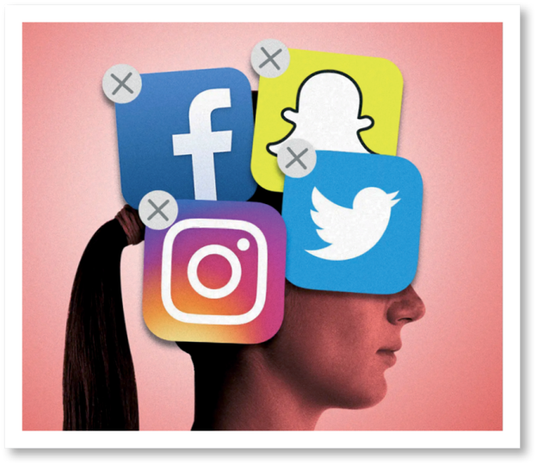
Like many 13-year-old girls, I have been caught up in the tide of social media. All of my friends have it; most of their parents have it… But I do not want to go with the flow – WhatsApp is all I allow myself now. I watch my
5 friends go about their lives – 7:30 am, wake up, check Snapchat, 8:15, final check of Instagram, hand phone in at school, 5:15, openphone, check YouTube andSnapchat updates, 5:45, get home, do homework, go on online games/Netflix, check Instagram, Tumblr. Stay on phone
10 until 10:00 pm talking to people they don’t really know on WhatsApp and Snapchat… Idesperatelywant to avoid that useless pattern.
Why bother? I have asked various friends this and always get similar answers… Social media “enables
you to communicate with people around the world”, “can inspire you” or even “help you to find friends
15 if you have trouble with that in real life”. But there are so many problems and flaws in social media – Snapchat deceives you into thinking that your picture is gone after it expires, but it is on the net forever, Instagram teaches jealousy and self-comparison to vulnerable children, and WhatsApp means that your friends can include you in a group with complete strangers late into the night.
I have to admit that for a 13-year-old British girl, my view of social media is undoubtedly a rare one. It
has changed considerably since what I thought only happens to other people who do stupid things online or hide in corners at school happened to me…
20

25

30
I have very recently been a victim of online bullying. My “best friend” sent me a nasty acronym spelling BLOCKED before blocking me and then she removed me from a WhatsApp group. She said some nasty things, inviting others to share their own negative opinions of me and making cruel rhymes. One of my closest friends told me what had happened the next day.
After this, the girl started texting me with nasty messages late at night. I started leaving my phone
downstairs and my parents began checking my devices for me so that I wasn’t receiving disgusting
messages when I was trying to sleep.
I am not the only teen to experience online hate and gossip like this… almost every teen in the UK will
experience it at some point, sadly some in a relentless way, which can result in self-harm and suicide.
The amount of bullying on social media is astonishing… People hide behind social media because they
can easily pretend to be someone they’re not.
Sure, social media can be great, but there are also many associated problems and distress it can cause. So, to all parents of teenagers, please try and protect us in our virtual world not just the real world.

https://www.fegans.org.uk/family-hub/social-media/ (abridged and adapted)
A. Match the highlighted words in the text with the corresponding equivalents below.
1. unpleasant ______________________ 4. gadgets _______________________
2. misleads ________________________ 5. amazing ______________________
3. imperfections ____________________
B. Choose the correct option according to the context.

1. “I have been caught up in the tide of social media” means:
a) Everybody was using social media and she did the same.
b) She was forced to use social media.

2. “I do not want to go with the flow” means:
a) She wants to use all social media like everybody else.
b) She doesn’t want to use all social media like everybody else.
C. Say if the following statements are true or false. Write T (true) or F (false).
1. At the moment she has no access to any social media. (paragraph 1)
2. When suffering from bullying, she asked her parents for help. (paragraph 5)
3. Some teens in the UK can’t deal with bullying and hurt themselves. (paragraph 6)
D. Answer the following questions.
1. Has her view on social media changed? Why? (paragraphs 3-4)
_____________________________________________________________________________
_____________________________________________________________________________

2. What does she ask all parents of teenagers to do? (paragraph 7)
_____________________________________________________________________________
_____________________________________________________________________________

II – LANGUAGE


A. Circle the correct words to complete the text.

Constantly connected

Today's children and teens are growing up immersed in digital ¹ balance / media. It ranges from TV and videos to social media, video ² games / benefits and so much more. And it's all available on multiple ³ devices / media – computers, e-readers, gaming consoles, smartphones and other ⁴ games / screens.
Media can ⁵ balance / influence how children and teens feel, learn, think and ⁶ behave / games.
This is why it's important to understand the risks and ⁷ influence / benefits of digital media use and how to keep them in ⁸ balance / influence for your family.
https://www.healthychildren.org/

B. Circle the odd one out.

1. Types of films: comedy – thriller – horror – characters

2. TV shows: interview – newspaper – news – chat show

3. Adjectives to describe films: novels – touching – intense – romantic

4. Actions on the internet: post – edit – website – upload
C. Label the pictures with the words from the box.
e-book newspapers internet mobile phone channel magazines





1. __________________ 2. __________________ 3. __________________




4. __________________ 5. __________________ 6. __________________

D. Choose the correct form of the verb – past simple or past continuous.
1. Last night while my parents watched / were watching a Netflix film, I did / wasn’t doing
anything interesting.

2. I read / was reading the nasty messages when my mum found out / was finding out about all
the bullying I went / was going through.

3. In the past, newspapers were / were being the main source of information. My grandparents
read / were reading the news in a weekly newspaper.

4. Where did you see / were you seeing that article about teen bullying yesterday? Was it / Was
it being on Instagram?

5. My brother didn’t suffer / wasn’t suffering from bullying when he was / was being a teen, but
he witnessed / was witnessing some terrible situations.

E. Complete the sentences with the verbs in brackets in the present perfect.
Remember

Present perfect – have/has + past participle of the main verb

1. Video calls ________________ (become) popular among families who live apart.
2. My parents ___________ (already) ___________ (try) to use Instagram to chat with me.
3. Our teacher ________________ (not speak) about the use of mobile phones in class yet.
4. “___________ you ever ___________ (be) to a place where social media was not allowed?”
“No, I ________________. I can’t even imagine that!”

5. My best friend “___________ just ___________ (buy) a new gadget in that shop.

F. Choose the correct form of the verb. Present perfect or past simple?

1. Last year I was / have been a victim of bullying and since then I felt / have felt the need to stay
away from social media.

2. He already saw / has already seen the film which was / has been released last week.

3. Your grandparents never learnt / have never learnt how to use social media, but you can still
teach them.

G. Complete the sentences with the missing part of the correlative conjunction (either / neither /
both).

1. I use ___________ my mobile phone and my computer to browse the web. I have no preference.

2. ___________ my dad nor my mum uses Instagram. They don’t particularly like social media.

3. You ___________ love reading or you hate it!

4. He can ___________ text nor call me. I don’t have a mobile phone!

Progress Test
Name No.: ______ Class: ________ Date: _____/ _____/ _____
Mark: ________________ Teacher: ________ __________________________ Enc. Educação: ______________________
1B
III – WRITING

Most teenagers use social media nowadays and sometimes expose themselves too much or spend too much time using it. Complete the following text. Use the guidelines below to help you.

Introduction | Social media is very popular nowadays, especially among teenagers. They  mostly use  . (3 examples of social media used by adolescents)
Main body | There are many social media platforms available, but my favourite  is (favourite social media) and I usually spend  (number of hours using social media) on it every day.  Like everything else in life, social media has advantages and disadvantages.  Two good things about it are  _______________________________________________________________  . (2 positive aspects of social media)  However, there are disadvantages as well. For example,  _______________________________________________________________  . (2 negative aspects of social media)
Conclusion | You must be careful using social media. I believe that  . (one reason why social media is or is not important to you)

