Progress Test
Name No.: ______ Class: ________ Date: _____/ _____/ _____
Mark: ________________ Teacher: __________________________________ Enc. Educação: ______________________
2A
I – READING
Read the following text about teens and body image.

1. _____________________
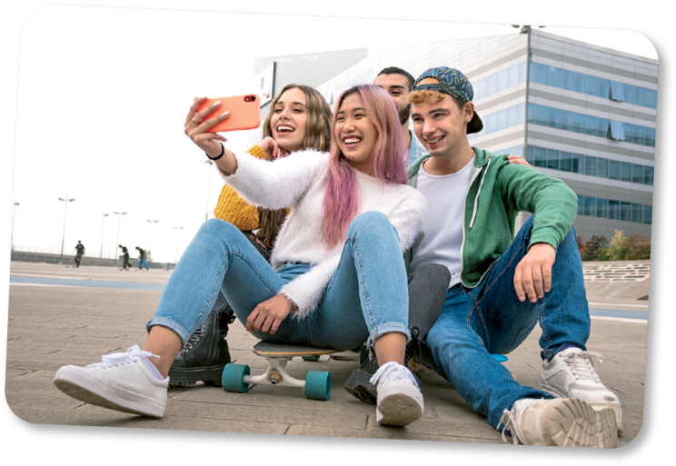

Teens’ body-image issues can have a huge impact on their daily lives. Teenagers might be the most fashion-conscious people on the
5 planet. Because they’re doing the hard work of forming their sense of self, what they wear becomes incredibly important. Furthermore, it’s one ofthe few ways they have toshow the world who they are – or who they want to be.
2. _____________________
10

Adolescence is marked by the search for a personal identity. Therefore, what you wear can be a huge part of forming that identity. For teens, clothing and hairstyles can express a connection with particular styles or communities (goth, punk…), honour their ethnic heritage, or demonstrate how they want the world to seethem. In addition,wearing clothes they feel good in helps teens feel good about themselves.
15 What teenagers choose to wear can also be a way of distinguishing themselves from their parents. Therefore,it’s important forparents to createboundaries around what’s appropriateforschool ora job, especially for younger adolescents.
3. _____________________

Teens dress alike because seeing each other in the same outfits provides a sense of affirmation and boosts their self-esteem.Dressing insimilar clothing alsogives teens a sense of belonging toa peer group.
20
4. _____________________

Alongwith theirpeers,themedia – includingteen magazines,onlinepublications,television,and films – has a powerful influenceon adolescents. That includes what theywear. Comparing yourself to what you seein themedia can also negativelyimpact bodyimage,which is closelyassociated with fashion choices.

www.newportacademy.com (abridged and adapted)

A. Write the following titles in the corresponding paragraphs in the text.
Fashion and teens’ peer relationships
The media and teen body-image issues
Teen body-image issues and the impact they have on teens
Self-expression through fashion

B. Match the highlighted words in the text with their equivalents.

1. similarly

2. very big

3. limits

4. clothes

5. decide

6. difficult

C. Complete the sentences with ideas from the text.

1. Teenagers choose to dress differently from their parents _______________________________
_____________________________________________________________________________

2. Wearing the same clothes as your peers gives you a ___________________________________
_____________________________________________________________________________

D. Say if the following statements are true or false. Write T (true) or F (false) and quote from the text to support your answers.

1. Body image has no influence on teenagers’ lives.
_____________________________________________________________________________

2. When you are a teenager, you look for your own identity.
_____________________________________________________________________________

3. The media have a powerful influence only on the way teens feel about themselves.
_____________________________________________________________________________

II – LANGUAGE
A. Complete the text with the words from the box.
self-esteem image appearances bodies development
look preschool media disorders weight

Teen body image refers to how adolescents perceive their ¹ ________________. In addition,
body image includes their feelings about their body and how they take care of it. As a result,
body ² ____________ is an essential part of adolescent ³ ___________________.
Moreover, teen body image is closely linked to ⁴ ________________. In part, that’s because
society and the media – including social media – place so much importance on the way we
⁵ ________________.
Hence, this persistent focus on ⁶ ______________________ contributes to teenage body- image issues and teen eating ⁷ _________________. For example, one study found that 93 per
cent of young women engage regularly in negative talk about their body and their desire to lose
⁸ _________________.
Awareness of body image and ideals around appearance develop early. That is why
young children have attitudes and behaviours related to body image by the time they are in
⁹ ________________. Their ideas about body image come from a variety of influences, including
family and ¹⁰ ________________.
www.newportacademy.com (abridged and adapted)

B. Label the pictures with the health problems from the box. There are two extra words/expressions.
a backache a headache a stomachache a toothache
an earache a sore throat fever a rash


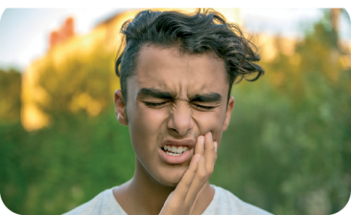
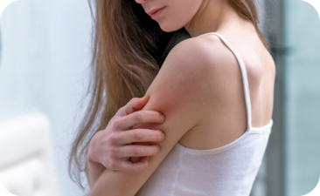

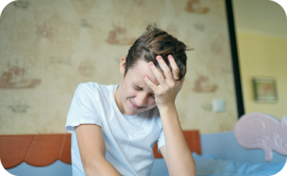


1. _______________ 2. _______________ 3. _______________

4. _______________ 5. _______________ 6. _______________

C. Complete the idioms with the body parts from the box. There are three extra words.
feet hand fingers eye leg arm back chest ears

1. I can’t clean everything up alone. Could you give me a ___________________, please?
2. I asked my brother to keep an ___________________ on the house when we are on holiday.
3. Today is your last French exam. Well, break a _________________! Do your best!
4. Whenever I need to decide about doing an exchange programme, I get cold ______________.
5. What happened at the party? Tell me! I’m all _______________________.
6. Thank you for listening to me. I really needed to get this off my _______________________.

D. Complete the sentences with the correct relative pronouns.
1. That is the boy __________ has an eating disorder.
2. I have a friend __________ mother suffers from depression.
3. Drugs can be a problem __________ some teens have to deal with.
4. She suffered from bullying, ________ is a hard problem to overcome when you are a teenager.

E. Join the sentences by using the connectors in brackets.

1. The media portrays ideal body images. We shouldn’t let ourselves be influenced by it. (although)
_____________________________________________________________________________
2. Teens feel the pressure to be perfect. They need to find their own identity. (despite)
_____________________________________________________________________________
3. I like my body. But sometimes I feel quite insecure. (even though)
_____________________________________________________________________________
4. I’m addicted to my mobile phone. I spend quality time with my friends. (in spite of)
_____________________________________________________________________________

F. Fill in the blanks with the correct form of the verb in brackets in the past perfect. There is one . example.
• They had forgotten (forget) how it felt to be bullied.
1. I thought they ___________________________ (quit) smoking.
2. Peter ___________________________ (have) problems with alcohol before.
3. My parents ___________________________ (not think) that I could become addicted to food.
4. ___________________________ (you / ever / suffer) from depression before?

Progress Test
Name No.: ______ Class: ________ Date: _____/ _____/ _____
Mark: ________________ Teacher: ________ __________________________ Enc. Educação: ______________________
2A
III – WRITING

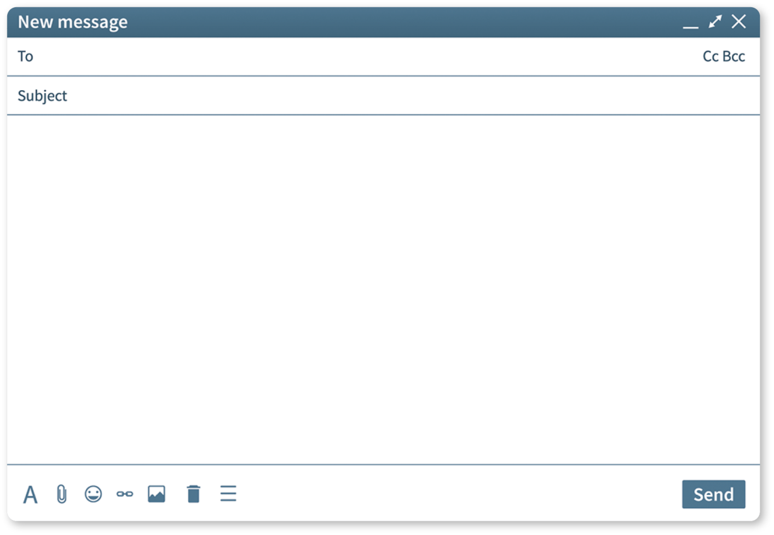
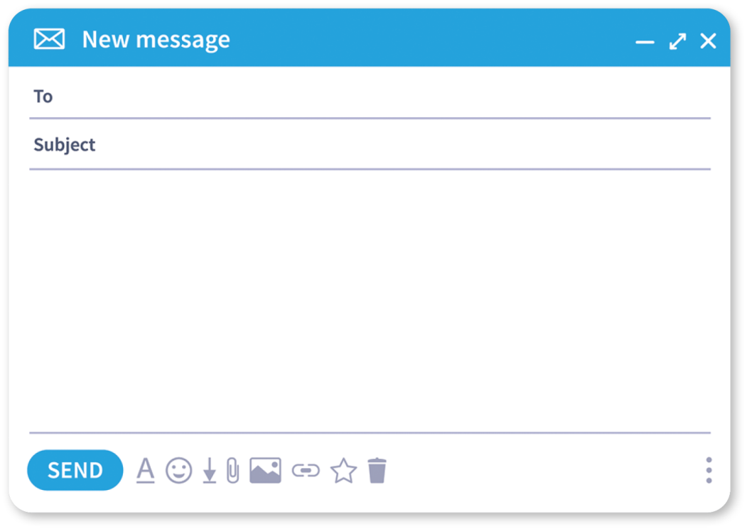
Read the email a teen sent to an online magazine to look for help. Then answer the email following the guidelines.
First piece of
advice and its
result
Second piece
of advice and
its result
Goodbye
Greeting
__________________,
________________________________________________________________________
________________________________________________________________________
________________________________________________________________________
________________________________________________________________________
________________________________________________________________________
________________________________________________________________________
________________________________________________________________________
________________________________________________________________________
________________________________________________________________________
________________________________________________________________________

Jane
RE: Help!
Dear DrM,
I’ve always struggled to fit in at school. I have always been the tallest in my
class and my classmates pull my leg all the time. It really brings me down
and it is getting more and more difficult to deal with this feeling and all the
bad jokes. Please help me.
Best regards,
Jane
Help!
AskDrM

