Progress Test
Name No.: ______ Class: ________ Date: _____/ _____/ _____
Mark: ________________ Teacher: __________________________________ Enc. Educação: ______________________
2B
I – READING
Read the following text about teens and body image.

1. Teen body-image issues and the impact they have on teens
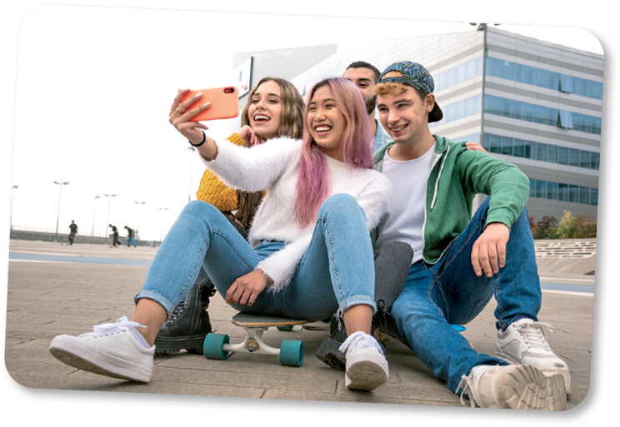

Teens’ body-image issues can have a huge impact on their daily lives. Teenagers might be the most fashion-conscious people on the
5 planet. Because they’re doing the hard work of forming their sense of self, what they wear becomes incredibly important. Furthermore, it’s one ofthe few ways they have toshow the world who they are – or who they want to be.
2. __________________________
10

Adolescence is marked by the search for a personal identity. Therefore, what you wear can be a huge part of forming that identity. For teens, clothing and hairstyles can express a connection with particular styles or communities (goth, punk…), honour their ethnic heritage, or demonstrate how they want the world to seethem. In addition,wearing clothes they feel good in helps teens feel good about themselves.
15 What teenagers choose to wear can also be a way of distinguishing themselves from their parents. Therefore,it’s important forparents to createboundaries around what’s appropriateforschool ora job, especially for younger adolescents.
3. __________________________

Teens dress alike because seeing each other in the same outfits provides a sense of affirmation and boosts their self-esteem.Dressing insimilar clothing alsogives teens a sense of belonging toa peer group.
20
4. __________________________

Alongwith theirpeers,themedia – includingteen magazines,onlinepublications,television,and films – has a powerful influenceon adolescents. That includes what theywear. Comparing yourself to what you seein themedia can also negativelyimpact bodyimage,which is closelyassociated with fashion choices.

www.newportacademy.com (abridged and adapted)

A. Write the following titles in the corresponding paragraphs in the text.
Fashion and teens’ peer relationships
The media and teen body-image issues
Teen body-image issues and the impact they have on teens
Self-expression through fashion

B. Find a highlighted word in the text that has the same meaning as the words below.

1. clothes

2. very big

3. decide

4. difficult
C. Choose the correct option to complete the sentences.

1. Teenagers choose to dress differently from their parents…
a) to distinguish themselves.
b) to feel bad about themselves.

2. Wearing the same clothes as your peers gives you a…
a) sense of depression.
b) sense of affirmation.

D. Say if the following statements are true or false. Write T (true) or F (false).

1. Body image has no influence on teenagers’ lives.
2. When you are a teenager, you look for your own identity.
3. The media have a powerful influence only on the way teens feel about themselves.

II – LANGUAGE

A. Circle the correct option to complete the text.
Teen body image refers to how adolescents perceive their ¹ disorders / bodies. In addition, body image includes their feelings about their body and how they take care of it. As a result,
body ² image / look is an essential part of adolescent ³ media / development.
Moreover, teen body image is closely linked to ⁴ self-esteem / development. In part, that’s
because society and the media – including social media – place so much importance on the way
we ⁵ look / preschool.
Hence, this persistent focus on ⁶ media / appearances contributes to teenage body-image
issues and teen eating ⁷ bodies / disorders. For example, one study found that 93 per cent of
young women engage regularly in negative talk about their body and their desire to lose ⁸ weight /
bodies.
www.newportacademy.com (abridged and adapted)

B. Label the pictures with the health problems from the box.
a backache a headache a stomachache
a toothache a rash a sore throat


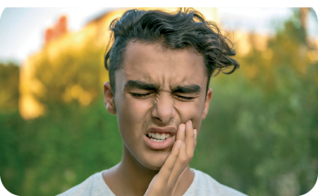
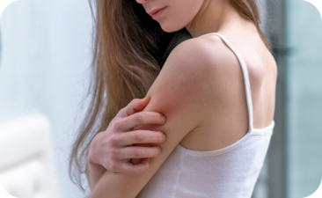

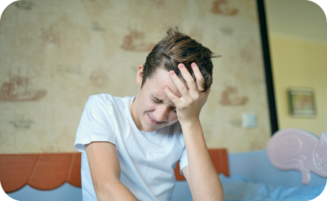
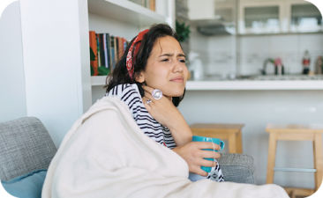

1. _______________ 2. _______________ 3. _______________

4. _______________ 5. _______________ 6. _______________

C. Circle the correct body part to complete the idioms.
1. I can’t clean everything up alone. Could you give me a hand / leg please?
2. I asked my brother to keep an arm / eye on the house when we are on holiday.
3. Today is your last French exam. Well, break a hand / leg! Do your best!
4. Whenever I need to decide about doing an exchange programme, I get cold ears / feet.
5. What happened at the party? Tell me! I’m all feet / ears.
6. Thank you for listening to me. I really needed to get this off my chest / eye.

D. Complete the sentences with the correct relative pronouns (who, which, whose).
1. That is the boy __________ has an eating disorder.
2. I have a friend __________ mother suffers from depression.
3. Drugs can be a problem __________ some teens have to deal with.
4. She suffered from bullying, ________ is a hard problem to overcome when you are a teenager.

E. Choose the correct connector to complete the sentences.

1. Although / In spite of the media portrays ideal body images, we shouldn’t let ourselves be . influenced by it.
2. Though / Despite feeling the pressure to be perfect, teens need to find their own identity.
3. Despite / Even though I like my body, sometimes I feel quite insecure.
4. In spite of / Although being addicted to my mobile phone, I spend quality time with my . friends.
F. Fill in the blanks with the correct form of the verb in brackets in the past perfect. There is one . example.
• They had forgotten (forget) how it felt to be bullied.
1. I thought they ___________________________ (quit) smoking.
2. Peter ___________________________ (have) problems with alcohol before.
3. My parents ___________________________ (not think) that I could become addicted to food.
4. ___________________________ (you / ever / suffer) from depression before?

Progress Test
Name No.: ______ Class: ________ Date: _____/ _____/ _____
Mark: ________________ Teacher: __________________________________ Enc. Educação: ______________________
2B
III – WRITING

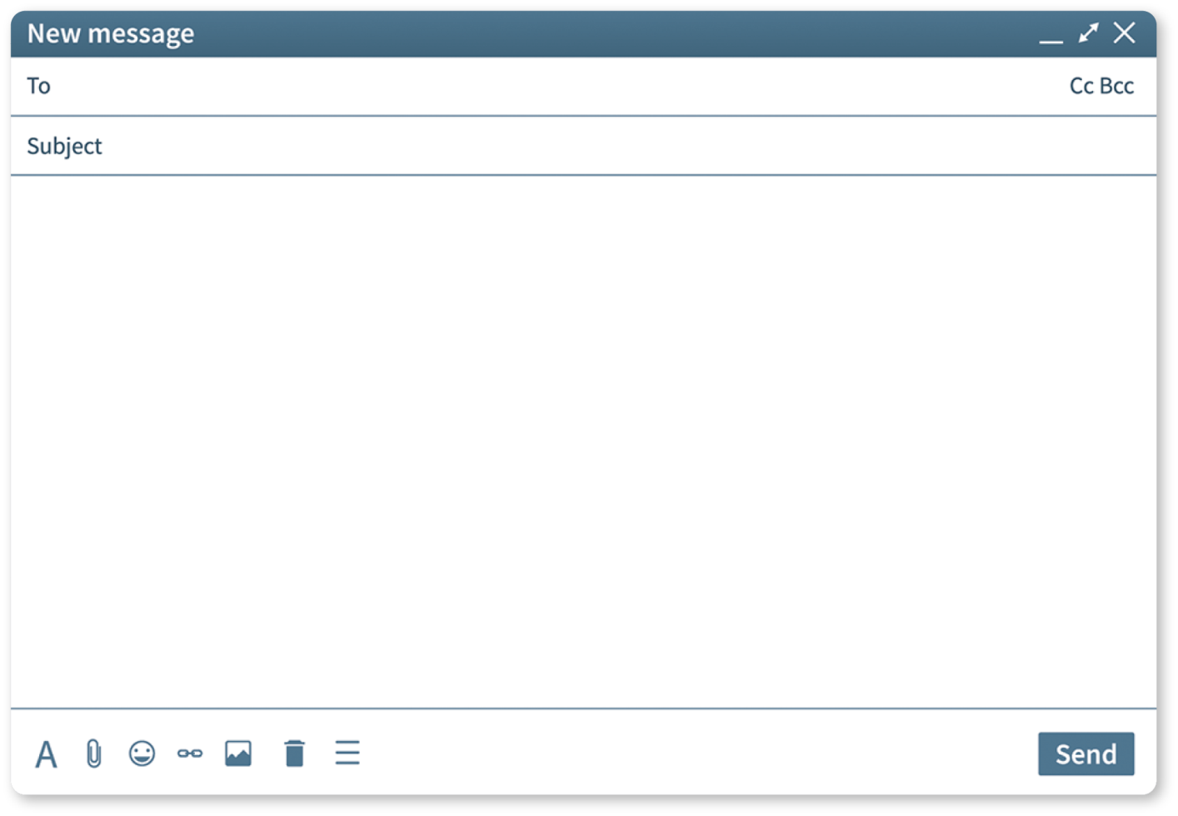
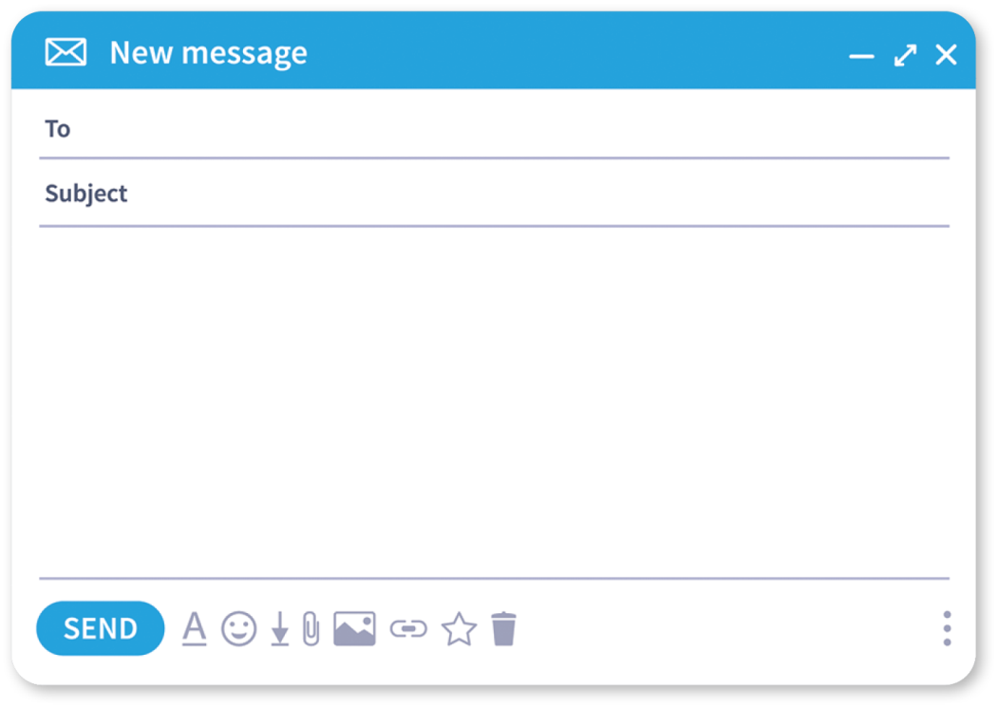
Read the email a teen sent to an online magazine to look for help. Then answer the email following the guidelines.
This way, you will feel
Why don’t you
You should
You can also
This will help you
Jane
RE: Help!
Greeting
First piece of
advice and its
result
Second piece
of advice and
its result
Goodbye
_____________________,
________________________________________________________________________
________________________________________________________________________
________________________________________________________________________
________________________________________________________________________
________________________________________________________________________
________________________________________________________________________
________________________________________________________________________
________________________________________________________________________
________________________________________________________________________

Dear DrM,
I’ve always struggled to fit in at school. I have always been the tallest in my
class and my classmates pull my leg all the time. It really brings me down
and it is getting more and more difficult to deal with this feeling and all the
bad jokes. Please help me.
Best regards,
Jane
Help!
AskDrM

