Progress Test 2C
FlyHigh 9 | TESTS

Table of Specifications (Unit 2)
I – READING
Objetivos/ Competências | Conteúdos | Estrutura | Cotações | Critérios  de classificação
Compreensão escrita  Compreender textos sobre temas abordados. | Body image | A. Fazer corresponder os títulos aos parágrafos. | 2 x 20% = 40% | Resposta errada: 0 pontos
 | Body image | B. Fazer corresponder as palavras sinónimas. | 3 x 10% = 30% | Resposta errada: 0 pontos
 | Body image | C. Completar as frases com informação do texto. | 2 x 15% = 30% | Resposta errada: 0 pontos
 |  | Total: | 100%

II – LANGUAGE
Objetivos/ Competências | Conteúdos | Estrutura | Cotações | Critérios  de classificação
Vocabulário e gramática  Compreender formas de organização do léxico e conhecer algumas  estruturas frequentes do funcionamento da língua. | Health problems | A. Legendar corretamente as imagens. | 5 x 6% = 30% | Resposta errada: 0 pontos
 | Body idioms | B. Legendar corretamente as imagens. | 3 x 10% = 30% | Resposta errada: 0 pontos
 | Relative pronouns | C. Selecionar o pronome correto. | 2 x 10% = 20% | Resposta errada: 0 pontos
 | Past perfect | D. Selecionar a forma verbal correta. | 2 x 10% = 20% | Resposta errada: 0 pontos
 |  | Total: | 100%

III – WRITING
Objetivos/ Competências | Conteúdos | Estrutura | Cotações | Critérios  de classificação
Produção escrita  Responder a perguntas sobre si. | Tema: Teens’ body image/ health problems | Responder a perguntas sobre si. | 5 x 20% = 100% | Resposta errada: 0 pontos

Progress Test
Name No.: ______ Class: ________ Date: _____/ _____/ _____
Mark: ________________ Teacher: __________________________________ Enc. Educação: ______________________
2C
I – READING
Read the following text about teens and body image.

1. _____________________
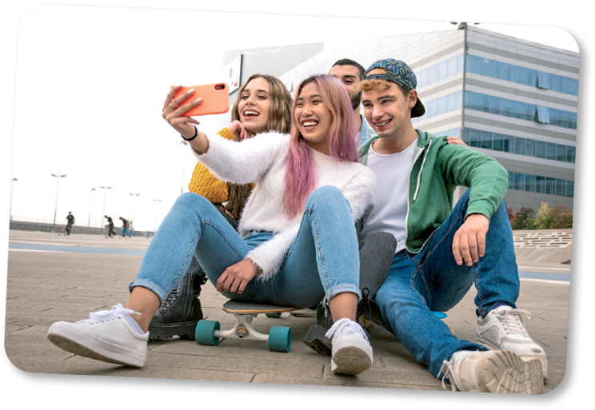

Teens’ body-image issues can have a huge impact on their daily lives. Teenagers might be the most fashion-conscious people on the
5 planet. Because they’re doing the hard work of forming their sense of self, what they wear becomes incredibly important. Furthermore, it’s one of the few ways they have to show the world who they are – or who they want to be.
2. _____________________
10

Adolescence is marked by the search for a personal identity. Therefore, what you wear can be a huge part of forming that identity. For teens, clothing and hairstyles can express a connection with particular styles or communities (goth, punk…), honour their ethnic heritage, or demonstrate how they want the world to seethem. In addition,wearing clothes they feel good in helps teens feel good about themselves.
15 What teenagers choose to wear can also be a way of distinguishing themselves from their parents. Therefore,it’s important forparents to createboundaries around what’s appropriateforschool ora job, especially for younger adolescents.

www.newportacademy.com (abridged and adapted)
A. Write the following titles in the corresponding paragraphs in the text (1-2).
Self-expression through fashion
Teen body-image issues and the impact they have on teens

B. Match the highlighted words in the text with their equivalents.

1. huge a) difficult

2. hard b) decide

3. choose c) very big
C. Complete the sentences with ideas from the text.

1. Body image has a huge _____________________________________________. (paragraph 1)
2. Adolescence is marked by __________________________________________. (paragraph 2)
II – LANGUAGE
A. Label the pictures with the health problems from the box.
a backache a headache a stomachache a toothache a sore throat





1. ________________ 2. ________________ 3. ________________

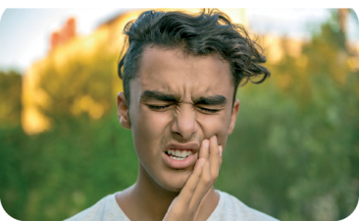

4. ________________ 5. ________________

B. Match the pictures with the idioms. Write a-c.
a) Break a leg! b) I’m all ears! c) Can you give me a hand, please?
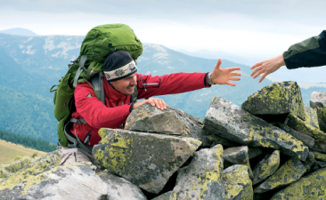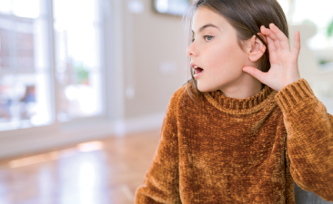
Good luck!
3

2

1


C. Circle the correct relative pronoun.
1. That is the boy who / which has an eating disorder.
2. Drugs can be a problem who / which some teens have to deal with.
D. Circle the correct form of the past perfect. There is one example.

• They had lived / had live that situation.
1. They had quitting / had quitted smoking.
2. Peter hadn’t had / haven’t had problems with alcohol before.

Progress Test
Name No.: ______ Class: ________ Date: _____/ _____/ _____
Mark: ________________ Teacher: ________ __________________________ Enc. Educação: ______________________
2C
III – WRITING

Answer the questions about you.
1. What do you think is the most important problem for teens? (body image, bullying, addiction…)
_____________________________________________________________________________.
2. What is the question that worries you the most? (body image, bullying, addiction, parents’
pressure, peer pressure…)
_____________________________________________________________________________.
3. Do you worry about your image?
_____________________________________________________________________________.
4. Should teenagers drink alcohol and smoke? Why?
I think they because it is
_____________________________________________________________________________
_____________________________________________________________________________.
5. Do you have any addiction?
_____________________________________________________________________________.

