Progress Test
Name No.: ______ Class: ________ Date: _____/ _____/ _____
Mark: ________________ Teacher: __________________________________ Enc. Educação: ______________________
3A
I – READING
Read the following testimonials of three young girls who participated in exchange programmes.
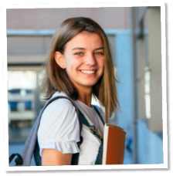
Triine, Estonia, 18

I got my first experience through a youth exchange in my hometown Pärnu when I
was still at school – a local youth worker invited me to an interesting project, which I
had no idea about. As it turned out, we spent a week with Spanish people, discussing
migration and its different types and getting to know each other's culture. Together
with this knowledge, great acquaintances, proper English language practice and a
wider worldview, I also took a little "germ" of Erasmus+ with me from this week.
Some germs disappear from the body, while others take root instead. You don't have to guess
much about what became of this little thing, because I now have exactly 8 Erasmus+ projects in
my experience.


Deimantė, Lithuania, 21

During my third year at university, I started to think about ways to use my knowledge.
I began to look for places in Lithuania. Still, I told myself that while I’m a student,
why don’t I use this fantastic privilege and gain experience abroad. And that is when
I decided that the Erasmus+ programme could make my dreams come true!
I did my internship in London, United Kingdom, and what can I say, what an experience it was! At first, it wasn’t easy to adapt to a new country and absolutely different culture, which is so diverse and unique.
What else can I say… Well, the fact that at first I hesitated to go to this experience abroad now
sounds completely ridiculous! I am glad I didn’t cancel my plans and decided to do this because it made me a better person in every possible way!



I had heard a lot about these projects and I was too afraid to make my first step
and participate. Now, after participating in several Erasmus+ projects as part of the
Youthmakers Hub team, I feel like a storyteller. Through these projects, I realised how
unique we are and, at the same time, how powerful if we have a common vision.
Communication, collaboration, action, inclusion are only a few words connected
with Erasmus+. It was an excellent opportunity for me to be out of my comfort zone
interact with other young people and co-create..
The overall experience is remarkable! If you have second thoughts, I definitely suggest making the first step and you won’t regret it.

Georgianna, Greece, 23

https://youth.europa.eu/stories_tr
A. Match the highlighted words in the text with the corresponding synonyms.

1. various _______________________

2. friends _______________________

3. frightened _______________________

4. general _______________________

5. out of your country _______________________
6. search _______________________
Triine | Deimantė | Georgianna
B. Tick (✔) the correct option(s). Say who…
1. was afraid to join the project at first.

2. feels empowered by a common vision.

3. had her first exchange experience when she was still at school.

4. feels she became a better person after the exchange programme.

5. did Erasmus+ in the UK.

C. Say if the following statements are true or false. Write T (true) or F (false) and correct the false . ones.
1. Triine went to Spain for a week.
_______________________________________________________________________________
2. Triine didn’t know anything about the project in her hometown.
_______________________________________________________________________________
3. Deimantė easily adapted to British culture right from the start.
_______________________________________________________________________________
4. Georgianna strongly advises young people to participate in Erasmus+.
_______________________________________________________________________________

D. Answer the following question.

1. What did Georgianna realise by participating in the projects?
_____________________________________________________________________________
_____________________________________________________________________________
_____________________________________________________________________________
II – LANGUAGE
A. Read the following testimonial of a volunteer who went to Nepal. Fill in the blanks with the words from the box.
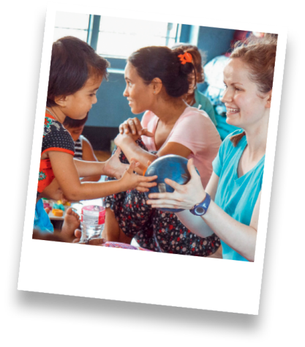
place orphanage amazing volunteer
relaxing abroad volunteers comfortable

“My name is Tiffany, I'm 22 years old and I’m from Australia. I volunteered
¹ ___________ in Pokhara, Nepal. Once I arrived, I met the children at the home
and there were 9 of them altogether. We took them on a picnic to the park next
to the lake and had an ² ___________ time. Just to see them smiling and having
fun at the simplest things was gorgeous. I could see myself growing to love the
³ ____________ and not wanting to leave. The director and his wife were very
welcoming and made me feel very ⁴ ____________ . There were also two other
⁵ ____________ staying at the ⁶ ____________ with the children. Pokhara
is a beautiful lakeside city with everything you need just 20 minutes’ walk
from the orphanage. Mountains surround the lake. There are a lot of things to do here, like
trekking, paragliding, sightseeing, rafting and just ⁷ ____________. I'm very glad I decided to
⁸ ____________ in Pokhara – I hope you decide to come here too! It's different and challenging,
but it's something I always wanted to do and was so worth it!”
www.vwbinternational.org

B. Label the pictures according to the volunteer activity. Write letters a-h. There are 3 extra activities.
a) hand out free meals d) help out at an animal shelter g) do the gardening

b) sort out donated clothes e) help out at a food bank h) take care of the elderly

c) take part in an f) clean up beaches
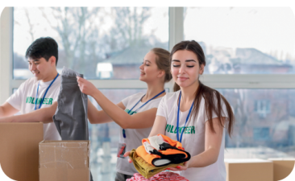
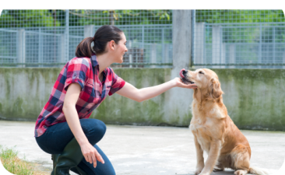
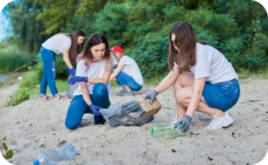
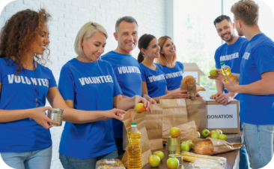
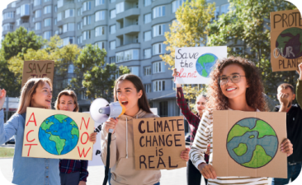
environmental campaign
1.

2.

3.

5.

4.

C. Label the pictures with the words/expressions from the box.
queue currency host family flight attendant boarding pass baggage

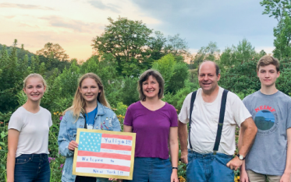
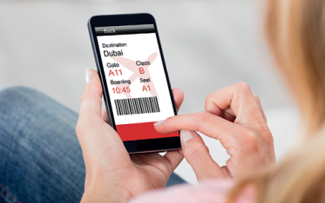


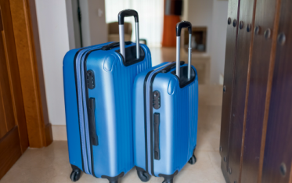


1. ____________________ 2. ____________________ 3. ____________________

4. ____________________ 5. ____________________ 6. ____________________
D. Rewrite the following statements in reported speech.
1. “I’m thinking about volunteering this year.”
Peter told her that ________________________________________________________
2. “I have learned these new languages in the exchange programme.”
She said that ____________________________________________________________
3. “We live right here near the lake.”
They told me that ________________________________________________________
4. “I travelled to France last year.”
John said that ___________________________________________________________
E. Report the following questions and orders/requests/advice.
1. “Which volunteering activity do you want to try?”
My teacher asked me _____________________________________________________
2. “Will you consider participating in an exchange programme?”
I asked them ____________________________________________________________
3. “Donate the clothes you don’t wear anymore.”
They advised us _________________________________________________________
4. “Don’t be afraid to go abroad!”
She told me ____________________________________________________________

Progress Test
Name No.: ______ Class: ________ Date: _____/ _____/ _____
Mark: ________________ Teacher: __________________________________ Enc. Educação: ______________________
3A
III – WRITING

Imagine you are an Erasmus student in a European city. Write an email to a relative or friend about your experience and your plans. Don’t forget to mention the people, the food, the places, the feelings, etc.

















