Progress Test
Name No.: ______ Class: ________ Date: _____/ _____/ _____
Mark: ________________ Teacher: __________________________________ Enc. Educação: ______________________
3B
I – READING
Read the following testimonials of three young girls who participated in exchange programmes.

Triine, Estonia, 18

I got my first experience through a youth exchange in my hometown Pärnu when I
was still at school – a local youth worker invited me to an interesting project, which I
had no idea about. As it turned out, we spent a week with Spanish people, discussing
migration and its different types and getting to know each other's culture. Together
with this knowledge, great acquaintances, proper English language practice and a
wider worldview, I also took a little "germ" of Erasmus+ with me from this week.
Some germs disappear from the body, while others take root instead. You don't have to guess
much about what became of this little thing, because I now have exactly 8 Erasmus+ projects in
my experience.


Deimantė, Lithuania, 21

During my third year at university, I started to think about ways to use my knowledge.
I began to look for places in Lithuania. Still, I told myself that while I’m a student,
why don’t I use this fantastic privilege and gain experience abroad. And that is when
I decided that the Erasmus+ programme could make my dreams come true!
I did my internship in London, United Kingdom, and what can I say, what an experience it was! At first, it wasn’t easy to adapt to a new country and absolutely different culture, which is so diverse and unique.
What else can I say… Well, the fact that at first I hesitated to go to this experience abroad now
sounds completely ridiculous! I am glad I didn’t cancel my plans and decided to do this because it made me a better person in every possible way!

https://youth.europa.eu/stories_tr

A. Match the highlighted words in the text with the corresponding synonyms.

1. out of your country

2. friends

3. search

4. happy

Triine | Deimantė
B. Tick (✔) the correct option(s). Say who…

1. was afraid to join the project at first.

2. had her first exchange experience when she was still at school.

3. feels she became a better person after the exchange programme.

4. did Erasmus+ in the UK.

C. Say if the following statements are true or false. Write T (true) or F (false).
1. Triine went to Spain for a week.
2. Triine didn’t know anything about the project in her hometown.
3. Deimantė easily adapted to British culture right from the start.
D. Answer the following question.

1. How many projects has Triine participated in so far?
_____________________________________________________________________________
_____________________________________________________________________________

II – LANGUAGE

A. Read the following testimonial of a volunteer who went to Nepal. Circle the correct words to complete it.
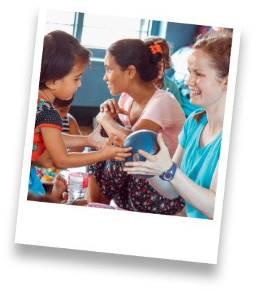
“My name is Tiffany, I'm 22 years old and I’m from Australia. I volunteered
¹ abroad / relaxing in Pokhara, Nepal. Once I arrived, I met the children at the
home and there were 9 of them altogether. We took them on a picnic to the
park next to the lake and had an ² comfortable / amazing time. Just to see them
smiling and having fun at the simplest things was gorgeous. I could see myself
growing to love the ³ place / abroad and not wanting to leave. The director
and his wife were very welcoming and made me feel very comfortable. There
were also two other ⁴ place / volunteers staying at the orphanage with the
children. Pokhara is a beautiful lakeside city with everything you need just 20 minutes’
walk from the orphanage. Mountains surround the lake. There are a lot of things to do here, like
trekking, paragliding, sightseeing, rafting and just ⁵ volunteer / relaxing. I'm very glad I decided
to volunteer in Pokhara – I hope you decide to come here too! It's different and challenging, but
it's something I always wanted to do and was so worth it!”
www.vwbinternational.org

B. Label the pictures according to the volunteer activity. Write letters a-e. There are 3 extra activities.
a) help out at a food bank c) take part in an d) help out at an animal shelter
environmental campaign
b) sort out donated clothes e) clean up beaches

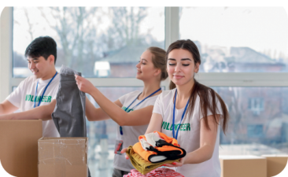

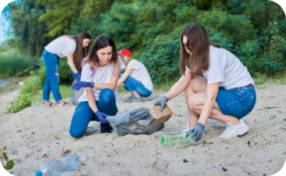

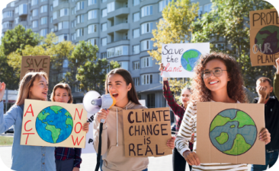
1.

2.

3.

5.

4.

C. Circle the correct words/expressions to label the pictures.
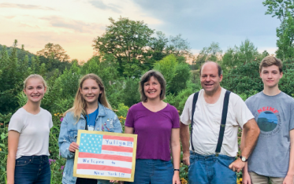
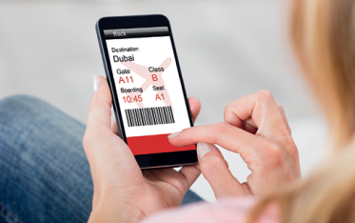





1. host family / currency 2. baggage/ currency 3. queue / baggage

4. boarding pass / 5. host family / queue 6. flight attendant /
currency boarding pass
D. Complete the following statements in reported speech.
1. “I’m thinking about volunteering this year.”
Peter told her that _________ _________ thinking about volunteering _________ year.
2. “I have learned these new languages in the exchange programme.”
She said that _________ _________ learned ___________ new languages in the exchange . programme.
3. “We live right here near the lake.”
They told me that _________ ______________ right _________ near the lake.
4. “I travelled to France last year.”
John said that _________ ______________ to France ________________________.
E. Complete the following questions and orders/requests/advice in reported speech.
1. “Which volunteering activity do you want to try?”
My teacher asked me which volunteering activity ________ __________ to try.
2. “Will you consider participating in an exchange programme?”
I asked them _________ _________ _________ consider participating in an exchange . programme.
3. “Don’t be afraid to go abroad!”
She told me _________ to be afraid to go abroad.

Progress Test
Name No.: ______ Class: ________ Date: _____/ _____/ _____
Mark: ________________ Teacher: __________________________________ Enc. Educação: ______________________
3B
III – WRITING

Imagine you are an Erasmus student in a European city. Write an email to a relative or friend about
your experience and your plans.
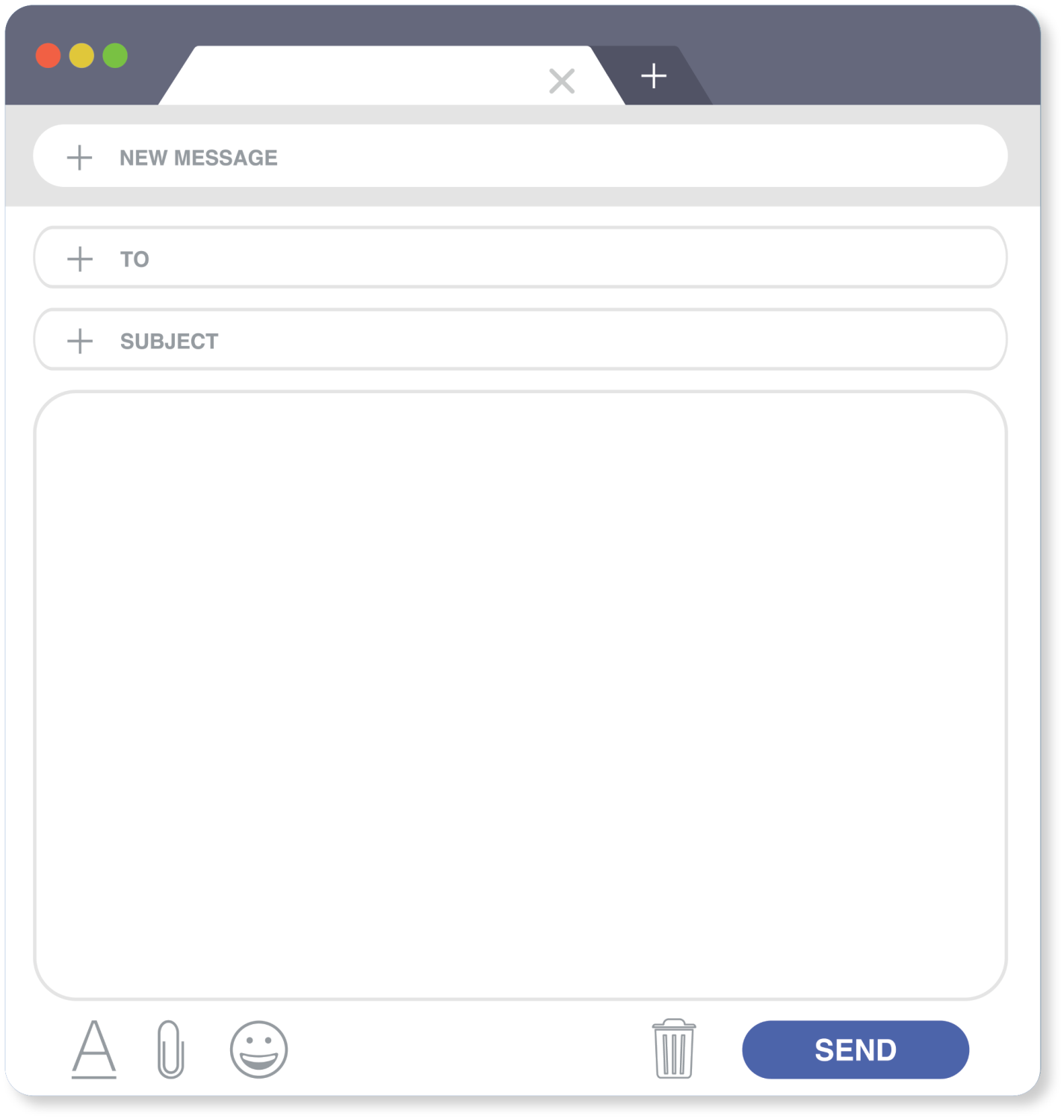
Dear _________________________,

It’s been almost ______________________________________________ (time spent) since I’ve been studying in ______________________ (city) and everything has been
____________________________________________ (opinion)! My host family is
______________________ (1 adjective) and the people here are __________________
______________________ (2 adjectives). In my class there are students from different nationalities, for example, ______________________ (1 nationality).

The weather is _____________________________________________ (1 adjective).

Last week I _________________________________________ (1 activity) and tomorrow I’m going _________________________________________ (1 activity).

Lots of love,

______________________ (name)

