Progress Test 3C
FlyHigh 9 | TESTS

Table of Specifications (Unit 3)
I – READING
Objetivos/ Competências | Conteúdos | Estrutura | Cotações | Critérios  de classificação
Compreensão escrita  Compreender textos sobre temas abordados. | Exchange programmes | A. Fazer corresponder a afirmação à opção correta. | 4 x 15% = 60% | Resposta errada: 0 pontos
 | Exchange programmes | B. Decidir se as frases são verdadeiras ou falsas. | 4 x 10% = 40% | Resposta errada: 0 pontos
 |  | Total: | 100%

II – LANGUAGE
Objetivos/ Competências | Conteúdos | Estrutura | Cotações | Critérios  de classificação
Vocabulário e gramática  Compreender formas de organização do léxico e conhecer algumas  estruturas frequentes do funcionamento da língua. | Volunteer work | A. Legendar corretamente as imagens. | 4 x 7% = 28% | Resposta errada: 0 pontos
 | Travel | B. Legendar corretamente as imagens. | 6 x 6% = 36% | Resposta errada: 0 pontos
 | Reported speech – statements | C. Selecionar a opção correta. | 3 x 6% = 18% | Resposta errada: 0 pontos
 | Reported speech – questions/ orders/advice/ requests | D. Selecionar a opção correta. | 3 x 6% = 18% | Resposta errada: 0 pontos
 |  | Total: | 100%

III – WRITING
Objetivos/ Competências | Conteúdos | Estrutura | Cotações | Critérios  de classificação
Produção escrita  Responder a perguntas sobre si. | Tema: Travelling and exchange programmes | Completar um email com as palavras dadas. | 10 x 10% = 100% | Resposta errada: 0 pontos

Progress Test
Name No.: ______ Class: ________ Date: _____/ _____/ _____
Mark: ________________ Teacher: __________________________________ Enc. Educação: ______________________
3C
I – READING
Read the following testimonials of three young girls who participated in exchange programmes.

Triine, Estonia, 18

I got my first experience through a youth exchange in my hometown Pärnu when I
was still at school – a local youth worker invited me to an interesting project, which I
had no idea about. As it turned out, we spent a week with Spanish people, discussing
migration and its different types and getting to know each other's culture. Together
with this knowledge, great acquaintances, proper English language practice and a
wider worldview, I also took a little "germ" of Erasmus+ with me from this week.
Some germs disappear from the body, while others take root instead. You don't have to guess
much about what became of this little thing, because I now have exactly 8 Erasmus+ projects in
my experience.


Deimantė, Lithuania, 21

During my third year at university, I started to think about ways to use my knowledge.
I began to look for places in Lithuania. Still, I told myself that while I’m a student,
why don’t I use this fantastic privilege and gain experience abroad. And that is when
I decided that the Erasmus+ programme could make my dreams come true!
I did my internship in London, United Kingdom, and what can I say, what an experience it was! At first, it wasn’t easy to adapt to a new country and absolutely different
culture, which is so diverse and unique.
What else can I say… Well, the fact that at first I hesitated to go to this experience abroad now
sounds completely ridiculous! I am glad I didn’t cancel my plans and decided to do this because it made me a better person in every possible way!

https://youth.europa.eu/stories_tr

Triine | Deimantė
A. Tick (✔) the correct option(s). Say who…
1. was afraid to join the project at first.
2. had her first exchange experience when she was still at school.
3. feels she became a better person after the exchange programme.
4. did Erasmus+ in the UK.

B. Say if the following statements are true or false. Write T (true) or F (false).

1. Triine went to Spain for a week.

2. Triine didn’t know anything about the project in her hometown.

3. Deimanté easily adapted to British culture right from the start.

4. Deimanté is glad that she decided to participate in the programme.
II – LANGUAGE
A. Label the pictures according to the volunteer activity. Write letters a-d.
a) clean up b) sort out c) take part in an d) help out at an
beaches donated clothes environmental animal shelter
campaign
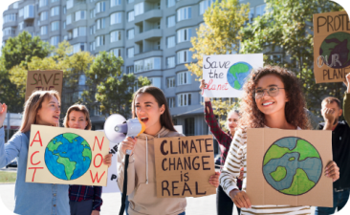
2

1

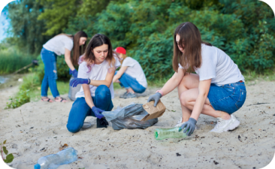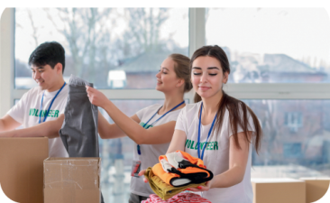

4

3

B. Choose the correct option to label the pictures
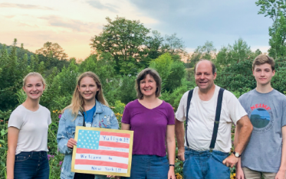
1. currency / host family 2. currency / baggage 3. baggage /
boarding pass
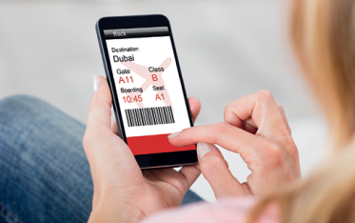
4. boarding pass / 5. host family / queue 6. baggage /
flight attendant flight attendant

C. Choose the correct option to report the following statements.

1. “I’m thinking about volunteering this year.”
a) Peter told her that he was thinking about volunteering that year.
b) Peter told her she is thinking about volunteering those years.
2. “I have learned these new languages in the exchange programme.”
a) She said that they had learned that new languages in the exchange programme.
b) She said that she had learned those new languages in the exchange programme.
3. “We live right here near the lake.”
a) They told me they lived right there near the lake.
b) They told me we live right here near the lake.

D. Choose the correct option to report the following questions and orders/requests/advice.

1. “Which volunteering activity do you want to try?”
a) My teacher asked me which volunteer activity I do want to try.
b) My teacher asked me which volunteering activity I wanted to try.
2. “Will you consider participating in an exchange programme?”
a) I asked them if they would consider participating in an exchange programme.
b) I asked them if he will consider participating in an exchange programme.
3. “Don’t be afraid to go abroad!”
a) She told me not to be afraid to go abroad.
b) She told me don’t be afraid to go abroad.

Progress Test
Name No.: ______ Class: ________ Date: _____/ _____/ _____
Mark: ________________ Teacher: __________________________________ Enc. Educação: ______________________
3C
III – WRITING

Imagine you are an Erasmus student in a European city. Write an email to a relative or friend about
your experience and your plans. Choose the words from the box to complete the text.

wonderful (your name) welcoming one month nice and helpful
English rainy and cloudy visit London friend

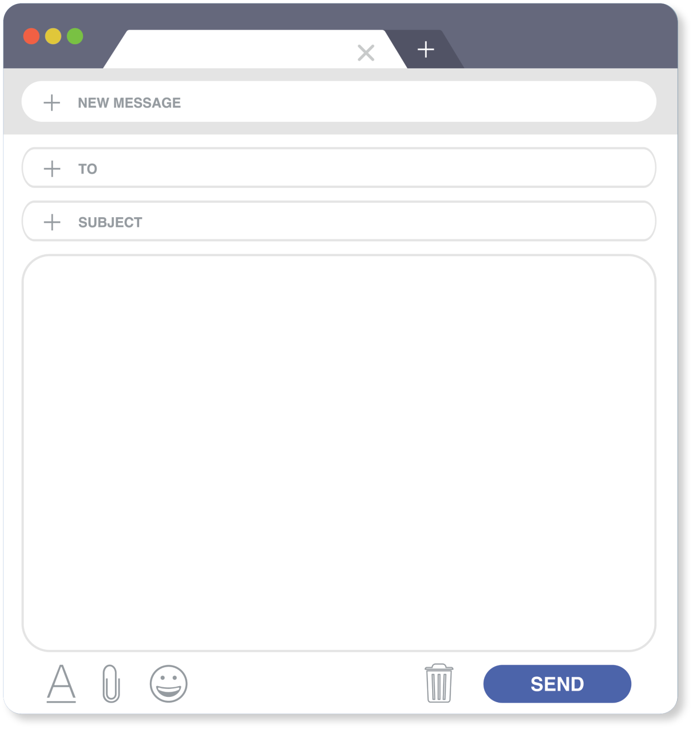
Dear _____________________,
It’s been almost _______________________________________________ (time spent)
since I’ve been studying in _____________________ (city) and everything has been
_____________________ (feeling)! My host family is _____________________
(1 adjective) and the people here are ____________________________________
(2 adjectives). In my class there are students from different nationalities and we speak
_____________________ together.
The weather is __________________________________________ most of the time.
Last week I visited Big Ben and tomorrow I’m going to __________________ the Natural
History Museum.

Lots of love,
_____________________ (name)

