Progress Test
Name No.: ______ Class: ________ Date: _____/ _____/ _____
Mark: ________________ Teacher: __________________________________ Enc. Educação: ______________________
5A
I – READING
Read the following text about technology.

Breaking gender barriers in tech: How I started a non-profit as a 15-year-old Filipina

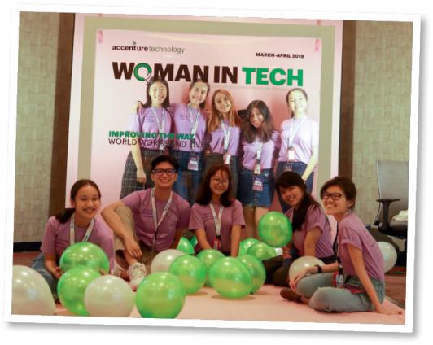
By Audrey

When I was 15, I founded a non-profit called WiTech (Women in Technology). It initially began as a blog that reported on and shared my interviews with women who held jobs in technology in various industries. I used to find them online via hashtags on Instagram,
5 LinkedIn, etc., and wanted to share their stories. It also had the additional benefit of meeting great femalementors and rolemodels in an industry that is traditionally dominated by men.

I startedtofeelthe desire toform a community inthe Philippines that
celebrated diversity and inclusivity in technology. Not only did I want to meet other young people who believed in tech and who shared my values and interests, but I also wanted to make it easier for them
10
to meet like-minded youth.
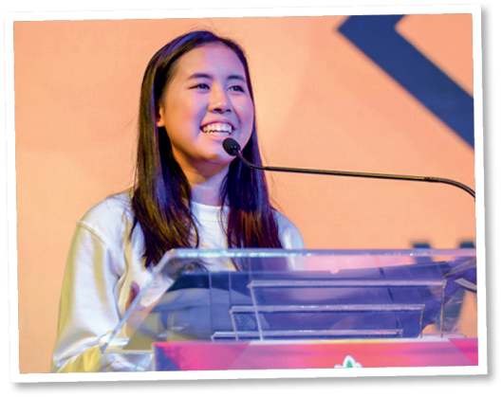
At a hackathon¹ with my friend Marla, I found myself joking that we should organise our own tech conference to specifically celebrate the achievements of women in the field of tech. I was quite surprised
15 when she agreed. After all, we were only high school students at that time. We got to planning and formally changed WiTech from a blog to a community organisation. We then recruited other girls interested in tech, whom we knew from student competitions and networking events. We managed to organise the very first women
20 in tech conference in the Philippines, by students for students. But in fact, that was only the beginning.
It’s been three years since WiTech was founded. Since then, we’ve held 7 events that have impacted over 190 students/fresh graduates and given 60+ students an introduction to programming. We’ve also been able to bring our blog to 22,000+ readers from over 100 countries. It also feels crazy to say that
25
from a team of one back in 2016, the year WiTech was founded, we’ve grown the team to 72 high school, collegestudents,and fresh graduates from 3countries (Philippines,United States and United Kingdom).

At its very core, WiTech stands for equality. As a non-profit that lives by that value every day, we launched an initiative called Wi-Teach (Women in Tech Teach), with the aim to bring introductory programming lessons as well as hardware to communities that need it.
www.voicesofyouth.org/blog

Vocabulary: ¹ hackathon = an event in which a large number of people meet to engage
in collaborative computer programming
A. Complete the sentences according to the information in the text.

1. She started her non-profit organisation when she _______________________________.

2. At first WiTech was simply _______________________________.

3. She wanted to meet ______________________________________________ and shared her . values and interests.

4. Audrey and her friend transformed the WiTech into _________________________________.

B. Read the following statements and say if they are true or false. Write T (true) or F (false). Correct the false ones.

1. Audrey found the women she interviewed through social media.
_____________________________________________________________________________

2. There are as many men as women in the tech industry.
_____________________________________________________________________________

3. The idea of organising her own tech conference started as a joke.
_____________________________________________________________________________

4. She didn’t know the girls recruited to her community organisation.
_____________________________________________________________________________

5. The main value of WiTech is equality.
_____________________________________________________________________________

C. Say what the following numbers refer to in the text.

1. 60+ _________________________________________________________

2. 22,000+ _____________________________________________________

3. 2016 ________________________________________________________

4. 72 __________________________________________________________

D. Answer the following question.

1. What is the purpose of the initiative WiTeach (Women in Tech Teach)?
_____________________________________________________________________________
_____________________________________________________________________________

II – LANGUAGE

A. Complete the text with the words from the box.
tools technology progress lifestyle
devices messages self-driving lives

Artificial intelligence (AI) is everywhere! It is not only about robots or ¹ __________________cars. Wecan find iton theinternet,on social mediaand on smart² _________________ orpersonal assistants such as Siri or Alexa.
AI affects all parts of our ³ ______________. In education, for example, it can help students by developing individualised learning ⁴ _________________; in healthcare theuseof apps can help people have a healthy ⁵ ; incommunicationemails, SMSor socialmedia ⁶ ________________
have becomeindispensable; transport,jobs,environment and morealso use AI. It has becomean essential piece of ⁷ _________________ which can help society ⁸ ________________.

B. Label the AI apps with words/expressions from the box.

autocomplete chatbot facial recognition robot floor cleaner speech-to-text





1. 2. 3.

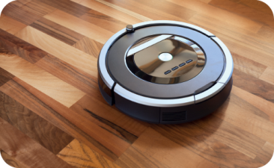


4. 5.

C. Choose the correct option to complete the statements.

1. In our modern store, you can find leading-edge / outdated technology.

2. My brother buys all the latest technological devices. He’s a real gamer / tech geek!

3. When you travel or learn a foreign language, translation apps / printers can be very helpful.

4. A charger / digital assistant is like a friend you talk to when you are lonely

D. Choose the correct option (to-infinite or -ing form) in each sentence.

1. Can you imagine to have / having all that leading-edge tech?

2. I gave up to try / trying to keep up to date with the new smartphones.

3. They would really like to watch / watching that science fiction film.

4. You promised to switch off / switching off the TV set.

E. Read the sentences. Are they in the active (A) or passive (P)? Tick (✔) the correct option.

A P

1. Our lives are changed by the use of technology.

2. Tech helped many girls in the Philippines.

3. They were given lots of new tech opportunities by the organisation.

4. The company recruits girls interested in tech.

F. Rewrite the following sentences in the passive.

1. Audrey founded WiTech.
_____________________________________________________________________________

2. The organisation celebrates tech achievements of women.
_____________________________________________________________________________

3. Her team organised seven tech conferences.
_____________________________________________________________________________

4. WiTeach gives the opportunity to have programming lessons.
_____________________________________________________________________________

III – WRITING

Progress Test
Name No.: ______ Class: ________ Date: _____/ _____/ _____
Mark: ________________ Teacher: ________ __________________________ Enc. Educação: ______________________
5A

Some people believe that technology is essential in every area of life. Do you agree? How important is technology in your life? Write an essay stating your opinion. You can follow the guidelines below.

Paragraph 1: Introduction

Paragraph 2: First idea

Paragraph 3: Second idea

Paragraph 4: Conclusion

_________________________________________________________________
_________________________________________________________________
_________________________________________________________________
_________________________________________________________________
_________________________________________________________________
_________________________________________________________________
_________________________________________________________________
_________________________________________________________________
_________________________________________________________________
_________________________________________________________________
_________________________________________________________________
_________________________________________________________________
_________________________________________________________________
_________________________________________________________________
_________________________________________________________________
_________________________________________________________________
_________________________________________________________________
_________________________________________________________________
_________________________________________________________________
_________________________________________________________________

