Progress Test
Name No.: ______ Class: ________ Date: _____/ _____/ _____
Mark: ________________ Teacher: __________________________________ Enc. Educação: ______________________
5B
I – READING
Read the following text about technology.

Breaking gender barriers in tech: How I started a non-profit as a 15-year-old Filipina

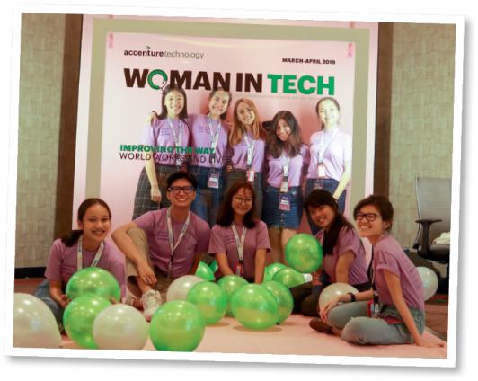
By Audrey

When I was 15, I founded a non-profit called WiTech (Women in Technology). It initially began as a blog that reported on and shared my interviews with women who held jobs in technology in various industries. I used to find them online via hashtags on Instagram,
5 LinkedIn, etc., and wanted to share their stories. It also had the additional benefit of meeting great femalementors and rolemodels in an industry that is traditionally dominated by men.

I startedtofeelthe desire toform a community inthe Philippines that
celebrated diversity and inclusivity in technology. Not only did I want to meet other young people who believed in tech and who shared my values and interests, but I also wanted to make it easier for them
10
to meet like-minded youth.

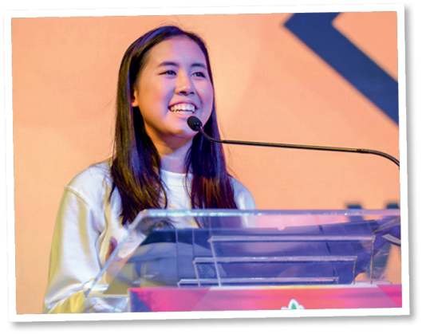
At a hackathon¹ with my friend Marla, I found myself joking that we should organise our own tech conference to specifically celebrate the achievements of women in the field of tech. I was quite surprised
15 when she agreed. After all, we were only high school students at that time. We got to planning and formally changed WiTech from a blog to a community organisation. We then recruited other girls interested in tech, whom we knew from student competitions and networking events. We managed to organise the very first women
20 in tech conference in the Philippines, by students for students. But in fact, that was only the beginning.
It’s been three years since WiTech was founded. Since then, we’ve held 7 events that have impacted over 190 students/fresh graduates and given 60+ students an introduction to programming. We’ve also been able to bring our blog to 22,000+ readers from over 100 countries. It also feels crazy to say that
25
from a team of one back in 2016, the year WiTech was founded, we’ve grown the team to 72 high school, collegestudents,and fresh graduates from 3countries (Philippines,United States and United Kingdom).

At its very core, WiTech stands for equality. As a non-profit that lives by that value every day, we launched an initiative called Wi-Teach (Women in Tech Teach), with the aim to bring introductory programming lessons as well as hardware to communities that need it.
www.voicesofyouth.org/blog

Vocabulary: ¹ hackathon = an event in which a large number of people meet to engage
in collaborative computer programming
A. Complete the sentences according to the information in the text.

1. She started her non-profit organisation when she _______________________________. . (paragraph 1)

2. At first WiTech was simply _______________________________. (paragraph 1)

3. She wanted to meet ______________________________________________ and shared her . values and interests. (paragraph 2)

4. Audrey and her friend transformed the WiTech into _________________________________. . (paragraph 3)

B. Read the following statements and say if they are true or false. Write T (true) or F (false).

1. Audrey found the women she interviewed through social media.

2. There are as many men as women in the tech industry.

3. The idea of organising her own tech conference started as a joke.

4. She didn’t know the girls recruited to her community organisation.

5. The main value of WiTech is equality.

C. Match the numbers taken from the text with what they refer to. Write letters a-d.

1. 60+ a) members of the WiTech team

2. 22,000+ b) the year WiTech was founded

3. 2016 c) students introduced to programming

4. 72 d) blog readers

D. Answer the following question.

1. What is the aim of the initiative WiTeach (Women in Tech Teach)? (paragraph 5)
_____________________________________________________________________________
_____________________________________________________________________________

II – LANGUAGE

A. Circle the correct words to complete the text.
Artificial intelligence (AI) is everywhere! It is not only about robots or ¹ progress / self-driving cars. It is on the internet, on social media and on smart ² devices / lives or personal assistants such as Siri or Alexa.
AI affects all parts of our ³ tools / lives. In education, for example, it can help students by developing individualised learning ⁴ messages / tools in healthcare, the use of apps can help people have a healthy ⁵ lifestyle / lives; in communication, emails, SMS or social media ⁶ messages / progress have indispensable; transport, jobs, environment and more also use AI. It has become an essential piece of our ⁷ technology / lifestyle which can help society ⁸ self-driving / progress.
B. Write the missing vowels to label the AI apps.




l
s
c
h
x
t
t
t
p
c
f
1. _ _ _ _ _ _ 2. _ _ _ _ _ _- _ _-_ _ _ _
n
t
n
g
c
r
_ _ _ _ _ _ _ _ _ _ _




3. _ _ _ _ _ _ _ _ _ _ _ _ 4. _ _ _ _ _ _ _
b
t
t
h
c
t
l
c
m
p
t



r
l
f
t
b
r
5. _ _ _ _ _ _ _ _ _ _
r
n
l
c
_ _ _ _ _ _ _

C. Circle the correct option to complete the statements.

1. In our modern store, you can find leading-edge / outdated technology.

2. My brother buys all the latest technological devices. He’s a real gamer / tech geek!

3. When you travel or learn a foreign language, translation apps / printers can be very helpful.

4. A charger / digital assistant is like a friend you talk to when you are lonely.
D. Circle the correct option (to-infinite or -ing form) in each sentence.

1. Can you imagine to have / having all that leading-edge tech?

2. I gave up to try / trying to keep up to date with the new smartphones.

3. They would really like to watch / watching that science fiction film.

4. You promised to switch off / switching off the TV set.

E. Read the sentences. Are they in the active (A) or passive (P)? Tick (✔) the correct option.

A P

1. Our lives are changed by the use of technology.

2. Tech helped many girls in the Philippines.

3. They were given lots of new tech opportunities by the organisation.

4. The company recruits girls interested in tech.

F. Choose the correct passive version of each sentence.

1. Audrey founded WiTech.
a) WiTech founded by Audrey.
b) WiTech was founded by Audrey.

2. The organisation celebrates tech achievements of women.

a) Tech achievements of women are celebrated by the organisation.
b) Tech achievements of women celebrated by the organisation.
3. Her team organised seven tech conferences.

a) Seven tech conferences were organised by her team.
b) Seven tech conferences was organise by her team.
4. WiTeach gives the opportunity to have programming lessons.

a) The opportunity to have programming lessons is given by WiTeach.
b) The opportunity to have programming lessons gives WiTeach.

III – WRITING

Progress Test
Name No.: ______ Class: ________ Date: _____/ _____/ _____
Mark: ________________ Teacher: __________________________________ Enc. Educação: ______________________
5B

Some people believe that technology is essential in every area of life. Do you agree? How important is technology in your life? Complete the essay stating your opinion.

Using technology is (1 adjective) in every area of life.
It is used in education, and
(2 areas).

For me, technology is (how important).
I usually use
(2 devices) every day. I use these technological devices to
(2 actions).

The use of technology can be
(1 negative adjective), but if you use your devices in an intelligent way, they can be really
(1 positive adjective).

