Progress Test 5C
FlyHigh 9 | TESTS

Table of Specifications (Unit 5)
I – READING
Objetivos/ Competências | Conteúdos | Estrutura | Cotações | Critérios  de classificação
Compreensão escrita  Compreender textos sobre temas abordados. | Technology | A. Completar as frases com informação do texto. | 5 x 14% = 70% | Resposta errada: 0 pontos
 | Technology | B. Fazer a correspondência correta. | 3 x 10% = 30% | Resposta errada: 0 pontos
 |  | Total: | 100%

II – LANGUAGE
Objetivos/ Competências | Conteúdos | Estrutura | Cotações | Critérios  de classificação
Vocabulário e gramática  Compreender formas de organização do léxico e conhecer algumas  estruturas frequentes do funcionamento da língua. | AI apps | A. Legendar corretamente as imagens. | 4 x 10% = 40% | Resposta errada: 0 pontos
 | Technology | B. Selecionar a palavra correta. | 3 x 10% = 30% | Resposta errada: 0 pontos
 | Gerund/ Infinitive | C. Selecionar a forma verbal correta. | 3 x 5% = 15% | Resposta errada: 0 pontos
 | Passive and active | D. Identificar corretamente as frases. | 3 x 5% = 15% | Resposta errada: 0 pontos
 |  | Total: | 100%

III – WRITING
Objetivos/ Competências | Conteúdos | Estrutura | Cotações | Critérios  de classificação
Produção escrita  Responder a perguntas sobre si. | Tema: Technology | Responder a perguntas sobre si. | 5 x 20% = 100% | Resposta errada: 0 pontos

Progress Test
Name No.: ______ Class: ________ Date: _____/ _____/ _____
Mark: ________________ Teacher: __________________________________ Enc. Educação: ______________________
5C
I – READING
Read the following text about technology.

Breaking gender barriers in tech: How I started a non-profit as a 15-year-old Filipina
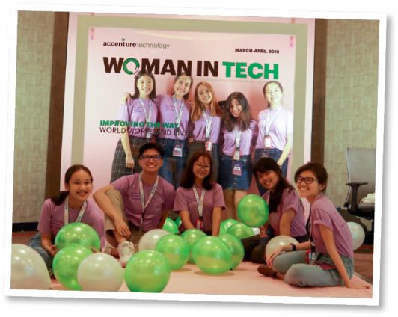
By Audrey
When I was 15, I founded a non-profit called WiTech (Women in
Technology). It initially began as a blog that reported on and shared
my interviews with women who held jobs in technology in various
industries. I used to find them online via hashtags on Instagram,
LinkedIn, etc., and wanted to share their stories. It also had the
additional benefit of meeting great female mentors and role models
in an industry that is traditionally dominated by men.
I started to feel the desire to form a community in the Philippines.
This tech community should celebrate diversity and inclusivity in technology. I wanted to meet other
young people who believed in tech and who shared my values and interests.

www.voicesofyouth.org/blog (adapted and abridged)
A. Complete the sentences with information from paragraph 1 of the text.
1. She started her non-profit organisation when she _______________________________.
2. The non-profit organisation was called _______________________________.
3. Initially it began _____________________________.
4. She found the women _________________________ via hashtags on Instagram, LinkedIn, etc.
4. The tech industry is traditionally _________________________________.
B. Read paragraph 2 and match the parts to make complete sentences. Write letters a-c.
1. She felt the desire a) should celebrate diversity and inclusivity in technology.
2. The tech community b) other people who believed in tech and shared her values.
3. Audrey wanted to meet c) to form a community in the Philippines.

II – LANGUAGE

A. Choose the correct words/expressions to label the AI apps.



1. facial recognition / 2. facial recognition /
robot floor cleaner speech-to-text

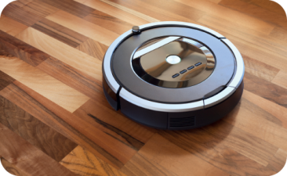


3. chatbot / 4. chatbot /
facial recognition robot floor cleaner

B. Circle the correct option to complete the statements.
1. My brother buys all the latest technological devices. He’s a real gamer / tech geek!
2. When you travel or learn a foreign language, translation apps / printers can be very helpful.
3. A charger / digital assistant is like a friend you talk to when you are lonely.
C. Circle the correct option in each sentence.
1. Can you imagine to have / having all that leading-edge tech?
2. They would really like to watch / watching that science fiction film.
3. You promised to switch off / switching off the TV set.

D. Read the sentences. Are they in the active (A) or passive (P)? Tick (✔) the correct option.

A P

1. Our lives are changed by the use of technology.

2. WiTech helped many girls in the Philippines.

3. They were given lots of new tech opportunities by the organisation.

III – WRITING

Progress Test
Name No.: ______ Class: ________ Date: _____/ _____/ _____
Mark: ________________ Teacher: ________ __________________________ Enc. Educação: ______________________
5C

Answer the questions about you.

I would buy
My favourite artificial intelligence device is
I usually
I spend
My favourite technological device is
1. What is your favourite technological device?
_______________________________________________________________________
2. How many hours a day do you spend on your phone?
_______________________________________________________________________
3. What do you usually do on your phone?
_______________________________________________________________________
4. What is your favourite artificial intelligence device? (personal assistant, robots, …)
_______________________________________________________________________
5. What gadget would you buy in a tech store?
_______________________________________________________________________

