Fly High 9 | PEA

Estrutura da Prova e Cotações
Prova Extraordinária de Avaliação

I – LISTENING
Objetivos/ Competências | Conteúdos | Estrutura | Cotações | Critérios  de classificação
Compreensão oral  Seguir, sem dificuldade, uma apresentação breve sobre um tema familiar; acompanhar informações com algum pormenor. | Fast fashion | A. Escrever as palavras corretas. | 6 x 2% = 12% | Resposta errada: 0 pontos
 | Teens’ fashion habits | B. Identificar corretamente as frases verdadeiras e falsas. | 8 x 1% = 8% | Resposta errada: 0 pontos
 |  | Total: | 20%

II – READING
Objetivos/ Competências | Conteúdos | Estrutura | Cotações | Critérios  de classificação
Compreensão escrita  Compreender textos sobre temas abordados. | Fashion and the  environment | A. Fazer corretamente a correspondência dos sinónimos. | 5 x 2% = 10% | Resposta errada: 0 pontos
 | Fashion and the  environment | B. Escolher a resposta correta. | 1 x 5% = 5% | Resposta errada: 0 pontos
 | Fashion and the  environment | C. Decidir se as frases são verdadeiras ou falsas. Corrigir as falsas. | 4 x 2% = 8% | Resposta errada: 0 pontos Erros de ortografia: -0,5 pontos  Erros de ortografia  + estrutura: -1 ponto
 | Fashion and the  environment | D. Responder corretamente à questão. | 1 x 7% = 7% | Resposta errada: 0 pontos Erros de ortografia: -0,5 pontos  Erros de ortografia  + estrutura: -1 ponto
 |  | Total: | 30%

III – LANGUAGE
Objetivos/ Competências | Conteúdos | Estrutura | Cotações | Critérios  de classificação
Vocabulário e gramática  Compreender formas de organização do léxico e conhecer algumas  estruturas frequentes do funcionamento da língua. | Clothes and accessories | A. Legendar corretamente as imagens. | 6 x 1% = 6% | Resposta errada: 0 pontos
 | Present simple; present continuous | B. Escolher a opção correta. | 3 x 1% = 3% | Resposta errada: 0 pontos
 | Past simple | C. Escrever corretamente a forma verbal. | 4 x 1% = 4% | Resposta errada: 0 pontos
 | Relative pronouns | D. Escrever o pronome relativo correto. | 3 x 2% = 6% | Resposta errada: 0 pontos
 | Adjective degrees | E. Escolher a opção correta. | 3 x 1% = 3% | Resposta errada: 0 pontos
 | Conditional sentences type 1 and type 2 | F. Escrever corretamente a forma verbal. | 4 x 2% = 8% | Resposta errada: 0 pontos
 |  | Total: | 30%

Fly High 9 | PEA

IV – WRITING
Objetivos/ Competências | Conteúdos | Estrutura | Cotações | Critérios  de classificação
Produção escrita  Produzir textos de 90 a 100 palavras utilizando vocabulário comum. | Fashion | Produzir um texto, apresentando um ponto de vista pessoal. | 20% | Ver tabela abaixo

Writing Assessment Criteria
Critérios | Descritores | Cotações
Género/Formato textual | Escreve um texto simples, claro e coerente, respeitando as instruções e/ou os elementos fornecidos, bem como toda a estrutura do género textual solicitado. | 5%
Género/Formato textual | Escreve um texto simples, claro, ainda que nem sempre coerente, respeitando a maioria das instruções e/ou dos elementos fornecidos, bem como a generalidade dos tópicos que compõem a estrutura do género textual solicitado. | 4%
Género/Formato textual | Escreve um texto muito simples, respeitando algumas instruções dadas, embora revelan-do bastante dificuldade em utilizar os elementos fornecidos, bem como a maioria dos tópicos que compõem a estrutura do género textual solicitado. | 3%
Extensão  (90-100 palavras) | Escreve um texto com um mínimo de 60 palavras sobre a temática apresentada. | 5%
Extensão  (90-100 palavras) | Escreve um texto com um mínimo de 30 palavras sobre a temática apresentada. | 4%
Extensão  (90-100 palavras) | Escreve um texto com um mínimo de 15 palavras sobre a temática apresentada. | 3%
Comunicação (tema e pertinência da informação) | Aborda os tópicos solicitados, recorrendo a informação pertinente; utiliza vocabulário adequado ao tema; e assegura a progressão da informação sem comprometer a coerência textual. | 5%
Comunicação (tema e pertinência da informação) | Aborda alguns tópicos solicitados, recorrendo a pouca informação pertinente; utiliza vocabulário nem sempre adequado ao tema; e a progressão da informação pode com-prometer parcialmente a coerência textual. | 4%
Comunicação (tema e pertinência da informação) | Aborda apenas um dos tópicos solicitados, recorrendo a quase nenhuma informação per-tinente; raramente utiliza vocabulário adequado ao tema; e a progressão da informação compromete globalmente a coerência textual. | 3%
Correção linguística | Comete pequenos erros linguísticos (ortografia/pontuação) que não comprometem a comunicação. | 5%
Correção linguística | Comete erros linguísticos que comprometem parcialmente a compreensão da mensagem. | 4%
Correção linguística | Comete erros linguísticos que comprometem globalmente a compreensão da mensagem. | 3%

.

PROVA EXTRAORDINÁRIA DE AVALIAÇÃO
3º CICLO DO ENSINO BÁSICO – 2022/23

Modalidade da Prova: Prova Escrita
Duração: 90 minutos

I – LISTENING

A. Listen to a young girl explaining what fast fashion is and complete the text with the missing words. The first letter is given.
Track 39
It’s Kristin and this is Fast Fashion in 5 Minutes or Less. Fast fashion is used to describe cheap
¹ _________ clothing that are very quickly coming in and out of style. Many fast fashion retailers
introduce new products multiple times in a week in order to stay on trend. Just go into your ²_________
and check the labels on your clothing. Chances are that most of them are from fast fashion ³ _________.
So, how did fast fashion manage to take over our closets and become so successful? It’s said that
fast fashion is a response to a huge market of consumers that are demanding high fashion at a low
⁴ __________, but the truth is that fast fashion retailers are actually creating that demand because
selling a ton of clothes is really profitable. But how exactly do they maximize their ⁵ __________? Well,
instead of replenishing their stock, they replace the items that sell out with new items of a different
⁶ __________ making our older clothes outdated and unfashionable and also making us constantly want
to keep shopping for new trendier clothes.
t
c
b
p
s
c

B. Listen to the audio about teens’ shopping habits and say if the statements are true or false. Write T (true) or F (false).
Track 40
1. Teenagers spend about 12 hours a week shopping for clothes.

2. They spend around 80 euros a month on clothes.

3. The sales in the UK are typically only in January.

4. The streets in Camden Lock are only busy on Saturdays and Sunday mornings.

5. The shops have strange alternative things.

6. Teenagers hate Camden Lock.

7. Both London and Manchester are good for shopping.

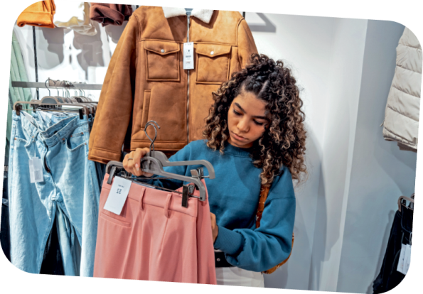
8. The girl buys whatever is in fashion.

II – READING

Read the following text about fast fashion.
Young voices: should we say no to fast fashion?

By Olivia Harris

So, what is fast fashion? Fast fashion is when clothing companies
push out trendy styles in a matter of weeks, aiming to please
the consumer at affordable prices. However, we all know that
this comes with a few consequences. Factory workers are often
treated unfairly and paid lower than what they can survive on,
many clothing items become disposable due to the rapid change
and it contributes a lot to pollution and environmental damage.
Recently, with the rising interest in environmental changes, it has got me thinking: will activists ever be able to put a stop to fast fashion?
A lot of us teenagers spend our money on seeking out the fashionable pieces for the year in
these fast fashion shops, mainly because of the low prices that we can afford and their ability to
follow the trends that everyone is talking about. Our generation has a huge focus on what we look like and the type of clothes we wear, making these accessible fast fashion brands our top pick. Personally, there have been moments where I have felt guilty for the consequences my expenditure in these shops has. However, my craving for a new outfit or a particular style of top has always managed to get the better of me.
Due to social media filling us in on the devastating impacts that fast fashion can have, and activists taking a stance, will we teens ever be drawn away from our favourite brands for good? Do we need to be more cautious about where we buy our clothes from in the future? Are other sustainable brands too expensive to attract teens with their money? Or should we not be worrying about making such an ethical choice when it comes to clothes?

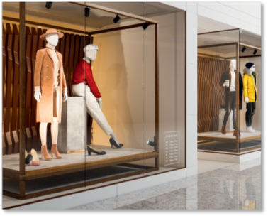

5

10

15

20

www.halesowennews.co.uk/news

A. Match the highlighted words in the text with the corresponding synonyms. Write letters a-e.
1. affordable a) pay

2. damage b) best choice

3. seeking out c) destruction

4. afford d) reasonable

5. top pick e) looking for

B. Choose the correct answer.
1. The phrase “activists taking a stance” means:
a) activists taking a position
b) activists taking a chance
c) activists having no opinion
C. Say if the following statements are true or false. Write T (true) or F (false). Correct the false ones.
1. You can buy fast fashion at cheap prices.
___________________________________________________________
2. Factory workers are well paid for the work they do.
___________________________________________________________
3. Fast fashion contributes much to environmental pollution.
___________________________________________________________
4. Teenagers are aware of their looks and fashion.
___________________________________________________________

D. Answer the question about the text.

1. How does she feel about spending her money on fast fashion?
_____________________________________________________________________________
_____________________________________________________________________________

III – LANGUAGE

A. Choose the words from the box to label the following accessories and clothes.
necklace hoodie trousers shirt earrings skirt

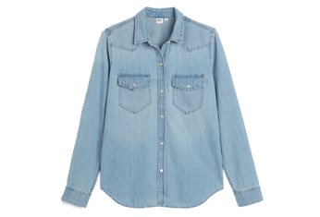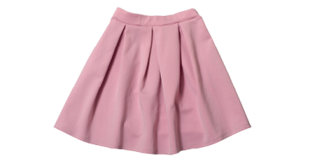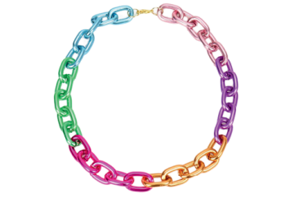
1. __________________ 2. __________________ 3. __________________
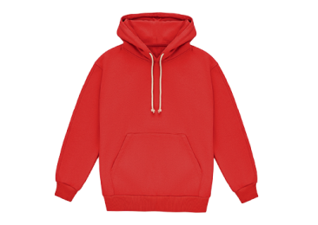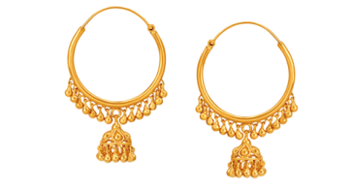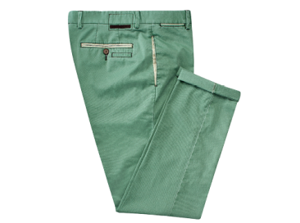
4. __________________ 5. __________________ 6. __________________

B. Choose the correct verb tense (present simple / present continuous).
1. At the moment that boy is buying / buys a pair of jeans in the new store.
2. Teenagers are usually wearing / usually wear fast fashion clothes.
3. I am checking / check my TikTok for the latest fashion styles every day.

C. Complete the sentences with the verbs in brackets in the past simple.
1. My mum _____________________ (buy) me a new jacket.
2. My friends _____________________ (watch) my TikTok last night.
3. They _____________________ (not post) any news.
4. Where ____________________________ (you / get) that outfit?

D. Complete the sentences with a relative pronoun (who / which / whose).
1. She bought clothes ______________ aren’t fast fashion.
2. Teenagers ______________ are very self-conscious about their image worry about the . clothes they wear.
3. That is the boy ______________ mother is a fashion designer.

E. Choose the correct form of the adjective.
1. That skirt is shorter / the shortest than mine.
2. This is more beautiful / the most beautiful dress I’ve ever seen.
3. Sustainable fashion is better / the best than fast fashion.

F. Complete the following conditional sentences with the correct form of the verbs in brackets: . type 1 – if + present simple, will + infinitive; type 2 – if + past simple, would + infinitive.
1. If you worry about the environment, you ___________________ (not buy) fast fashion.
2. If he ___________________ (look) for new clothes, he will find them in any online store.
3. They would wear sustainable clothes if they ___________________ (have) the money to buy . them.
4. I ___________________ (like) to be an activist if I had the chance.

IV – WRITING

Write about 90-100 words on the following topic.
For teenagers, style and fashion are usually a very important part of their lives.

Follow the guidelines:
• say how important fashion is for you;
• refer to the type of clothes you wear/your style;
• say how you choose your clothes and where you buy them;
• say if fashion defines who you are.

