Entertainment (TV shows and films)
+ Adjectives (Unit 1)
Vocabulary Worksheet
1C6
Name ________________________________ No.: _______ Class: __________ Date: _____/ _____/ _____

A. Look at the pictures below and circle the correct type of TV show.
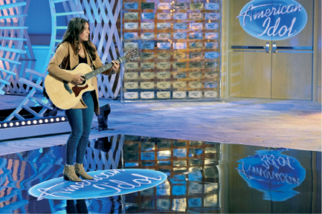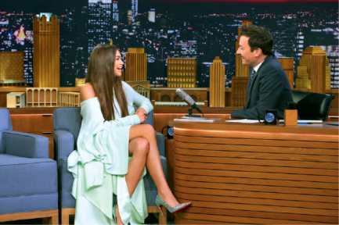
1. cookery quiz / cookery show 2. talent show / talent news 3. chat show / talk news
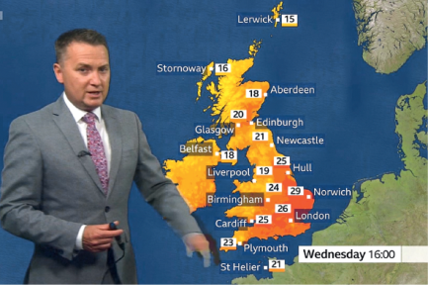
4. sitshow / sitcom 5. commercial / product show 6. weather news /
weather forecast

B. Write the missing letters and find out the types of films.
1. _ _ _ _ _ _ _ _ 2. _ _ _ _ _ 3. _ _ _ _ _ _ _
t h r l l r
a i e
f a t a y
4. _ _ _ _ _ _ _ 5. _ _ _ _ _ _ _ 6. _ _ _ _ _ _ _
f i t i n
w s t e n
m s i a l
s i e c e
_ _ _ _ _ _ _
C. Read the testimonies below and circle the adjective that best describes each film.

The film I watched last weekend was one of
the worst I’ve ever seen. The plot made no
sense and the characters’ relationships were
strange and superficial. The entire film was
³ mindless / entertaining.
Thrillers are definitely my favourite.
The film I watched this evening was
just great. I felt nervous and excited all
the time. It was such a ⁴ suspenseful /
weak film!
I went to the cinema yesterday. I was so disappointed… The
plot was boring. The dialogues were poor and dull. It was
such a ¹ tedious / funny film!
Wow! What a spectacular film last
night! It had adventure, excitement
and danger. I totally recommend it
because it has an ² action-packed /
dull plot!

A. Write each type of media from the box in the correct column. There is one example in each . of them.
The media + Adjectives to describe books (Unit 1)
Vocabulary Worksheet
2C6
Name ________________________________ No.: _______ Class: __________ Date: _____/ _____/ _____
TV e-book magazine newspaper social media radio

Print Media | Broadcast Media | Digital Media
_________________  _________________ | _________________  _________________ | _________________  _________________

radio
newspaper
e-book

B. E-books or printed books? Read the sentences below and circle the correct option to complete . them.

1. When I was a teen, my trips to the internet / library were regular and I often got lost in the pages of a romance novel / film.

2. In high school, I discovered Harry Potter fan fiction / pictures and quickly began reading it on my phone.

3. Suddenly, digital / romantic reading was not so bad. Meanwhile, I noticed that my aunt, a book lover, had a Kindle. Then, for Christmas, she bought me my first Kindle. I haven't been the same since.

4. Hardcover / Plot books were always there for me, but once I finished one video / title, who knew when I'd get to start the next?

5. My Kindle makes the process of searching for a book thrilling. It allows me to . navigate a list of thousands of authors and bestsellers / listeners.

www.oprahdaily.com/entertainment/books (abridged and adapted)
C. Read the sentences and tick (✔) the correct option to replace the underlined words/expressions in the sentences.

1. I’m reading the new detective fiction by my favourite author. The plot is captivating and full of mystery.
a) fascinating b) boring

2. The ending of the thriller I’m reading is really expected. I don’t think it will add much to the story. I’m a bit disappointed.
a) romantic b) predictable

3. This science fiction novel is a book you can’t miss! You can read the e-book on Kindle, too. You have no excuses!
a) a must-read b) dull

4. I’ve bought the paperback edition of the book The Perks of Being a Wallflower. I cried because the plot and the characters are really moving.
a) easy to read b) touching
New media + Actions on the internet (Unit 1)
Vocabulary Worksheet
3C6
Name ________________________________ No.: _______ Class: __________ Date: _____/ _____/ _____
A. Circle the correct option to complete the sentences about computers and the internet.

1. I usually post / type photos and videos of my favourite singers and bands on Facebook.

2. Sue follows / types fast, so she is in charge of the written part of our history project.

3. I couldn’t read your last tweet carefully because John was scrolling / running all the time.

4. Peter scrolls / follows the official Instagram and Facebook pages of the video games he plays.

5. Sophie and Michael edited / followed their last post on internet safety because it had wrong information.
B. Choose the correct option to complete the sentences.
1. I use Google Meet for… a) online video calls and meetings.
b) posts on social media.
2. We participated on a webinar… a) to share personal information online.
b) on streaming platforms and it was great!
3. With social media… a) I can chat, meet and have fun with friends online.
b) I can type texts for school projects.

C. Read the tips about internet safety and complete the words with the missing letters.

1. Create strong _ _ _ _ _ _ _ _ _ and change them regularly.
p s s o r s

2. Make _ _ _ _ _ _ _ of your files.
b c k u s

3. Use strict _ _ _ _ _ _ _ settings when using social media.
p i v c y

4. Avoid _ _ _ _ _ _ _ _ _ _ _ _ by not sharing personal information with
unknown people.
c b e r u l i e s
D. What can we use the internet for? Complete the diagram with the words/expressions from the
box.




video games in online video calls with friends comments

3. play ____________________
4. chat ____________________
1. participate _______________
2. post ____________________


A. Read the testimonies and circle the correct problem they refer to.
Body image (Unit 2)
Vocabulary Worksheet
4C6
Name ________________________________ No.: _______ Class: __________ Date: _____/ _____/ _____
a) binge eating/bulimia
b) headache
- I eat compulsively, without control. Then, I throw up
everything a minute after.

Alexis, 15

a) malnutrition
b) low self-esteem
- It’s difficult for me to make friends… I think I’m never
beautiful or intelligent enough…

Linda, 16

a) obsessions
b) bullying
- I’m constantly weighing myself, looking in the mirror, checking my make-up… I can’t help it. I just want to be perfect.

Sarah, 14

a) depression
b) dizziness
- I’m sad all the time. There’s nothing funny or interesting around me. Sometimes I just want to stay in bed alone.

Peter, 12

a) loss of control
b) anorexia
- I skip all the meals I can. I’ve felt dizzy and sick lately because I spend days without eating anything. I hate food.

Mariah, 15
B. Look at the pictures and circle the correct health condition.

1. headache / insomnia 2. fever / backache 3. sore throat / earache

4. nausea / fever 5. headache / toothache 6. dizziness / fever

A. Complete the table and discover three idiomatic sentences.
Body idioms (Unit 2)
Vocabulary Worksheet
5C6
Name ________________________________ No.: _______ Class: __________ Date: _____/ _____/ _____
…my leg!
…ears.
…cold feet.
1. I’m getting ________________
2. You’re pulling ______________
3. I’m all ____________________

B. Use the idiomatic expressions from exercise A to complete the gaps below.
1. I don’t believe this is your new car! ________________________________! (telling someone
something that is not true – as a joke)
2. I was going to take some strange dieting supplements I bought online, but now
________________________________. (becoming reluctant to do something)
3. Did you go to the doctor? What did he say about your insomnias? ___________________.
(being ready to hear something)
someone = alguém
something = alguma coisa
C. Circle the correct body parts to complete the idioms.

1. to cost an arm and a leg / 2. to be all ears / feet 3. to give someone a
a head and a foot leg / hand

4. Break an arm / a leg! 5. to get something off your
chest / mouth
D. Choose the idioms from exercise C that mean the following:
1. To help someone: _________________________________________________
2. To wish good luck: _________________________________________________
3. To be very expensive: ______________________________________________

A. Label the pictures with the correct problems from the box.
Teens’ addictions and problems (Unit 2)
Vocabulary Worksheet
6C6
Name ________________________________ No.: _______ Class: __________ Date: _____/ _____/ _____
bullying peer pressure addiction
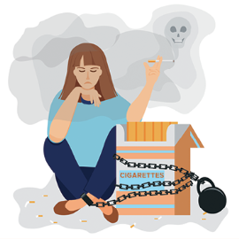
1. ___________________ 2. ___________________ 3. ___________________
B. Circle the correct option to label the pictures about addictions.

1. vaping / smoking 2. social media / fast food 3. computer / gambling

4. alcohol / shopping 5. drugs / video games 6. medicines / food
C. Complete the sentences with the addictions from the box. The words in bold will help you.
vaping social media alcohol gambling
1. Leonardo DiCaprio quit cigarettes and changed to _______________.
2. The Hollywood star Ben Affleck has admitted being addicted to _______________. He once lost
$400,000 in a secret game.
3. The model Kendall Jenner admitted that she can’t escape from _______________. She feels
pressured to keep all her accounts on Facebook, Twitter, Instagram, and so on…
4. Bradley Cooper admits that _______________ affected his relationships badly. He hasn’t drunk
alcoholic drinks for many years.

A. Read the descriptions and choose the correct option.
Air travel (Unit 3)
Vocabulary Worksheet
7C6
Name ________________________________ No.: _______ Class: __________ Date: _____/ _____/ _____
1. A company that transports passengers and goods by aircraft:
a) queue b) airline
2. The place where air passengers go from the terminal to the airplane:
a) baggage b) boarding gate
3. The area in an airport where passengers collect luggage transported in the airplane:
a) baggage claim b) seat
4. Suitcases and bags of a smaller size that passengers carry on to an aircraft:
a) airplane b) hand luggage
B. Use the numbers (1-4) from exercise A to label the pictures.
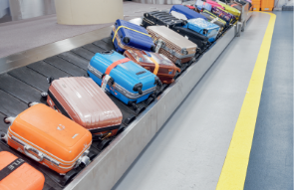

d)
c)

b)

a)

C. Read the email and circle the correct options to complete the text.
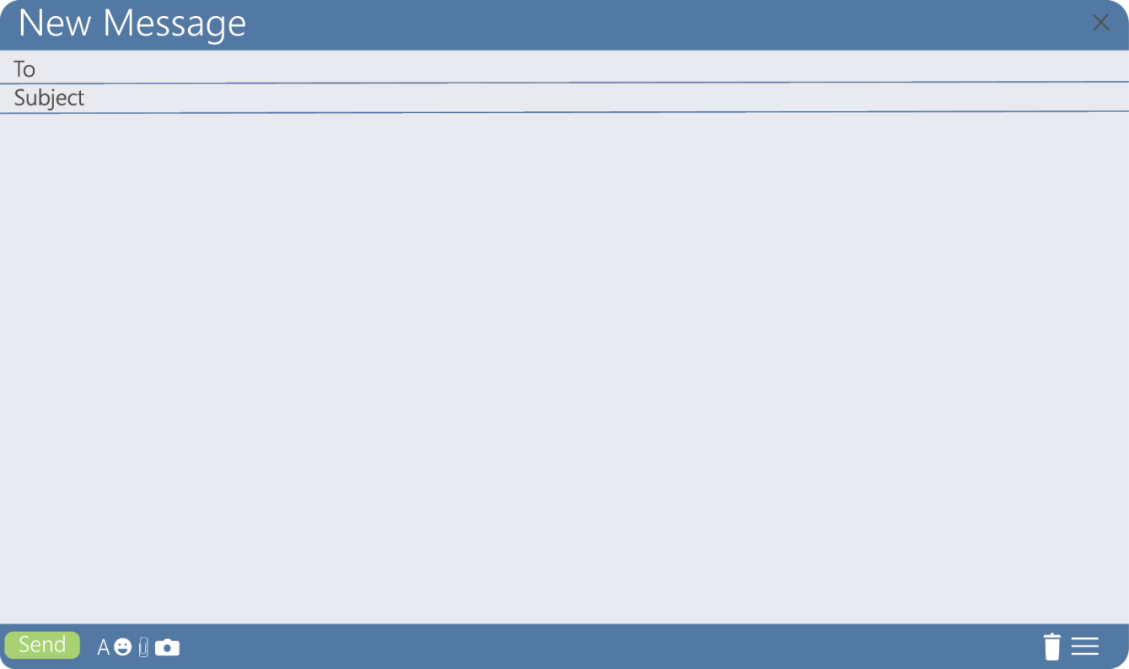
Dear Peter,
I have landed in London for my Erasmus programme! I’m comfortable now, but the ¹ flight /
captain was horrible. I didn’t do my ² departure / check-in online. Big mistake! When I got to
the airport, I waited in a ³ queue / cart for two hours. Then, after going past the ⁴ baggage
claim / security control, I had to wait for another hour to board, but my ⁵ boarding pass / flight
attendant was wrong, so I didn’t get the ⁶ airline / seat I asked for. I sat in the middle.
Hope you’re fine! Miss you a lot already.
Love,
Sue

A. Fill in the diagram with positive and negative aspects of studying abroad. Use the words from
the box.
living people language homesick
Studying abroad (Unit 3)
Vocabulary Worksheet
8C6
Name ________________________________ No.: _______ Class: __________ Date: _____/ _____/ _____


Positive aspects:
• meeting new ___________________
• improving a ____________________
Negative aspects:
• high cost of ____________________
• feeling ________________________

B. Read the opinions from three students studying abroad and circle the correct option to complete
the texts.

I’m studying in England for a ¹ semester / holiday. I love the city, but I
don’t like the food. They have dinner early in the evening! It was a kind
of a ² currency / culture shock, but now I’m used to it.
Sílvia, 18, Coimbra

Studying abroad with my classmates is a great experience! I’m taking
part in an eTwinning ³ student / project in Italy. We’ve visited so many
⁴ landmarks / countries and attractions in Verona, the city of Romeo and Juliet! The city is a bit expensive for students.
Theresa, 14, Londonderry


I have never felt motivated to go on an ⁵ online / exchange
programme, but my English teacher encouraged me a lot, so here I
am in Vienna. My ⁶ host family / airport is just great and I’ve improved
my German a lot! I’ve met wonderful people!
Pierre, 16, Paris


A. Read the sentences and choose the correct picture for the underlined words.
False friends (Unit 3)
Vocabulary Worksheet
9C6
Name ________________________________ No.: _______ Class: __________ Date: _____/ _____/ _____
1. I have an appointment with my English teacher about the eTwinning project with Turkey.



a) b)

2. João attends an international school in London with many other exchange students.



a) b)

3. My parents met abroad when they were Erasmus students. We are a multicultural family.



a) b)

4. I just couldn’t find the right exit at the Frankfurt Airport. It is such a gigantic building!



a) b)

5. I bought a traditional costume when I visited Venice at Carnival.



a) b)



B. Circle the correct translation of the words into Portuguese or English.
Portuguese | English
estrangeiro (adj.) | foreign / stranger
1 empurrar / puxar | push
2 legenda / lenda | legend
fábrica | 3 fabric / factory

Remember
False friends: palavras que se escrevem e pronunciam de forma semelhante
em duas línguas distintas, mas que têm significados diferentes.

A. Label the pictures with the phrases about different ways/places to do volunteering.
Volunteering (Unit 3)
Vocabulary Worksheet
10C6
Name ________________________________ No.: _______ Class: __________ Date: _____/ _____/ _____
fundraising campaign animal shelter environmental action


1. ___________________ 2. ____________________ 3. ____________________
B. Complete the phrases about different ways/places to do volunteering with the words from the
box.
tutoring charity bank


1. food _______________ 2. virtual ______________ 3. international ________
C. Read the texts about humanitarian celebrities and some causes they defend and circle the
correct option to complete them.

David Beckham is a founding ¹ member / person of Malaria No More UK Leadership
Council. His own ² company / charity , the Victoria and David Beckham Charitable
Trust, provides wheelchairs to children in need. His focus on helping 3 children /
animals has led to his appointment as a UNICEF ambassador.


Taylor Swift is often engaged with ⁴ fundraising / parties and donations for the World
Health Organization, Feeding America and Make-A-Wish Foundation to reach people
in need. She uses her fame to ⁵ help / influence young people to volunteer in their local
⁶ communities / home and play an individual part in changing the world.


Brad Pitt joined One Campaign as a spokesperson to fight for an additional 1%
of the U.S. budget to help Africa with basic ⁷ help / needs such as clean water,
education, medicine and food. Pitt has also assisted the charity by helping
⁸ projects / books focused on better health, community ⁹ development / hunger,
environment and education in Haiti through media, sports and music.

www.volunteerfdip.org (abridged and adapted)

www.volunteerfdip.org (abridged and adapted)
A. Read the texts and match the part-time jobs with the descriptions. Write numbers 1-4.
Part-time jobs (Unit 4)
Vocabulary Worksheet
11C6
Name ________________________________ No.: _______ Class: __________ Date: _____/ _____/ _____
1. babysitter 2. tutor 3. car wash attendant 4. sales assistant

I’m a student. In the evening and at weekends I
help younger students with their projects and
skills in certain subjects.
Michael, 19, New Jersey
I’ve decided to take a part-time job. I’m working
with something I love: cars. I wash and polish
cars outside and inside.
Joshua, 18, Aberdeen

b)

a)
Taking care of babies and little kids when their
parents go out for dinner or have to work late is
a huge responsibility, but I enjoy it very much.
Anne, 18, Canberra
I’ve decided to apply for a part-time job at a
famous clothes shop. I’m usually at the cash
desk, but I also help in the fitting rooms.
Sophie, 20, London

c)
d)

B. Label the pictures with the correct part-time job from the box.
waiter lifeguard construction worker


1. ___________________ 2. ____________________ 3. ____________________
C. Choose the correct option to complete the diagram with pros and cons of taking a part-time job.


Part-time jobs

CONS
3. stressful / relaxing workplace
4. more time / less time to have
fun
PROS
1. work conflicts / experience
2. earning your own money /
your parents’ money

A. Look at the list of jobs and match them with the skill that you think is the most necessary for
each job. Write letters a-e.
1. scientist a) problem-solving
2. YouTuber b) people management
3. video game designer c) creativity
4. lawyer d) innovation
5. businessman e) communication
Life skills (Unit 4)
Vocabulary Worksheet
12C6
Name ________________________________ No.: _______ Class: __________ Date: _____/ _____/ _____
B. Circle the correct option to complete the texts.

John is a hairdresser in Manhattan. The ¹ salary / work schedule is from
9 a.m. to 7 p.m. He loves his job and he thinks that good ² communication /
cooperation skills are important to deal with his customers.


Maria has always wanted to be a nurse and she doesn’t mind working
³ well-paid / shifts, even at night. In her opinion, ⁴ cultural awareness /
problem-solving and flexibility are important in her job in order to solve
urgent situations.


Louis is a professional cook. He thinks it is a ⁵ well-paid / part-time job.
His salary is high. You need ⁶ innovation / cooperation skills to work with
your team in the kitchen and divide tasks.

C. Complete the box with information about your dream job. Use a skill from exercise A.

My dream job is to be a/an ____________________ (dream job).
I need ___________________________ (skill) to do this job.

A. Circle the correct job to label the pictures.
Finding your dream job (Unit 4)
Vocabulary Worksheet
13C6
Name ________________________________ No.: _______ Class: __________ Date: _____/ _____/ _____
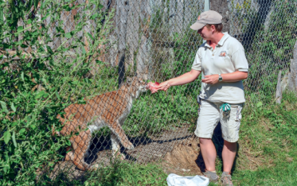
1. zookeeper / vet 2. surgeon / teacher 3. cook / painter
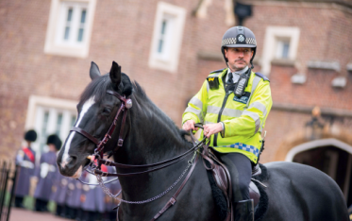
4. football player / gymnast 5. firefighter / police officer 6. author / pilot
B. Complete the words/expressions with the missing letters that match the definitions.
t o h r
1. To employ someone: _ _ _ _ _ _
o b v a a n c
2. A job that is not filled: _ _ _ _ _ _ _ _ _ _
f u l - i m e j b
3. Usually working eight hours a day/forty hours a week: _ _ _ _ _ _ _ _ _ _ _
v o c t i n
4. A feeling that you should follow a certain career or occupation: _ _ _ _ _ _ _ _
t o p l y
5. Writing a letter or email or filling in a form in order to show interest in a job: _ _ _ _ _ _ _
q a l i f c a i o n s
6. The examinations you have passed and that are on your CV: _ _ _ _ _ _ _ _ _ _ _ _ _ _
C. Circle the correct words/expressions to replace the underlined ones.
1. I work in McDonald’s as a cashier. We are around twenty employers in the fast-food restaurant. employment / employees

2. John was hired by a new company last month, so he isn’t employed anymore. unemployed / hired

3. I feel so frustrated with my low salary. I’m definitely well paid! badly paid / happy

4. Mary has the same schedule every day. She doesn't work 9 to 5. full-time / shifts

5. When you choose your dream job you usually have high job frustrations. skills / expectations

6. I think my last job contest went very well. I hope they get back to me. interview / vocation

A. Complete the words with the missing letters to find the gadgets.
Technology (Unit 5)
Vocabulary Worksheet
14C6
Name ________________________________ No.: _______ Class: __________ Date: _____/ _____/ _____
1.
_ _ _ _ _ _ _
2.
_ _ _ _ _ _ _
_ _ _ _ _ _
3.
_ _ _ _ _ _ _
5.
_ _ _ _ _ _ _ _ _
4.
_ _ _ _ _ _ _ _
_ _ _ _ _ _ _
6.
_ _ _ _ _ _
c h r e r
d a i n g
a b l e
e a b u d
w i e l e s
s e a e r
p o j c o r
A r t a

B. Label the pictures with the gadgets from exercise A.
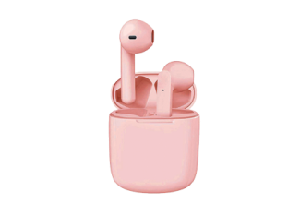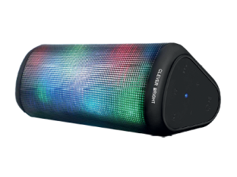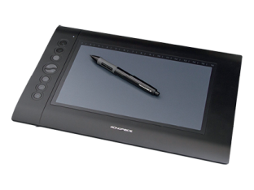
1. ________________ 2. ________________ 3. ________________
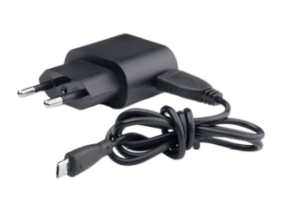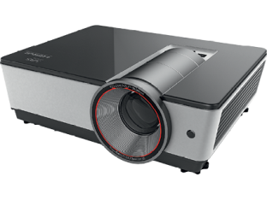
4. ________________ 5. ________________ 6. ________________

C. Circle the correct option to complete the sentences.
1. My brother is a tech geek / technophobe, so he’s always looking for the most old-fashioned /
leading-edge gadgets.
2. I always connect / customise the gadgets I buy to make them suit my personal taste.
3. A 3D smartphone / printer that syncs / develops with my laptop is my new technological
acquisition!

A. Choose the correct words/expressions to complete the sentences.
1. I have a headband / facial recognition system to unlock my smartphone.
2. I find digital assistant / autocomplete very useful because you just have to type the first few letters. It avoids mistakes, so it saves time.
3. I usually use a speech-to-text / social media app, so I type with my voice and not with my hands!
4. I also have a voice assistant / robot on my smartphone to help me with things like setting reminders, alarms, getting quick answers and finding directions.
5. In our robotics classes, we are now developing a robot floor cleaner / chatbot for the school website. It will be an excellent way to communicate with students and families.
B. Circle the correct option.
Which AI apps/gadgets do you use if…
1. you need to learn other languages: translation app / location chip
2. you need some suggestions about what to buy: social media feed / shopping AI app
3. you want to keep updated about the latest news: surveillance cameras / social media feed
4. you want to find your personal belongings: location chip / headband
5. you want to control and monitor behaviour in a place: surveillance camera / projector
C. Imagine you have the chance to have a personal robot assistant. Complete the list of pros and
cons with the ideas from the box.
multitasking expensive difficult to build it does boring tasks

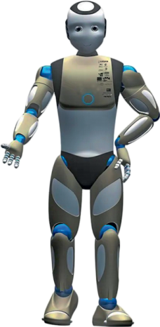


Pros
1. ______________________
2. ______________________
Cons
3. ______________________
4. ______________________
Computing and robotics (Unit 5)
Vocabulary Worksheet
15C
Name ________________________________ No.: _______ Class: __________ Date: _____/ _____/ _____

