Unit 2
Reading Worksheet
2A6
Name No.: ______ Class: ________ Date: _____/ _____/ _____
Read the text carefully.
Teenage girls, body image and Instagram — “the perfect stormˮ
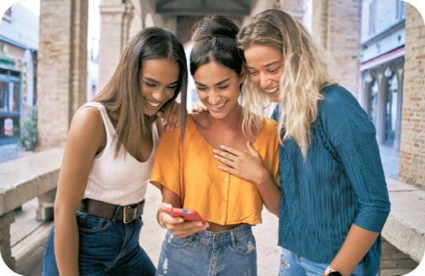
Emily started using Instagram when she was in her mid-teens and found it helpful at first. She used the photo-sharing
app to follow fitness influencers, but what began as a healthy
relationship with the platform ended up in a crisis centred on
body image. At 19 she was diagnosed with an eating disorder.
“I felt like my body wasn’t good enough because even though
I went to the gym a lot, my body still never looked like the
bodies of these influencers,” says Emily, a student who is in
5

10

15

20
1
recovery. Emily, who preferred not to use her real name, uses Instagram sparingly¹ now. She is one of
many Instagram users who decided to make her story public because news revealed that Instagram’s
owner, Facebook, seemed to know it was damaging teenage girls’ mental health.
2
According to internal research leaked² to the Wall Street Journal, the app has made body image issues worse for one in three girls. A Facebook study of teenagers in the UK and the US showed that more than 40% of Instagram users said they felt “unattractive”. Two in five girls (40%) aged 11 to 16 in the UK say they have seen images online that have made them feel insecure or less confident about themselves. This increases to half (50%) in girls aged 17 to 21, according to research by Girlguiding in its annual girls’ attitudes survey.
32
Instagram has more than 1 billion users worldwide and an estimated 30 million in the UK, with Kim
Kardashian, Selena Gomez and Ariana Grande (all showing off ‘perfect’ bodies) among the accounts with
hundreds of millions of followers between them. In the UK, the Love Island couple Liam Reardon and
Millie Court have already raced to a combined following of nearly 3 million since winning the 2021 title.
4
Facebook’s research stated that Instagram had a deeper effect on teenagers because it focused more
on the body and lifestyle, compared with TikTok’s emphasis on performance videos such as dancing and
Snapchat’s jokey face features. “Social comparison is worse on Instagram,” said the Facebook study.

www.theguardian.com (abridged and adapted)
Vocabulary: ¹ sparingly = com moderação;
² leaked = revelada

A. Match the titles with the paragraphs (1-4). There are two extra titles.
Paragraph
a) Instagram and the influence of celebrities

b) The good impact of Instagram on body image

c) Body image on Instagram and other social media

d) Body shame: the worrying reality of statistics

e) The particular case of Emily: how Instagram led to an eating disorder

f) The popularity of Instagram among teens

B. Find the following numbers in the text and write them in the spaces.
1. The percentage of Instagram users in the UK and US that feel unattractive: ____________________
2. The percentage of teenage girls between 17 to 21 that feel insecure about themselves: ____________________
3. The number of Instagram users worldwide: ____________________
4. The number of Instagram users in the UK: ____________________
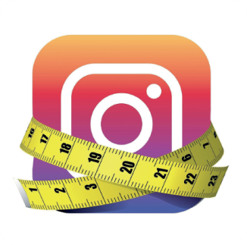
C. What do these words refer to in the text (paragraph 1)?
1. it (line 2) _______________________________________
2. my (line 6) _______________________________________
3. who (line 10) ____________________________________

D. Answer the questions about the text.
1. What did Emily use Instagram for in the beginning?

2. Why did Emily feel that her body wasn’t good enough?

3. Who is the owner of Instagram?

4. Instagram and TikTok have a different effect on teenagers. Why?

