Body image (Unit 2)
Vocabulary Worksheet
4A
Name No.: ______ Class: ________ Date: _____/ _____/ _____
A. Read the testimonies and match them with the problems from the box.

low self-esteem binge eating/bulimia anorexia depression obsessions
1. I can’t control myself. I eat compulsively, without control, until I feel like
I'm going to explode. Then, I feel so guilty, so awful and so fat that I throw
up everything a minute after.


Alexis, 15
_____________________
2. I’ve always had confidence issues. It’s difficult for me to make friends,
to feel that I fit… I think I’m never beautiful or intelligent enough…
_____________________
Linda, 16
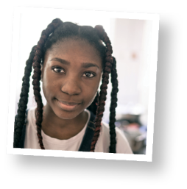

3. I’m constantly weighing myself, looking in the mirror, checking my make-up… I
can’t help it. I just want to be perfect because my image is everything for me.
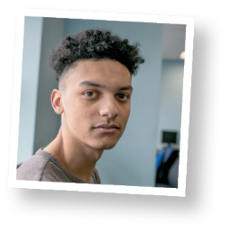
Sarah, 14
_____________________

4. I’m sad all the time. There’s nothing funny or interesting around me. I don’t know why,
but sometimes I just want to stay in bed alone and even there I feel uncomfortable…
Peter, 12
_____________________
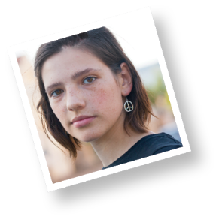
_____________________
5. I have to invent an excuse every day so that my parents don’t make me have
dinner. I skip all the meals I can. I’ve felt dizzy and sick lately because I spend days
without eating anything. I hate food and I hate being fat despite wearing a 34
now. It’s not enough, though!
Mariah, 15

B. Look at the pictures and label them with the correct health condition. The first letter is given.

t
s
b
i
1. _______________________ 2. _______________________ 3. ___________ ___________

f
h
n
4. _______________________ 5. _______________________ 6. ______________________


A. Read the testimonies and circle the correct problem they refer to.

Body image (Unit 2)
Vocabulary Worksheet
4B
Name No.: ______ Class: ________ Date: _____/ _____/ _____
1. I can’t control myself. I eat compulsively, without control, until
I feel like I'm going to explode. Then, I feel so guilty, so awful and
so fat that I throw up everything a minute after.
Alexis, 15
a) binge eating/bulimia
b) headache


2. I’ve always had confidence issues. It’s difficult for me to make friends,
to feel that I fit… I think I’m never beautiful or intelligent enough…
a) malnutrition
b) low self-esteem
Linda, 16


Sarah, 14
3. I’m constantly weighing myself, looking in the mirror, checking my
make-up… I can’t help it. I just want to be perfect because my image
is everything for me.
a) obsessions
b) bullying


4. I’m sad all the time. There’s nothing funny or interesting around me.
I don’t know why, but sometimes I just want to stay in bed alone and
even there I feel uncomfortable…
a) depression
b) dizziness
Peter, 12


5. I have to invent an excuse every day so that my parents don’t make
me have dinner. I skip all the meals I can. I’ve felt dizzy and sick lately
because I spend days without eating anything. I hate food and I hate
being fat despite wearing a 34 now. It’s not enough, though!
Linda, 16
Mariah, 15
a) loss of control
b) anorexia

Mariah, 15
B. Look at the pictures and label them with the correct health condition.
backache headache insomnia fever nausea sore throat
1. ______________________ 2. _______________________ 3. ______________________
4. ______________________ 5. _______________________ 6. ______________________

