A. Write each problem from the box next to the correct definition.

Teens’ addictions and problems (Unit 2)
Vocabulary Worksheet
6A
Name No.: ______ Class: ________ Date: _____/ _____/ _____
bullying peer pressure addiction

1. A feeling that one must do the same things as other people of one's age and social group in
order to be liked or respected by them: _____________________
2. Abuse and mistreatment of someone vulnerable by someone stronger and more powerful:
_____________________
3. A compulsive, chronic, physiological or psychological need for a habit-forming substance,
behaviour or activity with harmful consequences: _____________________
www.merriam-webster.com/dictionary (abridged)
B. Label the pictures with the correct addictions from the box.
alcohol drugs vaping social media food gambling

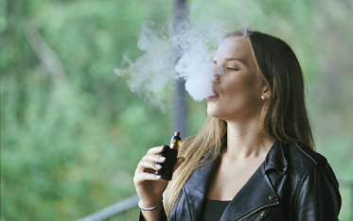
1. ___________________ 2. ___________________ 3. ___________________
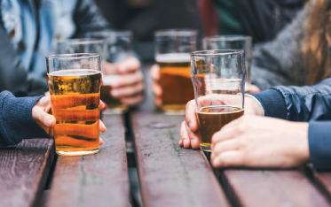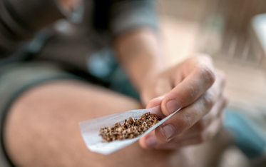
4. ___________________ 5. ___________________ 6. ___________________
C. Complete the sentences with the addictions from exercise B.
1. Leonardo DiCaprio has smoked since he was a teenager, but he quit cigarettes and switched to
_______________.
2. The famous Hollywood star Ben Affleck has admitted being addicted to _______________. He
once lost $400,000 to the president of Universal Studios in a secret game.
3. The model Kendall Jenner admitted that there is no way to escape from _______________.
She feels pressured to keep all her accounts while she tries to control her anxiety.
4. Bradley Cooper admits that _______________ affected his relationships badly. He has been
sober for many years now after rehab.

Teens’ addictions and problems (Unit 2)
Vocabulary Worksheet
6B
Name No.: ______ Class: ________ Date: _____/ _____/ _____
A. Write each problem from the box next to the correct definition.
bullying peer pressure addiction

1. A feeling that one must do the same things as other people to be liked: _________________
2. Abuse of someone vulnerable by someone stronger: _________________
3. A compulsive need for a substance, behaviour or activity with bad consequences:
_________________
www.merriam-webster.com/dictionary (abridged and adapted)
B. Unscramble the letters and find the addiction for each picture.
AVINGP OCAILS MIEAD AGBINLGM
1. ___________________ 2. ___________________ 3. ___________________
CHOOLA UGSDR ODOF
4. ___________________ 5. ___________________ 6. ___________________
C. Complete the sentences with the addictions from the box.
vaping social media alcohol gambling
1. Leonardo DiCaprio has smoked since he was a teenager, but he quit cigarettes and switched to
_______________.
2. The famous Hollywood star Ben Affleck has admitted being addicted to _______________. He
once lost $400,000 to the president of Universal Studios in a secret game.
3. The model Kendall Jenner admitted that there is no way to escape from _______________.
She feels pressured to keep all her accounts while she tries to control her anxiety.
4. Bradley Cooper admits that _______________ affected his relationships badly. He has been
sober for many years now after rehab.

