A. Read the positive thoughts about quitting addictions from the blog Quit to Be Free. Write a post
(90-100 words) to motivate your readers to quit an addiction (smoking, vaping, gambling, social
media, fast food, etc.).
Unit 2
Writing Worksheet
2A6
Name No.: ______ Class: ________ Date: _____/ _____/ _____
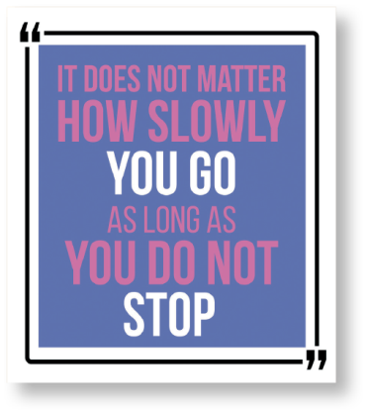
Title (Use a question or the
imperative to make your reader think
about the problem: Can you imagine
your life without [...]?; Believe in
yourself!)
________________________________________________
________________________________________________
________________________________________________
________________________________________________
________________________________________________
________________________________________________

________________________________________________
________________________________________________
________________________________________________

________________________________________________

Opening (Motivate your reader to
read your post. Begin with a positive
thought: It’s possible to…; It all
depends on…)

Subtitle (Include the important
keyword(s) of your text. Use a
motivational sentence: […] is
possible. You can do it!)
________________________________________________

Body (Explain the main idea(s)
about the topic quitting addictions:
First, …; Furthermore…; Finally, …)

Conclusion (With a call for action:
I believe in you! I’m sure you’ll feel
[…])
________________________________________________
________________________________________________
________________________________________________

A. Read the positive thoughts about quitting addictions from the blog Quit to Be Free. Then
complete the post below to motivate your readers to quit an addiction (smoking, vaping,
gambling, social media, fast food, etc.).
Unit 2
Writing Worksheet
2B6
Name No.: ______ Class: ________ Date: _____/ _____/ _____

__________________________________________________
__________________________________________________
__________________________________________________
__________________________________________________
__________________________________________________
__________________________________________________

__________________________________________________
__________________________________________________
__________________________________________________

______________________________________________
__________________________________________________
Title
Why should you quit ?
(choose an addiction)

Opening
(motivate your reader to
read your post)
Is it possible to quit (addiction)? You just need to

(the most important thing the reader should do to quit an addiction)
Subtitle
(include the important
keyword(s) of your text)
Quitting is possible and you can do it!

If you want to quit (addiction) you should
Body
(explain the main idea(s)
about the topic quitting
addictions)
(advice) and
Keep in mind that it is not always easy because
(advice).
(reason)
but you can do it!

Conclusion
(with a call for action)
__________________________________________________
__________________________________________________
__________________________________________________
__________________________________________________

I’m sure you will feel and (examples of
feelings) if you quit (addiction). So, this is the right
moment to
(tell the readers to take action, to do something for themselves, to change their lives…)

