A. Complete the sentences with the past perfect of the verbs in the box.
eat admit not notice try not make
Past perfect (Unit 2)

Grammar Worksheet
10A
Name No.: ______ Class: ________ Date: _____/ _____/ _____

1. Francis ___________ to quit cigarettes several times before he started vaping.
2. By the time Sophie got home, Susan __________________ the whole chocolate cake. She was
feeling sick and depressed.
3. John lost money on online poker. Until that day his mother __________________ that he was
addicted to gambling.
4. I felt depressed last year because I __________________ any friends at my new school yet.
5. Caroline joined a rehab programme only after she _______________ her problem with alcohol.
B. Label the pictures with the correct form of the verbs in brackets in the past perfect.

By the time I met my friends yesterday evening, I…
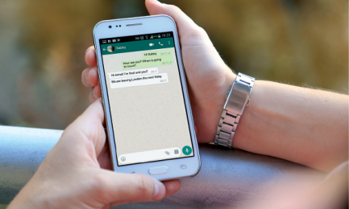
1. _______________ (upload) 2. ___________ (send) some 3. ___________ (play) my

a new TikTok video. messages on WhatsApp. favourite game online.

4. __________ (not watch) my 5. ___________ (not finish) 6. ___________ (not tidy up)
favourite series on Netflix. the homework. my bedroom.
C. Fill in the gaps with the correct verb tenses: past simple or past perfect.
1. John __________ (suffer) from an eating disorder after his classmates __________ (bully)
him because of his body image.
2. Before I _____________ (find out) about my lung condition, I _____________ (not have) the
courage to quit smoking.
3. __________ (you / listen) to the podcast on addictions I __________ (tell) you about before?

A. Match the two columns to build sentences with the past perfect. Write letters a-e.
1. Francis had tried to quit cigarettes several
times
a) Susan had eaten the whole chocolate
cake.
b) Until that day his mother hadn’t noticed
that he was addicted to gambling.
c) I hadn’t made any friends at my new
school yet.
d) before he started vaping.
e) after she had admitted her problem
with alcohol.

Past perfect (Unit 2)

Grammar Worksheet
10B
Name No.: ______ Class: ________ Date: _____/ _____/ _____
2. By the time Sophie got home,

3. John lost money on online poker.

4. I felt depressed last year because

5. Caroline joined a rehab programme


B. Circle the correct option to label the pictures with the past perfect.
By the time I met my friends yesterday evening, I…
1. had upload / had uploaded 2. had sent / had send some 3. had played / had plays my
a new TikTok video. messages on WhatsApp. favourite game online.
4. hadn’t watched / han’t 5. not finished / hadn’t 6. hadn’t tidy up / hadn’t
watch my favourite series finished the homework. tidied up my bedroom.
on Netflix.
C. Circle the past simple or the past perfect form of the verbs to complete the sentences.
1. John suffered / had suffered from an eating disorder after his classmates had bullied / bullied
him because of his body image.
2. Before I had found out / found out about my lung condition, I hadn't had / didn't have the
courage to quit smoking.
3. Did you listen / Had you listened to the podcast on addictions I had told / told you about before?

