A. Match the two columns to build sentences. Write letters a-d.
a) I try to make some friends and fit in.

b) Boys also suffer from confidence issues,
though.
c) media and advertising constantly promote
the idea of beauty and perfection.
d) John hasn’t drunk alcohol for a year.
Connectors (Unit 2)

Grammar Worksheet
9A
Name No.: ______ Class: ________ Date: _____/ _____/ _____
1. Even though it is difficult to stop binge
drinking,

2. Despite my lack of self-confidence,

3. In spite of the fact that body shame is a
serious problem,

4. Anxiety and depression are more common
among girls that lack self-esteem.

B. The connectors in the sentences are all wrong. Replace them with the correct ones.
1. Although eating compulsively, Susan is not overweight.
____________________________________________________________________________
2. Despite physical appearance is relevant, character and personality are important too.
____________________________________________________________________________
3. Even though my eating disorder, I try to lead a normal life.
____________________________________________________________________________
C. Join the sentences using the connectors in brackets.
1. We work out regularly. We aren’t obsessed with a perfect body image. (in spite of)
____________________________________________________________________________
2. I enjoyed the documentary on teens’ eating disorders. I don’t agree with some ideas. (though)
____________________________________________________________________________
3. The weather was bad. Sophie went to the gym. (despite)
____________________________________________________________________________
D. Read the comic strips and complete them with the right connector: in spite of or although.
1. _________
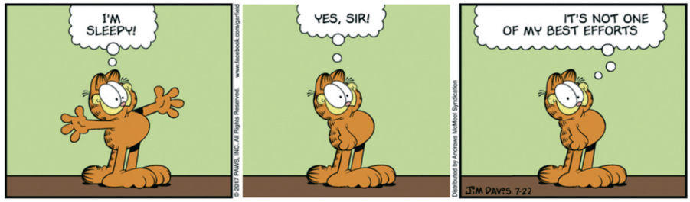

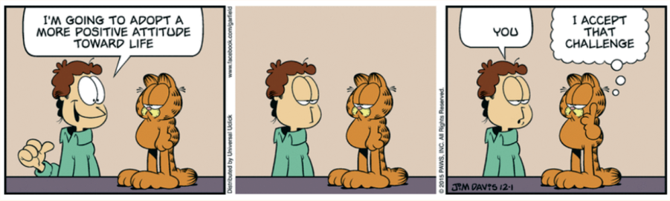
2. _________

gocomics.com

A. Match the two columns to build sentences. Write letters a-c.
a) I try to make some friends and fit in.

b) Boys also suffer from confidence issues,
though.
c) John hasn’t drunk alcohol for a year.
Connectors (Unit 2)

Grammar Worksheet
9B
Name No.: ______ Class: ________ Date: _____/ _____/ _____
1. Even though it is difficult to stop binge
drinking,

2. Despite my lack of self-confidence,

3. Anxiety and depression are more common
among girls that lack self-esteem.
B. The connectors in the sentences are all wrong. Replace them with the words in brackets.
1. Although eating compulsively, Susan is not overweight. (despite)
_____________________________________________________________________________
2. Despite physical appearance is relevant, character and personality are important too. (although)
_____________________________________________________________________________
3. Even though my eating disorder, I try to lead a normal life. (in spite of)
_____________________________________________________________________________

C. Circle the correct connector in each sentence.
1. In spite of / Although we work out regularly, we aren’t obsessed with a perfect body image.
2. Despite / Though I enjoyed the documentary on teens’ eating disorder, I don’t agree with
some ideas.
3. Despite / Even though the bad weather, Sophie went to the gym.
D. Read the comic strips and complete them with the right connector: in spite of or although.
1. _________

2. _________
gocomics.com

