Unit 3
Reading Worksheet
3B6
Name No.: ______ Class: ________ Date: _____/ _____/ _____
Read the texts below.
STUDYING ABROAD? NOTHING COMPARES TO IT!
TEXT A
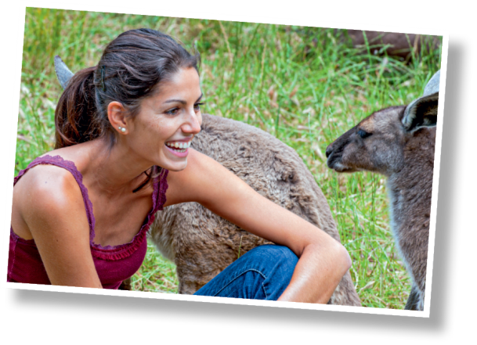
Australia was the experience of a lifetime. Living on your
own for almost six months, dealing with situations without
the help of parents or anyone else you would typically go
to when at home, really makes you grow up. I am so much
older than I was before I went abroad, thanks to the tons of
travelling and the people I was so lucky to meet while there.
Studying abroad in Australia taught me a lot about myself
and gave me a worldview I could not have without this.

Deanna Williams
TEXT B
My decision to study abroad was the best I have ever
made. Every day was a new adventure. It was my goal to
get out and go somewhere every day with the wonderful
group of friends I made or just enjoy a solo adventure.
Regents University is an international school, so every
student there is from somewhere different around the
world. As you walk through the library, you can hear
students talking in different languages and all sorts of
accents. I am so proud of the fact that I now have friends
in not only places all across the United States, but also
across the world such as England, Ireland, Scotland,
Germany, Austria and France.
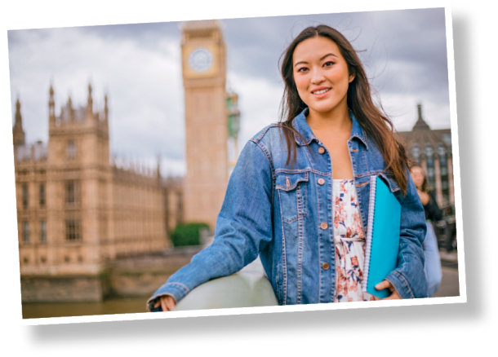

Caitlin Ellenby

TEXT C
My trip to Cádiz taught me so many life lessons that I don’t
even know where to start. In six weeks, I have created bonds
and friendships with almost every single person who travelled
with me. Most of all, I learnt to appreciate and love a different
culture that I wish were more present in the United States (I
want my siesta back!). I studied abroad to further improve my
Spanish-speaking skills and to put it on my résumé, but what I
had not counted on was having an experience where I could say
that there is a special place for Cádiz in my heart.

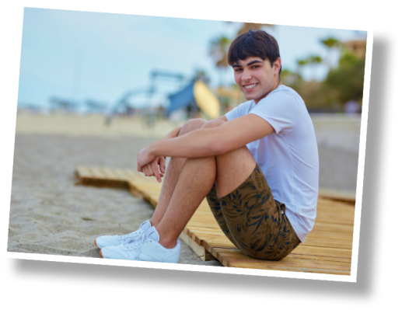

Bryan Cucinotta

www.monmouth.edu (abridged and adapted)

A. Read the texts A and B and tick (✔) the student who…
Deanna Caitlin
a) studied with people from across the world.

b) really grew up after this experience.

c) studied abroad for almost six months.

d) experienced many adventures either alone or with
a wonderful group of friends.

B. In text A, there are four highlighted words/phrases. Choose the correct option for the meanings
below. There is one extra highlighted word/phrase.

1. in or to a different country a) experience b) abroad

2. fortunate a) lucky b) on your own

3. alone a) on your own b) worldview
4. the way you see and understand the globe a) experience b) worldview

C. Tick (✔) the only correct sentence about text B.
1. Studying abroad wasn’t a special decision in Caitlin’s life.

2. Her university was mostly attended by British students.
3. She made friendships with people from all over the world.

D. Choose the correct option to complete the sentences about text C.
1. Brian stayed in Cádiz…

a) for more than a month.

b) for a week.
2. The most important aspect of his experience was…

a) learning about a new culture.

b) travelling and making friends.
3. How does he feel about Cádiz?

a) should be in the United States.

b) is a place that he really likes.

