At the airport
(Unit 3)
Speaking Worksheet
3AB6
Name No.: ______ Class: ________ Date: _____/ _____/ _____
Spoken production
Checking in at the airport/Travelling by plane
A. Read the dialogue at the check-in desk of an airline and fill in the gaps with the words from the box.
suitcase departure middle hand luggage ID card boarding pass

Ground staff member: Good morning, Sir. Can I check your ¹ ________________, please?
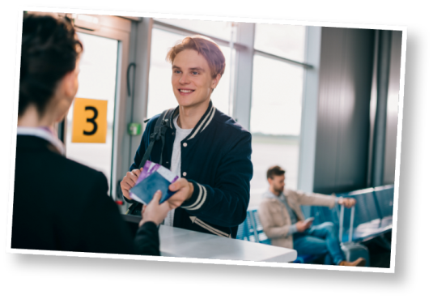
Passenger: Good morning. Here you are.
Ground staff member: The plane is not full. Would you prefer an
aisle, ² ________________ or window seat?
Passenger: A window seat would be great, preferably in a back row.
Ground staff member: Of course. You can only carry ³ ______________,
as you know.
Passenger: Yes, I know. I only have this small ⁴ __________________ and
this backpack.
Ground staff member: Good. Here is your ⁵ ________________. You now have to go past the security
checkpoint. Boarding will be at gate 3A at 10:30. ⁶ ________________ will be on time. Have
a nice flight.
Passenger: Thank you very much. Have a nice day.
B. Role-play a dialogue at the airport check-in desk similar to the one from exercise A. Use the
missing words and the words in bold. You may introduce some changes:
The passenger has to sit in an aisle seat in a front. row.
• The plane is full.
The passenger has a backpack
and a big suitcase to dispatch.
• The passenger can take hand
luggage and hold luggage.

• Departure is delayed.
The passenger complains about it.
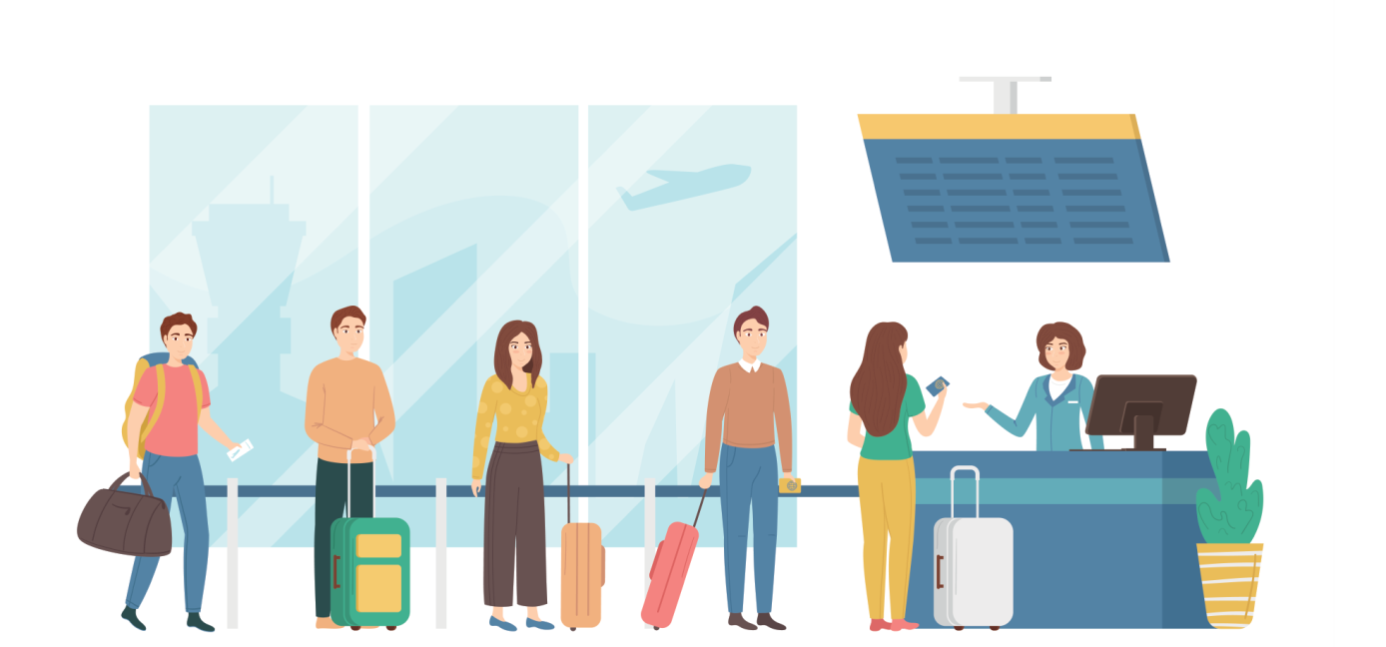

At the airport
(Unit 3)
Speaking Worksheet
3BB6
Name No.: ______ Class: ________ Date: _____/ _____/ _____
Spoken production
Checking in at the airport/Travelling by plane
A. Read the dialogue at the check-in desk of an airline and choose the correct option to fill in the
gaps.
Ground staff member: Good morning, Sir. Can I check your
¹ ID card / email, please?
Passenger: Good morning. Here you are.
Ground staff member: The plane is not full. Would you prefer
an aisle, ² comfortable / middle or window seat?
Passenger: A window seat would be great, preferably in a back row.
Ground staff member: Of course. You can only carry
³ pets / hand luggage, as you know.
Passenger: Yes, I know. I only have this small ⁴ suitcase / cat and
this backpack.
Ground staff member: Good. Here is your ⁵ passport / boarding
pass. You now have to go past the security checkpoint.
Boarding will be at gate 3A at 10:30. ⁶ Boarding /
Departure will be on time. Have a nice flight.
Passenger: Thank you very much. Have a nice day.

B. Role-play a dialogue at the airport check-in desk similar to the one from exercise A. Follow the
guidelines below.
Student A Student B
• Greets; gives ID card.
• Greets; asks for ID card.

• Says preferred seat and row.
• Asks about preferred type of seat.

• Thanks and wishes a nice day.
• Says he/she knows about it; shows the
luggage he/she has.
• Gives boarding pass; informs about
security checkpoint, boarding gate
and time; wishes a nice flight.
• Informs about type of luggage allowed.

