A. Label the pictures with the different ways/places to do volunteering from the box.

Volunteering (Unit 3)
Vocabulary Worksheet
10A
Name No.: ______ Class: ________ Date: _____/ _____/ _____
fundraising campaign animal shelter environmental action
virtual tutoring food bank international charity

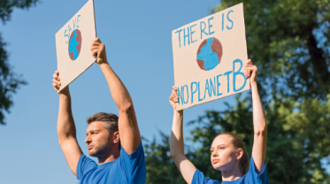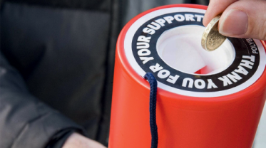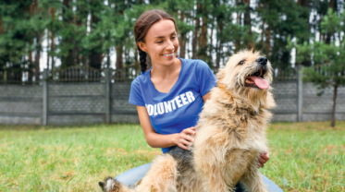
1. ___________________ 2. ___________________ 3. ___________________
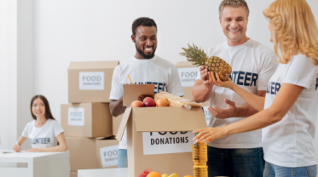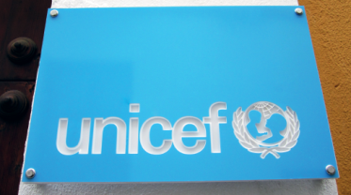
4. ___________________ 5. ___________________ 6. ___________________
B. Read the texts about humanitarian celebrities and some causes they defend and fill in the gaps
with the words from the box.
fundraising projects member needs communities
charity development ambassador influence

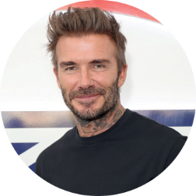
David Beckham is a founding ¹ __________ of Malaria No More UK
Leadership Council. His own ² ___________, the Victoria and David
Beckham Charitable Trust, provides wheelchairs to children in need.
His focus on helping children has led to his appointment as a UNICEF
³ _______________.

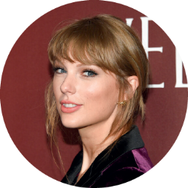
Taylor Swift is often engaged with ⁴ _______________________ and
donations for the World Health Organization, Feeding America and
Make-A-Wish Foundation to reach people in need. She uses her fame to
⁵ ___________ young people to volunteer in their local ⁶ ___________
and play an individual part in changing the world.

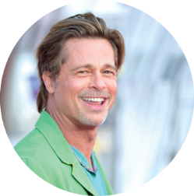
Brad Pitt joined One Campaign as a spokesperson to fight for
an additional 1% of the U.S. budget to help Africa with basic
⁷ ___________ such as clean water, education, medicine and food.
Pitt has also assisted the charity by aiding ⁸ ___________ focused
on better health, community ⁹ _______________, environment
and education in Haiti through media, sports and music.

www.volunteerfdip.org (abridged and adapted)

Volunteering (Unit 3)
Vocabulary Worksheet
10B
Name No.: ______ Class: ________ Date: _____/ _____/ _____
A. Choose the correct option to label the pictures about different ways/places to do volunteering.
3
1
2
a) environmental action a) virtual tutoring a) animal shelter

b) food bank b) fundraising campaign b) beach clean-up
4
5
6
a) food bank a) donation a) international charity

b) animal shelter b) virtual tutoring b) nature reserve

B. Read the texts about humanitarian celebrities and some causes they defend and fill in the gaps
with the missing words from the boxes.
charity
ambassador
member
David Beckham is a founding ¹ __________ of Malaria No More UK
Leadership Council. His own ² ___________, the Victoria and David
Beckham Charitable Trust, provides wheelchairs to children in need.
His focus on helping children has led to his appointment as a UNICEF
³ _______________.

Taylor Swift is often engaged with ⁴ _______________________ and
donations for the World Health Organization, Feeding America and
Make-A-Wish Foundation to reach people in need. She uses her fame to
⁵ ___________ young people to volunteer in their local ⁶ ___________
and play an individual part in changing the world.
fundraising
communities
influence

Brad Pitt joined One Campaign as a spokesperson to fight for
an additional 1% of the U.S. budget to help Africa with basic
⁷ ______________ such as clean water, education, medicine and
food. Pitt has also assisted the charity by aiding ⁸ _____________
focused on better health, community ⁹ ______________________,
environment and education in Haiti through media, sports and music.
fundraising
communities
influence

www.volunteerfdip.org (abridged and adapted)

