Air travel (Unit 3)
Vocabulary Worksheet
7A
Name No.: ______ Class: ________ Date: _____/ _____/ _____
A. Read the descriptions and label them with the words/expressions from the box.
baggage claim airline overhead compartments boarding gate hand luggage

1. A company that operates regular services to transport passengers and goods by aircraft:
______________
2. The place where air passengers go from the terminal to the airplane: ______________
3. The area in an airport where arriving passengers collect luggage transported in the airplane:
____________________
4. Suitcases and bags of a smaller size that passengers carry on to an aircraft: ______________
5. Small cupboards above the seats in a plane where passengers can store things during a flight:
____________________
B. Use the numbers (1-5) from exercise A to label the pictures.
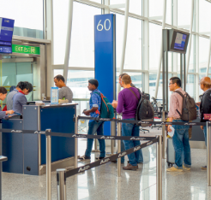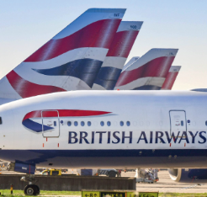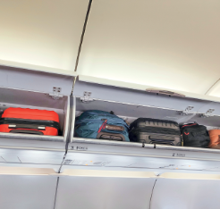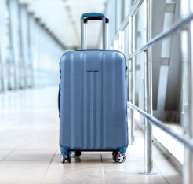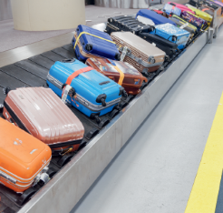
e)

d)

c)

b)

a)

C. Read the email and fill in the gaps with the missing words/phrases. The first letter is given.
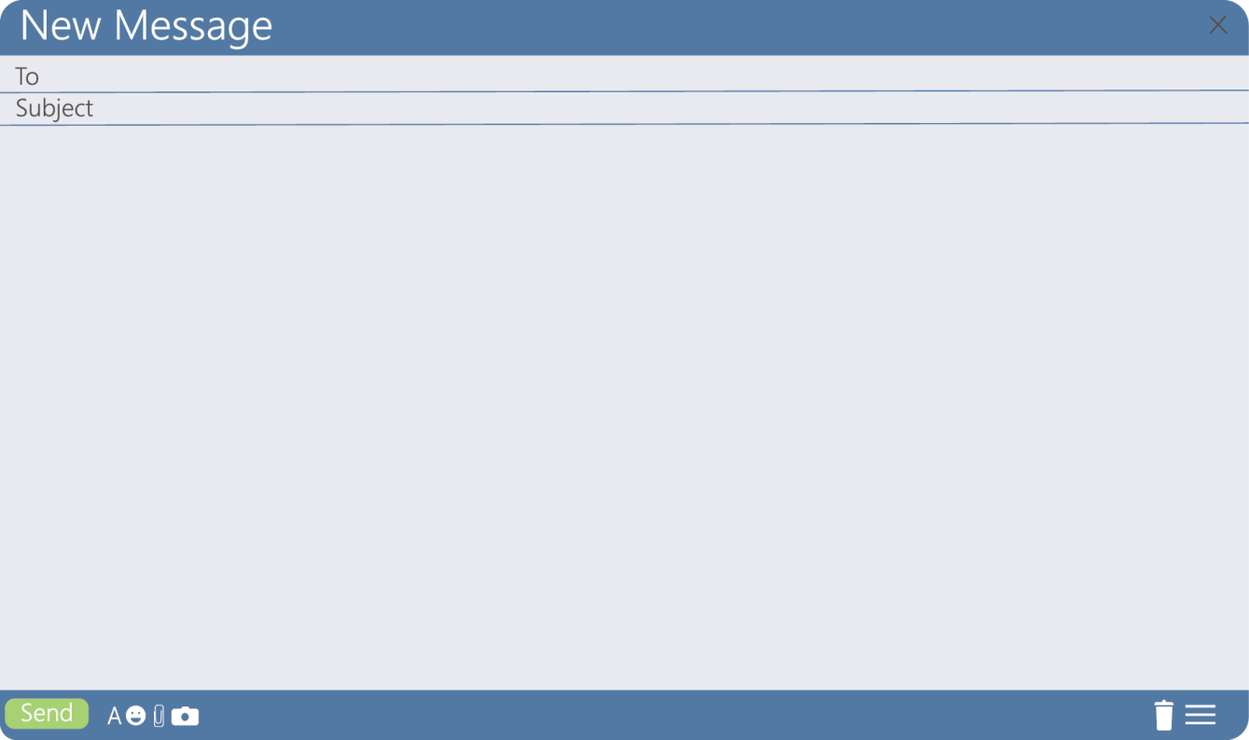
b
a
f
s
a
p
b
c
s
q
c
f
Dear Peter,
I have landed in London for my life-changing adventure: the Erasmus programme! I’m comfortable
now, but the ¹_____________ was a nightmare. I didn’t do my ²_____________ online. Big
mistake! When I got to the airport, I waited in a ³_____________ for two hours. Then, after going
past the ⁴_____________ _____________, I had to wait for another hour to board, but my
⁵____________ ____________ was wrong, so I didn’t get the ⁶____________ ____________
I asked for. I sat in the middle. The cherry on top of the cake? Well, I was starving, so I asked the
⁷_____________ ____________ for a hot meal from the menu. Sold out! I had a cold snack
and a hot tea… At least, they didn’t lose my ⁸_____________!
Hope you’re fine! Miss you a lot already.
Love,
Sue

A. Read the descriptions and choose the correct option.

Air travel (Unit 3)
Vocabulary Worksheet
7B
Name No.: ______ Class: ________ Date: _____/ _____/ _____
1. A company that operates regular services to transport passengers and goods by aircraft:

a) hand luggage b) airline
2. The place where air passengers go from the terminal to the airplane:

a) baggage claim b) boarding gate
3. The area in an airport where arriving passengers collect luggage transported in the airplane:

a) baggage claim b) flight attendant
4. Suitcases and bags of a smaller size that passengers carry on to an aircraft:

a) boarding pass b) hand luggage
B. Use the numbers (1-4) from exercise A to label the pictures.

d)

c)

b)
a)

C. Read the email and fill in the gaps with the missing words/phrases from the box.
flight attendant queue boarding pass flight
baggage check-in aisle seat security control

Dear Peter,
I have landed in London for my life-changing adventure: the Erasmus programme! I’m comfortable
now, but the ¹_____________ was a nightmare. I didn’t do my ²_____________ online. Big
mistake! When I got to the airport, I waited in a ³_____________ for two hours. Then, after going
past the ⁴_____________ _____________, I had to wait for another hour to board, but my
⁵____________ ____________ was wrong, so I didn’t get the ⁶____________ ____________
I asked for. I sat in the middle. The cherry on top of the cake? Well, I was starving, so I asked the
⁷_____________ ____________ for a hot meal from the menu. Sold out! I had a cold snack
and a hot tea… At least, they didn’t lose my ⁸_____________!
Hope you’re fine! Miss you a lot already.
Love,
Sue

