A. Read the testimonial below from Aline Sternberg, who volunteered in India with Volunteers
Without Borders.
Unit 3
Writing Worksheet
3A6
Name No.: ______ Class: ________ Date: _____/ _____/ _____
It is not easy to describe what I experienced while volunteering
for two months in India. It was a fantastic and touching experience
that helped me realise that we can be happy with so little.
Joining a programme with Volunteers Without Borders allows
you to see what life is really like for poor people. You get a taste
of culture by living with host families and visiting various places in
the country. It was amazing to take part in so many projects such
as a school for special needs children, an orphanage, a school for
slum¹ children and others.
I spent most of the time helping in the school for street children
and even though the children and I did not speak the same language,
communication was not a problem and we became friends. During
my stay in India, I met inspiring people who spend their lives helping
others and making the world a better place.
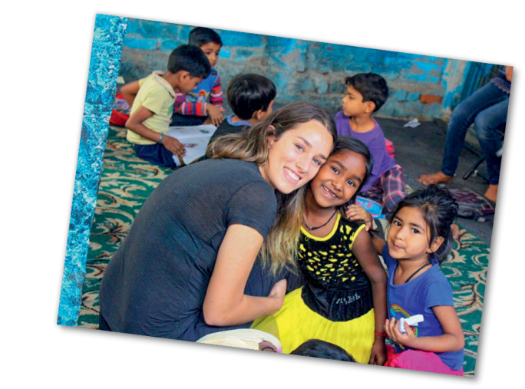

www.vwbinternational.org (abridged and adapted)
Vocabulary: ¹ slum = bairro de lata
B. Choose one of the projects below and write a testimonial based on the text from exercise A.
Include the following points:
• your general opinion/feelings about the volunteering experience;
• what you learnt from it;
• where you worked, what you did, what you saw, etc.;
• the people you met.

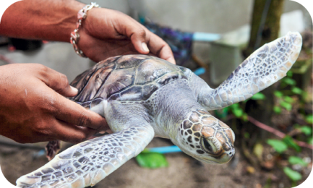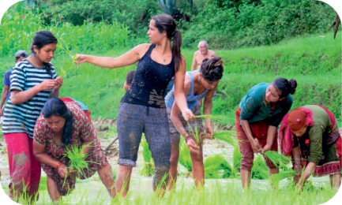
Project 1 – Sea turtle
conservation in Ecuador
Project 2 - Medical help and
support in hospitals in Mexico
Project 3 – Sustainable
agriculture and farm
work in Nepal

Unit 3
Writing Worksheet
3B6
Name No.: ______ Class: ________ Date: _____/ _____/ _____
A. Read the testimonial below from Aline Sternberg, who volunteered in India with Volunteers
Without Borders.
It is not easy to describe what I experienced while volunteering
for two months in India. It was a fantastic and touching experience
that helped me realise that we can be happy with so little.
Joining a programme with Volunteers Without Borders allows
you to see what life is really like for poor people. You get a taste
of culture by living with host families and visiting various places in
the country. It was amazing to take part in so many projects such
as a school for special needs children, an orphanage, a school for
slum¹ children and others.
I spent most of the time helping in the school for street children
and even though the children and I did not speak the same language,
communication was not a problem and we became friends. During
my stay, I met inspiring people who spend their lives helping others
and making the world a better place.

www.vwbinternational.org (abridged and adapted)
Vocabulary: ¹ slum = bairro de lata
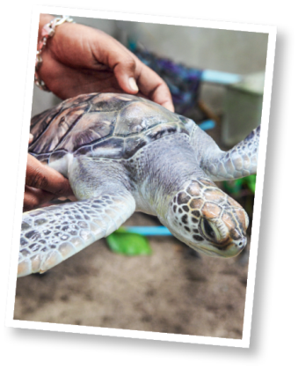
B. Complete a testimonial about a sea turtle conservation project in Ecuador. Use the model text
from exercise A to help you fill in the text with the words/phrases from the box.
their habitat working on the beach Ecuador lovely and important they are
sea turtles protecting nature beach clean-ups wonderful and intense

It is not easy to describe what I experienced while volunteering for two months in
¹ _______________. It was a ² _______________ experience that helped me realise
that we can be happy with so little.
Joining a programme with Volunteers Without Borders allows you to see what life
is really like for ³ _______________. You get a taste of how they live, ⁴ _______________ and
characteristics. It was amazing to take part in so many projects such as the protection of nests,
⁵_______________ and medical treatments.
I spent most of the time ⁶ _______________ and even though I knew nothing about sea turtles,
I understood how ⁷ _______________. During my stay, I met inspiring people who spend their
lives ⁸ _______________ and making the world a better place.

