A. Complete the sentences with the correct question tag from the word cloud.
Question tags (Unit 4)
Grammar Worksheet
14AB
Name No.: ______ Class: ________ Date: _____/ _____/ _____
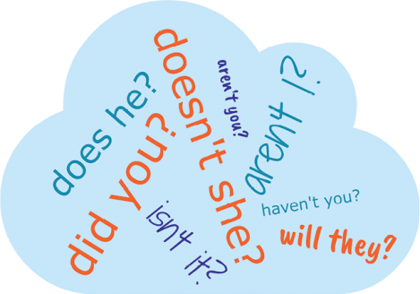

1. Mary likes her new summer job as a dog walker, _______________
2. You didn’t apply for the position in the video company, _______________
3. You have updated your CV, _______________
4. They won’t be late for the job interview, _______________
5. John doesn’t have to work shifts in his new job, _______________
6. Cooperation is a very important skill, _______________
7. I am a good candidate for this part-time job as a waiter, _______________
8. You are motivated because of your new salary, _______________
B. Spot the wrong question tags and correct them. Tick (✔) the correct ones.
1. Meghan wants to find a summer job, she doesn’t? _______________

2. Phillip doesn't have a new restaurant in the city centre, does he? _______________

3. You met your colleagues for dinner, haven’t you? _______________

4. A part-time job isn’t always easy, is it? _______________

5. You and Louise won’t work tomorrow, will you? _______________

6. Miriam and John don’t listen to their boss much, did they? _______________

C. Complete the sentences with the correct question tag.
1. They are travelling abroad next week, _______________?
2. John was upset because of his work schedule, _______________?
3. My neighbours don’t usually work late, _______________?
4. You have to work part-time to pay for your studies, _______________?
5. We will be at a meeting this afternoon, _______________?
6. He didn’t finish his project last night, _______________?
7. My sister hasn’t found her dream job yet, _______________?

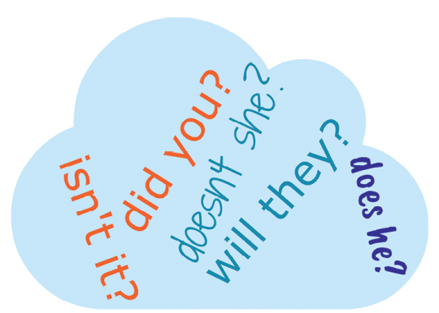
A. Complete the sentences with the correct question tag from the word cloud.
Question tags (Unit 4)
Grammar Worksheet
14BAB
Name No.: ______ Class: ________ Date: _____/ _____/ _____

1. Mary likes her new summer job as a dog walker, _______________
2. You didn’t apply for the position in the video company, _______________
3. They won’t be late for the job interview, _______________
4. John doesn’t have to work shifts in his new job, _______________
5. Cooperation is a very important skill, _______________
B. Tick (✔) the correct sentences.
1. Meghan wants to find a summer job, she doesn’t?

2. Phillip doesn't have a new restaurant in the city centre, does he?

3. You met your colleagues for dinner, haven’t you?

4. A part-time job isn’t always easy, is it?

5. You and Louise won’t work tomorrow, will you?

6. Miriam and John don’t listen to their boss much, did they?


C. Circle the correct question tag to complete the sentences.
1. They are travelling abroad next week, are they / aren’t they?
2. John was upset because of his work schedule, was he / wasn’t he?
3. Your neighbours don’t usually work late, do they / don’t they?
4. You have to work part-time to pay for your studies, must you / don’t you?
5. We will be at a meeting this afternoon, will we / won’t we?
6. He didn’t finish his project last night, did he / didn’t he?
7. My sister hasn’t found her dream job yet, has she / hasn’t she?

