A. John wants to find a summer job as an event photographer. He saw an ad on the school notice
board and wrote a CV to apply for the job.
Unit 4
Writing Worksheet
4A6
Name No.: ______ Class: ________ Date: _____/ _____/ _____

Experience
2021 – Present Moments Forever
Freelance photographer, Liverpool
Helping main photographers cover events, editing
videos and photoshopping photos
2020 – 2021 Gaming ON
Video game designer, Liverpool
Assisting in the design of video games, brainstorming
ideas, testing video games
Education
2021 – Present Secondary Education
Central Secondary School, Liverpool
9 GCSEs
2020 – 2021 Primary Education
St Julian’s School, Liverpool
6 SATs
Skills
Skill group Skill group
Languages Flexibility
ICT Communication
Creativity Cooperation
References
Mr Peter Norton, Headmaster Mrs Anne Clark, Photographer
0151 0987 6543 0151 0123 456
peter.norton@email.com anne.clark@email.com

JOHN STUART
Student

Interests
Reading
Extreme sports
Computers

Contacts
Liverpool
0151 3456 7890
06 1234 5678
john.stuart@email.com

john.stuart
@johnstuart
/john.stuart







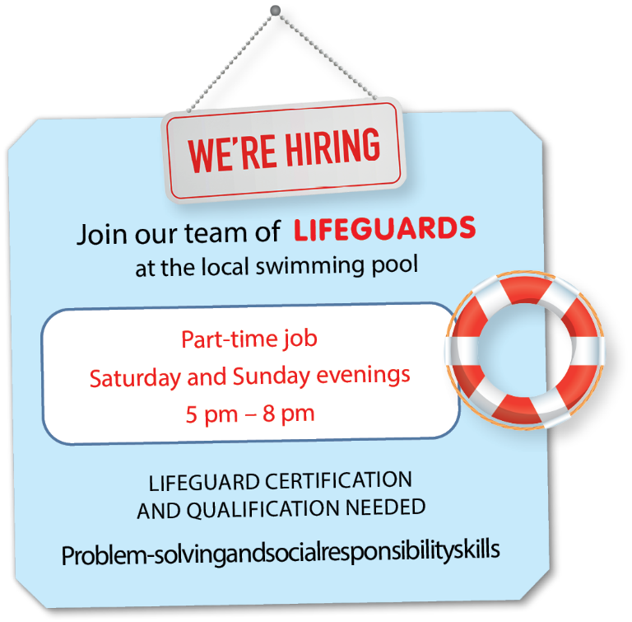
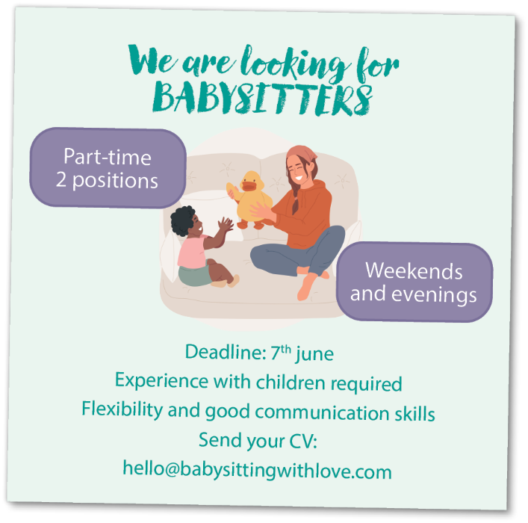
B. Imagine you want to apply for a summer job. Read the job ads, choose one of them and write a
CV to apply for it. Use the example from exercise A.
Problem-solving and social responsibility skills

A. Read the CV.
Unit 4
Writing Worksheet
4BA6
Name No.: ______ Class: ________ Date: _____/ _____/ _____

JOHN STUART
Student

Interests
Reading
Extreme sports
Computers

Contacts
Liverpool
0151 3456 7890
06 1234 5678
john.stuart@email.com

john.stuart
@johnstuart
/john.stuart
Experience
2021 – Present Moments Forever
Freelance photographer, Liverpool
Helping main photographers cover events, editing
videos and photoshopping photos
2020 – 2021 Gaming ON
Video game designer, Liverpool
Assisting in the design of video games, brainstorming
ideas, testing video games
Education
2021 – Present Secondary Education
Central Secondary School, Liverpool
9 GCSEs
2020 – 2021 Primary Education
St Julian’s School, Liverpool
6 SATs
Skills
Skill group Skill group
Languages Flexibility
ICT Communication
Creativity Cooperation
References
Mr Peter Norton, Headmaster Mrs Anne Clark, Photographer
0151 0987 6543 0151 0123 456
peter.norton@email.com anne.clark@email.com

B. Read the ad for a summer job as a lifeguard and write a CV using the example from exercise A.
Problem-solving and social responsibility skills
________________
________________

Interests
________________
________________
________________
Contacts
________________
________________
________________
________________

Experience
______ – ______ ______________
_______________
______ – ______ ______________
_______________
Education
______ – ______ ______________
_______________
______ – ______ ______________
_______________
Skills
______________ ______________

References
______________ ; ______________
________________________


Photo

