Unit 5
Reading Worksheet
5B
Name No.: ______ Class: ________ Date: _____/ _____/ _____
Read the text.
Personal robots that you can buy –
when fiction becomes reality
Anything that automates specific tasks, executes them with speed and precision and performs the job
with little or no human interference is a robot. Robots are useful in security, agriculture, healthcare and
space exploration. One of the most recent fields is TV and film media, where robots help hold the camera
and shoot a scene with the same angle multiple times.
5

10

15

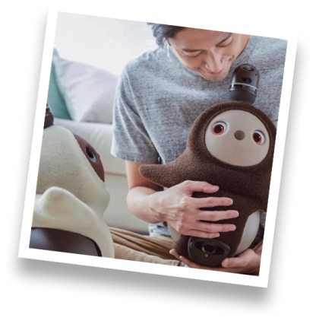
Humans are fascinated with robots. And why not? We want our work to be completed as quickly as
possible and robots have become a part of our everyday life. They are being developed and getting quicker
and more efficient every day. AI brought the world of human imagination to reality, allowing the field of
robotics and the human mind to grow together. Here are two examples of the best personal robots you
can buy and make your dreams come true:
Lovot
Lovot Robot has a supercomputer mounted inside it to make decisions and take
action. This robot’s brain has over 50 sensors fitted. It weighs just over 4 kg and is
easy to maintain. Lovot is programmed to act like a friend and it can react to your
mood and will do everything to uplift it. It has proven to be a great companion
and can fill you with joy and bring your lost energy back.
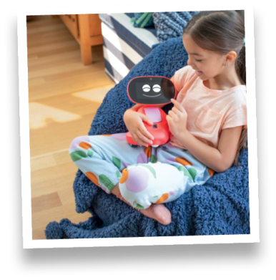
Miko
Miko is helpful in the field of learning. It aims to bring out the best
technology and develop young minds through education. Miko has come
up with a Miko 3 Robot that, by using artificial intelligence, promotes learning
and educates and entertains kids. It shows and reacts to your emotions the
same way a living being would respond to them. Miko can dance and make
jokes. The more you spend time with Miko, the more it will know you and
vice versa. It will adapt according to your requirements.
20

https://geekflare.com/best-personal-robots (abridged and adapted)

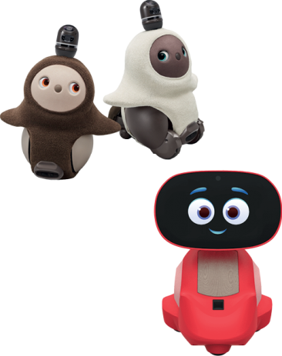
A. Lovot or Miko? Write L (Lovot) or M (Miko) next to each characteristic.

1. This robot now has a version 3.

2. It is light and maintenance is easy.

3. It can make you feel energetic.
4. It is more dedicated to teaching and learning.

5. This robot can become a friend.

6. It is an entertaining robot that dances and tells jokes.


B. What do the highlighted words in the text refer to? Circle the correct option.
1. them (line 1) – anything / tasks
2. We (line 5) – robots / humans
3. it (line 11) – Lovot Robot / supercomputer
4. that (line 19) – Miko 3 Robot / technology
C. Complete the sentences about the text with the information from the box.
are fascinated quicker… more efficient
security, agriculture, healthcare and space exploration personal robots

1. Robots can help in different fields such as _____________________________________________________
_________________________________________________.
2. Humans _______________________ with robots because of what they can do for them.
3. Robots are becoming ______________________ and ______________________.
4. It is now possible to buy ___________________________ and bring AI to your home and life.
D. Answer the questions about the text.
1. According to the text, what is a robot? (paragraph 1)
A robot automates specific tasks,
2. How do robots help in the TV and film industry? (paragraph 1)
Robots help
3. AI brought the world of human imagination to reality. How? (paragraph 1)
AI has allowed

