Tech gadget review
(Unit 5)
Speaking Worksheet
5A
Name No.: ______ Class: ________ Date: _____/ _____/ _____
Spoken production
Talking about a gadget you bought: uses, price, good and bad aspects
A. Read the gadget reviews below.



¹ I bought a new Bluetooth speaker ² in an online
shop. ³ It was on sale with 50% discount, so it
was a top pick! ⁴ I bought it because it connects
to my smartphone and tablet wirelessly. ⁵ It is
really compact and portable and I can take it to
the beach or to the park when I hang out with my
friends. We can listen to music and have great
fun together. Sometimes there’s a bit of a sound
delay, ⁶ but overall, it was a great purchase. It
was worth every cent! I truly recommend it!
Miriam, 15, London

I’m a tech geek, so I’m always looking for the
latest trends. After buying a radio toaster (yes,
I make my morning toast while I listen to the
radio!), ¹ I decided to buy a drone ² from a
famous tech retailer. ³ It cost 100 euros and
it was my parents’ Christmas present. ⁴ I’m
interested in photography, so taking pictures
with a drone seemed amazing! ⁵ Well, it was a
big disappointment. I constantly have problems
with GPS signals, it runs out of battery after a few
minutes and the compass* has so many problems
that it flies in the wrong direction all the time.
⁶ I have to say it was a complete waste of time
and money. Don’t think about getting one!
Josh, 13, New Jersey

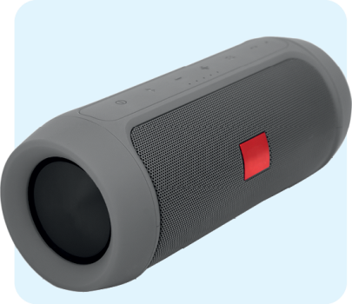
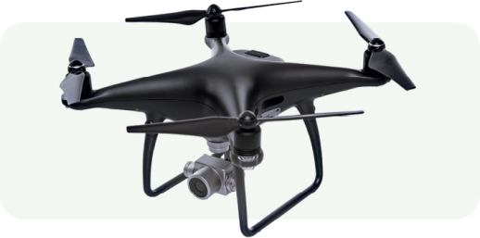

*compass = bússola
B. Now it’s your turn! Think about a tech gadget that you have recently bought and present a
review of it to the class. Use the texts from exercise A as a model. In your presentation you
should answer the following questions (check how they are answered in the texts in exercise A):

1. What is the gadget?
2. Where did you buy it?
3. How much did it cost?
4. Why did you buy it?
5. What are the pros/cons of this gadget?
6. Do you recommend people to buy it?
TIP
You can bring the gadget you bought to class and show it to your classmates and
teacher or you can project it/bring a photo of it.

Tech gadget review
(Unit 5)
Speaking Worksheet
5A
Name No.: ______ Class: ________ Date: _____/ _____/ _____
Spoken production
Talking about a gadget you bought: uses, price, good and bad aspects
A. Read the gadget review below.

¹I bought a new Bluetooth speaker ²in an online
shop. ³ It was on sale with 50% discount, so it
was a top pick! ⁴ I bought it because it connects
to my smartphone and tablet wirelessly. ⁵ It is
really compact and portable and I can take it to
the beach or to the park when I hang out with my
friends. We can listen to music and have great
fun together. Sometimes there’s a bit of a sound
delay, ⁶ but overall, it was a great purchase. It
was worth every cent! I truly recommend it!
Miriam, 15, London


B. Now it’s your turn! Think about a tech gadget that you have recently bought and present a
review of it to the class. Use the text from exercise A as a model. In your presentation, you
should answer the following questions:
1. What is the gadget?
2. Where did you buy it?
3. How much did it cost?
4. Why did you buy it?
5. What are the pros/cons of this gadget?
6. Do you recommend people to buy it?
TIP
You can bring the gadget you bought to class and show it to your classmates and
teacher or you can project it/bring a photo of it.

