A. Read the definitions and match them with the correct item from the box. Write letters a-f.

Technology (Unit 5)
Vocabulary Worksheet
14A
Name No.: ______ Class: ________ Date: _____/ _____/ _____
a) charger b) drawing tablet c) earbuds
d) wireless speaker e) projector f) AirTag

1. A computer device that enables a user to draw images, animations and graphics with
a special pen.

2. A loudspeaker that receives audio signals using radio waves instead of audio cables.

3. A tracking device developed by Apple that helps people to find personal objects.

4. A device that uses a system of lenses to show slides or video on a screen.

5. A device for charging batteries or battery-powered equipment.
6. Very small headphones to use inside the ear.

B. Label the pictures with the gadgets from exercise A. There are two extra pictures.
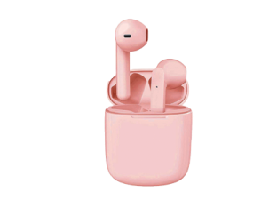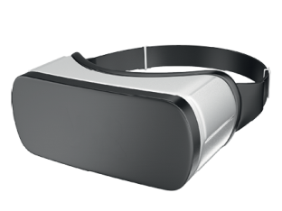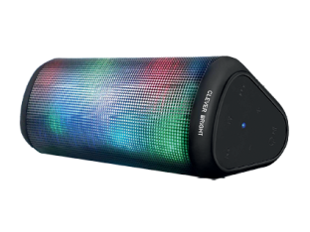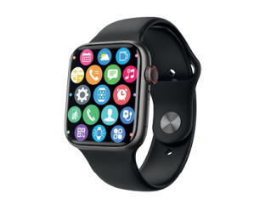
1. ________________ 2. ________________ 3. ________________ 4. ________________
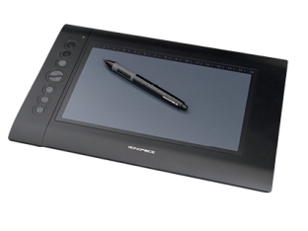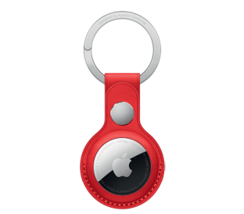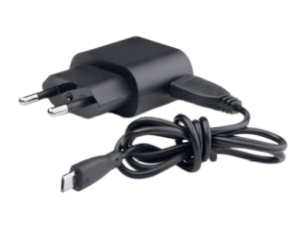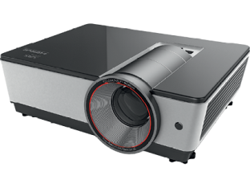
5. ________________ 6. ________________ 7. ________________ 8. ________________

C. Complete the sentences with the words/expressions from the box.
printer tech geek customise leading-edge syncs

1. My brother is a ____________, so he’s always looking for the most ____________ gadgets.
2. I always ____________ the gadgets I buy because they are an important part of my personal
and professional life.
3. A 3D ____________ that ____________ with my laptop is my new technological acquisition.

A. Unscramble the letters to find the gadgets. The first letter is given.
2. WAGDNIR TTELBA
__________ __________
1. HRGRECA
__________
3. BARUSDE
__________
e
t
d
c

A
w
s
p
5. RPJCOOTER
__________
6. RTAAIG
__________
4. SESWRELI RPEEKAS
__________ __________

B. Label the pictures with the gadgets from exercise A.

Technology (Unit 5)
Vocabulary Worksheet
14B
Name No.: ______ Class: ________ Date: _____/ _____/ _____
1. ________________ 2. ________________ 3. ________________
4. ________________ 5. ________________ 6. ________________

C. Circle the correct option to complete the sentences.
1. My brother is a tech geek / technophobe / technical, so he’s always looking for the most
outdated / old-fashioned / leading-edge gadgets.
2. I always change / connect / customise the gadgets I buy to make them suit my personal taste.
3. A 3D smartphone / printer / microphone that syncs / develops / streams with my laptop is my
new technological acquisition!

