Present simple or present continuous
(Unit 0)
Grammar Worksheet
1A6
Name No.: ______ Class: ________ Date: _____/ _____/ _____
A. Complete the book review with the present simple of the verbs in brackets.
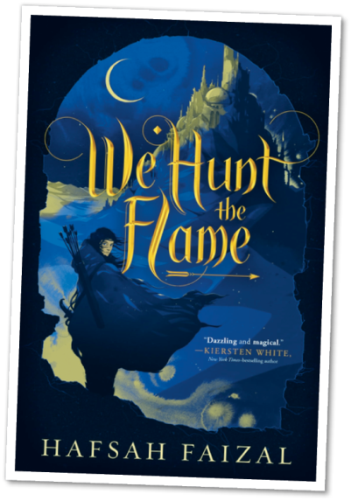
We Hunt the Flame ¹____________ (be) about a girl named Zafira
who ²_________ (become) the family breadwinner after her father
³________ (die). She is an independent character who ⁴_________
(get) involved in the search for a rare item with strong power.
While she ⁵_________ (have) noble intentions, the prince, Nasir,
⁶________ (take on) a role of assassin as he fights to find the artefact before she ⁷_________ (do).
I really ⁸_________ (like) the romance throughout the book and
how Zafira's personality ⁹___________ (not change) as she falls in
love with Nasir.
The plot twists at the end ¹⁰__________ (be) interesting but
unnecessary. However, I ¹¹____________ (think) you might catch me
reading the sequel! ¹²__________ (you / enjoy) fantasy too? This is the book for you!
https://ppld.org/teens/book-reviews (abridged and adapted)
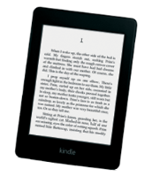
B. Write sentences using the present continuous.
1. I / read a romance novel / on Kindle / for my Portuguese project / this week / .

____________________________________________________________
2. I / play Minecraft with my friends / while / my sister / listen to music / on Spotify / .

____________________________________________________________
3. we / not chat online / now because we / watch a new episode of Heartstopper on Netflix /.
____________________________________________________________

4. "What / you / look for / on YouTube?" – "I / try / to find a good video on online games."
____________________________________________________________
C. Complete the dialogue with the present simple or the present continuous of the verbs in brackets.
Carol: Hi, guys! ¹______________ (you / play) video games again?
Michael: Hi, there! Yep! ²_____________ (you / want) to join us?
Carol: Boring… I ³___________ (not be) keen on gaming. You ⁴___________ (know)
that! Let’s go out and have some fun outside. Sophie and I ⁵__________ (plan)
a new dance for a TikTok challenge this week. It must be ready by Saturday.
Justin: Well, good luck, but our plans for the afternoon ⁶___________ (be) a bit
different: sofa, snacks, Netflix and the first season of The Last Bus!
Carol: Streaming is the worst thing ever… Well, what ⁷__________ (do) this evening?
Michael: We ⁸___________ (not have) any plans, but I can call you later…
Carol: OK. Please do! You definitely ⁹____________ (need) some fresh air. Bye!
Michael and Justin: Bye!


A. Circle the correct verb forms to complete the book review.
Present simple or present continuous
(Unit 0)
Grammar Worksheet
1B6
Name No.: ______ Class: ________ Date: _____/ _____/ _____
We Hunt the Flame ¹ are / is about a girl named Zafira who ² become/ becomes the family breadwinner after her father ³ die / dies. She is an independent character who ⁴ get / gets involved in the search for a rare item with strong power. While she ⁵ have / has noble intentions, the prince, Nasir, ⁶ take on / takes on a role of assassin as he fights to find the artefact before she ⁷ do / does.
I really ⁸ like / likes the romance throughout the book and how Zafira's personality ⁹ doesn’t change / don’t change as she falls in
love with Nasir.
The plot twists at the end ¹⁰ are / is interesting but unnecessary. However, I ¹¹ think / thinks you might catch me reading the sequel! ¹² Do you enjoy / Does you enjoy fantasy too? This is the book for you!
https://ppld.org/teens/book-reviews (abridged and adapted)
B. Complete the sentences with the verb forms from the box.
am playing am trying is listening aren't chatting
are you looking for are watching am reading
1. I ______________ a romance novel on Kindle for my Portuguese project this week.
2. While my sister______________ to music on Spotify, I ______________ Minecraft
with my friends.
3. We______________ online now because we ______________ a new episode of
Heartstopper on Netflix.
4. “What ______________ on YouTube?” “I ______________ to find a good video on online games.
C. Present simple or present continuous? Circle the correct verb forms to complete the dialogue.
Carol: Hi, guys! ¹ Do you play / Are you playing video games again?
Michael: Hi, there! Yep! ² Do you want / Are you wanting to join us?
Carol: Boring… I ³ am not / am not being keen on gaming. You ⁴ know / are knowing
that! Let’s go out and have some fun outside. Sophie and I ⁵ plan / are planning
a new dance for a TikTok challenge this week. It must be ready by Saturday.
Justin: Well, good luck, but our plans for the afternoon ⁶ are / are being a bit
different: sofa, snacks, Netflix and the first season of The Last Bus!
Carol: Streaming is the worst thing ever… Well, what ⁷ do you do / are you doing this . evening?
Michael: We ⁸ don’t have / aren’t having any plans, but I can call you later…
Carol: OK. Please do! You definitely ⁹ need / are needing some fresh air. Bye!
Michael and Justin: Bye!

