A. Label the pictures with the past simple of the verbs in brackets.
Last weekend, Patrick…
Past simple (Unit 0)
Grammar Worksheet
2A6
Name No.: ______ Class: ________ Date: _____/ _____/ _____
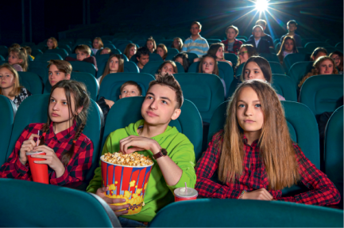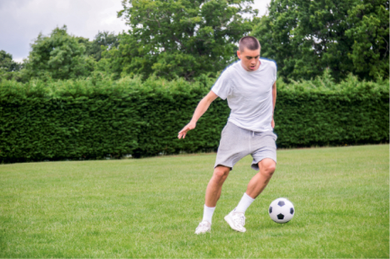
1. ___________ (chat) with his 2. ___________ (go) to the 3. ___________ (play) football
friends. cinema. in the city park.
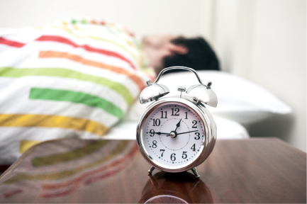
4. ___________ (study) hard 5. ___________ (sleep) late on 6. ___________ (update) his
for his science project. Sunday. Instagram stories.
B. Write about the things Patrick didn’t do last weekend.

Patrick…
1. ___________ (write) an essay for English.
2. ___________ (eat out) with his cousins.
3. ___________ (watch) his favourite YouTube channel.
4. ___________ (shop) online.
5. ___________ (read) the email from his best friend.


C. Patrick’s parents were away last weekend. Read the voice message that Patrick’s mother sent him
on WhatsApp and fill in the gaps with the past simple of the verbs in brackets.
“Hello, Pat! Are you OK? I hope you get some rest, but don’t forget your
science school project! ¹____________ (meet) your friends to do it? Where
²____________ (go)? To the city library? I guess it ³_______________ (be)
open yesterday until 1 p.m., right? Dad and I are relaxing by the sea. We
⁴_________________ (visit) some attractions yesterday morning and we
⁵____________ (have) a great time on the beach. We will be back tomorrow.
There’s plenty of food in the fridge. I ⁶____________ (not buy) the pepperoni
pizza you like, but there are other yummy things. Love you. Mum.”
Past simple (Unit 0)
Grammar Worksheet
2B6
Name No.: ______ Class: ________ Date: _____/ _____/ _____

A. Circle the correct option to label the pictures with the verbs in the past simple.
Last weekend, Patrick…
1. watched / chatted with 2. went / goes to the cinema. 3. went / played football
his friends. in the city park.
4. listened / studied hard for 5. slept / talked late 6. updated / updating his
his science project. on Sunday. Instagram stories.
B. Write about the things Patrick didn’t do last weekend using the verbs in brackets. There is one
example.
Patrick…
• ___________ (not write) an essay for English.
1. ___________ (not eat out) with his cousins.
2. ___________ (not watch) his favourite YouTube channel.
3. ___________ (not shop) online.
4. ___________ (not read) the email from his best friend.
didn’t write

C. Patrick’s parents were away last weekend. Read the voice message that Patrick’s mother sent him
on WhatsApp and circle the correct option to complete the text.

“Hello, Pat! Are you OK? I hope you get some rest, but don’t forget your
science school project! ¹ Did you meet / Did you met your friends to do it? Where ² did you went / did you go? To the city library? I guess it ³ was /
were open yesterday until 1 p.m., right? Dad and I are relaxing by the sea. We ⁴ visit / visited some attractions yesterday morning and we ⁵ have / had a great time on the beach. We will be back tomorrow. There’s plenty of food in the fridge. I ⁶ didn’t buy / didn’t bought the pepperoni
pizza you like, but there are other yummy things. Love you. Mum.”

