A. Choose the past simple or the past continuous form of the verbs to complete the sentences.
Past simple and past continuous (Unit 1)
Grammar Worksheet
4A6
Name No.: ______ Class: ________ Date: _____/ _____/ _____
1. When Mum arrived / was arriving home, the boys prepared / were preparing lunch.
2. While William downloaded / was downloading some files, his friend tried / was trying to fix
the computer.
3. “What did you do / were you doing when I called / was calling you at break time?” Sophie
asked her best friend.
4. I didn’t buy / wasn’t buying a new mobile phone yesterday because I didn’t have / wasn’t
having time.
B. What were these people doing online yesterday evening? Fill in the gaps with the verbs from
the boxes in the past simple or past continuous.
go take hear
track go off miss
While John ⁴__________ on a virtual trip to
Argentina, Katie ⁵__________ a 3D-tour in
the National Gallery, in London.
Suddenly, they ⁶__________
a strange noise in the basement
and…
I ¹____________ Breton, my favourite white
shark, on OCEARCH when the lights
²____________.
I ³____________ his wonderful crossing of
the North Atlantic
Ocean.




C. Complete the phone conversation below with the past simple or past continuous forms of the
verbs in brackets.
Lydia: Hello, Tom! Sorry for calling you this late. I ¹____________ (leave) a message on your
WhatsApp earlier this afternoon, but I guess you ²____________ (not read) it…
Tom: Hi! No… sorry, I didn’t. I ³____________ (run out) of battery while
I ⁴____________ (come) home. Then Peter and I ⁵____________ (decide)
to work on our new YouTube channel on high tech.
Lydia: Oh… that sounds nice. I ⁶____________ (not know) about it…
Tom: So, what ⁷____________ (be) your message about?
Lydia: I ⁸____________ (have) lunch with Paul and John when they
⁹____________ (remind) me of the ICT project for next week.
We are running out of time.
Tom: You’re right. Perhaps we could meet at your place tomorrow
and start planning it!
Lydia: Great! I ¹⁰____________ (think) about that, too.
See you tomorrow after lunch! Bye!
Tom: Bye! See you…

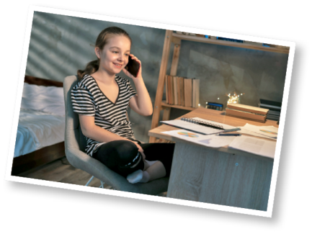

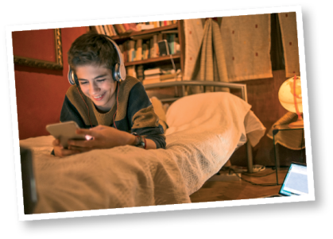

A. Match the two halves to build sentences using the past simple and the past continuous. Write
letters a-d.
Past simple and past continuous (Unit 1)
Grammar Worksheet
4B6
Name No.: ______ Class: ________ Date: _____/ _____/ _____
1. When Mum arrived home, a) because I didn’t have time.

2. While William was downloading some files, b) his friend was trying to fix the computer.

3. What were you doing c) the boys were preparing lunch.

4. I didn’t buy a new mobile phone yesterday d) when I called you at break time?
B. What were these people doing online yesterday evening? Fill in the gaps with the verb forms
from the boxes.
went off missed was tracking
was going heard was taking

While John ⁴__________ on a virtual trip to
Argentina, Katie ⁵__________ a 3D-tour in
the National Gallery, in London.
Suddenly, they ⁶__________
a strange noise in the basement
and…
I ¹____________ Breton, my favourite white
shark, on OCEARCH when the lights
²____________.
I ³____________ his wonderful crossing of
the North Atlantic
Ocean.


C. Circle the correct option to complete the dialogue below.
Lydia: Hello, Tom! Sorry for calling you this late. I ¹ left / was leaving a message on your
WhatsApp earlier this afternoon, but I guess you ² weren’t reading / didn’t read it…
Tom: Hi! No… sorry, I didn’t. I ³ ran out / was running out of battery while I ⁴ came /
was coming home. Then Peter and I ⁵ were deciding / decided to work on our new
YouTube channel on high tech.
Lydia: Oh… that sounds nice. I ⁶ didn’t know / wasn’t knowing about it…
Tom: So, what ⁷ was being / was your message about?
Lydia: I ⁸ had / was having lunch with Paul and John when they
⁹ were reminding / reminded me of the ICT project for
next week. We are running out of time.
Tom: You’re right. Perhaps we could meet at your place
tomorrow and start planning it!
Lydia: Great! I ¹⁰ thought / was thinking about that, too.
See you tomorrow after lunch! Bye!
Tom: Bye! See you…

