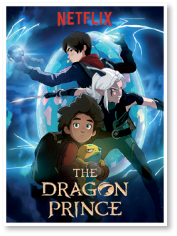
A. Complete the sentences with the words from the box.
Present perfect (Unit 1)
Grammar Worksheet
5A
Name No.: ______ Class: ________ Date: _____/ _____/ _____
since just for already ever
1. I have ___________ watched the new season of The Dragon Prince. I loved it!
2. Have you ___________ read The Hunger Games book series?
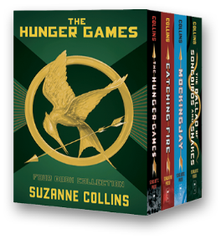
3. I haven’t turned my TV on ___________ weeks! I prefer watching live streaming
videos on my smartphone.
4. Susan has ___________ downloaded the files I emailed her this morning. She can
start working now.
5. Peter and John haven’t posted anything ___________ last weekend.
B. Read the sentences and match them with the correct use of the present perfect.



I’ve broken my
laptop, so I must
work at home now.
Anne has created
a new Facebook
account.

c)

b)

a)
The internet has changed
our lives since the 1950s.

2. Finished actions that
happened at an indefinite
time in the past.
3. Actions that took place
in the past and affect
the present.
1. Actions that started in
the past and continue
to the present.

C. The sentences below are ALL wrong. Spot the mistake in each sentence and correct it.
1. Sophie has changed her login password yet.
________________________________________________________
2. Spotify have been one of my favourite apps for ages.
________________________________________________________
3. I have just saw Fantastic Beasts: The Secrets of Dumbledore in 4D. Awesome!
________________________________________________________
D. Write sentences using the present perfect.
1. Where / you / buy / your new smartphone?
_______________________________________________________________________
2. Michael / always / use / the internet safely.
_______________________________________________________________________
3. They / write / some annoying comments on my last post.
_______________________________________________________________________


A. Circle the correct option to complete the sentences.
Present perfect (Unit 1)
Grammar Worksheet
5B
Name No.: ______ Class: ________ Date: _____/ _____/ _____
1. I have already / ever watched the new season of The Dragon Prince. I loved it!
2. Have you ever / since read The Hunger Games book series?
3. I haven’t turned my TV on since / for weeks! I prefer watching live video
streaming on my smartphone.
4. Susan has never / just downloaded the files I emailed her this morning. She can
start working now.
5. Peter and John haven’t posted anything for / since last weekend.
B. Read the sentences and match them with the correct use of the present perfect.
a)

b)

Anne has created
a new Facebook
account.
The internet has changed
our lives since the 1950s.

1. Actions that started in
the past and continue
to the present.
2. Finished actions that
happened at an indefinite
time in the past.

C. The sentences below have mistakes. Replace the underlined words with the correct ones.
1. Sophie haven't changed her login password yet.
________________________________________________________
2. Spotify have been one of my favourite apps for ages.
________________________________________________________
3. I have just saw Fantastic Beasts: The Secrets of Dumbledore in 4D. Awesome!
________________________________________________________
D. Complete the sentences using the present perfect of the verbs in brackets.
1. __________ you __________ (buy) a new smartphone? I need one too!
2. Michael __________ always __________ (use) the internet safely.
3. They _____________ (write) some annoying comments on my last post.

