A. Label the pictures with the correct form of the verbs in brackets in the present perfect or past
simple.
Present perfect or past simple (Unit 1)
Grammar Worksheet
6A
Name No.: ______ Class: ________ Date: _____/ _____/ _____
1. What did Sarah do on Saturday evening?
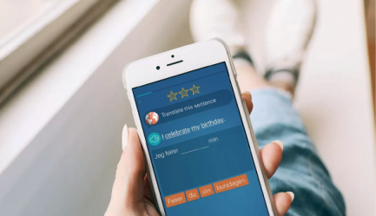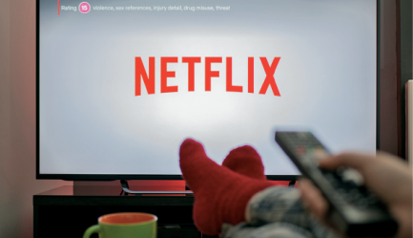
c) She _________ (watch) a
comedy film on Netflix.
b) She _________ (meet) her
friends for a picnic in the
park.
a) She _________ (get) a new
language-learning app for
her smartphone.

2. What has Sarah done lately?
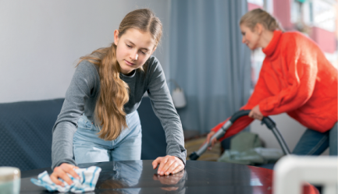
c) She _____________ (read)
a lot for a school geography
project.
a) She _____________ (help)
her mother with the
household chores.
b) She ___________ (update)
her blog PerfecTeamEver
more often.

B. Read the texts below and fill in the gaps with the present perfect or past simple of the verbs from
the boxes.
How has technology impacted my life?
Shopping? Amazon. Want to be entertained? Netflix
or online gaming. Research? Google. The internet
⁴ _______ us vulnerable, but technology ⁵ _________ us
ways to protect ourselves, so I feel safe when I browse
the web. ⁶ ____________ I ever ___________ insecure
online? Of course I have, but I ⁷ ____________ to create
strong passwords in my ICT lessons last year and that
helps a lot.
Miriam, 16, Sidney
give feel make learn
dream see invent
In 1876, Bell ¹____________ the phone
and ² ____________ there would be
“one in every town”. He was almost
right – in fact, these days, there’s one in
every person’s pocket! The traditional
audio calls are great, but video calls
³ ____________ an increase lately.
Michael, 14, New Jersey

1
understand not have not cancel become
A gigantic change in my life was social media. I ⁸ ____________ a Snapchat, TikTok or Instagram account
a few years ago, but I ⁹ ____________ the advantages of all these apps since I started using them.
Learning, hanging out and playing online ¹⁰ ___________ easier since then. I ¹¹ ___________ Facebook
yet, but I think I will soon. It’s a kind of a bygone reality right now.
Layla, 15, Oxford

https://tech.co/vpn/main-ways-technology-impacts-daily-life (abridged and adapted)

A. Label the pictures with the verbs from the boxes.
Present perfect or past simple (Unit 1)
Grammar Worksheet
6B
Name No.: ______ Class: ________ Date: _____/ _____/ _____
1. What did Sarah do on Saturday evening?
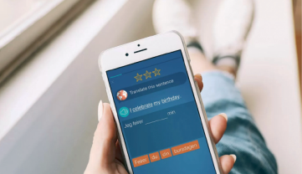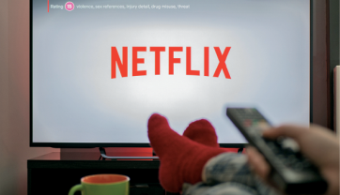
met
watched
got
c) She _________
a comedy film on Netflix.
b) She _________ her
friends for a picnic in
the park.
a) She _________ a new
language-learning app
for her smartphone.

2. What has Sarah done lately?
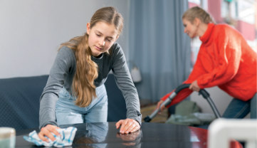
has updated
has helped
has read
c) She _____________
a lot for a school
geography project.
b) She ____________
her blog PerfecTeamEver
more often.
a) She _____________
her mother with the
household chores.


B. Read the texts below and circle the correct options to complete the texts.
How has technology impacted my life?
Shopping? Amazon. Want to be entertained? Netflix or
online gaming. Research? Google. The internet ⁴ made /
has made us vulnerable, but technology ⁵ gave / has
given us ways to protect ourselves, so I feel safe when
I browse the web. ⁶ Did I ever feel / Have I ever felt
insecure online? Of course I have, but I ⁷ learnt / have
learnt to create strong passwords in my ICT classes last
year and that helps a lot.
Miriam, 16, Sidney
In 1876, Bell ¹ invented / has invented the
phone and ² dreamt / has dreamt there
would be “one in every town”. He was
almost right – in fact, these days, there’s
one in every person’s pocket! Traditional
audio calls are great, but video calls ³ saw /
have seen an increase lately.
Michael, 14, New Jersey

1
A gigantic change in my life was social media. I ⁸ didn’t have / haven’t had a Snapchat, TikTok or Instagram
account a few years ago, but I ⁹ understood / have understood the advantages of all these apps since
I started using them. Learning, hanging out and playing online ¹⁰ became / have become easier since
then. I ¹¹ didn’t cancel / haven’t cancelled Facebook yet, but I think I will soon. It’s a kind of a bygone
reality right now.
Layla, 15, Oxford

https://tech.co/vpn/main-ways-technology-impacts-daily-life (abridged and adapted)

