Unit 1
Reading Worksheet
1A6
Name No.: ______ Class: ________ Date: _____/ _____/ _____
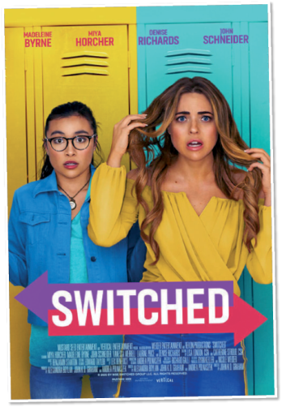

Read the film reviews written by teenagers for teenagers.
9/10
Switched
Every day, many movies are released in many genres and languages.
Still, a movie that captured my heart is Switched.
Switched is about an unpopular girl named Cassandra Evans who is
bullied by the most popular girl Katie Sharp. Cassandra, the protagonist,
wishes that Katie Sharp could know how it feels to be bullied. Her wish
becomes real when she finds their bodies switched. The rest of the story
is about how Cassandra lives Katie's life and vice-versa and how the girls
go through friendships and conflicts with each other and finally, but
unexpectedly, get a solution for their problem.
Switched, a wonderful drama with a phenomenal cast (starring Miya Horcher as Cassandra Evans and Madeleine Byrne as Katie Sharp), shows that kindness is one of the best gifts in the world.
My favourite part of the movie is when Cassandra (in the body of Katie) gets Katie's social
media account and puts up a video saying, "I'm Cassandra Evans. I mean everyone is Cassandra
Evans." That shows her voice towards all the girls who are bullied.
Out of many movies that I've seen, Switched is one of the best movies ever. It tells a touching
story about kindness, fame and friendship through the voice of an unpopular girl. You will find
out that their life-story will stay with you, even after the credits.
So, check it out.
Posted by Afra, 16, Kandy, Sri Lanka

5

10

15

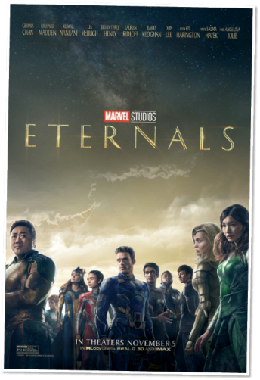
Eternals
1/10
Eternals is the worst science fiction Marvel film I've ever watched and
it's likely to be the worst film I'll ever see. From awful jokes to bad character
connections, this film has it all.
The film is set on Earth 7,000 years ago. The eternals arrive on a mission
to ban their enemies (the deviants), to destroy the world and eliminate
humanity. They decide to stay on Earth after completing part of their mission
to see how it develops and everyone travels in their own direction…
Even though Akaris is the main character with the most screenplay, I
don't think she has a convincing role. There are too many characters and not
enough emotional connections to be made with everyone.
The plot is spread across the film, with back-and-forth action. The audience has to try to fit
the puzzle together, but with so much going on, they become disoriented.
This movie is a complete waste of more than two hours!!! The plot is twisted and left me with
unanswered questions, the characters are uninteresting, and the ending couldn’t be worse. The
fight scenes were supposed to make me nervous, but they didn't. This film is not one I would
suggest to anyone. You should only watch at your own risk.
Posted by Angel, 17, Sacramento, USA

5

10

15

www.teenink.com (abridged and adapted)
A. Are the following sentences true, false or not mentioned? Write T (true), F (false) or NM (not
mentioned).
1. Switched is about bullying, popularity and friendship.

2. Afra thinks that Miya Horcher performs better than Madeleine Byrne.

3. The message and morals in Switched is one of the strongest aspects of the film.

4. Angel doesn’t recommend the film and he abandoned the cinema theatre in the
middle of the film.

5. According to Angel, the main character in Eternals doesn’t have a powerful role.
6. The plot of Eternals is so simple and clear that Angel had no questions in the end.

B. Find words in the first two paragraphs of the review about Switched that mean the same as:

1. types _________________________________________________________
2. caught ________________________________________________________
3. desire _________________________________________________________
4. disagreements ________________________________________________
5. without counting on something ________________________________
C. Answer the questions about the film reviews.
1. Identify the film types of Switched and Eternals.

2. What is Switched about?

3. According to Afra, what is the most powerful scene of the film? Why?

4. Why doesn’t Angel recommend the film Eternals? Mention his reasons.

