A. Complete the sentences with verbs that refer to actions on the computer and on the internet.
Make the necessary changes to the verbs.
p
New media + Actions on the internet (Unit 1)
+
Vocabulary Worksheet
3A
Name No.: ______ Class: ________ Date: _____/ _____/ _____
1. I usually _____________ photos and videos of my favourite singers and bands on Facebook.
t
2. Sue _____________ fast, so she is in charge of the written part of our history project.
s
3. I couldn’t read your last tweet carefully because John was _____________ all the time.
f
4. Peter _____________ the official Instagram and Facebook pages of the video games he plays.
e
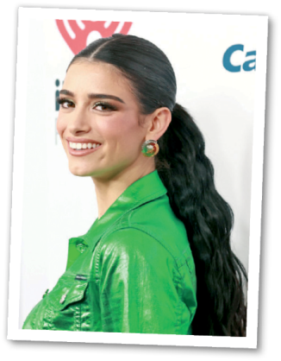
5. Sophie and Michael _____________ their last post on internet safety because it had wrong
information.
B. Match the two columns to build sentences. Write letters a-e.
1. Dixie D’Amelio’s latest video on TikTok
a) so I was hacked.
b) online video calls and
meetings.
c) on streaming platforms
and it was great!
d) viral in a few hours.
e) I can chat, meet and have fun
with friends online.

became

2. I shared personal information online,
3. I use Google Meet for

Dixie D’Amelio
4. We participated on a webinar

5. With social media

C. Read the tips about internet safety and fill in the gaps using the definitions in brackets.

1. Create strong ____________ and change them regularly. (a secret word or phrase used online)
2. Make ____________ of your files. (spare copies of data)
3. Use strict ____________ settings when using social media. (means to control what things
you share and who gets to see them)
4. Avoid ____________ by not sharing personal information with unknown people. (people
who use the internet to harm or frighten another person)
D. What can we use the internet for? Complete the diagram. Use exercises A, B and C to help you.

1. _________________
2. _________________
4. _________________
3. _________________

A. Use the verbs from the box to complete the sentences about computers and internet use.
types edited post scrolling follows

1. I usually ____________ photos and videos of my favourite singers and bands on Facebook.
2. Sue ____________ fast, so she is in charge of the written part of our history project.
3. I couldn’t read your last tweet carefully because John was ____________ all the time.
4. Peter ____________ the official Instagram and Facebook pages of the video games he plays.
5. Sophie and Michael ____________ their last post on internet safety because it had wrong
information.
B. Match the two columns to build sentences. Write letters a-c.
a) on streaming platforms and it was great!
b) I can chat, meet and have fun with friends online.
c) online video calls and meetings.

1. I use Google Meet for

2. We participated on a webinar
3. With social media


C. Read the tips about internet safety and circle the correct option to complete them.
1. Create strong files / passwords and change them regularly.
2. Make backups / videos of your files.
3. Use strict privacy / password settings when using social media.
4. Avoid internet users / cyberbullies by not sharing personal information with unknown people.
D. What can we use the internet for? Complete the diagram with the words/expressions from the
box.
video games in online video calls with friends comments
New media + Actions on the internet (Unit 1)
+
Vocabulary Worksheet
3B
Name No.: ______ Class: ________ Date: _____/ _____/ _____
4. chat ________________
1. participate ___________
3. play _________________
2. post ________________

