PET KIT – Unit 1
Part 2 (2-3 min)
Speaking Part 2
Say to both students:
I’m going to describe a situation to you.
A Spanish student from Madrid was selected to go on an exchange programme and is going to stay with a host family in Ireland. He is leaving next week and wants to buy a present for his host parents.
Here is a picture with some ideas to help you.
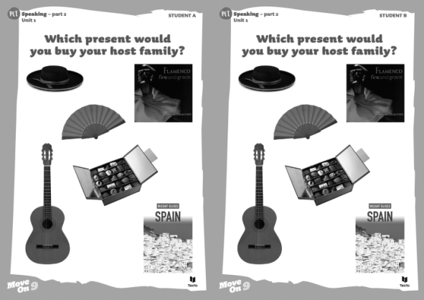
Place the pictures in front of the students.
I’ll say that again.
A Spanish student from Madrid was selected to go on an exchange programme and is going to stay with a host family in Ireland. He is leaving next week and wants to buy a present for his host parents.
All right? Talk together.

Allow the students enough time to complete the task without intervention.
Use prompts only if necessary.
Thank you. Can I have the pictures please?
Back-up prompts:
Spanish hat Box of chocolates
Spanish guitar Flamenco CD
Fan A book about Spain

PET KIT – Unit 1
Part 3 (3 min) / Part 4 (3 min)
Speaking Part 3
Say to both students:
Now, I’d like each of you to talk on your own about something. I’m going to give each of you a photograph of teens doing volunteer work. Student A, here is your photograph.
Place part 3 photograph 1 in front of student A.
Please show it to student B, but I’d like you to talk about it. Student B, you just listen. I’ll give you your photograph in a moment.
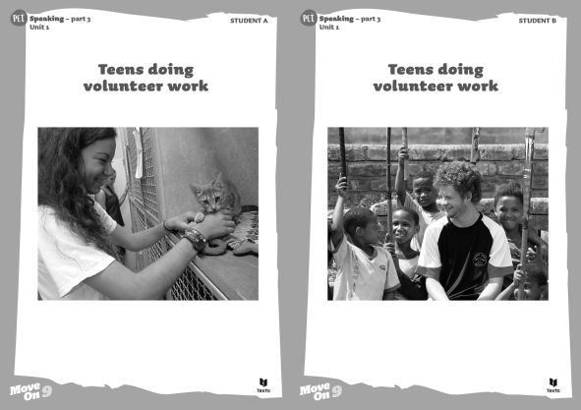
Student A, please tell us what you can see in your photograph.
If there is a need to intervene, prompts rather than direct questions should be used.
Approximately one minute.
Thank you. Can I have the photograph, please?
Now, student B, here is your photograph (task 1 B). It also shows teens doing volunteer work.
Place part 3 photograph 2 in front of student B.
Please show it to student A and tell us what you can see in the photograph.
Approximately one minute.
Thank you. Can I have the photograph, please?
Back-up prompts:
1. Describe the people you see (a teenage boy, a child…)
2. Describe the place they are in, what they are doing and their role (photograph 1 – taking care of a cat; volunteer; photograph 2 – taking care of a young boy maybe in Africa)
3. Describe the background (photograph 1 – there are other cages, so maybe it’s an animal shelter…; photograph 2 – they are outside, maybe at school…
Speaking Part 4
Say to both students:
Your photographs showed different types of volunteer work. Now, I’d like you to talk together about which type of volunteer work you would choose.
Allow the students enough time to complete the task without intervention.
Use prompts only if necessary.
Thank you. This is the end of the test.
Back-up prompts:
1. Talk about type of volunteer work you prefer and why;
2. Talk about the activities it involves;
3. Talk about reasons for volunteering (you feel good when you help people in need; it boosts your self-esteem; it’s a very rewarding experience; you can make a difference…)
PET KIT – Unit 2
Part 2 (2-3 min)
Speaking Part 2
Say to both students:
I’m going to describe a situation to you.
You are going to spend a week in London and can only take one technological device with you.
Here is a picture with some ideas to help you.
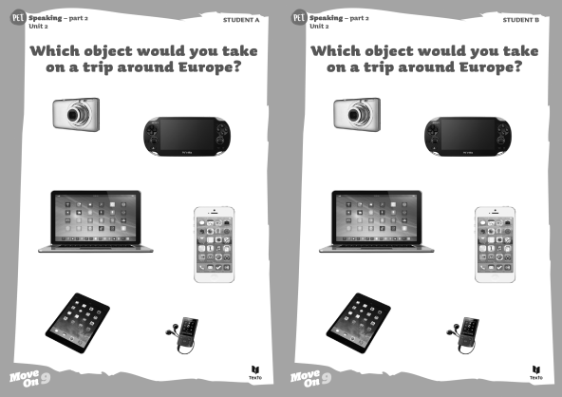
Place the pictures in front of the students.
I’ll say that again.
You are going to spend a week in London and can only take two technological devices with you.
All right? Talk together.
Allow the students enough time to complete the task without intervention.
Use prompts only if necessary.
Thank you. Can I have the pictures please?
Back-up prompts:
Laptop Tablet
iPhone Console game
Digital camera Mp3 player

PET KIT – Unit 2
Part 3 (3 min) / Part 4 (3 min)
Speaking Part 3
Say to both students:
Now, I’d like each of you to talk on your own about something. I’m going to give each of you a photograph of people using technology. Student A, here is your photograph.
Place part 3 photograph 1 in front of student A.
Please show it to student B, but I’d like you to talk about it. Student B, you just listen. I’ll give you your photograph in a moment.
Student A, please tell us what you can see in your photograph.
Approximately one minute.
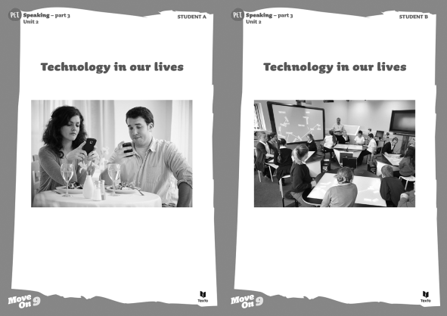
Thank you. Can I have the photograph, please?
If there is a need to intervene, prompts rather than direct questions should be used.
Now, student B, here is your photograph. It also shows people using technology.
Place part 3 photograph 2 in front of student B.
Please show it to student A and tell us what you can see in the photograph.
Approximately one minute.
Thank you. Can I have the photograph, please?
Back-up prompts:
1. Describe the people you see (photograph 1 – a woman / long wavy brown hair, a man short straight dark hair; photograph 2 – students, teacher…)
2. Describe the place where they are, what they are doing (photograph 1 – at a restaurant sitting at a table / focused on their mobile phones / aren’t eating / two plates with salads / two glasses of white wine; photograph 2 – a classroom / the students are sitting in groups at a table with a multi-touch surface / two interactive boards / the teacher using a tablet / maybe to monitor the students’ work)

Speaking Part 4
Say to both students:
Your photographs showed different ways of using technology. Now, I’d like you to talk together about the positive and negative aspects of using technology.
Allow the students enough time to complete the task without intervention.
Use prompts only if necessary.
Thank you. This is the end of the test.
Back-up prompts:
1. Talk about the advantages of new technologies in the classroom (students are more engaged/motivated / interactive devices improve learning / learning is very dynamic / students use tablets and don’t have to take heavy backpacks to school)
2. Talk about the disadvantages of technologies (people get obsessed with or addicted to technology / people are disconnected even when they are together / they are glued to the screen and don’t interact face-to-face)

PET KIT – Unit 3
Part 2 (2-3 min)
Speaking Part 2
Say to both students:
I’m going to describe a situation to you.
You and your friends are going to have dinner out. What type of food would you prefer?
Here is a picture with some ideas to help you.
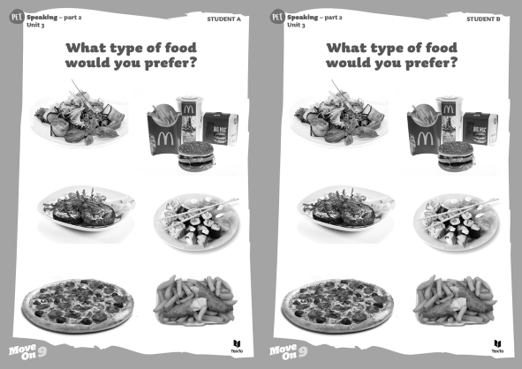
Place the pictures in front of the students.
I’ll say that again.
You and your friends are going to have dinner out. What type of food would you prefer?
All right? Talk together.
Allow the students enough time to complete the task without intervention.
Use prompts only if necessary.
Thank you. Can I have the pictures please?
Back-up prompts:
Pizzeria Jananese restaurant
Fish and Chips Vegetarian restaurant
Pizzeria Fast-food restaurant

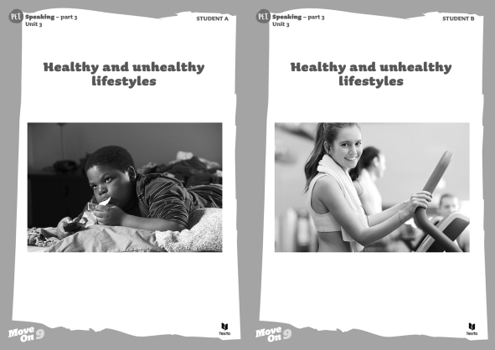
PET KIT – Unit 3
Part 3 (3 min) / Part 4 (3 min)
Speaking Part 3
Say to both students:
Now, I’d like each of you to talk on your own about something. I’m going to give each of you a photograph of teens’ healthy or unhealthy lifestyles. Student A, here is your photograph.
Place part 3 photograph 1 in front of student A.
Please show it to student B, but I’d like you to talk about it. Student B, you just listen. I’ll give you your photograph in a moment. Student A, please tell us what you can see in your photograph.
If there is a need to intervene, prompts rather than direct questions should be used.
Now, student B, here is your photograph. It also shows teens’ healthy or unhealthy lifestyles.
Place part 3 photograph 2 in front of student B.
Please show it to student A and tell us what you can see in the photograph.
Approximately one minute.
Thank you. Can I have the photograph, please?
Back-up prompts:
1. Describe the people you see and what the clothes they are wearing (photograph 1 – a teenage boy /
t-shirt / obese; photograph 2 – a teenage girl / sports clothes / a towel around her neck / slim / light brown hair and brown eyes / smiling / another girl exercising / a man who seems to be the personal trainer…)
2. Describe the place where they are, what they are doing (photograph 1 – the boy lying down on his bed / watching TV / eating junk food; photograph 2 – a gym / exercising on a treadmill /listening to music because we can see the earphones; the personal trainer and the other girl are talking)
3. Describe the background (photograph 1 probably a bedroom; photograph 2 – we can see gym equipment, a girl wearing headphones)
Speaking Part 4
Say to both students:
Your photographs showed teens’ healthy and unhealthy lifestyles. Now, I’d like you to talk together about the lifestyle you would choose and why.
Allow the students enough time to complete the task without intervention.
Use prompts only if necessary.
Thank you. This is the end of the test.
Back-up prompts:
1. Talk about the lifestyle you would choose and why;
2. Talk about the dangers of an unhealthy lifestyle (obesity and lack of exercise can cause serious health problems/diseases such as heart diseases, high blood pressure, diabetes…);
3. Talk about the benefits of a healthy lifestyle (eating a balanced diet and doing physical exercise is very important for our health; eat fewer calories, be more physically active and make healthy food choices…)
PET KIT – Unit 4
Part 2 (2-3 min)
Speaking Part 2
Say to both students:
I’m going to describe a situation to you.
A teenager wants to get a part-time job but he/she hasn’t decided yet what job to choose.
Here is a picture with some ideas to help you.
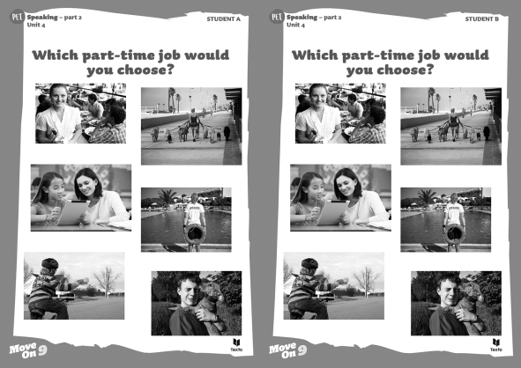
Place the pictures in front of the students.
I’ll say that again.
A teenager wants to get a part-time job but he/she hasn´t decided yet what job to choose.
All right? Talk together.
Allow the students enough time to complete the task without intervention.
Use prompts only if necessary.
Thank you. Can I have the pictures please?
Back-up prompts:
Waiter/waitress Tutor
Pet sitter Lifeguard
Dog walker Do paper rounds

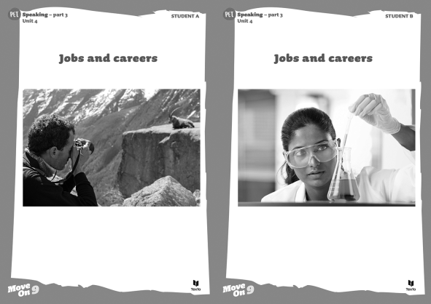
Speaking Part 3
PET KIT – Unit 4
Part 3 (3 min) / Part 4 (3 min)
Say to both students:
Now, I’d like each of you to talk on your own about something. I’m going to give each of you a photograph of people’s jobs. Student A, here is your photograph.
Place part 3 photograph 1 in front of student A.
Please show it to student B, but I’d like you to talk about it. Student B, you just listen. I’ll give you your photograph in a moment. Student A, please tell us what you can see in the photograph.
If there is a need to intervene, prompts rather than direct questions should be used.
Approximately one minute.
Thank you. Can I have the photograph, please?
Now, student B, here is your photograph. It also shows people’s jobs.
Place part 3 photograph 2 in front of student B.
Please show it to student A and tell us what you can see in the photograph.
Approximately one minute.
Thank you. Can I have the photograph, please?
Back-up prompts:
1. Describe the people (animals) you see; (photograph 1 – a man with camera; short curly hair / black shirt photograph 2 – a woman working in a lab, microscope, computer lab equipment / long straight hair / white lab coat and white rubber gloves)
2. Describe the place where they are, what they are doing and their role (photograph 1 – outdoor / mountain / taking a photo of a type of goat; maybe a professional photographer; photograph 2 – lab scientist looking at a microscope / maybe doing some research work)
3. Describe the background (photograph 1 – mountains, snow…)
Speaking Part 4
Say to both students:
Your photographs showed different jobs. Now, I’d like you to talk together about what is important when choosing your future job/career.
Allow the students enough time to complete the task without intervention.
Use prompts only if necessary.
Thank you. This is the end of the test.
Back-up prompts:
1. Talk about the activities it should involve (research, travel, attend meetings, creativity, imagination…)
2. Talk about other important aspects of your future job/career (good salary, good promotion opportunities, makes you happy…)

PET KIT – Unit 5
Part 2 (2-3 min)
Speaking Part 2
Say to both students:
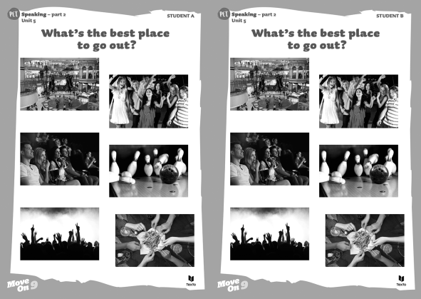
I’m going to describe a situation to you.
You and your BFF are planning to go out next Saturday but you haven’t decided where to go yet. Choose the best place to go out.
Here is a picture with some ideas to help you.
Place the pictures in front of the students.
I’ll say that again.
You and your BFF are planning to go out next Saturday but you haven’t decided where to go yet. Choose the best place to go out.
All right? Talk together.
Allow the students enough time to complete the task without intervention.
Use prompts only if necessary.
Thank you. Can I have the picture please?
Back-up prompts:
Shopping centre Restaurant
Cinema Live concert
Party Bowling alley

PET KIT – Unit 5
Part 3 (3 min) / Part 4 (3 min)
Speaking Part 3
Say to both students:
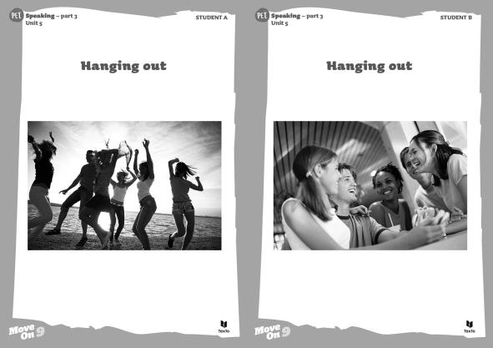
Now, I’d like each of you to talk on your own about something. I’m going to give each of you a photograph of teens hanging out. Student A, here is your photograph.
Place part 3 photograph 1 in front of student A.
Please show it to student B, but I’d like you to talk about it. Student B, you just listen. I’ll give you your photograph in a moment. Student A, please tell us what you can see in the photograph.
If there is a need to intervene, prompts rather than direct questions should be used.
Approximately one minute.
Thank you. Can I have the photograph, please?
Now, student B, here is your photograph. It also shows teens having fun.
Place part 3 photograph 2 in front of student B.
Please show it to student A and tell us what you can see in the photograph.
Approximately one minute.
Thank you. Can I have the photograph, please?
Back-up prompts:
1. Describe the people you see and the clothes they are wearing
2. Describe the place where they are, what they are doing
3. Describe the background
Speaking Part 4
Say to both students:
Your photographs showed teens having fun. Now, I’d like you to talk together about how you usually have fun with your friends.
Allow the students enough time to complete the task without intervention.
Use prompts only if necessary.
Thank you. This is the end of the test.
Back-up prompts:
1. Talk about how you have fun with your friends (where you go, what you do)
2. Talk about what you usually drink and why (alcohol, juice, coke… - alcohol is dangerous and can have serious consequences, teens behave in a stupid way)

