


Placement Tests
Table of specifications 4
Test 1 5
Test 2 9
Test 3 13
Answer Key / Audio Scripts 17

Progress Tests

Unit 1 – Walking the red carpet
Table of specifications 19
Test 1 20
Test 2 24
Test 3 28
Mock PET for Schools Test 32
Answer Key / Audio Scripts 44

Unit 2 – Ready, steady… fit!
Table of specifications 47
Test 1 48
Test 2 52
Test 3 56
Mock PET for Schools Test 60
Answer Key / Audio Scripts 72

Mock PET answer sheet 75
Progress Tests correction criteria 78
Progress Tests correction grid 79

Introduction

More than ever, teachers need to possess a range of resources that will invest the assessment of their students’ work with greater validity and reliability. The present set
of tests is designed to offer teachers opportunities to use resources that prepare students both for internal and external assessment.
These books of tests have two goals. They aim to aid teachers along the “long trail of assessment” by providing resources they can use to assess their students at different stages of learning and, at the same time, help prepare students to face the external assessment challenge they will encounter, namely the PET for Schools Test.
With this in mind, a wide range of tests have been created. First and foremost,
a selection of three placement tests has been created in order to determine where each learner stands and what their specific learning needs are.
Then three progress tests per unit can be used to assess the students’ development; each one can be edited in order to create two different versions of the same test or even to adapt the test to the specific group each teacher is working with. The tests herein include a variety of items and a level of difficulty appropriate for 9th graders. These tests are based on the same texts but are graded in terms of difficulty with the purpose
of suiting three levels of proficiency, thereby catering for all abilities in the classroom. There is also a Mock PET Test for each unit, so that teachers can thoroughly prepare their students for the questions they will encounter in the PET test.
We believe the tests in these brochures can also be viewed as an opportunity
for formative assessment, which will foster reflection and discussion about teaching
and learning between teachers and students. What is more, they can be re-used or edited in order to re-assess particular areas of weakness.

We hope all the materials will prove useful and helpful.

The Team
Isabel Filipe
M.ª Adelaide Rabaça
Paula Simões
© ASA • UPGRADE 9 / TESTS
Table of specifications
Placement Tests

Skills | Contents |  | CEF competences | Types of items | Number  of items | Marks
Skills | Topics | Language
A – Listening | Year 8 syllabus and learning outcomes  (review) | Year 8 syllabus and learning outcomes  (review) | Linguistic  • lexical  • grammatical  • semantic  • orthographic  Pragmatic  • functional  • discoursive | • Multiple choice  • True / false  • Matching  • Sequencing  • Short answer (blank  filling; sentence  completion;  rephrasing)  • Short answer  (text comprehension) | 3 | 20
B – Reading  (250-300  words) |  |  |  |  | 4 | 30
C – Language |  |  |  |  | 3 | 30
D – Writing | Year 8 syllabus and learning outcomes  (review) | Year 8 syllabus and learning outcomes  (review) |  | • Essay (80 words) | 1 | 20

4

A – Listening 20 marks

1. Listen to a text about Anna’s holidays and choose the correct answer (a, b or c). 6 marks (3x2 marks)

1.1. Where did Anna and her family go on holiday?
□ a. Paris. □ b. London. □ c. Porto Santo.

1.2. How many people went in Anna’s family group?
□ a. 8. □ b. 9. □ c. 10.

1.3. How warm was the water?
□ a. 24 ºC. □ b. 22 ºC. □ c. 23 ºC.

2. Listen to what you should do to protect the environment in the country you’re visiting.
For each question, choose a, b or c. 4 marks (4x1 mark)

2.1. If you’re staying for a longer period, the hotel… your towels and sheets daily.
□ a. will never change □ b. doesn’t need to change □ c. should be asked to change

2.2. Unnecessary lights and air conditioning should be...
□ a. paid by the hotel. □ b. turned off. □ c. replaced.

2.3. Waste disposal...
□ a. isn’t important. □ b. is the hotel’s responsibility. □ c. is the tourist’s responsibility.

2.4. Plastic water bottles…
□ a. should be recycled. □ b. can be used again. □ c. must be kept in a cool place.

3. You will hear some advice about how to be a more responsible tourist.
For each question, fill in the missing information. 10 marks (5x2 marks)

Responsible tourist

Help a. Stay in d. …………………………………..…………

Shop at b. Choose local e. …………………………………..…...

Buy products from c.

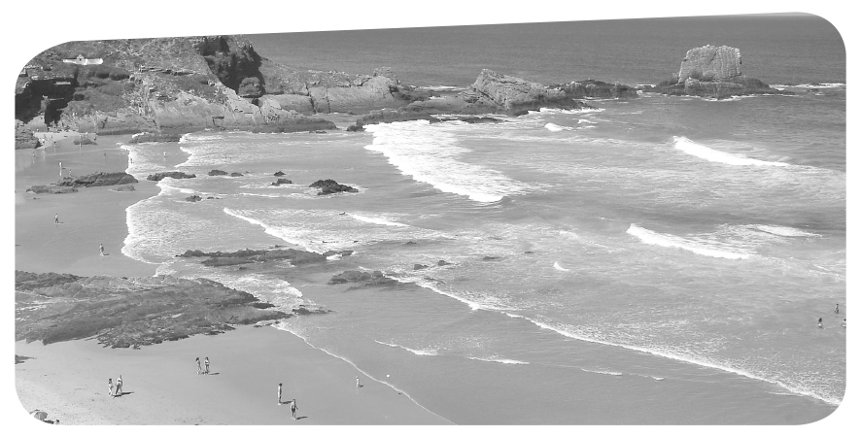
5

10

15

10

10

15

15

10

15

B – Reading 30 marks

1. Have you ever been to Alentejo? What do you know about this region? 4 marks

2. Read the text.

A guide to Portugal’s Alentejo region,
home of Europe’s finest beaches

It’s 7 pm on a warm Saturday night in June and I am in Zambujeira do Mar, a seaside resort on the Alentejo coast. To travel here is to step back in time 40 or 50 years. Life
is very slow and the landscape is very quiet. But that quietness ends suddenly at the
Atlantic Ocean, and the drama begins. Protected by the South West Alentejo and
Costa Vicentina national park, the 100 km of coastline from Porto Covo in the Alentejo
to Burgau in the Algarve is the most beautiful in Europe. And yet few people seem to
know about it.
These beaches are a good two hours’ drive from either Faro or Lisbon airports
and there is no beachside accommodation, but there are some beautiful, independent guesthouses in this area, although they are hidden in the backroads.
Our base was Herdade da Nespereira, a beautiful area of land covered in trees and wild flowers, 13 km inland from Zambujeira. Stepping out of the house in the morning to greet our neighbours – wild horses on one side, donkeys on the other – with nothing but birdsong filling the air, I felt a sense of adventure you normally only get with wild camping.
“When people first arrive, they feel a little anxious, wondering what they’re going
to do the whole time,” Sarah Gredley, the English owner of Nespereira, told me. “But
it doesn’t usually take them long to realise that the whole point of being here is to slow down, to enjoy nature.”

http://www.theguardian.com/travel/2014/jul/12/-sp-portugal-alentejo-region-europe-finest-beaches
(abridged and adapted), accessed in August 2014


3. Find opposites for the words or expressions below in paragraph 1.
6 marks (3x2 marks)

a. go ahead

b. fast

c. gradually

4. Complete the sentences according to the text. 8 marks (4x2 marks)

4.1. The weather was...
□ a. better than the writer expected.
□ b. so hot they could only get out in the evening.
□ c. very pleasant.

4.2. The writer states that...
□ a. there has been immense development for the past 40 years in the Alentejo.
□ b. the Alentejo is a very busy region.
□ c. life is very calm and peaceful there.

4.3. In the writer’s opinion, ...
□ a. the Alentejo coast is extremely well-known in Europe.
□ b. people don’t know much about the wonderful beaches there.
□ c. all tourists should visit the Alentejo.

4.4. According to the writer, the thing about the Alentejo is that...
□ a. it takes a long time to get there.
□ b. there are too many hotels near the beaches.
□ c. the quality of the guesthouses is not very good.

5. Answer these questions about the text. 12 marks (4x3 marks)

5.1. Do you think the writer met many holidaymakers in Zambujeira? Why/why not?

5.2. What was the place they were staying at like?

5.3. What is people’s first reaction when they get there? Why?

5.4. What makes them change their mind?

C – Language 30 marks

1. Complete the text with the words in the box. One isn’t used. 10 marks (5x2 marks)

Northern Portugal offers some great surfing. Join us for a surf camp or surfari and we’ll show you beaches where there are fantastic waves a. ……………… no crowds. Our team knows all the best spots in the region around Porto, b ……………… you can be sure to have a great time. c. ……………… you’re a beginner d. ……………… want to improve your surfing, we e. ……………… offer surfing lessons. The lessons take place on the beaches of Matosinhos or Leça and last for one hour.
www.portugal-sport-and-adventure.com/surfing-north-portugal.html (abridged and adapted), accessed in August 2014

2. Fill in the gaps with the correct form of the words in brackets. 10 marks (5x2 marks)

Come and discover Madeira’s Canyons! Enjoy the majestic nature of these a. ………………… (fascinate) places, ideal for those who love adventure and b. ……….……………… (excite). Discover the deepest gullies, the steepest slopes and the most c. …………………………… (amaze) waterfalls, which can only be d. …………..…………… (reach) by the most e. …………………..…… (fear).
http://www.madeiraoutdoor.com/en/1/canyoning (abridged and adapted), accessed in August 2014

3. Fill in the gaps using the correct conditional: type 0 or 1. 10 marks (10x1 mark)

a. If you ……………… (be) interested in water sports, you ……………… (enjoy) visiting Ferreira do Zêzere and the nearby river.
b. I think you ……………… (get) to know the area quite well if you ……………… (stay) for about three days.
c. If visitors ……………… (not drive), they ……………… (come) by bus or by train.
d. If you ……………… (feel) tired, you ……………… (need) a holiday.
e. You ……………… (love) the people and the river if you ……………… (visit) Ferreira do Zêzere.
http://comeniusletstravel.blogspot.pt/2012/06/water-sports-in-ferreira-do-zezere.html (abridged and adapted), accessed in August 2014

D – Writing 20 marks

Write a text of about 80 words expressing your opinion on the best activities tourists/visitors
can find in the area where you live.
Don’t forget to mention which you find most interesting and why.
or
also
where
but
if
so
© ASA • UPGRADE 9 / TESTS
8

A – Listening 20 marks

1. You will hear Thomas talking about different sports.
Listen to part 1 and choose the correct answer (a, b or c). 6 marks (3x2 marks)

1.1. How many years did Thomas’s father play futsal?
□ a. 1. □ b. 3. □ c. 4.

1.2. How many players are there in a futsal team?
□ a. 5. □ b. 6. □ c. 3.

1.3. Which sport did Thomas’s mother take part in?
□ a. Horse riding. □ b. Swimming. □ c. Fencing.

2. Listen to part 2 and choose the correct answer. 9 marks (3x3 marks)

2.1. Thomas tried a new sport because…
□ a. his cousin invited him. □ b. his parents told him to do so. □ c. he liked it.

2.2. After the new experience…
□ a. his parents were happy. □ b. nothing happened. □ c. something changed.

2.3. His cousin, Peter…
□ a. was interested in sports. □ b. played tennis with him. □ c. didn’t like swimming.

3. Now listen to part 3 and tick () the two sentences that are mentioned in the text. 5 marks (5x1 mark)

□ a. I always go kayaking at seven o’clock in the morning.
□ b. I think what I like most about kayaking is the sense of freedom.
□ c. My father drives to the club every morning.
□ d. I would like my brother to paddle with me.
□ e. I’m the one who is responsible for making my kayak move in the right direction.

Summer programme

For an athlete now into his third decade of international competition, windsurfer João Rodrigues is proof that age really is no barrier to success.
A native of Madeira, Rodrigues was approaching the age of 40 when, on June 14 2012, he fulfilled a life-long dream of entering the Guinness Book of World Records. He broke the record for the longest non-stop ocean crossing by a windsurfer when he sailed across the
open Atlantic Ocean between Madeira and the smaller island of Selvagem Grande, covering the 296-kilometre distance in just over 10 hours.
He has always been proud of his roots and even
more so when it was announced that his home town
of Funchal would host the European Windsurfing Championships in February 2012, and that Rodrigues himself would be the ambassador for the event.
Rodrigues actually made his Olympic debut way back at Barcelona 1992, where he finished 23rd. He finished seventh in Atlanta (1996), 18th in Sydney (2000) and sixth in Athens (2004).
He finished 11th at the Olympic regatta in Qingdao, China, and has continued to represent his country since then. He now has over 120 appearances at international
level to his name and has come a long way from the early days, when he first started windsurfing at the age of nine and raced in his first competitions at 11.
“When you’re surrounded by water, it is obvious to windsurf,” he once said about why he took up the sport. Windsurfing is simply part of his life.

http://sport.uk.msn.com/olympics-2012/athletes/portugal-joao-rodrigues
(abridged and adapted, accessed in August 2014

5

10

15

20

25

Born: 01/11/1971
Place of birth: Santa Cruz, Madeira
Event: Windsurfing
Previous Olympics: 5
Previous medals: 0
B – Reading 30 marks

1. Choose the best option to complete the sentence. 5 marks

The Olympic Games…
□ a. always take place in Greece.
□ b. have never taken place in Asia.
□ c. take place every four years.

2. Read the text.
proof (l. 2) a.
barrier (l. 3) b.
fulfilled (l. 5) c.
non-stop (l. 7) d.
roots (l. 12) e.
1. obstacle

2. continual

3. origins

4. friend

5. accomplished

6. evidence
3. Match the sentences with the correct paragraph. 10 marks (5x2 marks)

□ a. A dream come true.
□ b. Early start.
□ c. First Olympics appearance.
□ d. Becoming a sports ambassador.
□ e. Competing after thirty years.

4. Match the words from the text with their synonyms. One isn’t used. 5 marks (5x1 mark)

5. Answer these questions about the text. 10 marks (4x2,5 marks)

5.1. Why did João Rodrigues get into the Guinness Book of World Records?

5.2. What is his best result in the Olympics?

5.3. How successful has João Rodrigues been? Explain.

5.4. Do you think he still enjoys windsurfing? Why?

If Vanessa Fernandes competes in the a.
Olympic Games again,

Vanessa says an athlete feels the need b.
to go on competing

She will become one of the best c.
Portuguese athletes ever

If Vanessa works and trains very hard d.
1. if she gives an interview.

2. she will overcome all the obstacles in her
sports life.

3. if he she wins an Olympic medal.

4. she will go for gold.

5. if she gets the gold medal .
12
C – Language 30 marks

1. Fill in the gaps with an appropriate verb form: present simple or present continuous.

10 marks (4x2,5 marks)

Carlos Lopes, the first Portuguese Olympic Champion, a. …………………………. (appear) in the 14th episode of the season 12 of The Simpsons, while Homer b. …………………………. (watch) great moments of the Olympic history. Lopes c. ……………………. (inspire) Homer, who d. …………………… (claim) to be almost his age, to enter the Springfield Marathon. Lopes was 37 when he won the marathon. At least Homer pronounces his name correctly in Portuguese (Lopes).
http://en.wikipedia.org/wiki/Carlos_Lopes (abridged and adapted), accessed in November 2014

2. Complete the sentences with the past simple. 10 marks (5x2 marks)

Joana Vasconcelos, who a. …………………………………. (be) born on February 22, 1991 in Porto, Portugal, is a Portuguese sprint canoer who b. ………………………………….…. (compete) in 2010 for the first time. She c. …………………………. (win) a bronze medal in the K-2 200 metres event at the 2012 European Championships in Zagreb. She currently represents Benfica.
Joana d. …………………..…………. (qualify) for London 2012 in the World Championships.
She e. …………………………. (finish) 6th in the 2012 Summer Olympics in the Women’s K-2 500 metres race with Beatriz Gomes and 6th in the Women’s K-4 500 metres with Teresa Portela, Helena Rodrigues and Beatriz Gomes.
http://en.wikipedia.org/wiki/Joana_Vasconcelos_(canoeist) (adapted), accessed in August 2014

3. Match the clauses on the left with those on the right to make sentences.
One is not used. 10 marks (4x2,5 marks)

D – Writing 20 marks

Write a text of about 80 words expressing your opinion about sports.
Do not forget to mention some of its benefits and disadvantages.
© ASA • UPGRADE 9 / TESTS

A – Listening 20 marks

1. Listen to John talking about this new school year and choose the correct answer (a, b or c).

6 marks (3x2 marks)
1.1. Where did John live before?
□ a. The countryside. □ b. A caravan Park. □ c. A big city.

1.2. How many places did John live in before coming to the new town?
□ a. 2. □ b. 1. □ c. 3.

1.3. What day does the family get together?
□ a. Sunday. □ b. Saturday. □ c. Monday.

2. Listen to the text again and say if the sentences are true (T) or false (F). 6 marks (3x2 marks)

□ a. John doesn’t say how old he is.

□ b. The fact that he’s changing school doesn’t really affect him.

□ c. His parents decided not to move before their holidays.

3. Choose the correct answer. 8 marks (4x2 marks)

3.1. John misses…
□ a. the city. □ b. his friends. □ c. his home.

3.2. He feels the change in their life…
□ a. was very negative. □ b. was uncertain. □ c. was positive.

3.3. His parents get back home…
□ a. earlier than before. □ b. even later than before. □ c. at exactly the same time.

3.4. As a consequence of his new life, John…
□ a. is able to do sports. □ b. had to give up sports. □ c. doesn’t want to do sports anymore.

5
10
15
20
Following my heart

I love going to school and doing all the work there: the classes, the tests, the presentations and the group work.
I also enjoy talking to my colleagues during the breaks, sharing little secrets about our lives and calling each other at the end of another school day to check what the homework is. Even if we only really want to chat for another minute or two! Yes, school has been a great experience!
The year which is about to start is even more significant for me! For the first time I’m going to be able to do what I’ve always wanted to do: to dance at school. In fact, I’m going to attend two different schools!
In the morning I’m going to attend a “normal” school. I’ll have to study all the subjects that pupils in year 9 have to. Since I’m doing year 9, this should be no surprise. The difference is that while my colleagues will stay on at school to do their Physical Education and Computer Studies lessons, I am going to study subjects which are
directly related to Dance, at the local Dance School.
While I continue with school work, I can also work on different artistic activities related to Dance, as a complement to my education. More importantly, I can use this experience in a professional way in the future. I believe this is a great benefit for all of us who feel a special love for Dance. It’s also possible for pupils to take up Music, Drama and Art, depending on their area of preference. The school has two main objectives:
to offer a good education with regard to different artistic areas and, at the same time,
help prepare students to take up a career in any of these areas, or simply develop their interest and appreciation of the Performing Arts.

3. Re-read the first paragraph and complete the table. 8 marks (4x2 marks)

a. type of school work
b. other good things about school
c. reasons for phone calls
d. feelings about school

B – Reading 30 marks

1. Choose the best option to complete the sentence. Education is… 4 marks
□ a. a good behaviour. □ c. receiving instruction,
especially at a school or university.
□ b. reading a lot of books.

2. Read the text.

Sarah feels enthusiastic a.
about the new school year

She is going b.

Sarah’s mornings c.

She will d.
1. will be spent at school.

2. because she is going to Dance School.

3. are going to be fully dedicated to dancing.

4. to attend two different schools.

5. study exactly the same subjects
as her 9th year colleagues.
4. Match the sentence halves according to the information in the text. One isn’t used.
8 marks (4x2 marks)

5. Answer the following questions. 10 marks (4x2,5 marks)

5.1. What does she mean when she says a “normal” school?

5.2. Why does she say that attending Dance School is a “great benefit” for pupils?

5.3. Do you think Sarah made a good decision? Why?

5.4. Is school a good experience to you? Why/why not?

C – Language 30 marks

1. Choose the correct word to fill in the gaps. 8 marks (4x2 marks)

The film Billy Elliot centres on the character of an 11-year-old boy, a. …………….……………… love of dance and his hope to become a professional ballet dancer. Billy b. ……………….…………with his widowed father, Jackie, and his older brother, Tony, both coal miners out on strike, and c. ………………………….……his invalid grandmother, d. ………………………once dreamt of being a professional dancer in Durham.
http://en.wikipedia.org/wiki/Billy_Elliot (abridged and adapted) accessed in November 2014

 | 1. | 2. | 3.
a. | her | his | him
b. | lives | lived | has lived
c. | but | also | because
d. | which | when | who

16
2. Choose the correct option. 12 marks (6x2 marks)

a. Sarah might / must / doesn’t have to work very hard to get good marks.

b. Billy mustn’t / didn’t have to / couldn’t tell his brother about ballet because he wouldn’t understand.

c. You can / shouldn’t / mustn’t succeed if you work hard.

d. Sarah mustn’t / doesn’t have to / may be selected to take part in the new musical the Dance School is organising.

e. Fourteen years after Billy started ballet at the local gym, his father might / could / may see him dancing in London.

f. A ballet dancer should / can’t / mustn’t dedicate most of his/her time to practising.

3. Put the words in order to form sentences using the past simple. 10 marks (4x2,5 marks)

a. young / start / she / ballet / practising / when / Sarah / be / very

b. a / Sarah / last / year / school / attend / normal

c. before / practise / on / ballet / she / the / year / Saturdays

d. the / enjoy / school / going / studying / to / past / in / she / and / ?

D – Writing 20 marks

Write a text of about 80 words in which you explain what aspects you enjoy most about school.
Don’t forget to mention your favourite activities and subjects.
© ASA • UPGRADE 9 / TESTS


Placement tests

Answer Key

Test 1

A – Listening
1.1. c; 1.2. b; 1.3. a.
2.1. a; 2.2. b; 2.3. c; 2.4. b.
3. a. the local economy; b. local markets;
c. roadside vendors; d. locally owned hotels;
e. guides and drivers.

B – Reading
1. Personal answer.
3. a. step back (l. 2); b. slow (l. 3); c. suddenly (l. 3).
4.1. c; 4.2. c; 4.3. b; 4.4. a.
5.1. No, he didn’t because the text says Zambujeira is
very quiet.
5.2. It was a very peaceful and wild place, where
nature was fully preserved.
5.3. At first, visitors feel somewhat nervous because
they don’t know what they can do there.
5.4. The realisation that it’s the perfect place to relax
and enjoy the natural beauty around them.

C – Language
1. a. but; b. so; c. If ; d. or; e. also.
2. a. fascinating; b. excitement; c. amazing;
d. reached; e. fearless.
3. a. are… will enjoy; b. will get… stay; c. don’t
drive… come; d. feel… need; e. will love… visit.

Test 2

A - Listening
1.1. c; 1.2. a; 1.3. b.
2.1. a; 2.2. c; 2.3. a.
3. b; e.

B – Reading

1. c.
3. a. 2nd; b. 5th; c. 4th; d. 3rd; e. 1st.
5. a. 6; b. 1; c. 5; d. 2; e. 3.
5.1. He got into the Guiness Book of World Records
because he sailed between Madeira and Selvagem
Grande without stopping, for 10 hours.
5.2. The 6th position in Athens 2004.
5.3. He has been extremely successful because he has
participated in many international competitions and
has won important prizes.
5.4. Yes, because it is a very important part of his
life and he still continues to windsurf after so many
years.

C - Language
1. a. appears; b. is watching; c. inspires; d. claims.
2. a. was; b. competed; c. won; d. qualified;
e. finished.
3. a. 4; b. 3; c. 5; d. 2.

Test 3

A - Listening
1.1. c; 1.2. b; 1.3. a.
2. a. T; b. F; c. T.
3.1. b; 3.2. c; 3.3. a; 3.4. a.

B – Reading
1. c.
3. a. classes, tests, presentations and the group work;
b. talking to colleagues during the breaks, sharing
little secrets; c. check the homework; chat; d. great
experience.
4. a. 2; b. 4; c. 1; d. 5.
5.1. She means a school where people get a regular
education, without any professional or artistic
classes.
5.2. It is a great benefit for pupils because they have
the opportunity to do what they enjoy most and, at
the same time, start the preparation for a future
career.
5.3. Yes, because she can take part in the two things
that matter to her: her education and her dancing,
which she loves.
5.4. Personal answer.

C – Language
1. a. 2; b. 1; c. 2 ; d. 3.
2. a. must; b. couldn’t; c. can; d. may; e. could;
f. should.
3. a. Sarah was very young when she started
practising ballet.
b. Last year Sarah attended a normal school.
c. She practised ballet on Saturdays the year before.
d. Did she enjoy going to school and studying in
the past?

AUDIO SCRIPTS

Test 1

CD 4 – Track 1

Summer holidays
Louise: Where did you spend your summer holidays, Anna?
Anna: I visited the island of Porto Santo, in Madeira,
with my whole family: my parents, my grandmother
and grandfather and my four brothers and sisters.
Louise: Did you have a good time?
Anna: Oh yes. We spent most of our time on the beach.
Louise: What about the temperature of the water?
Anna: It was always warm. My Dad said it was about
24 °C every day.
Louise: It must have been wonderful to swim there!
Anna: Indeed it was.
Louise: Did you fly to Porto Santo?
Anna: Oh no, we didn’t. We took the ferry from
Funchal.
Louise: Did it take long to get there? What did you do
on the boat?
Anna: About two and a half hours. We watched a film
in the cinema. Before we knew it, we were in Porto
Santo.

CD 4 – Track 2

Are you a responsible tourist?
• Go green. This could start in your hotel with towels
and bed sheets. If you are staying longer, ask them not
to change your sheets and towels every day. Turn off
lights and air conditioning when not needed and think
about your waste disposal. Reuse plastic water bottles. Don’t buy products made from endangered species.


Placement tests

CD 4 – Track 3

• Go local. Support the local economy. Buy from local
markets and roadside vendors. Eat in local restaurants.
Stay in locally owned hotels. This keeps money in the
economy and helps local people keep their jobs.
• Use local guides and drivers. Not only is it a great
opportunity to interact with the locals and make
friends, but it encourages local people to learn about
their history and culture and take pride in it.

http://thesoriamoria.com/responsible-tourism/be-a-responsible-tourist/
(adapted and abridged), accessed in August 2014

Test 2

CD 4 – Tracks 4, 5 and 6

My interest in sports
[Part 1]
I have never been very interested in sports until very
recently. My father and my mother enjoyed sports
very much. My father played futsal – a type of football
played by five players – for four years. My mother
was a good swimmer and participated in many
competitions. They always tried to encourage me to
choose a sport to do, but I wasn’t really interested.

[Part 2]
My perspective on sports changed when my oldest
cousin, Peter, from Porto, invited me to go kayaking
with him during the holidays. He has always been a
very enthusiastic sportsman. He took part in local and
national competitions during the years he practised
kayaking, and he still loves this sport very much.
He also played tennis, football, futsal and table tennis
when he was younger and I think he did swimming
too. Kayaking turned out to be a very good experience.
Everyone was friendly and all we had to do was take
the kayak into the sea and paddle. For the first time
I really had a good time doing sport.

[Part 3]
I still go kayaking three times a week. I think what
I like most about kayaking is the sense of freedom.
I go kayaking with a team of colleagues and the coach,
but I’m the one who is responsible for making my
kayak move in the right direction and this gives me
great pleasure and satisfaction. It’s true I don’t like
it very much when we have to go to the gym, but no
sports is perfect, is it?

Test 3

CD 4 – Track 7

John’s new school year
Very soon a new school year will start and I have to
say I feel a bit nervous. This is because I had to change
school this year. I lived in a big city all my life, but
now my family and I have moved to a much smaller
location. We now live in a small city. We’ve just moved
because we had to wait till after the holidays. So far it’s
been a great experience! The city isn’t as noisy or busy
as the one I lived in before.
I’m sorry I had to leave some of my friends behind
but there are good points too. Since it’s much easier to
move around, it’s much faster for my parents to get
home after work, so I can do sports a few days a week,
which was completely impossible in the city I lived in
before. Another good thing is that my family is now
much closer and I see my grandparents, uncles and
aunts and cousins every day. We all have a family
meal together on Sunday, which I like very much.
Table of specifications
Progress Tests (Unit 1)

Skills | Contents |  | CEF competences | Types of items | Number  of items | Marks
Skills | Topics | Language
A – Listening | VIPs  Life is a stage  Storytellers | Grammar  • Past simple and  past continuous  • Present perfect  • Past simple and  present perfect  Vocabulary  • Celebrities and  famous people  • Showbiz and  entertainment  • Writers and  books | Linguistic  • lexical  • grammatical  • semantic  • orthographic  Pragmatic  • functional  • discoursive | • Multiple choice  • True / false  • Matching  • Sequencing  • Short answer (blank  filling; sentence  completion;  rephrasing)  • Short answer  (text comprehension) | 3 | 20
B – Reading  (200-300  words) |  |  |  |  | 4 | 30
C – Language |  |  |  |  | 4 | 30
D – Writing | VIPs  Life is a stage  Storytellers |  |  | • Essay (80 words) | 1 | 20

19
© ASA • UPGRADE 9 / TESTS
A –Listening 20 marks

1. Listen to a text about Sara Sampaio and answer the question. 5 marks

1.1. What do you hear?
□ a. Friends chatting. □ b. An interview. □ c. An advertisement.

2. Listen again and choose the correct answer (a, b or c). 10 marks (5x2 marks)

2.1. Who is Sara Sampaio?
□ a. A model. □ b. An actress. □ c. A writer.
2.2. Where does she live?
□ a. In Lisbon. □ b. In New York. □ c. In Paris.
2.3. How old is she?
□ a. 22. □ b. 20. □ c. 23.
2.4. Sara’s fashion week is going…
□ a. really nice. □ b. really well. □ c. really fine.
2.5. The only stress she has is getting…
□ a. prepared for shows. □ b. dressed for dinner □ c. ready for parties.

3. Listen to part 2 of the text and match the words with the expressions they are associated to.
One isn’t used. 5 marks (5x1 mark)
winter a. 1. a cute dress
summer b. 2. a leather jacket
sometimes c. 3. red and blue
colours d. 4. jeans or shorts
fall e. 5. don’t know how to dress
6. black and white
5

10

15

B – Reading 30 marks

1. Tick () the correct definition of actor/actress. 6 marks
□ a. A person who directs the film.
□ b. A person who plays a character.
□ c. Someone who manages the finances and the marketing of a film.

2. Read the text.

The greatest film role ever cast

The Portuguese actor Diogo Morgado plays the part of Jesus in the Son of God. He is the latest film actor to play the role. Mr Morgado is not so dark
as historians might wish, but he could play the part of a strong or a gentle character, one of the producers said.
Diogo Morgado, who is very similar to Brad Pitt, plays the lead role.
“The best story is the story that gets to the most people. If the message of Jesus was love, hope and compassion, and I can bring that to more people
by being a more appealing Jesus, I am happy with that,” Mr Morgado said.
It took the producers a while to find Mr Morgado. They were just weeks from filming, and they still didn’t know who was going to play the role.
“We wanted an actor who was strong and charismatic, but who could also
be a carpenter,” Ms Downey, one the producers, said.
Mr Burnett, the other producer, said the intention was to create a story that was true to the Gospels but that also showed the courage and terror
of the time Jesus lived in.

http://www.nytimes.com/2014/02/16/movies/heading-off-criticism-when-picking-an-actor-to-play-jesus.html
(abridged and adapted), accessed in November 2014

3. Match the definitions with the words/expressions in bold in the the text. 6 marks (4x1,5 marks)

a. to perform a character in a film or a play
b. the main character in a film
c. a man whose profession is acting on the stage, in films, or on television
d. a person in a novel, play or film.

Diogo Morgado a. 1. much like a famous American actor.
He looks very b. 2. is a Portuguese actor.
Morgado feels that c. 3. the producers to decide who was going to play Jesus.
It was not easy for d. 4. the more people a story gets to, the better.
4. Match the sentence halves according to the text. 6 marks (4x1,5 marks)

5. Choose the correct option. 12 marks (3x4 marks)

5.1. What is the main difference between Morgado and Jesus according to historians?
□ a. Morgado is too blonde. □ b. His skin is very dark. □ c. Morgado is Portuguese.

5.2. What did the producers want the actor playing the part of Jesus to be like?
□ a. Tall and slim. □ b. Attractive and blonde. □ c. Strong and charismatic.

5.3. One of the producers said they wanted the film to be about…
□ a. the Bible gospels. □ b. Diogo Morgado. □ c. a fictional story.

C – Language 30 marks

1. Choose the correct option each time. 10 marks (5x2 marks)

Morgado a. …………..…...……. his career at the age of fifteen when he b. ………....…………. the cast of a top rated television series. Diogo c. ……………………………..……. again and again in Portuguese television and d. ………………………. over 15 roles. Diogo’s film credits include a performance in the title role as Portuguese dictator Salazar. Diogo is also a passionate theatre actor who e. ……………...…………. lead roles in prestigious plays such as Skylight and The royal hunt to the sun.
http://www.imdb.com/name/nm0604430/bio?ref_=nm_ov_bio_sm (adapted and abridged), accessed in November 2014

 | 1. | 2. | 3.
a. | begins | was beginning | began
b. | joined | join | was joining
c. | has worked | is working | was working
d. | was playing | has played | played
e. | has had | was having | has


2. Choose the option to complete the sentences below. 10 marks (5x2 marks)

a. Portuguese television showed / has shown the Son of God last year.
b. The film had / has subtitles in Portuguese.
c. Diogo Morgado appeared / was appearing in this film.
d. The producers were inviting / invited Morgado to play the lead role.
e. Diogo Morgado was playing / played the role of Jesus in Son of God.

3. Choose the correct option. 5 marks (5x1 mark)
a. I have already / since watched Morgado’s film Son of God.
b. The series “The Messenger” hasn’t been shown on Portugueses TV never / yet.
c. Many artists have never / ever had the opportunity to work in the US.
d. Portuguese television producers have just / ever decided to start a new series.
e. That actress has recently / for got married to an American stuntman.

4. Complete the sentences with the present perfect or the past simple. 5 marks (5x1 mark)

a. Diogo Morgado ………………… (play) the part of Jesus in the fim Son of God.
b. I ………………… (recently / watch) the film Son of God.
c. I (not watch) the mini-series The Bible, which they ………………… (film) in Morocco.
d. Diogo Morgado ………………… (not make) a Hollywood blockbuster yet but hopes to in the future.

D – Writing
20 marks
Read the email from your friend Jill.
Write an email (about 80 words) to Jill and answer her questions.

From: Jill
I’m so glad you have agreed to help me with my English project about famous people.
Who is your favourite actor or actress?
What is his/her nationality?
Name two reasons why you like this celebrity.

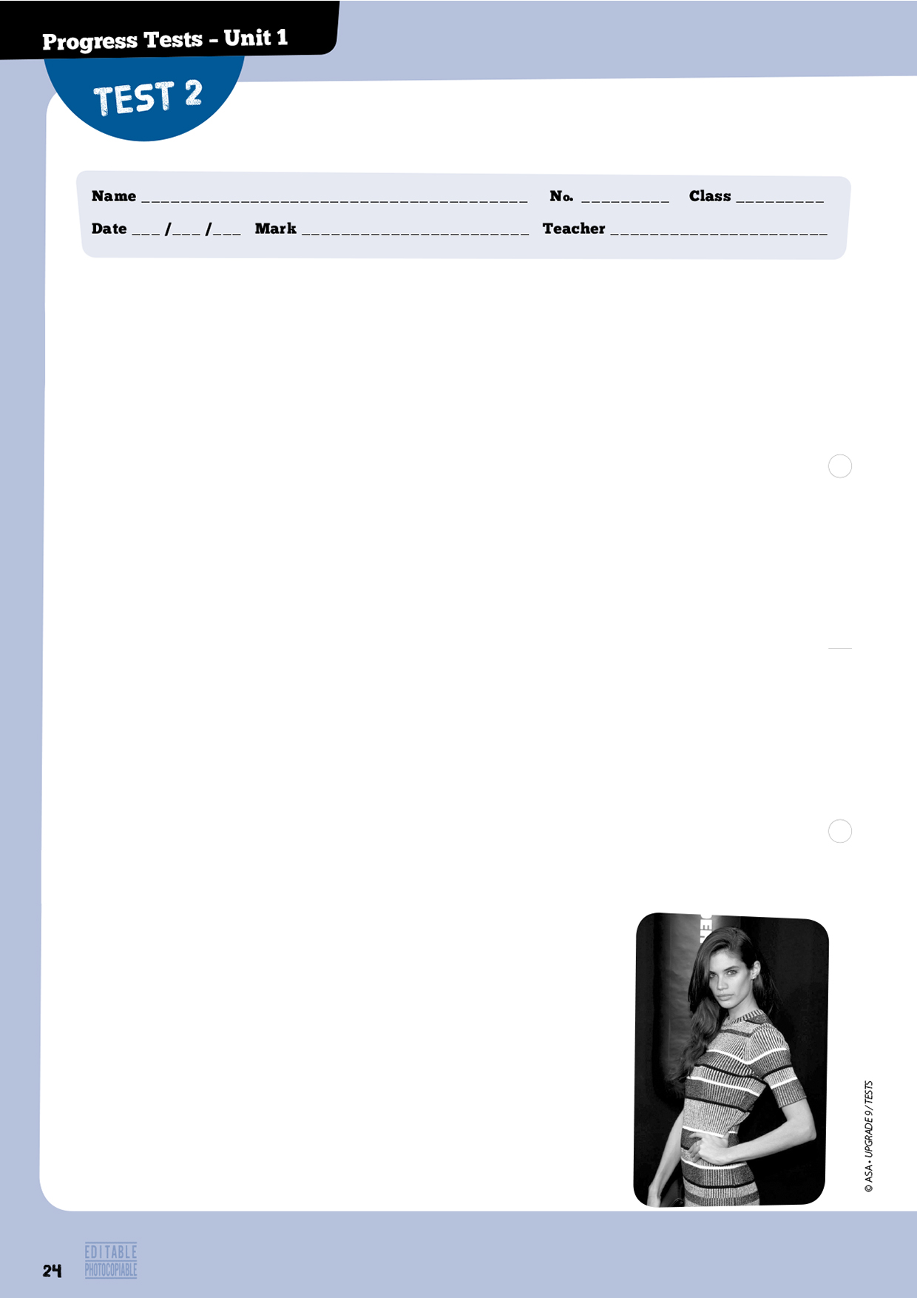
A – Listening
20 marks

1. Listen to a text about Sara Sampaio and answer the question. 5 marks

1.1. What do you hear?
□ a. Friends chatting. □ b. An interview. □ c. An advertisement.

2. Listen again and choose the correct answer (a, b or c). 5 marks (5x1 mark)

2.1. Who is Sara Sampaio?
□ a. A model. □ b. An actress. □ c. A writer.
2.2. Where does she live?
□ a. In Lisbon. □ b. In New York. □ c. In Paris.
2.3. How old is she?
□ a. 22. □ b. 20. □ c. 23.
2.4. Sara’s fashion week is going…
□ a. really nice. □ b. really well. □ c. really fine.
2.5. The only stress she has is getting…
□ a. prepared for shows. □ b. dressed for dinner. □ c. ready for parties.

3. Listen to part 2 of the text and complete the table about what Sara
wears in note form. 10 marks (5x2 marks)

a. winter
b. summer
c. sometimes
d. colours
e. fall essential

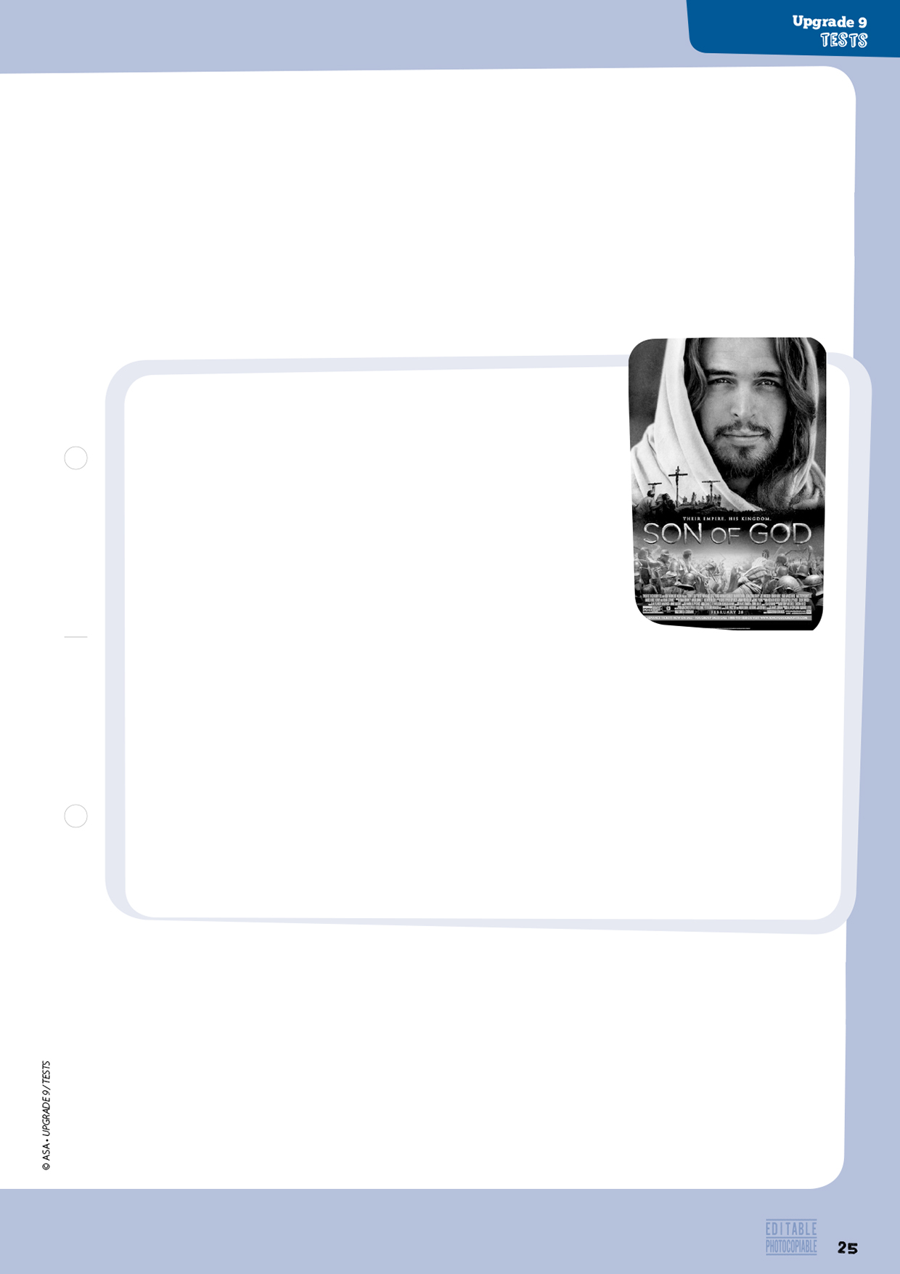
The greatest film role ever cast

The Portuguese actor Diogo Morgado plays Jesus in the Son of God. He is the latest film actor to play the part. Mr Morgado is not so dark as historians might wish, but he could play the part of
a strong or a gentle character, one of the producers said.
Diogo Morgado, who looks a bit like a young Brad Pitt, plays the lead role. “The best story is the story that gets to the most people.
If the message of Jesus was love, hope and compassion, and I can bring that to more people by being a more appealing Jesus, I am happy with that,” Mr Morgado said.
The film’s main producers, Mark Burnett, and his wife, the actress
Roma Downey, worked together to make the hugely successful 2013 History channel mini-series The Bible. It took the producers a while to find Mr Morgado. The Bible was just weeks from filming, and they still hadn’t filled the role. “We wanted an actor who was strong and charismatic, but who could also be a carpenter,” Ms Downey said. “Diogo is tall and well-built. He has a strong presence.”
The idea for the film came up during filming of The Bible. As they were reviewing some scenes, Mr Burnett said that he and Ms Downey “realised how incredible this Jesus footage was looking with Diogo,” so in the end casting for the film was easy.
Mr Burnett said the intent was to create a story that was true to the Gospels but that also captured the courage and terror of the era.

http://www.nytimes.com/2014/02/16/movies/heading-off-criticism-when-picking-an-actor-to-play-jesus.html?
(abridged and adapted), accessed in November 2014

5

10

15

20

B – Reading 30 marks

1. Tick () the correct definition of actor. 5 marks

□ a. A person who directs the film.
□ b. A person who plays a character.
□ c. someone who manages the finances and the marketing of a film.

2. Read the text.

3. Match the definitions with the words/expressions in bold in the text. 5 marks (5x1 mark)

a. attractive
b. the choice of actors for a part
c. to perform a character in a film or a play
d. a succession of regular TV programmes
e. the main character in a film

was leaving
has had
began
has played
was playing
joined
has worked
1. much like a famous American actor.
2. is a Portuguese actor.
3. the producers to decide who was going to play
Jesus in the film.
4. before the producers chose the actor.
5. the more people a story affects, the better.
6. Diogo was exactly the type of actor
they were looking for.
7. the film said Morgado could play different types
of characters.
Diogo Morgado a.
One of the producers said b.
He looks very c.
Morgado feels that d.
It was easy for e.
4. Match the halves to form sentences according to the text. Two aren’t used. 10 marks (5x2 marks)

5. Complete the sentences according to the text. 10 marks (4x2,5 marks)

a. The main difference between Morgado and Jesus, according to historians, is
b. The two producers of the film were husband .
c. The producers wanted the actor playing the part of Jesus to be .
d. One of the producers said they wanted the film to be about………………………………………………….…….

C – Language 30 marks

1. Complete the text with the verb forms on the right. Two aren’t used. 10 marks (5x2 marks)

Morgado a. ………………………….….. his career at the age of fifteen when he b. …………………………….. the cast of a well-known television series. Diogo c. …………………………….…….. again and again in Portuguese television and d. …………………………..……….. over 15 roles. Diogo’s film credits include a performance in the title role of Portuguese polititian Salazar.
Diogo is also a passionate theatre actor who e. ……………….. lead roles in prestigious plays such as Skylight and The royal hunt to the sun.

http://www.imdb.com/name/nm0604430/bio?ref_=nm_ov_bio_sm (abridged and adapted),
accessed in August 2014

2. Choose the correct verb form to complete the sentences below. 5 marks (5x1 mark)

a. Diogo Morgado appeared / was appearing in The Bible. Then the film producers invited / were inviting him to play the lead role in Son of God.
b. The film became / was becoming a major success.

c. Diogo accepted / was accepting an invitation from Oprah Winfrey, the famous American TV celebrity, while he was working / worked in the USA.

3. Choose the best word for each space.
5 marks (5x1 mark)
Newspapers and magazines have been writing about young Portuguese artists and actors a. …………….… some time. Diogo Morgado has become famous b. ……………… he played the part of Jesus. He has c. …………….… returned to Portugal and has been working on a new television project d. ……………….….… the past few months. Morgado has been one of the best known Portuguese actors of his generation in the USA e. ………………...… 2013.
http://www.imdb.com/name/nm0604430/bio?ref_=nm_ov_bio_sm (adapted and abridged), accessed in November 2014

 | 1. | 2. | 3.
a. | recently | for | never
b. | already | ever | since
c. | since | for | just
d. | for | since | lately
e. | recently | for | since

4. Complete the sentences with the present perfect or past simple. 10 marks (5x2 marks)

a. I ………….…………….…… (not watch) the mini-series The Bible, which they ……….…………… (film) in Morocco but I ………………… (recently / watch) the film Son of God.
b. Diogo ………………..……… (not make) a Hollywood blockbuster yet but hopes to in the future.
c. The producers selected Diogo Morgado for the cast after he ……………..………… (play) the part of Jesus.

D – Writing 20 marks

Read the email from your friend, Jill.
Write an email (about 80 words) to Jill and answer her questions.

From: Jill
I’m so glad you have agreed to help me with my English project about famous people.
Who is your favourite actor or actress? What is her/his nationality?
Name two reasons why you like him/her.



A — Listening 20 marks

1. Listen to part 1 of a text about Ruben Correia, a young Portuguese writer,
and tick () the correct option. 5 marks (2x2,5 marks)

1.1. Topic of the second book.

1.2. Topic of book four.

2. Listen to part 2 and answer the questions. 5 marks (5x1 mark)

2.1. When did he start enjoying writing?
□ a. When someone read his texts. □ b. When he learned to read and write. □ c. At the age of 6.
2.2. What types of texts did he start writing?
□ a. Novels. □ b. Diaries. □ c. Short stories.
2.3. Who encouraged him to go on writing?
□ a. His mum. □ b. A teacher. □ c. A friend.
2.4. How old was Ruben when he decided he was going to be a writer?
□ a. 14. □ b. 17. □ c. 10.
2.5. How long has he been writing?
□ a. For two years. □ b. For several years. □ c. For five years.

3. Listen to part 3 and complete the table in note form. 10 marks (5x2 marks)

a. 2011
b. at 15
c place where he presents his books
d. 2014
e. type of book

B – Reading 30 marks

1. In your opinion, how important is to read books? Why? 5 marks

2. Read the text.

5

10

15

20

José Rodrigues dos Santos’s successful path

José Rodrigues dos Santos is the bestselling novelist in Portugal. He is the author of seven essays and thirteen novels, including Portuguese blockbusters Codex 632, which sold 211,000 copies, and Seal, which sold 202,000 copies in Portugal. His total sales worldwide are greater than two million copies, and he has reached the no. 1 position in bestselling lists in several countries.
José’s fiction is already published in about 20 languages. His novel
The Wrath of God won the 2009 Porto Literary Club Award, and The Devil’s Hand won the Portal da Literatura Best Novel Award in 2012. Both Codex 632 and The Einstein Enigma were shortlisted for the 2010 and 2012 Dublin Literary Award, although they didn’t win.
José is also a journalist and a university lecturer. He works for Portuguese public television, where he presents RTP’s Evening News. As a reporter he has covered wars around the globe, including Angola, South Africa, the Israeli-Palestinian conflict and Libya. His latest assignments in the field
were the 2014 Ukranian crisis and the 2014 Iraqi war on ISIS. He has won three awards from CNN for his reporting and two from the Portuguese Press Club.
José Rodrigues dos Santos was born in Mozambique in 1964, and started working as a reporter for Radio Macau. He returned to Portugal in 1982 and then moved to the UK,
in 1986, to work for the BBC in London. In 1990 he came back to Portugal. In 2002,
a friend involved in a literary magazine asked José to write a short story for him. He believed José could be a novelist although José did not agree with his friend. But in 2012, 2013 and 2014 readers elected him the Reader’s Digest Trusted Brand Novelist of Portugal.

http://www.joserodriguesdossantos.com/01_theAuthor/default.html (abridged and adapted), accessed in November 2014



Rodrigues dos Santos’ novels a.

José has received b.

He has worked
around the world c.

As a young journalist
he worked for d.

1. Radio Macau and the BBC.
2. have been translated into different languages.
3. before he decided what to do.
4. as a war reporter.
5. a university teacher and a journalist.
6. prizes and awards in Portugal and abroad for his work.
bestselling
book
published
written
set
present
based
novel
30
3. Match the highlighted words in the text with the definitions given. 5 marks (5x1 mark)

a. very successful books, films or plays which attract the attention of many people
b. a university teacher
c. a prize someone receives in recognition of his work
d. the person who creates a piece of artistic work: a play, a book, a painting
e. a type of literature that describes imaginary people and events

4. Match the sentence halves to form sentences according to the text. Two aren’t used.

10 marks (4x2,5 marks)

5. Complete the sentences below according to the text. 10 marks (4x2,5 marks)

a. José Rodrigues dos Santos has sold .
b. José writes .
c. His last work as a reporter .
d. Portuguese readers .

C — Language 30 marks

1. Complete the text with the words on the right. Two aren’t used. 6 marks (6x1 mark)

In 2005, José a. …………………………. Codex 632, a historical thriller about the true identity of Christopher Columbus and his origins, b. ………………………….on real documents. This novel became the third c. ………………………….book of 2005. His next d. …………………………., The Einstein Enigma, became the no. 1 bestselling e. ………………………….of 2006 in Portugal. José’s 2007 novel, The Seventh Seal is f. ………………………….in Antarctica, Portugal, Austria, Siberia and Australia.
http://www.joserodriguesdossantos.com/01_theAuthor/extendedBio/default.html
(abridged and adapted), accessed in November 2014

31
2. Choose the best word/expression for each space. 6 marks (6x1 mark)

José Rodrigues dos Santos a. ………………………… as a journalist for RTP b. …………..……………… more than twenty years, c. …………………………… 1990. In 1993, while he d. ………….………………… for RTP, he e. ………………………… a regular CNN World Report contributor. He f. ………………………… usually involved in war reporting, a situation he is familiar with, as a result of his childhood in Mozambique.

http://www.joserodriguesdossantos.com/01_theAuthor/extendedBio/default.html (abridged and adapted), accessed in November 2014

 | 1. | 2. | 3.
a. | worked | has worked | works
b. | for | from | since
c. | just | since | for
d. | was working | works | has worked
e. | becomes | has become | became
f. | was | is | is being

3. Complete the sentences with the past simple or the past continuous. 10 marks (5x2 marks)

In 1990, José a. ………………………… (return) to Portugal where he was hired by RTP, Portugal’s public television station. While he b. ………………………… (work) for RTP, he c. ………………………… (begin) teaching at university. At RTP he d. …………………………… (start) as a reporter for “Telejornal”, but soon he e. ………………………… (become) a presenter for “24 Horas”, RTP’s Late News.

4. Complete the sentences with the present perfect or the past simple. 8 marks (8x1 mark)

a. I ………………………… (never / read) any of José Rodrigues dos Santos’ books. I would like to read the first one he ………………………… (write).
b. I ………………………… (read) a review of the book and I ………………………… (find) it very interesting.
c. ………………………… Dos Santos (do) a lot of research before writing the book.
d. When he ………………………… (publish) his first book, he said that he ………………………… (not write) about any topic if he ………………………… (not have) the time to look for the necessary information.

D — Writing
20 marks
Write an email (80 words) to José Rodrigues dos Santos telling him you admire his work.
Explain who you are. You can ask some questions about his work and his life.


Carla

The librarian phoned – you must return the books you borrowed tomorrow. She will be in at 9 o’clock, before lessons start. I’ve left them on your desk.

Paul
Reading • Part 1

Questions 1 – 4

Look at the text in each question.
What does it say?
Mark the correct letter A, B or C on your answer sheet.

NEW

Search the
library catalog
from home!
Oh. Ok.
My face accidentally
called you… the touch
screen on this new
phone is way too
sensitive.
U called. What’s up?

A Carla needs to call the librarian at 9.
B The books must be taken back.
C Paul will look for the books.
What should Liv do?
A Touch the screen as much as she can.
B Make sure no one touches the screen on her phone.
C Be more careful when touching her phone screen.
A Students wishing to find a book must bring a catalogue
from home.

B Students interested in books can look them up in the
catalogue.

C Students who want to find a book can access the catalogue
from home.
A Students are not allowed to use their phones in the library.
B Students are not allowed to take their phones into the library.
C There are no phones available in the library.



A The Help – Kathryn Stockett’s novel tells the story of black maids working in white Southern homes in the early 1960s in Jackson, Mississippi, and of Miss Eugenia “Skeeter” Phelan, a 22-year-old graduate from Ole Miss, who returns to her family’s plantation, Longleaf.

http://www.cliffsnotes.com (abridged and adapted),
accessed in November 2014

C A Game of Thrones – The first novel in A Song of Ice and Fire, a series of high fantasy novels by American author George R. R. Martin. This book is the basis for the first season of Game of Thrones, an HBO television series that premiered in April 2011.

http://en.wikipedia.org/ (abridged and adapted),
accessed in November 2014

B Bridget Jones’s Diary – The book is in diary form. Not only is it funny, it is autobiographical, about a woman trying to make a living while going through the process of life and dating.

http://www.likesbooks.com (abridged and adapted),
accessed in November 2014

D Life of Pi – This is the story of Piscine Patel, nicknamed Pi, and his misadventures. His experiences growing up with animals, his family, and his faiths are the main topic of the first part of the fantasy adventure story written by Yann Mantel.

http://blogcritics.org/book-review-life-of-pi-by2/
(abridged and adapted), accessed in November 2014
33
Reading • Part 2

Questions 5 – 7

The people below all want to find a book which matches their interests.
Below are descriptions of four books.
Decide which book would be suitable for the following people.
For questions 5 – 7, mark the correct letter (A – D) on your answer sheet.

5 Peter is 23. He likes reading fantasy novels, especially if they are
interesting ones and written by American writers.

6 Anna is a true bookworm! She loves reading, especially in English.
She is looking for a book which will entertain her and which
describes the incidents in the daily life of a young woman.

7 Matilda has a special interest in novels which are based on true
stories or historic facts. One of her favourite topics is slavery and
black people’s life during the 1950s and the 1960s.


Reading • Part 3

Questions 8 – 12

Look at the sentences below about musicals in the West End.
Read the text below to decide if each sentence is correct or incorrect.
If it is correct, mark A on your answer sheet.
If it is not correct, mark B on your answer sheet.

8 Mamma Mia! is a musical which is not appropriate for children.
9 Charlie feels very excited about the opening of Willie Wonka’s factory.
10 The Lion King is being shown at the Theatre Royal.
11 Charlie and the Chocolate Factory is an example of a great production.
12 Not all the musicals get a good review.

Some of the West End’s best musicals

Mamma Mia!
Mamma Mia! is energetic, funny and entertaining and appeals to all ages. No doubt one of the reasons the show is a success is because it does not try to be anything other than popular entertainment, and the production has the confidence to recognise this fact and does not take itself too seriously. For example, songs, such as “Chiquitita”, “Take a chance on me”, “Does your mother know” are ingeniously slipped into the story line, and the audience bursts into favourable applause each time it happens.

Charlie and the Chocolate Factory
The mysterious Willy Wonka is opening his Chocolate Factory for just one day, and for Charlie Bucket it promises to be a mouth-watering chance to feast his eyes on sweets beyond his wildest imagination. Mendes’s hugely inventive production is magical. Overall, Charlie and the Chocolate Factory is terrific fun, amazing in many respects, and a production approaching monumental proportions.

The Lion King
The Lion King, Disney’s award-winning Broadway musical has come to the West End with over 40 actors, singers and dancers performing a spectacular show at the beautiful Lyceum Theatre. The musical, which opened in November 1997, has won 24 major awards including the 1998 Tony Award for best musical and the show has been sold-out for every performance since it opened.

http://www.londontheatre.co.uk/londontheatre/reviews/ (abridged and adapted), accessed in November 2014

35
Reading • Part 4

Questions 13 – 15

Read the text and the questions below.
For each question, mark the correct letter A, B, C or D on your answer sheet.

Enid Blyton’s Famous Five

Enid Mary Blyton was born on 11th August 1897 and died on 28th November 1968. She was an English children’s writer whose books have been among the world’s bestsellers since the 1930s, selling more than 600 million copies. Blyton’s books are still enormously popular, and have been translated into almost 90 languages.
In 1942, Blyton published the first novel in the Famous Five series, Five on a Treasure Island, with illustrations by Eileen Soper. Its popularity resulted in twenty-one books between then and 1963, and the characters of Julian, Dick, Anne, George (Georgina) and Timmy the dog became popular names in Britain. Blyton based the character of Georgina, an energetic girl she described as “short-haired, freckled, bold and daring, hot-tempered and loyal”, on herself.
The stories always take place in the children’s school holidays after they have returned from their respective boarding schools. Each time they meet they get caught up in an adventure. In some books the children go camping in the countryside, on a hike or holiday together elsewhere.
hhttp://en.wikipedia.org/wiki/Enid_Blyton (adapted and abridged), accessed in November 2014

13 What is this text about?
A Enid Blyton’s early life.
B Enid Blyton’s work.
C Enid Blyton’s style of writing.
d The people who read Enid Blyton’s books.

14 Who did she write books for?
A For people who needed to learn English.
B For adults, children and teenagers.
C For children.
D For those who had enough money to buy them.

15 The names of the characters in the Famous Five series
A were ignored by everyone.
B were based on Blyton’s cousins.
C were traditional names.
D became very popular.


36
Reading • Part 5

Questions 16 – 21

Read the text below and choose the correct word for each space.
For each question, mark the correct letter A, B, C or D on your answer sheet.

The Nobel Prize in Literature

(16) …..…………..………. 1901, the Nobel Prize in Literature has been awarded annually to an author (17) …..………………. any country who has created “in the field of literature the (18) …..………………. outstanding work in an ideal direction”. The Swedish Academy decides who will (19) …..……….…………. the prize in any specific year. The academy announces the name of the chosen laureate in early October.
A Literature Nobel Prize laureate receives a gold medal, a diploma and a sum of money. The amount of money awarded (20) …..………………. on the money the Nobel Foundation makes (21) …..………………. year. If a prize is awarded to more than one laureate, the money is split evenly (22) …..………………. them.

http://en.wikipedia.org/wiki/Nobel_Prize_in_Literature (adapted and abridged), accessed in 2014

16 A In B During C Before D Since

17 A for B from C by D in

18 A least B most C less D furthest

19 A receive B catch C lose D refuse

20 A varies B differs C depends D changes

21 A that B this C the D one

22 A by B for C to D betweend
37
Writing • Part 1

Questions 1 – 5

Here are some sentences about entertainment.
For each question, complete the second sentence so that it means the same as the first sentence.
Use no more than three words.
Write only the missing words on your answer sheet.

1 Why don’t you read a good book?
You ……………………….……… read a good book.

2 I hope you have some spare money to buy the tickets for the musical.
If you don’t have any spare money, you ……………….…………… able to buy the tickets for the musical.

3 I spent very little money in the bookshop.
I didn’t ……………………………… money in the bookshop.

4 It took Tom and Louise a long time to select a film to watch.
Tom and Louise took too long ……………………….………… a film to watch.

5 Angelina Jolie’s new film is much better than the previous one.
Angelina Jolie’s previous film wasn’t …………………………………… as her new film.

Writing • Part 2
Question 6

The Reading Club in your school has just set up a special programme which allows you to invite a friend to come and share a book/short story they have read with the other members.

Write an email to Andrea. In your email, you should:
• ask her to come and present a short story she has recently read;
• explain who the audience is;
• suggest a date for the presentation.

Write 35 – 45 words on your answer sheet.
Writing • Part 3

Write an answer to one of these questions (7 or 8) in this part.
Write an answer in about 100 words on your answer sheet.

Question 7

• This is part of a letter you received from your penfriend Stephanie.

In your next letter, please tell me about your favourite actor or actress.
What’s your favourite kind of film?
Do you go to the cinema regularly?
Who do you normally go with?

• Now write a letter, answering your penfriend’s questions.
• Write a letter in about 100 words on your answer sheet.

Question 8

• Your teacher has asked you to write a story.
• This is the title of the story: A special occasion
• Write your story in about 100 words on your answer sheet.
38
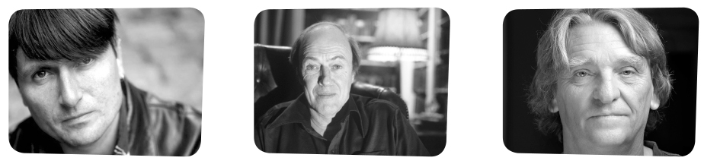


43
34
23
39
Listening • Part 1

Questions 1 – 4

There are four questions in this part.
For each question, there are three pictures and a short recording.
Choose the answer (A, B or C).

1 How many books were sold?

A B C
2 Which author’s books sold best?

A Simon Armitage B Roald Dahl C Melvin Burgess

3 In which theatre is the musical being shown?

A The Theatre Royal B Victoria Place Theatre C Vaudeville Theatre

4 Which does the man prefer?

A B C

40
Listening • Part 2

Questions 5 – 11

Listen to Rachel talking to her friend about books.
For each question, choose the correct answer A, B or C.

5 What is Rachel’s favourite type of book?
A Thrillers. B Novels. C Poetry.

6 Rachel used to read
A short stories. B scary stories. C funny stories.

7 Rachel admits that
A her favourite writer is Agatha Christie.
B she prefers Poe’s books to all the others.
C she doesn’t have a favourite writer.

8 Rachel likes going to the bookshop to
A buy books.
B have fun.
C look for a good book to read.

9 Where’s the new bookshop?
A Opposite the school.
B Near the park.
C In the city centre.

10 How are Rachel and Karen going there?
A They’re walking.
B They’ll take the bus.
C Karen’s Dad will drive them.

11 What time does Karen have to be home?
A At 5 o’clock.
B At 3 o’clock.
C At 8 o’clock.
“Name that film”
Radio 45 and Radio 5
Cinema.
Literature
Name of the new programme: ………………………….
Radio Stations: ………………………….
Topic: ………………………….
Percentage of votes: (12) …………………………. of listeners.
Second topic: ………………………….
Broadcasting days: (13) …………………………. and every other weekend.
Participation: (14) Listeners call ………………………….
Number of participations: (15) ………………………….
This week’s prize: (16) …………………………. opening session of Brad Pitt’s new film.
Duration of trip: (17) ………………………….
41
Listening • Part 3

Questions 12 – 17

You will hear a radio announcer talking about a new radio programme.
For each question, fill in the missing information in the numbered spaces.

Listening • Part 4
Questions 18 – 23

Look at the six sentences for this part.
You will hear a girl, Catherine, asking a friend about Drama Club.
Decide if each sentence is correct or incorrect.
If it is correct, choose the letter A for YES. If it is not correct, choose the letter B for NO.

YES NO

18 Mary is not a member of the school’s Drama Club anymore. A B

19 The Drama Club is open to any students in or outside the school. A B

20 Miss Abrioux prefers to meet new members at the time of rehearsals. A B

21 Catherine doesn’t have to meet the teacher at her office. A B

22 Mary has no idea about the type of conversation Miss Abrioux A B
will have with Catherine.

23 Mary and Catherine will walk together to the auditorium. A B



A famous singer has asked his fans to donate one of their belongings to be sold. The money will be used to help hungry children in Africa. Talk together about the different things they could donate and then decide which would be best.
• Where do you live/come from?
• How big is your family?
• Who’s the person in your family you
admire most?
• Do you have any brothers or sisters?
• Who do you like best in your family?
• How long have you been studying English?
• What’s your favourite subject?
• Tell us about your favourite teacher at
school.
• How often do you speak English?
• Do you speak English with friends?
• Would you like to visit London?
• Which English speaking country would you
like to visit?
Speaking • Part 1

(2 - 3 minutes)

Be prepared to say your names and spell them and answer questions about yourself, your daily
life, interests, etc. For example:

Speaking • Part 2

(2 - 3 minutes)

Talk to your partner about the following situation. The pictures below will help you.
42
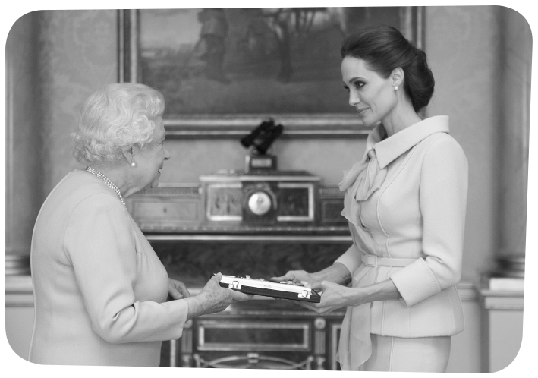

43
Speaking • Part 3

(3 minutes)

Look at one of the following photographs and talk by yourself about what you see.

Speaking • Part 4

(3 minutes)

Talk to your partner about what some famous people have done to make the world a better place and what they can still do in the future.


Unit 1 – Progress tests and mock PET
Answer Key

Test 1

A – Listening

1. b.
2.1. a; 2.2. b; 2.3. c; 2.4. b; 2.5. c.
3. a. 5; b. 4; c. 1; d. 6; e. 2.

B – Reading

1. b.
3. a. play the part (l. 3); b. lead role (l. 5); c. actor (l. 1);
d. character (l. 4).
4. a. 2; b. 1; c. 4; d. 3. 5.1. a;
5.2. c; 5.3. a.

C – Language

1. a. 3; b. 1; c. 1; d. 2; e. 1. 2. a. showed; b. had; c. appeared;
d. invited; e. played. 3. a. already; b. yet; c. never; d. just;
e. recently. 4. a. played; b. have recently watched; b. haven’t
watched… filmed; d. hasn’t made.

Test 2

A – Listening

1.1. b.
2.1. a; 2.2. b; 2.3. c; 2.4. b; 2.5. c.
3. a. don’t know how to dress; b. jeans or shorts; c. a cute dress; d. black and white; e. a leather jacket.

B – Reading

1. b.
3. a. appealing (l. 8); b. casting (l. 18); c. play the part (l. 2); d. series (l. 11); e. lead role (l. 6).
4. a. 2; b. 6; c. 1; d. 5; e. 3.
5. a. that his hair is too blonde and his skin is too fair; b. and wife; c. strong and charismatic; d. the story of the Bible.

C – Language

1. a. began; b. joined; c. has worked; d. has played; e. has
had.
2. a. appeared… invited; b. became; c. accepted… was
working.
3. a. 2; b. 3; c. 3; d. 1; e. 3.
4. a. haven’t watched… filmed… have recently watched;
b. has not made; c. played.

Test 3

A – Listening

1.1. c; 1.2. b.
2.1. b; 2.2. c; 2.3. b; 2.4. c; 2.5. b.
3. a. first book published; b. 3 books published; c. schools, cultural centres, inside and outside Portugal; d. fourth book published; e. a novel.

B – Reading

1. Personal answer.
3. a. blockbusters (l. 3); b. lecturer (l. 12); c. award (l. 8);
d. author (l. 2); e. fiction (l. 7).
4. a. 2; b. 6; c. 4; d. 1.
5. a. more books than any other writer
in Portugal; b. different types of books; c. was in 2014.
d. have distinguished him on three occasions.

C – Language

1. a. published; b. based; c. bestselling; d. novel; e. book;
f. set.
2. a. 2; b. 1; c. 2; d. 1; e. 3; f. 2.
3. a. returned; b. was working; c. began; d. started;
e. became.
4. a. have never read… wrote; b. read… found;
c. did; d. published… didn’t write… didn’t have.

Mock PET

READING

Part 1 – 1. A; 2. C; 3. C; 4. B.
Part 2 – 5. D; 6. C ; 7. A.
Part 3 – 8. B; 9. A; 10. B; 11. A; 12. B.
Part 4 – 13. B; 14. C; 15. D.
Part 5 – 16. D; 17. B; 18. B; 19. A; 20. C; 21. A; 22. D.

WRITING

Part 1 – 1. should; 2. won’t be; 3. spend much; 4. selecting;
5. as good.
Part 2 – 6. Personal answer.
Part 3 – 7. and 8. Personal answers.

LISTENING

Part 1 – 1. B; 2. C; 3. A; 4. B.
Part 2 – 5. A; 6. B; 7. C; 8. C; 9. A; 10. B; 11. A.
Part 3 – 12. 88%; 13. on week days; 14. to name the film;
15. no limit; 16. two tickets for; 17. 8 days.
Part 4 – 18. B; 19. B; 20. A; 21. A; 22. B; 23. A.

AUDIO SCRIPTS

Tests 1 and 2

CD 4 – Tracks 8 and 9

Sara Sampaio

[Part 1]
One of our favorite models of the moment is Sara Sampaio.
There’s no doubt that this Portuguese model living in New
York will go far. So when we were given the opportunity
to chat with Sampaio we were very happy. Here’s what we
learned from the 23-year-old.

How’s fashion going?
Actually really well, really smoothly. I’m only doing one
show, Jeremy Scott. The only stress I have is getting ready for
the parties, but it’s more fun than stress. I’m usually really
busy, flying all over the place, so fashion week for me is the
opposite because I actually can have time to sleep and relax.
It’s nice.

[Part 2]
What’s your signature model-off-duty look?
It depends a lot if it’s summer or winter. I don’t really know
how to dress for winter, but in the summer, I just like a really
simple look, so jeans or shorts and sometimes, a really cute
summer dress. I tend to go with black and white.

So what’s your fall wardrobe essential?
A leather jacket. It’s always the same.

http://www.nylon.com/articles/nylonfw-interview-sara-sampaio-september-
2014 (abridged and adapted), accessed in November 2014


Unit 1 – Progress tests and mock PET
Test 3

CD 4 – Tracks 10, 11 and 12

A Portuguese writer
[Part 1]
Ruben Correia writes about different topics and concerns.
While his second book was about the environment and the need to stop polluting our planet so that it won’t be destroyed, the fourth book is a love story, about the relationship between two university students.

[Part 2]
Ruben confesses that he has always enjoyed writing.
To his mind, his love of writing started when he learned how to read and write. He started writing short stories for fun, but after he showed some to his Portuguese teacher, she encouraged him to go on writing. It was then, at the age of ten, that Ruben realised he was going to become a writer.
The truth is that he hasn’t stopped writing since, and he’s been writing books for several years now.

[Part 3]
His first book was written when he was ten years old and published in 2011, when he was fourteen and by the age of fifteen, three of his books had been published.
Because of his writing, he has received different prizes and distinctions from Portuguese authorities and has been invited to participate in a number of different projects.
He has presented his books in schools and cultural centres, both inside and outside Portugal.
In 2014, his fourth book was published. This is his first novel, and he is determined to go on writing.

http://www.cmjornal.xl.pt/cultura/detalhe/acoriano_de_17_anos_lanca_4_livro.htmlhttp://sembargo.blogspot.pt/2012/02/ruben-correia-omeumaior-sonho-e-ser.html (based on), accessed in November 2014

Mock PET

Part 1

CD 4 – Track 13

1. How many books were sold?
Woman: How many books were sold today?
Man: Many. I haven’t confirmed the exact numbers. There
were so many people in and out of the bookshop, I didn’t
have any time. Some people were looking for teens’ books,
others were interested in a good read, a bestseller, in most
cases. We’ve sold a considerable number of books, in fact.
Woman: Can you check now?
Man: Yes. Let’s see. Eighteen. Here’s another one, nineteen.
We’ve sold nineteen books for teens. Then there’s the
bestsellers. Eight, nine. Yes, nine bestsellers. And then
there were six others of different types.
Woman: Did we sell more books than yesterday?
Man: Yes, we did. Yesterday we sold twenty-three books.
Today we’ve sold eleven more, thirty-four in total. But that
number is smaller than the number of books sold the day
before yesterday. We sold forty-three books then.

CD 4 – Track 14

2. Which author’s books sold best?
Woman: Do you remember who wrote the books that were
sold? Were they British writers?
Man: Yes, most of them were British. The majority of the
books sold were written by Melvin Burgess. But there were
also some short stories by Roald Dahl.
Woman: Were any of these books published recently?
Man: No, none of the books were recent, but these two
writers are very popular among British readers. There were
also two poetry books by Simon Armitage. The best sellers
were written by a diversity of English speaking writers:
Australians, Americans and British too.
CD 4 – Track 15

3. Which theatre is the musical being show?
Jill: Is there a show you’d like to go to? It would be a good
idea to choose one with good reviews.
Janet: There’s a lot to choose from. The Wind in the Willows
is a possibility. Do you remember we used to watch the
adventures of the four friends on Nickelodeon when we
were very young? In the musical their adventures are told
through dance, song, music and puppets. It is being shown
at Vaudeville Theatre.
Jill: I’m not sure I’d enjoy the puppets. It sounds too
childish.
Janet: What about Charlie and the Chocolate Factory? It’s
been produced by Sam Mendes.
Jill: It’s shown at The Theatre Royal, isn’t it?
Janet: Yes. Billy Elliot, The Musical, would be a good idea
too. It’s at Victoria Place Theatre and the music’s by Elton
John.
Jill: I think I’d rather watch Charlie and the Chocolate
Factory. They seem to use bad language in Billy Elliot. And
it takes longer than the other two musicals: 3 hours, which
would mean we’d miss the last train home.
Janet: All right then, let’s go and get the tickets for Charlie
and the Chocolate Factory. I’m sure it’ll be a good show.

CD 4 – Track 16

4. Which do you prefer?
John: Do you prefer going to the theatre or to musicals?
Mark: It depends, you know. I’ve been to the theatre on
many occasions and I enjoyed the plays very much. When
you go to the theatre, the actors perform very close to
you. It’s as if you were also part of the play. Musicals also
appeal to me. They’re a very good form of entertainment,
particularly when they’re funny and the plot is interesting.
I also like the fact that there’s live singing. Music is very
important to me, it has great impact on the audience and
creates great effect.
John: Would you say that they’re your favourite forms of
entertainment?
Mark: I think I can say they’re among my favourite forms
of entertainment, but films are definitely my favourite
form of entertainment. Nothing compares to a good film,
with an interesting storyline and good music to go with it.

Part 2

CD 4 – Track 17

Karen: Be honest, Rachel. What’s your favourite type of book?
Rachel: I‘ve always enjoyed reading thrillers. I like the
suspense in the plot. Every page you turn takes you closer
to the solution of the mystery. All the excitement and the
anxiety I experience as a reader isn’t replicated when I read
another type of book. What’s more, I never feel bored while
reading a thriller. Every book is a whole new story, with
different characters and situations… and mysteries too!
Karen: Is there a particular writer you admire?
Rachel: Not really. When I was younger, I loved reading
Louise Cooper’s short scary stories because they were always
so funny and full of imagination. Sherlock Holmes, by Sir
Conan Doyle, was a character whose stories I enjoyed reading
too. I read many of Agatha Christie’s books too. I particularly
enjoyed the character of Hercule Poirot because he had such
great reasoning skills. There was the French writer Simenon
and his Commissaire Maigret and I even read some of Poe’s
writings. I’ve also read many other writers whose names
I can’t remember.

Unit 1 – Progress tests and mock PET

Karen: What about now? Whose books do you like reading?
Rachel: It depends. I love spending the afternoon in a bookshop, looking for the perfect book to read. There are many good reads waiting to be bought. I’ve found many good books this way.
Sometimes written by people I’d never heard of. That’s the great value of a bookshop, I think.
Karen: Which bookshop would you recommend?
Rachel: No bookshop is better than the next one. You just have to spend some time inside, looking through the books, reading the covers and trying to decide if a book will interest you. Sometimes I read the reviews in newspapers and then I try to find the books that seem to be more interesting. I know there’s a new bookshop opposite the school that has lots of new books. Would you like to visit it?
Karen: Do we have to walk there?
Rachel: No, of course not. Let’s take the bus.
Karen: Ok then. But I have to be home at five.

Part 3

CD 4 – Track 18

Good evening! Today we bring you the latest news about a new programme on Radio Station 45 and Radio 5. It is called
“Name that Film”. We know many of our listeners are cinema fans and we hope you’ll want to take part in the programme.
Our main objective is to encourage our listeners to share with us the knowledge they have about cinema. The topic of the programme, cinema, was chosen by listeners through a survey this channel did, together with Radio 5. It was the most voted topic and the second most voted was literature, but the difference between the two was considerable: 88% of the listeners voted for cinema, while only 10% chose literature.
The programme will be broadcast on week days, and every other weekend. So we’ll be talking about cinema during the next few months.
Now let me explain how the programme will work. I’ll read a line from a famous film then listeners call us and name the film. This programme will revolutionise the two stations, as it will allow the listeners to participate as much as they want. There’s no limit to the number of times you participate.
There will be a daily prize for listeners. We intend to offer various types of prizes. They will vary from week to week, depending on our sponsors. For the first programme we have two tickets for the opening session of Brad Pitt’s latest film.
It’s said to be one of his best yet! Expectations are high.
We’re also preparing a special prize for listeners who participate
regularly and get the greatest number of correct answers. We’re
working with a travel agent’s to organise a trip for two to
Los Angeles for eight days. A Hollywood studio has already agreed to offer a tour of its facilities to the travelers. They will have the opportunity to meet the stars who’ll be working in the studio.
These are all good reasons for you to participate in the new
contest. The only cost you’ll have to face is the cost of the call
you make.

Part 4

CD 4 – Track 19

Catherine: Can anyone become a member of the Drama Club?
Mary: Yes, of course. You just have to be a pupil at the
school. The Drama Club has been set up to give students the
opportunity to develop their performance skills. The Club has
taken part in various competitions and has been awarded
several prizes. There’s an annual competition for High School
Drama Clubs every year and the school’s participated in it
since 2000.
Catherine: Which teacher is in charge?
Mary: The English teacher, Miss Abrioux. She’s been doing a
great job, you know. Since she was appointed for the Drama
Club, the number of members has doubled. Miss writes the
plays herself and they are based on funny events which take
place in the school. Everyone’s anxious to know what the
next play will be about. It’s sure to be very funny but always
innovative.
Catherine: Do you know where I can find Miss Abrioux at this time?
Mary: She’s normally in her office, on the second floor,
between 2 and 4 in the afternoon. But I think it would be
better for you to meet her at the auditorium, at 4 o’clock.
That’s the time for rehearsals. You don’t really need to meet
her at the office first. Everyone’s welcome to the rehearsals.
Miss Abrioux prefers to talk to prospective members of the
Club during rehearsals. That way she can ask you about your
reasons for wanting to join in.
Catherine: Does that mean I’ll have to go through an
interview?
Mary: No, not really. It’s an informal conversation. Miss
Abrioux likes to talk to students and to find out about their
motivation. She also tells the new members about the agenda
of the Drama Club: the performances which have already
been planned.
Catherine: Fine. And where’s the auditorium? I don’t think
I’ve seen it.
Mary: It’s quite hard to give you directions to get there if
you’re not familiar with the school grounds. What about
meeting here at about 3:50?
46
47
© ASA • UPGRADE 9 / TESTS
Table of specifications
Progress Tests (Unit 2)

Skills | Contents |  | CEF competences | Types of items | Number  of items | Marks
Skills | Topics | Language
A – Listening | Choices  Looks  Tastes | Grammar  • Past perfect  • Question tags  • Modal verbs  Vocabulary  • Addictions  • Boddy image  • Food, health  and well-being | Linguistic  • lexical  • grammatical  • semantic  • orthographic  Pragmatic  • functional  • discoursive | • Multiple choice  • True / false  • Matching  • Sequencing  • Short answer (blank  filling; sentence  completion;  rephrasing)  • Short answer  (text comprehension) | 3 | 20
B – Reading  (200-300  words) |  |  |  |  | 4 | 30
C – Language |  |  |  |  | 4 | 30
D – Writing | Choices  Looks  Tastes |  |  | • Essay (80 words) | 1 | 20





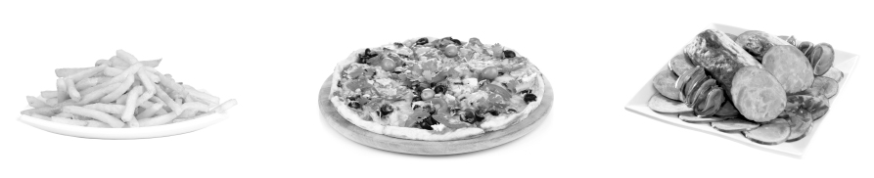
A – Listening 20 marks

1. You will hear a man talking about food. Tick () the correct option. 5 marks
The man talks about…
□ a. foods that everyone should eat.
□ b. the worst foods you can eat.
□ c. the types of foods you mustn’t buy.

2. Listen again and tick () the pictures which match the information in the text. 9 marks (3x3 marks)

2.1. The first food mentioned.

□a. □b. □c.

2.2. A condiment not to be used very much.

□a. □b. □c.

2.3. The first thing to eliminate from your diet.

□ a. □b. □c.

5

10

15

Tree’s life as a vegan

Tree lives with her mother Amanda, who raised her as a vegetarian. Aged 10, Tree left school to be taught at home by her mother. At 13
she decided to become vegan, and persuaded her mother to join her.
“I used to eat dairy products – tons of cheese, especially. And then
I realised the cruelty to cows that being vegetarian involved.”
She and her mother don’t eat any cheese, eggs, butter, honey, chocolate, milk and milk powder products. “It forced me to be interested in food,” says Tree. “As a vegetarian I’d got lazy. And I couldn’t just switch to vegan cheese on potatoes, because it’s like plastic.”
Receiving a vegan cookbook for her 13th birthday caused Tree to
become interested in preparing meals, listening to Mika, her favourite
singer, as she cooked. “Now I’m more interested and more confident. I’m a ‘kitchenista’. Tonight I’m making onion tart with walnut pastry, and caramelised onions fried in olive oil, soya cream and mustard, with new potatoes. In the mornings I make breakfast. Because I don’t have to go
to school, there’s time to have proper breakfasts. Mum says I make better porridge and pancakes than her, but it’s probably just an excuse to get me to serve her in bed.”

http://www.theguardian.com/lifeandstyle/2011/apr/17/teens-adolescents-food-eating-cooking
(abridged and adapted), accessed in November 2014

3. Now listen to someone talking about tips for healthy eating and choose the correct option.
6 marks (3x2 marks)
3.1. Choose good carbohydrates. …………………………… are the best.
a. Beans b. Bread c. Whole grains
3.2. Poultry, …………………………… are the best choices.
a. fish, nuts and beans b. broccoli, spinach, cauliflower c. eggs and butter
3.3. Choose …………………………… and limit foods high in saturated fat.
a. foods with any fats b. fat-free foods c. foods with healthy fats

B – Reading
30 marks

1. Tick () the correct the correct option. 6 marks

A vegan is someone who…
□a. doesn’t eat any animal products. □b. only eats beef. □c. dislikes fruit and vegetables.

2. Read the text.

had never been
decided
imagined
thought
Mother and daughter a. 1. started when she turned 13.
Tree’s interest in cooking b. 2. to become vegan.
Her mother likes c. 3. eating breakfast in bed.
Tree convinced her mother d. 4. don’t eat dairy products anymore.
3. Complete the table with information from the text. 4 marks (4x1 mark)

a. name | Tree Marshall
b. type of diet

4. Match the sentence halves according to the information in text. 10 marks (4x2,5 marks)

5. Choose the correct option.
10 marks (4x2,5 marks)
5.1. When Tree was thirteen she…
□a. to become a vegetarian. □b. became a vegan. □c. stopped being a vegan.
5.2. Which species did Tree decide to protect?
□a. Chickens. □b. Cows. □c. Plants.
5.3. Whose songs does Tree listen to while she cooks?
□a. Taylor Swift’s. □b. Mika’s. □c. No one’s.
5.4. She can have a good breakfast because she…
□a. doesn’t have to go to school. □b. cooks it herself. □c. eats her mother’s cooking.

C – Language 30 marks

1. Choose the correct option. 4 marks (4x1 mark)

a. After dieting for three weeks my friend Mandy realised / had realised she hadn’t lost / didn’t lose any weight.
b. She hadn’t gone / didn’t go on a diet ever before and she felt / had felt very sad.

2. Complete the sentences with the correct verb form in the box. 8 marks (4x2 marks)

a. Last year my friend Simona …………………...……. to go on a diet because …………….………. she she needed to lose some weight.

b. Simona …………………. on a diet and I never ………………………. she would find the determination to do so.
51
3. Choose the option to complete the sentences below. 10 marks (5x2 marks)

3.1. In the past adolescent girls tried to reduce calories to lose weight, …………………….?
a. did they b. don’t they c. didn’t they
3.2. This was the first time someone went on a diet, …………………….?
a. was it b. wasn’t it c. isn’t it
3.3. I am going to go on a diet too, …………………….?
a. aren’t I b. don’t I c. am I
3.4. Nowadays many teenagers eat unhealthy foods, …………………….?
a. did they b. don’t they c. didn’t they
3.5. Mary doesn’t need to lose weight, …………………….?
a. does she b. doesn’t she c. did she

4. Choose the correct option each time. 8 marks (4x2 marks)

Many young people think that they a. ………………………. stop eating so that they b. ……………………….
reduce their weight in a quick way. This is a wrong idea and teenagers c. ……………………. know that
by not eating they d. ……………………. become seriously ill.
http://www.imdb.com/name/nm0604430/bio?ref_=nm_ov_bio_sm (adapted and abridged), accessed in November 2014

 | 1. | 2. | 3.
a. | mustn’t | must | couldn’t
b. | must | couldn’t | can
c. | should | can | mustn’t
d. | couldn’t | should | may

D – Writing
20 marks

In what way is eating healthy food good for you health?
Write a short commentary (80 words) stating your opinion.


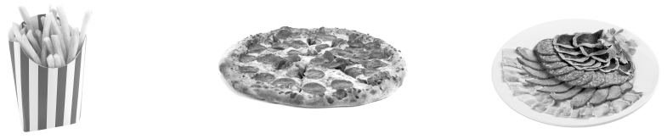
A – Listening 20 marks

1. You will hear a man talking about food. Tick () the correct option. 5 marks
The man talks about…
□ a. foods that everyone should eat.
□ b. the worst foods you can eat.
□ c. the types of foods you mustn’t buy.

2. Listen again and tick () the pictures which match the information in the text. 9 marks (3x3 marks)

2.1. The first food mentioned.

□a. □b. □c.

2.2. A condiment not to be used very much.

□a. □b. □c.

2.3. The first thing to eliminate from your diet.

□ a. □b. □c.

20

15

10

5

Tree’s life as a vegan

Tree lives with her mother Amanda, who raised her as a vegetarian, in Puckington, Somerset. Aged 10, Tree left school to be taught at home by her mother. At 13 she decided to become vegan, and persuaded her mother to join her. “I used to eat dairy products – tons of cheese, especially. And then
I realised the cruelty to cows that being vegetarian involved.”
They don’t eat any cheese, eggs, butter, honey, chocolate, milk and milk powder products. “It forced me to be interested in food,” says Tree. “As a vegetarian I’d got lazy. And I couldn’t just switch to vegan cheese on potatoes, because it’s like plastic.”
It was receiving a vegan cookbook for her 13th birthday that caused Tree to become interested in preparing meals, listening to Mika, her favourie singer, as she cooked. “I’m more interested and more confident. Now I’m a ‘kitchenista’. Tonight I’m making onion tart with walnut pastry, and caramelised onions fried in olive oil, soya cream and mustard, with new potatoes. In the mornings
I make breakfast. Because I don’t have to go to school, there’s time to have proper breakfasts. Mum says I make better porridge and pancakes than her, but it’s probably just an excuse to get me to serve her in bed.”
“I search the internet for recipes,” Tree continues. “What veganism’s done is make me feel healthier both mentally and physically. While others my age are eating hamburgers, I’m avoiding lots of unhealthy food, making meals and saving animals’ lives. It would be nice if everyone was vegan in the future. Or, if they weren’t, that they didn’t start arguments about it. I’m vegan, so deal with it.”

http://www.theguardian.com/lifeandstyle/2011/apr/17/teens-adolescents-food-eating-cooking
(abridged and adapted), accessed in November 2014
3. Now listen to someone talking about tips for healthy eating and choose the correct option. 6 marks (3x2 marks)
3.1. Choose good carbohydrates. ………………………………are the best.
a. Beans b. Bread c. Whole grains
3.2. Poultry, ……………………………… are the best choices.
a. fish, nuts, and beans b. broccoli, spinach , cauliflower c. eggs, poultry and butter
3.3. Choose ……………………………… and limit foods high in saturated fat.
a. foods with any fats b. fat-free foods c. foods with healthy fats

B – Reading 30 marks

1. Tick () the correct the correct option. 4 marks
A vegan is someone who…
□ a. doesn’t eat any animal products. □ b. only eats beef. □ c. dislikes fruit and vegetables.

2. Read the text.

Tree convinced her mother a. 1. started when she turned 13.
Mother and daughter b. 2. to become vegan.
Tree’s interest in cooking c. 3. eating breakfast in bed.
Her mother likes d. 4. don’t eat dairy products anymore.
Tree wishes e. 5. don’t eat dairy products anymore.
3. Complete the table with information from the text. 6 marks (4x1,5 marks)

a. name | Tree Marshall
b. type of diet
c. benefits of veganism
d. Tree’s wish for the future

4. Match the sentence halves according to the information in text. 10 marks (4x2,5 marks)

5. Answer the questions about the text. 10 marks (4x2,5 marks)

5.1. What happened when Tree was thirteen?

5.2. How did she become interested in cooking?

5.3. What does Tree do while she cooks?

5.4. Why can she take time to prepare a good breakfast?

C – Language 30 marks

1. Choose the correct option. 10 marks (5x2 marks)

a. After dieting for three weeks my friend Mandy realised / had realised she hadn’t lost / didn’t lose any weight.

b. She hadn’t gone / didn’t go on a diet ever before and she felt / had felt very sad.
c. She told me she had expected / expected to reduce her weight immediately.
54
55
2. Complete the sentences with the correct forms of the past perfect or the past simple. 10 marks (4x2,5 marks)

a. Last year my friend Simona …………………… (decide) to go on a diet because
she …………………… (think) she needed to lose some weight.

b. Simona …………………… (never be) on a diet and I never …………………… (imagine)
she would find the determination to do so.

3. Complete the sentences below with a question tag. 5 marks (5x1 mark)

a. In the 1920s adolescent girls tried to reduce calories to lose weight, ……………………?
b. This was the first time someone went on a diet, ……………………?
c. I am going to go on a diet too, ……………………?
d. Nowadays many teenagers eat unhealthy foods, ……………………?
e. Mary doesn’t need to lose weight, ……………………?

4. Choose the correct option each time. 5 marks (5x1 mark)

Many young people think that they a. ……………….……stop eating so that they b. …………..…...………reduce their weight quickly. This is wrong and teenagers c. ……………………………………………know that by not . they d. ……………………become seriously ill because their bodies e. ……….……………be properly nourished.
http://www.imdb.com/name/nm0604430/bio?ref_=nm_ov_bio_sm (abridged and adapted), accessed in November 2014

 | 1. | 2. | 3.
a. | mustn’t | must | couldn’t
b. | must | couldn’t | can
c. | should | can | mustn’t
d. | couldn’t | should | may
e. | must | might | could

D – Writing 20 marks

It is important to eat healthy foods.
• How does it affect your health?
• And your life?
Write a short commentary (80 words) stating your opinion.

A – Listening 20 marks

1. Listen to someone talking about exercising. Tick () the correct option. 5 marks

The title Too Much of a Good Thing suggests that…
□ a. exercise may be unhealthy if it becomes an addiction.
□ b. physical fitness is always unhealthy.
□ c. weight control is always negative.

2. Listen again and tick () the correct option to answer the questions. 5 marks (5x1 mark)

2.1. How often do the cheerleading team practise?
□ a. Three to six times a week.
□ b. Three to five times a week.
□ c. Three to four times a week.

2.2. How much pressure does Rachel feel to keep her weight down?
□a. Very little. □b. None. □c. A lot.

2.3. Who sets an example to the team?
□a. Carla.. □b. Anne. □c. Rachel.

2.4. What part does she play in the team?
□a. Coach. □b. Head cheerleader. □c. Advisor.

2.5. How often does Rachel do extra workouts?
□a. Daily. □b. Weekly. □c. Monthly.

3. Say if the statements are true (T) or false (F). 10 marks (5x2 marks)

□ a. People are not aware of the benefits of exercise.
□ b. People should exercise more.
□ c. Any kind of exercise is good.
□ d. Exercise contributes to the reduction of body fat.
□ e. If you exercise, you reduce the risks of diseases.

20

15

10

5

Compulsive disorders

Addiction to video games and the internet is starting to be considered a psychological problem, and experts say it’s not uncommon for kids to become violent when their “drug” is taken away.

Violent video games can be as addictive as drugs, experts say. Video game addiction will be acknowledged for the first time this year.
“If you look at alcoholism and internet addiction, it’s definitely the same model of behaviour,” agreed Dr. Kimberly Young, director of the Centre for Online Addiction. She says the use of violent video games and aggressive behaviour in kids are related. “The reality is, these games must teach you something,” she said. As with other addictions, some people may be easier to influence than others.
“We wouldn’t want anybody to think, when we use the term ‘video game addiction’ or ‘compulsive gaming’ that there is any problem
with the video games.” Dr Michael Fraser, a clinical psychologist said. “Many people can play one game, and that’s it. Others won’t be able to stop.”
Cases of extremely violent attitudes and actions influenced by video games may be rare, but Fraser and Young agreed that parents need to actively set usage and access limits. “Monitoring is very important,” Fraser said. “If you put an iPad into a 6-year-old’s hands, that’s no different to sending them to a cinema that shows films for adults without parent or adult control.”
“When you see an alcoholic going into a bar, you know what they’re going in there for,”
he also said. “But when a kid goes into the library or their room and sits at a laptop, it’s not always certain that they’re going to do something harmful.”
There’s no formal diagnosis for video game addiction – but that doesn’t mean it’s not real.

http://www.nydailynews.com/life-style/health/kids-addicted-video-games-violent-experts-article-1.1298338
(abridged and adapted), accessed in November 2014

B – Reading 30 marks

1. Choose the correct option (A, B or C) to complete the sentence. 5 marks
An addiction is something…
□ a. you do every day. b. you cannot stop doing. c. you’re used to doing.

2. Read the text.

3. Who says what: Dr Young (A), Dr Fraser (B) or both (C)? 10 marks (5x2 marks)
□ a. Violent attitudes may be caused by video games. □ d. There are different types of players.
□ b. Not everyone is influenced in the same way. □ e. Children’s gaming must be supervised.
□ c. Games are not the problem.
experts (l. 2) a. 1. for sure
taken away (l. 3) b. 2. connected to each other
acknowledged (l. 5) c. 3. recognised
definitely (l. 6) d. 4. which cannot be controlled or managed
related (l. 9) e. 5. addictive
6. people who know a lot about the topic
7. removed
4. Match the words/expressions from the text with the words/expressions on the right.
Two aren’t used. 5 marks (5x1 mark)

5. Answer the questions about the text. 10 marks (5x2 marks)

5.1. What are two examples of the new forms of compulsive behaviour among teens referred to in the text?

5.2. How do some teenagers react if they are not allowed to play games?

5.3. What can some of the negative consequences of gaming be?

5.4. Whose responsibility is it to monitor young players?

5.5. How easy is it to identify compulsive gaming?

C – Language 30 marks

1. Complete the text with the past simple or the past perfect of the verbs in brackets. 6 marks (6x1 mark)

Last year my friend Simona a. ………….………………………….….. (decide) to go on a diet because she b. ………….…………..…….. (think) she needed to lose some weight. When Simona’s sister heard about it she asked me “Why c. ……………………….. (you / not try) to make her change her mind?” I explained that Simona d. ………………………….. (not want) to hear about it. She e. ………..………….. (make) it very clear that she f. ……………………..….. (make) her decision.
58
should
must
may
shouldn’t
would
59
2. Complete the sentences with the correct question tags. 6 marks (4x1,5 marks)

a. Rachel and her friends are somewhat obsessed with exercising, ……………………..?
b. Teens who get plastic surgery can face serious dangers, ……………………..?
c. You must stop worrying about getting the perfect body, ……………………..?
d. I’m really going to get a slimmer body, ……………………..?

3. Complete the text with the verbs on the right. One isn’t used. 8 marks (4x2 marks)

Nowadays young people a. …………………….. easily be influenced by the images of perfection that are shown by the media. To most teens the message these images transmit is “b. …………………….. you like to have a perfect body?” And even if teens are told that they c. …………………….. believe what newspapers and magazines say about physical appearance, they do. d. …………………….. the media be allowed to go on spreading unreal messages to teens? No, of course not.

4. Choose the best word/expression for each space.
10 marks (5x2 marks)
Stephen Black, who a. …………………….. be addicted to the internet said “It’s no secret that many teens are big fans of video games and the internet.” Stephen said that was exactly the way he b. …………….……….. when he c. …………………….. completely hooked by the internet. He d. ………………….….. on to explain that for some of his teen friends, and himself, what e. …………………….. as an interest in technology, a means of entertainment, or a way to keep in touch with friends soon became a serious problem.
http://www.crchealth.com/troubled-teenagers/internet-addiction-teenagers/ (abridged and adapted), accessed in November 2014

 | 1. | 2. | 3.
a. | used to | could | may
b. | feels | has felt | felt
c. | had become | became | become
d. | goes | had gone | went
e. | had started | starts | was starting

D – Writing
20 marks

• Write an entry for your diary (80 words) starting with the following prompt:
If I could make teens change their mind about looking perfect…
• Don’t forget to express your emotions and make sure you write in an informal style.

A Students cannot use the computers in the library.

B Students can only use the computers if accompanied by
a teacher.
C Students mustn’t play online games.
A Students are not allowed to smoke.
B Smoking is forbidden.
C No cigarettes allowed.
A Students must take care of their possessions.
B No one is going to steal the students’ belongings.
C The supervisor will take care of the students’ belongings.
A Students are only allowed to take in their mobile phones.
B Students can use tablets to access the internet.
C Students cannot carry any electronic devices with them.
Reading • Part 1

Questions 1 – 4

Look at the text in each question. What does it say?
Mark the correct letter A, B or C on your answer sheet.



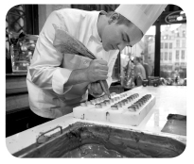
A French recipes – Participants in the course will become familiar with French-style techniques to bake chocolates. Participants will be encouraged to learn to prepare exotic gluten-and-palm-oil-free chocolate. In addition, they will also learn to select the finest natural products: cocoa, marzipan, fruits and nuts, for example.

C Adjust your cooking – After this workshop you will change the way you cook and make it more healthy. Participants will learn how to prepare varied recipes using ingredients which are safe and natural, such as olive oil rather than butter, for example.

B Arabic cuisine – Participants in this workshop will find out about some of the secrets of Arabic cuisine. During the workshop participants will learn to cook many different dishes with diverse origins. Fresh and dried fruits and nuts are widely used.

http://eatocracy.cnn.com/ (abridged and adapted), accessed
in December 2014

D Creativity and decoration workshop – This is a workshop meant for creative young people who are interested in baking and decorating. It’s easy to see when a cake decorating job is well done, with impressive finishing touches and techniques such as perfect roses, borders or fondant accents.

http://www.wilton.com/cakes/decorating-cakes/ (abridged and adapted), accessed in December 2014
61
Reading • Part 2

Questions 5 – 7

The young people below all want to find a workshop related to food that matches their interests
and preferences.
Below there are descriptions of four workshops.
Decide which workshop would be suitable for the following people.
For questions 5 –7, mark the correct letter (A – D) on your answer sheet.

5 Chloë is 12 and likes designing and making cakes. She is looking
for a workshop which will allow her to use her ideas and
creativity.

6 Louis works as a chocolatier. He wants to attend a workshop
which will teach him innovative techniques and methods of
producing chocolate.

7 Mathew is 11 and he grows his own tomatoes, carrots and onions.
He always cooks healthy foods and always tries to find new
recipes.

http://www.dailyfinance.com/2011/01/03/compare-and-contrast-the-best-gym-membership-for-your-money/
(abridged and adapted), accessed in November 2014
Bally Total Fitness
Locations: More than 300 nationwide.
Extras: Free weeklong pass; friends and family discount memberships; personal training programs; weight training and cardio equipment; group exercise classes involving Pilates, martial arts and more (vary by club, most free with membership).
Costs: Similar to 24 Hour Fitness, membership packages can be monthly. In New York City, membership is $29.99 a month. In Chicago, is $23.99 and in Los Angeles, is $19.99 a month.

24 Hour Fitness
Locations: 420 locations in 14 states.
Extras: Free weeklong pass; reduced costs for family members living at your residence; many locations open 24 hours; weight training and cardio equipment; free personal training programs; group exercise classes involving aerobics, kickboxing, dance, cycling, and more (vary by club, most free with membership); supervised children’s play area.

Costs: Similar to Bally Total Fitness, prices vary, not only based on location, but also club type. Membership packages can be monthly and cover all 24 Hour Fitness clubs, or just a single club.

Planet Fitness
Locations: 390 locations in 40 states.
Extras: Massage chairs, fitness equipment, and a strict silence policy.
Costs: In New York and Chicago, it’s $10 a month (plus taxes) and a $29 enrollment fee for the most basic package that provides access to equipment. In San Francisco, the cost is $10 a month.
The best gym membership for your money

To select one of gyms, simply read the list of some of the best opportunities for gym membership available.
Reading • Part 3

Questions 8 – 12

Look at the sentences about the best gym membership for your money.
Read the text below to decide if each sentence is correct or incorrect.
If it is correct, mark A on your answer sheet.
If it is not correct, mark B on your answer sheet.

8 24 Hour Fitness is good for someone who wants choice because it has the greatest number of clubs.

9 If you are interested in lifting weight, Planet Fitness is the best choice.

10 Bally Total Fitness members get free access to most group classes.

11 All three gyms offer members the opportunity to plan their nutrition and meals.

12 The fee of Bally Total Fitness is the highest.


Veganism

Being a vegan is definitely more of a lifestyle choice and a philosophy than a diet. A vegan mustn’t eat anything that is of animal origin. Vegans will not use animal based products for clothing, or any other purpose.
A person can become a vegan because of moral reasons involving animal rights, for environmental reasons, or for better health. The Vegetarian Resource Group states that “vegans are vegetarians who do not use other animal products or by-products such as eggs, dairy products, honey, leather, fur, silk, wool, cosmetics, and soaps derived from animal products.”
Vegans do not consume or use dairy products or eggs even though doing so would not kill the animal. Part of the reason is a belief in the absolute right of animals to exist freely without human interference, but also because many egg-laying chickens and dairy cows are killed when they produce less with age. In addition, farming today is very different from what it used to be. Modern farms are highly mechanised factories – a lot of animals are given products to make them produce more.

http://www.medicalnewstoday.com/articles/149636.php (abridged and adapted), accessed in December 2014
63
Reading • Part 4

Questions 13 – 15

Read the text and the questions below.
For each question, mark the correct letter A, B, C or D on your answer sheet.

13 What is this text about?
A Ways to become a vegan.
B Reasons why some people become vegans.
C Vegans and vegetarians.
D People who treat animals cruelly.

14 Being a vegan
A is an option people make for health reasons.
B means that you will only eat cheese and butter on special occasions.
C is a way of life more than a way of eating.
D is not suitable for athletes and sportsmen.

15 Vegans
A are just like vegetarians.
B don’t eat animals or use animal based products.
C do not worry about the conservation of species.
D and their eating habits have become very popular.
64
Reading • Part 5

Questions 16 – 22

Read the text below and choose the correct word for each space.
For each question, mark the correct letter A, B, C or D on your answer sheet.

Healthy diets

Extreme diets may in some cases lead to malnutrition. Heavily processed and
(16) ………………… foods as well as sweets, junk foods, and alcohol should also be
(17) ………………… in a healthy diet.
Nutritionists say that people (18) ………………… be aware of the importance of avoiding fats, especially saturated fats, because (19) ………………… mustn’t be consumed too often.
This way, they (20) ………………… still reduce weight and be healthier. They also agree that people shouldn’t consume (21) ………………… salt because commercial foods such as snacks, biscuits, and bread, (22) ………………… others, already contain salt, and this might mean an excess of salt consumed daily.
MyPyramid Food Guidance System is the result of extensive research performed by the United States Department of Agriculture.

http://en.wikipedia.org/wiki/Dieting#Low-fat_diets (abridged and abridged), accessed in December 2014

16 A fried B healthy C raw D boiled

17 A consumed B used C avoided D cooked

18 A need B needn’t C mustn’t D must

19 A this B which C those D all

20 A must B need C can D will

21 A much B few C little D any

22 A like B as C among D with
65
Reading • Part 1

Questions 1 – 5

Here are some sentences about healthy living habits. For each question, complete the second
sentence so that it means the same as the first sentence.

Use no more than three words.
Write only the missing words on your answer sheet.

1 I didn’t eat breakfast and now I regret it.
I wish ……………………. breakfast.

2 It is forbidden for children to use the gym.
Children ……………………. the gym.

3 Is it possible for us to go to the gym with you?
……………………. to the gym with you?

4 It is forbidden to use phones in here.
You ……………………. turn off your phone.

5 Tom advised us to wait for him to start cooking.
Tom said we ……………………. wait for him.

Writing • Part 2

Question 6

You have completely forgotten to meet your friend Julia at the gym this evening.
Write an email to Julia.
In your email, you should:
• apologise to Julia;
• say why you forgot;
• offer to go to the gym with her some other day.
Write 35 – 45 words on your answer sheet.

13 What is this text about?
A Ways to become a vegan.
B Reasons why some people become vegans.
C Vegans and vegetarians.
D People who treat animals cruelly.

14 Being a vegan
A is an option people make for health reasons.
B means that you will only eat cheese and butter on special occasions.
C is a way of life more than a way of eating.
D is not suitable for athletes and sportsmen.

15 Vegans
A are just like vegetarians.
B don’t eat animals or use animal based products.
C do not worry about the conservation of species.
D and their eating habits have become very popular.
66
Writing • Part 3

Write an answer to one of these questions (7 or 8) in this part.
Write an answer in about 100 words on your answer sheet.

Question 7

• This is part of a letter you received from your penfriend Ruth.

In your next letter, please tell me about your school.
Are you allowed to take your cell phone to school?
Is there a Wi-Fi zone at the school?
Are you allowed to play online games in the library?

• Now write a letter, answering your penfriend’s questions.
• Write a letter in about 100 words on your answer sheet.

Question 8

• Your teacher has asked you to write a story.
• This is the title of the story: An incident in the gym
• Write your story in about 100 words on your answer sheet.
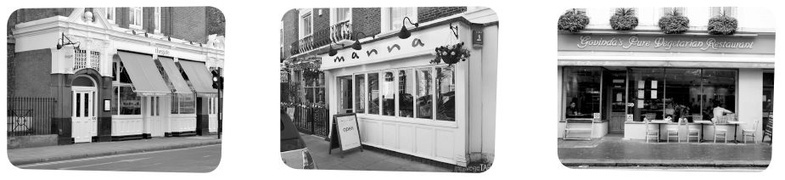



Listening • Part 1

Questions 1 – 4

There are five questions in this part.
For each question, there are three pictures and a short recording.
Choose the correct answer (A, B or C).

1. Where did you have breakfast?

A B C

2 What sort of breakfast did you eat?

A B C

3. Where will we have dinner?

A B C

4. Which gym did you choose?

A B C

67
68
Listening • Part 2

Questions 5 – 11

Listen to two friends, Jill and Paul, who meet after a long time.
For each question, choose the correct answer A, B or C.

5 Paul works much more at the gym because
A he’s a coach.
B he’s the manager.
C he likes working there.

6 Ted
A works for another gym.
B is one of Paul’s colleagues at the gym.
C asked Paul to be his partner.

7 Paul tells Jill
A the gym doesn’t accept any more new members.
B there’s a special promotion at the moment.
C she should wait for the next month’s promotion.

8 New members can
A come in whenever they want.
B get free access to all the gym facilities.
C get promotions in shops.

9 The exercise plan
A includes information on a healthy diet.
B is created by Paul.
C costs more.

10 Paul says the cafeteria
A is for members’ friends and family.
B was opened long ago.
C caters for vegans and vegetarians.

11 Paul suggests
A Jill could go to the gym with him.
B they should meet later.
C showing Jill around the gym.
222 New Road, Exeter
First name: (12) ……………………..
Surname: (13) ……………………..
Reference number: (14) ……………………..
Postcode: (15) ……………………..
Postal address: ……………………..
Item bought: (16) ……………………..
Model: (17) ……………………..
Listening • Part 3

Questions 12 – 17

You will hear a woman on the phone complaining about not receiving an item she ordered.
For each question fill in the missing information in the numbered spaces.

Listening • Part 4

Questions 18 – 23

Look at the six sentences for this part.
You will hear a young cook, Jonathan, being interviewed by the presenter of a radio programme
called “The Food Show”. Decide if each sentence is correct or incorrect.
If it is correct, choose the letter A for YES. If it is not correct, choose the letter B for NO.

YES NO
18 As a child Jonathan used to go to his father’s restaurant daily. A B
19 Jonathan watched his father while he prepared dinner for the customers. A B
20 When he ate at the restaurant, he could choose what he wanted to eat. A B
21 Jonathan thinks his choice of career didn’t surprise his parents. A B
22 He thinks his father should modernise his restaurant and the dishes he cooks. A B
23 Jonathan thinks he has all the knowledge he needs to become an outstanding Chef. A B

69


Your school has decided to ask the pupils about the activities they think are most dangerous for young people between the ages of 13 and 14. Talk together about the activities and decide which three activities are most likely to cause addiction.
70
Speaking • Part 1

(2 - 3 minutes)

Be prepared to say your names and spell them and answer questions about yourself, your daily
life, interests, etc. For example:

• Where do you live/come from? • Where do you normally go with your friends?
• Do you live in…? • Do you normally visit your friends’ houses?
• Do you like English? • Who’s the person you trust most? Why?
• Tell us about your best friend.
• What’s your best friend like?
• How often do you go out with your friends?

Speaking • Part 2

(2 - 3 minutes)

Talk to your partner about the following situation.
The pictures below will help you.


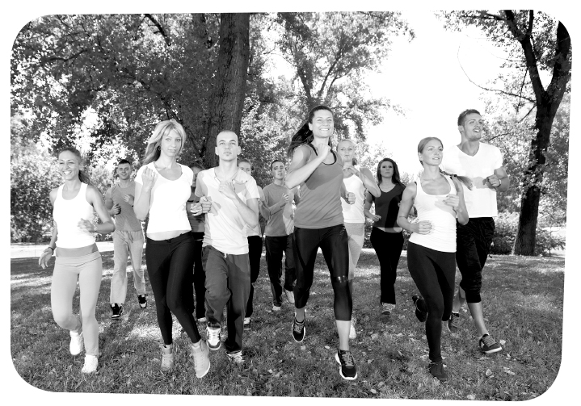
Speaking • Part 3

(3 minutes)

Look at one of the following photographs and talk by yourself about what you see.

Speaking • Part 4

(3 minutes)

Talk to your partner about how healthy your lifestyle is and how you could improve it.

71
Unit 2 – Progress tests and mock PET
72
Answer Key

Test 1

A – Listening
1. b.
2.1. c; 2.2. b; 2.3. c.
3.1. c; 3.2. a; 3.3. c.

B – Reading
1. a.
3. b. vegan.
4. a. 4; b. 1; c. 3; d. 2.
5.1. b; 5.2. b; 5.3. b; 5.4. a.

C – Language

1. a. realised… hadn’t lost; b. hadn’t gone… felt.
2. a. decided… thought; b. had never been… imagined.
3.1. c; 3.2. b; 3.3. a; 3.4. b; 3.5. a.
4. a. 2; b. 3; c. 1; d. 3.

Test 2

A – Listening
1. b.
2.1. c; 2.2. b; 2.3. c.
3.1. c; 3.2. a; 3.3. c.

B – Reading
1. a.
3. b. vegan; c. feel healthier, avoiding unhealthy food, saving animals’ lives; d. everyone being vegan.
4. a. 4; b. 5; c. 1; d. 3; e. 2.
5.1. She decided to become a vegan.
5.2. She received a vegan cookbook for her 13th birthday that
caused her to become more interested and confident in preparing meals.
5.3. While she cooks, Tree listens to Mika, her favourite singer.
5.4. She can take time to prepare a good breakfast because she doesn’t have to go to school.

C – Language
1. a. realised… hadn’t lost; b. hadn’t gone… felt; c. had expected.
2. a. decided… thought; b. had never been… imagined.
3. a. didn’t they; b. wasn’t it; c. aren’t I; d. don’t they; e. does she.
4. a. 2; b. 3; c. 1; d. 3; e. 1.

Test 3

A – Listening
1. a.
2.1. b; 2.2. c; 2.3. c; 2.4. b; 2.5. a.
3. a. F; b. T; c. F; d. T; e. T.

B – Reading
1. b.
3. a. A; b. B; c. B; d. B; e. C.
4. a. 6; b. 7; c. 3; d. 1; e. 2.
5.1. The text clearly refers to video games and the internet.
5.2. When they are not allowed to play games, some teens behave aggressively.
5.3. There have been some situations of extremely violent attitudes and actions as a result of games.
5.4. It is parents’ responsibility.
5.5. It is not very easy. In fact, some other addictions are much easier to detect.

C – Language
1. a. decided; b. thought; c. didn’t you try; d. hadn’t wanted/ didn’t want; e. made; f. had made.
2. a. aren’t they; b. can’t they; c. mustn’t you; d. aren’t I.
3. a. may; b. Would; c. shouldn’t; d. Should.
4. a. 1; b. 3; c. 2; d. 3; e. 1.
Mock PET (Unit 2)

READING
Part 1 – 1. C; 2. B; 3. A; 4. C.
Part 2 – 5. D; 6. A; 7. C.
Part 3 – 8. A; 9. B; 10. A; 11. B; 12. B.
Part 4 – 13. B; 14. C; 15. B.
Part 5 – 16. A; 17. C; 18. D; 19. C; 20. C; 21. A; 22. C.

WRITING
Part 1 – 1. I had eaten; 2. mustn’t use; 3. Can we go; 4. must;
5. should.
Part 2 – 6. Personal answer.
Part 3 – 7. and 8. Personal answers.

LISTENING
Part 1 – 1. C; 2. A; 3. A; 4. C.
Part 2 – 5. B; 6. C; 7. B; 8. B; 9. A; 10. C; 11. A.
Part 3 – 12. Hannah; 13. Oaxley; 14. KM 66540; 15. EX2 7NR; 16. Kitchen Machine; 17. Thermix Silver 2000.
Part 4 – 18. A; 19. B; 20. B; 21. A; 22. B; 23. B.

AUDIO SCRIPTS

Tests 1 and 2

CD 4 – Track 20
The worst foods you can eat

Processed meats – Consuming these products regularly
(meaning several times a week) puts you at risk for various
serious diseases. What exactly are processed meats, anyway?
Any meat that has been salted or undergone a chemical process – such as hot dogs, ham or smoked meats – falls into this category.
Mayonnaise sauce – You may not realise just how
unhealthy it is. One tablespoon contains 90 calories, 10 g of
fat, and 90 mg of sodium. This is one condiment that should be used very sparingly.
Soda and sweet drinks – Looking to lose weight? Soda
is almost always the first thing that doctors suggest you
eliminate from your diet, as it is full of sugar.

http://learni.st/users/dulcie.wilcox/boards/42349-the-worst-foods-youcan-
eat (abridged and adapted), accessed in November 2014

CD 4 – Track 21
Plate power – tips for healthy eating

1. Choose good carbohydrates. Whole grains are your best bet.
2. Pay attention to the protein you eat. Poultry, fish, nuts and
beans are the best choices.
3. Choose foods with healthy fats, limit foods high in
saturated fat, and avoid foods with trans-fat. Plant oils, nuts,
and fish are the healthiest sources.

http://www.hsph.harvard.edu/nutritionsource/2013/11/06/healthy-eating-tennutrition-tips-for-eating-right/ (adapted and abridged), accessed in November 2014
Test 3

CD 4 – Track 22
Too much of a good thing?

You may think you can’t get too much of a good thing, but in the case of exercise, a healthy activity can sometimes turn into an unhealthy compulsion.
Rachel and her cheerleading team practise three to five times a week. Rachel feels a lot of pressure to keep her weight down –as head cheerleader, she wants to set an example to the team. So she adds extra daily workouts to her regimen.
We all know the benefits of exercise, and it seems that everywhere we go, we hear that we should exercise more.
The right kind of exercise does great things for your body and soul: it can strengthen your heart and muscles, lower your body fat, and reduce your risk of many diseases.

Unit 2 – Progress tests and mock PET
Mock PET

Part 1

CD 4 – Track 23
1. Where did you have breakfast?
Girl: Did you have breakfast at school this morning?
Boy: No, I went to the new café.
Girl: Is that the one in the new shopping centre?
Boy: No it’s the one around the corner. I was actually
planning to ride into the city centre, but I found a space to
park my motorbike right outside so I decided to go there.

CD 4 – Track 24
2. What sort of breakfast did you eat?
Woman: What did you have for breakfast?
Girl: I had a cooked breakfast at the new café.
Woman: Did you have scrambled eggs and bacon?
Girl: No, I chose a full breakfast: sausages, bacon,
mushrooms, a fried egg, beans and some toast.

CD 4 – Track 25
3. Where will we have dinner?
Man: Would you like to go out for dinner?
Woman: Yes. Why don’t we go to Govinda’s, the one with
the yellow and pink front?
Man: What about the vegan restaurant? We haven’t tried it yet.
Woman: Is it Manna?
Man: No. I don’t really know the name. It’s a beautiful red
brick house with two floors. The doors and windows are
painted white and the sun blinds are black. It’s just beside
the traffic light.
Woman: Ok. Let’s go there.

CD 4 – Track 26
4. Which gym did you choose?
Mark: Why didn’t you go the gym I told you about?
Alan: Because there were no windows and it looked rather old.
Mark: What does your gym have to offer?
Alan: The facilities are excellent. It’s a very modern
building. And there’s lots of natural light because the walls
on the second floor are all made of glass. Also, the location
is great as it overlooks the wood nearby. You can’t park
nearby so people have to walk there.

Part 2

CD 4 – Track 27
Jill: Hi Paul!
Paul: Jill! I haven’t seen you for so long. How’re you doing?
Jill: Fine. And you Paul?
Paul: I’m fine thanks.
Jill: Do you still work for that gym in Wells Street?
Paul: Well, yes. I suppose you could say that. I own it now. I’m the manager.
Jill: That’s great news. How did that happen?
Paul: Do you remember Ted? He always wanted to own his own gym so when he heard this gym was for sale, he got in touch with me and we agreed that it was a great opportunity
to start our own business.
Jill: I’ve been trying to find the courage to enrol in a gym.
Paul: We’ve got a special promotion for new members. You
get a 20% discount during the first year and you don’t have to
pay an enrolment fee. You also get free access to all the areas
of the gym: the sauna and the swimming pool, for example.
Members can also try any class they’re interested in before
they decide whether to join it or not. Zumba and Pilates
seem to be what everyone’s doing at the moment – men and
women.
Jill: But I’ve got no idea about what classes I want to do.
Paul: No problem. We’ve got a team of people to advise and
counsel our new members. They’ll start by making a plan of
the exercises you should do and the types of foods you should
eat to make sure you get the most from your experience.
Jill: That’s great!
Paul: Family members also get a yearly discount, but they
can’t use your free access card. If they become members,
they’ll get the same benefits.
Jill: Sounds great.
Paul: We’ve just opened up a café at the gym, which was
something I’d always wanted to do. The emphasis obviously
is on healthy food for everyone. For example, vegans and
vegetarians, can depend on us to serve them up an enjoyable
meal there.
Jill: It really sounds like the type of gym I’d like to exercise in.
Where is it?
Paul: I’m on my way there now. You could come with me
if you like. When we’re there I’ll find someone to show you
around before you make your decisions. I’m afraid I’ve got an
important business meeting; otherwise I’d show you around
myself.
Jill: No problem. Thanks, Paul.

Part 3

CD 4 – Track 28
My name is Hannah Oaxley. My name is not spelt A-double
N-A. No, it is H-A–double N–A– Oaxley is spelt O-A-X-L-E-Y.
Today I had to call a retailer to complain about their faulty
service. I started the conversation by saying that I was
phoning about a product I ordered but hadn’t received yet.
The assistant wanted to know when I had ordered it. I told
her I had ordered it three weeks before and that I was told it
would be delivered in seven days, maximum. But I still hadn’t received anything. I had to give the assistant the reference number I received in the email following the purchase. I still remember it, because I had to repeat it so many times: KM 66540. Then I had to confirm my postcode. It’s a good thing that I memorised it, otherwise I’d have to look it up and the call would take even longer.
It’s EX2 7NR, New Road, Exeter. My house number is 222.
I also had to repeat I because the assistant didn’t get it the first time. I ordered a kitchen machine, and when I ordered it I was promised it would take no more than five days to be delivered, but I told the assistant I’ve been waiting nearly one month for it to be delivered. A bit more than three weeks, to be more precise. “And you know,” I told her, “I paid when I ordered so it would arrive more quickly.” She asked me if I had used a credit card to pay for the machine and I confirmed. I wondered if this could be the problem, maybe they don’t like people paying with credit cards. She said it was all right. I clearly remembered the make
I ordered and the model too: a Thermix, Silver 2000. I thought it would perfect in my kitchen, which is all white.
Finally, the problem was identified. The model of the machine I ordered wasn’t included on the order form and that’s why my machine hadn’t been delivered yet. They didn’t know which model I wanted and there are five different models available. The assistant wrote the model down and said they could send it to me immediately today. I’ll get it in 2 or 3 days. I feel so excited! I can hardly wait to start cooking delicious meals with this machine. It literally does everything for you! I decided I didn’t want to file a complaint against the company for not delivering the kitchen machine on time now that it’s on its way. It might even take longer for it to be delivered!

73
Unit 2 – Progress tests and mock PET

Part 4

CD 4 – Track 29

Presenter: So, Jonathan, what was it like growing up as the son of well-known Chef?
Jonathan: Well, I guess my childhood was a bit different from most children’s. For instance, when I was four I just loved helping my father around the kitchen, and my mother made sure I spent some time at my father’s restaurant every day.
Presenter: Don’t you think it was dangerous for such a young child to be in the kitchen while meals were being prepared?
Jonathan: No, not really. I was only allowed in the kitchen before the restaurant opened for dinner. I had an early dinner at the restaurant with Mum and Dad. I was never allowed to eat unhealthy food. There were always lots of vegetables and either fish or meat on my plate. No chips, no ketchup and no mayonnaise. Those were the rules. Both my parents were very strict about the family’s diet.
Presenter: Now you’re about to become a Chef yourself. Do
your parents agree with your choice of career?
Jonathan: They’ve always encouraged me to follow my heart.
I don’t think it came as a surprise to them that I chose
cooking. My happiest moments as a child were in the
kitchen. At home with Mum or at the restaurant with Dad
and the team of cooks and staff in the restaurant. People say
that home is where you are happy, so the restaurant kitchen
must be my home.
Presenter: Many people say you’re an even better cook than
your dad. Do you agree?
Jonathan: No, not at all. Dad has been a Chef for more than
thirty years. I’ve just started my career. Actually, when he
was my age my father had already won several international
cookery prizes. He’s always been very active and innovative.
I like to take my time doing my things. I’d say I take after my mother.
Presenter: Do you think you’ll end up working with your father at his restaurant?
Jonathan: Maybe. My motivation and interest in cookery are the result of all the years I worked with my father. But I think it’s still too early to make that decision. I want to work with other people, to get more experience and knowledge. I want to try to be as good as he is.
Presenter: Thank you for talking to us, Jonathan.
Jonathan: Thank you.

74
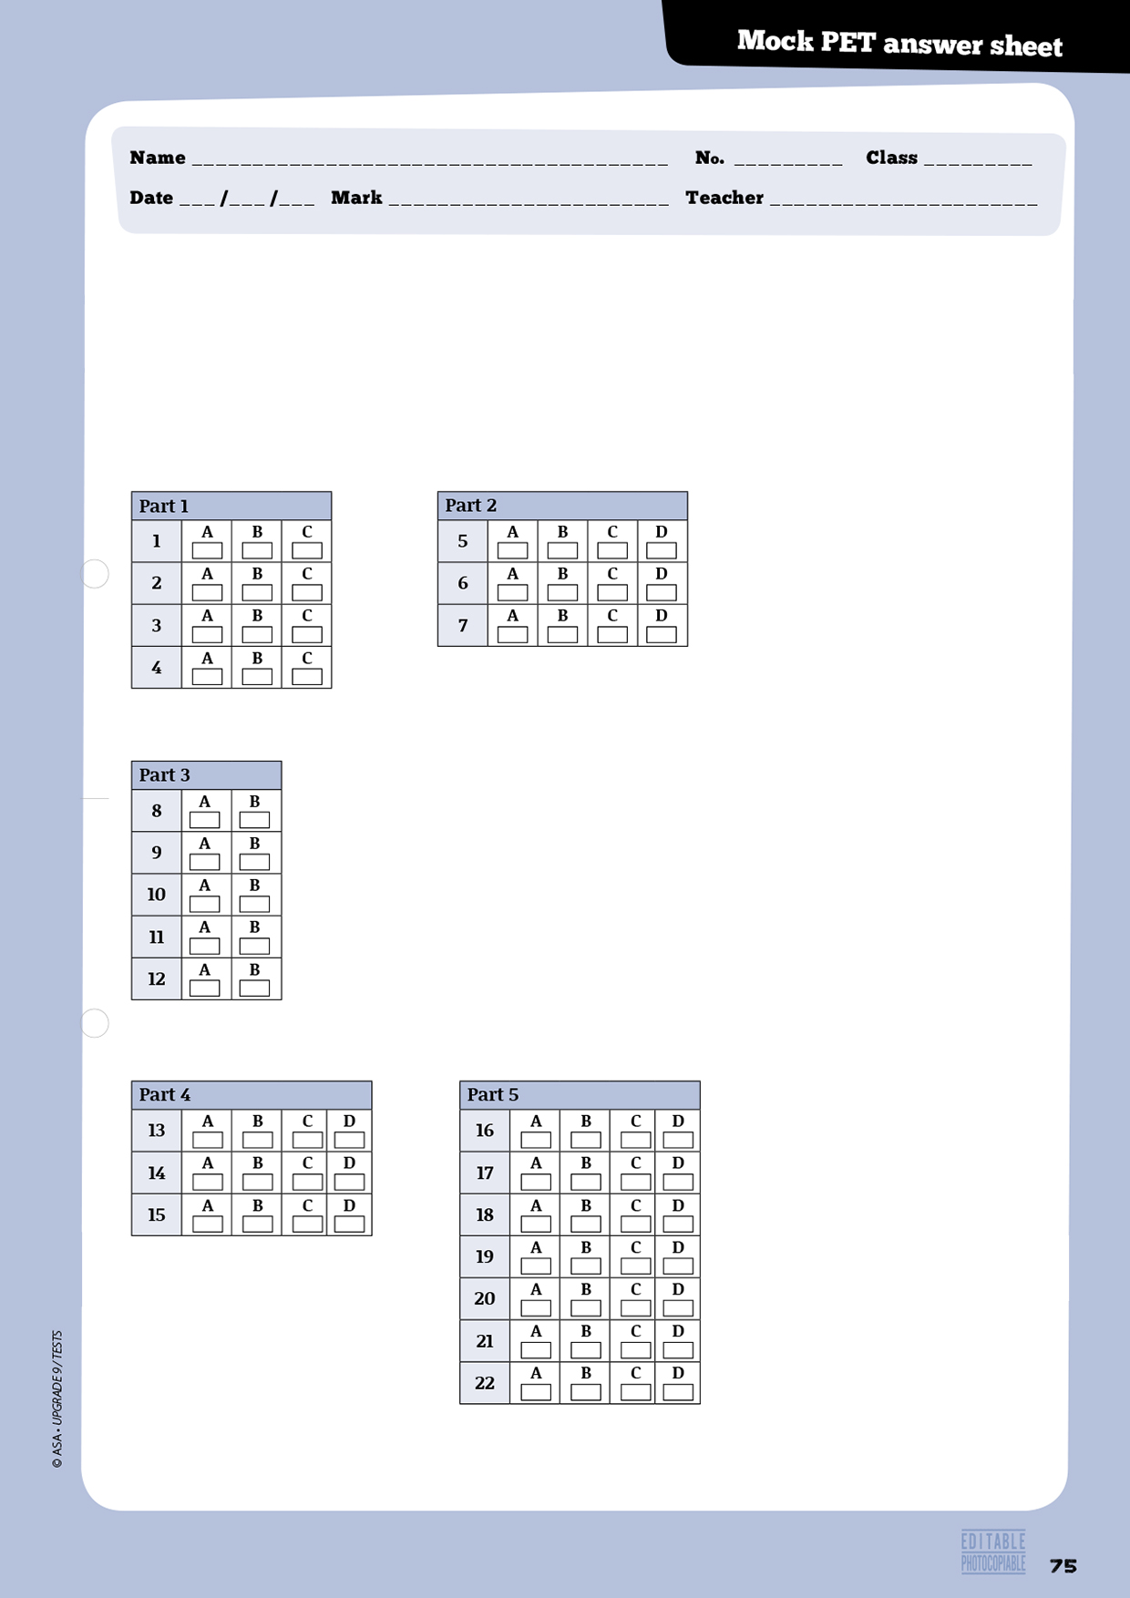
Reading

Instructions

For parts 1, 2, 3, 4 and 5, mark ONE letter for each question.

7
8
Writing

Instructions

For parts 1, 2 and 3, write your answers in the spaces provided.

Part 1: write your answer below.
1
2
3
4
5

Part 2 (Question 6): write your answer below.

Part 3: mark the number of the question you are answering here: →
write your answer below.

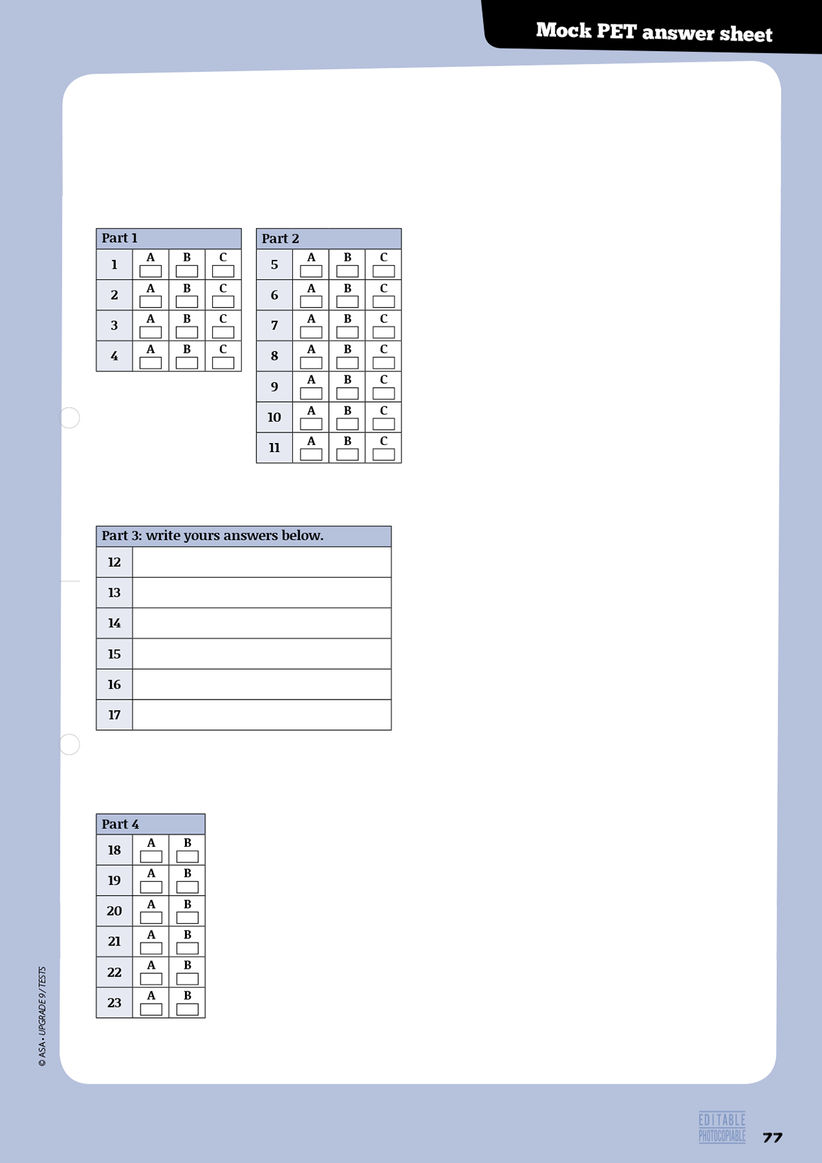
Listening

Instructions

For parts 1 and 2 mark ONE letter for each question.

Instructions

For part 3, write your answers clearly next to the numbers.

Instructions

For part 4, mark ONE letter for each question.
Progress Tests Correction Criteria
Type of items | Criteria
• Multiple choice  • True / false  • Matching  • Sequencing  • Short answer (blank filling) | • Correct/incorrect  - Sequencing items will only be given marks if the whole sequence is correct  - One mark off in true/false items for each incorrect quotation from the text, when applicable  - One mark off in true/false items for each incorrect answer, if quotation from the text is correct, when applicable
• Short answer (sentence completion;  rephrasing) | • One mark less for each language mistake, up to a maximum of 3 marks  • Incomprehensible or decontextualised answers will be marked wrong
• Short answer (text comprehension) | • One mark less for language mistakes, up to a maximum of 3 marks
• Essay | 17 to 20: The student shows excellent writing skills; totally respects the topic or text type; presents his own ideas about the topic, contextualises and develops them; uses appropriate and varied cohesive devices; organises the text in a coherent manner; mistakes (structure or spelling) are irrelevant for the comprehension of message.
• Essay | 13 to 16: The student shows reasonable writing skills; respects the topic or the text type; presents some ideas about the topic and contextualises them; uses simple cohesive devices to text but not always sucessefully; choice of words is good; makes few mistakes (structure or spelling) which hardly affect message.
• Essay | 9 to 12: The student shows some writing skills; respects the topic or the text type; presents some ideas about the topic and tries to contextualise them; uses some cohesive devices but the text is slightly disorganised; choice of words is reasonable; makes some mistakes (structure or spelling) which sometimes make message slightly confusing.
• Essay | 5 to 8: The student shows poor writing skills; mostly respects the topic or the text type; presents some ideas about the topic but the text is slightly confused; uses few cohesive devices but the text is not well organised; choice of words is poor; makes some mistakes (structure or spelling) which sometimes impede meaning.
• Essay | 0 to 4: The student shows very poor writing skills; doesn’t fully respect the topic or the text type; ideas are scarce and mostly decontextualised; uses few cohesive devices and the text is disorganised; choice of words is very poor; makes many mistakes (structure or spelling) which sometimes make message incomprehensible or illegible.  Note: the student will get 0 marks if the topic or text type is not respected, or if the whole text is incomprehensible or illegible.


74
© ASA • UPGRADE 9 / TESTS
 |  | A - Listening |  |  |  | B - Reading |  |  |  |  | C - Language |  |  |  |  | D - Writing |  | Total | Mark
 |  | 1 | 2 | 3 | Total | 1 | 2 | 3 | 4 | Total | 1 | 2 | 3 | 4 | Total | 1 | Total | Total | Mark
No. | Name |  |  |  | 20 |  |  |  |  | 30 |  |  |  |  | 30 |  | 20 | 100
1
2
3
4
5
6
7
8
9
10
11
12
13
14
15
16
17
18
19
20
21
22
23
24
25
26
27
28
29
30

74

