


Progress Tests

Unit 3 – Life changes
Table of specifications 3
Test 1 4
Test 2 8
Test 3 12
Mock PET for Schools Test 16
Answer Key / Audio Scripts 28

Unit 4 – S mart and techy
Table of specifications 31
Test 1 32
Test 2 36
Test 3 40
Mock PET for Schools Test 44
Answer Key / Audio Scripts 56

Mock PET answer sheet 59
Progress Tests correction criteria 62
Progress Tests correction grid 63

© ASA • UPGRADE 9 / TESTS
3
Table of specifications
Progress Tests (Unit 3)

Skills | Contents |  | CEF competences | Types of items | Number  of items | Marks
Skills | Topics | Language
A – Listening | Living updates  Trendy jobs  Smart and techy | Grammar  • Conditionals –  type 0 and 1  • Conditionals –  type 2  • Phrasal verbs  Vocabulary  • Life and work  changes  • Technological  innovations | Linguistic  • lexical  • grammatical  • semantic  • orthographic  Pragmatic  • functional  • discoursive | • Multiple choice  • Sequencing  • Matching  • Short answer (blank  filling; sentence  completion;  rephrasing)  • Short answer  (text comprehension) | 3 | 20
B – Reading  (200-300  words) |  |  |  |  | 4 | 30
C – Language |  |  |  |  | 4 | 30
D – Writing | Living updates  Trendy jobs  Smart and techy |  |  | • Essay (80 words) | 1 | 20

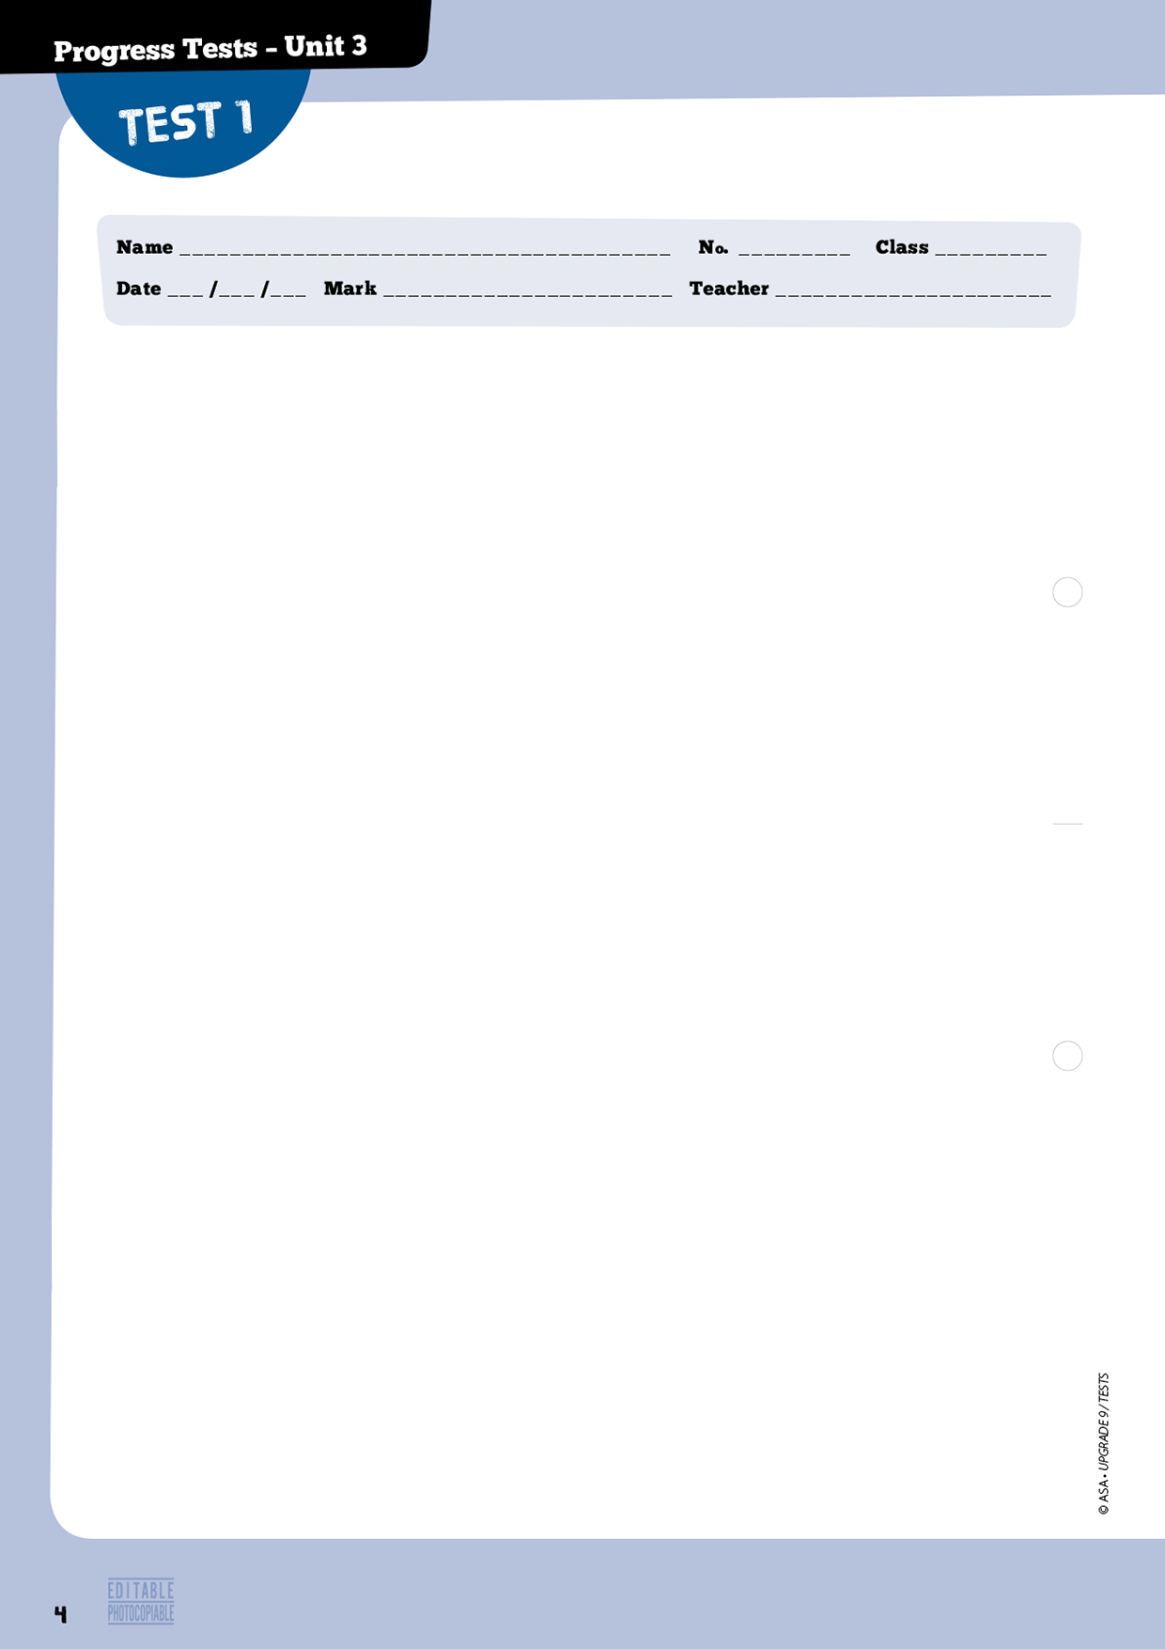

A – Listening 20 marks

1. Listen to a text about one of the world’s oddest jobs. Choose the correct option. 4 marks

1.1. Which food is mentioned in the text?

□a. □b. □c.

2. You will listen to a man talking about why non-tech people should apply for jobs in technology. Listen to part 1 and decide if each sentence is true or false. If it is true, put a tick () under YES.
If it is false, put a tick () under NO. 8 marks (4x2 marks)

Yes No
a. People who own electronic gadgets don’t know anything about the tech revolution. □ □
b. Anyone can apply for jobs related to technology. □ □
c. There aren’t many jobs available in the technology industry. □ □
d. People have to be intelligent and fast learners to work in technology. □ □

3. Now listen to part 2 and choose the correct option. 8 marks (4x2 marks)

3.1. How is most training done nowadays?
□ a. Informally. □b. Formally. □c. Through workshops.
3.2. In technology related jobs you learn the job by…
□ a. working, observing and helping other people.
□ b. observing, communicating with colleagues and taking part in projects.
□ c. listening, communicating with colleagues and taking part in projects.
3.3. One of the positions in which you can increase your skills is…
□ a. product developer. □b. president. □c. cleaner.
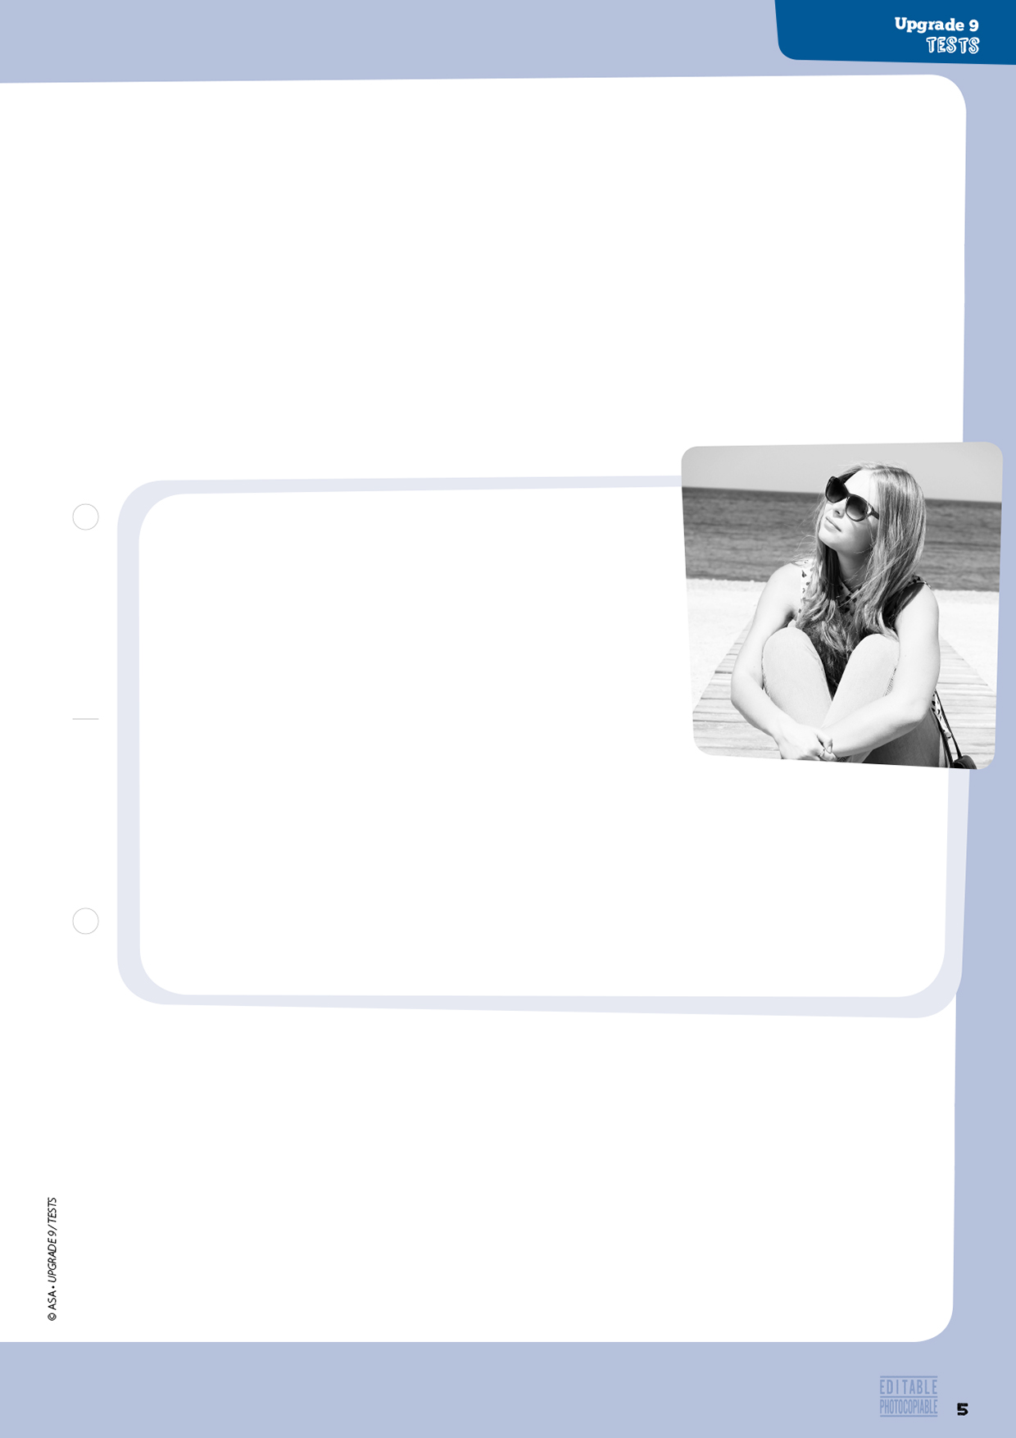
15

10

5

apprehensive (l. 6) a. 1. grief
agony (l. 9) b. 2. happiness
irrational (l. 12) c. 3. diminish
reduce (l. 14) d. 4. Nervo
5. unreasonable
3.4. The greatest advantage of working in technology is…
□ a. the creation of products.
□ b. the creation of solutions.
□ c. the creation of products and solutions.

B – Reading 30 marks

1. Do you ever feel anxious about your school work and marks? Why/Why not?
Answer the question in 15 - 20 words. 5 marks

2. Read the text below.

3. Match the words from the text to their synonyms on the right. One isn’t used. 4 marks (4x1 mark)

How teens cope with anxiety

Say your best friend tells you she’s going to the airport with her dad to learn to skydive. She’s totally excited. But just thinking of skydiving makes you very nervous.
For teens or anyone else, anxiety is a normal reaction to stress. Things like tests, meeting new people, speaking in public, going on a date, and competing in sports can make us feel apprehensive or upset. But some teens react much more strongly to stressful situations than others. Even thinking about the situations may cause them great agony.
Anxiety can be a good thing when it helps you deal with a tense situation. For example, when you’re studying for a test, a little anxiety can make you want to study hard so you do well. But at other times, anxiety can be harmful, especially when it is excessive and irrational, and prevents
you from being able to focus.
To reduce normal levels of anxiety, set aside a period of about 20 minutes each day to relax. Stay away from distractions as much as possible. Turn off the sound on your computer and the ringer
on your cell phone. Some silence will help you calm down and get ready for a stressful situation.

http://teens.webmd.com/anxiety-and-teens (adapted and abridged), accessed in December 2014


4. Choose the correct option. 9 marks (3x3 marks)
4.1. What type of text is this?
□ a. An article.
□ b. A blog post.
□ c. An opinion text.

4.2. Anxiety is positive when it helps you...
□ a. deal with tense situations.
□ b. meet new people.
□ c. do your homework.

4.3. One of the disadvantages of anxiety is that...
□ a. it makes you work.
□ b. you lose your concentration.
□ c. you react irrationally.

5. Complete the sentences below. 12 marks (4x3 marks)
a. Anxiety is caused .
b. Not all teens react to .
c. You can reduce anxiety by .
d. Silence will both for a stressful situation.

C – Language 30 marks

1. Choose the best word for each space. 10 marks (5x2 marks)
One reason a. ………….….…..…….. society expects so much b. ………………..….…….. teens and children is c. ………….…………….. there are so many technological resources available. d. ………....….………….. the advances in technology, young people e. ………….……....……….. use innovative resources to support their research and study.

 | 1. | 2. | 3. | 4.
a. | who | why | what | whose
b. | from | for | on | in
c. | which | who | that | whose
d. | Because | As a result of | However | Although
e. | can | must | could | shouldn’t



2. Choose the correct phrasal verb to complete the sentences. 8 marks (4x2 marks)

Different people choose different ways to a. take up / let off / back up steam. Some like to b. log in / pop up / hang out with their friends after school or after work. Others c. freeze up / take up / set up some sort of physical activity: going for a walk or exercising at the gym, for example. I myself like going for a walk every day after a day of study and work and it is so relaxing that I don’t think I’ll ever d. give up on / hack into / be into it.

3. Choose the correct option. 6 marks (4x1,5 marks)

If you a. didn’t / don’t relax, you b. will / would feel anxious and it c. will / would affect the quality of your work and your life unimaginably. But if you became a compulsive worker, your life d. will be / would be much more lonely than it is.

4. For each question, complete the second sentence so that it means the same as the first sentence.
Use no more than two words. 6 marks (3x2 marks)
a. Don’t pressurise your children or else they will become anxious.
If you …………………….. your children, they will become anxious.
b. Teenagers feel stressed. They don’t work or study.
If teens didn’t feel stressed, they …………………….. and study.
c. Demanding too much from students makes them feel demotivated and worried.
If you demand too much from students, they …………………….. demotivated and worried.

D – Writing 20 marks

Write a blog entry about The best way to relax from school work.
Write about 80 words on your answer sheet.
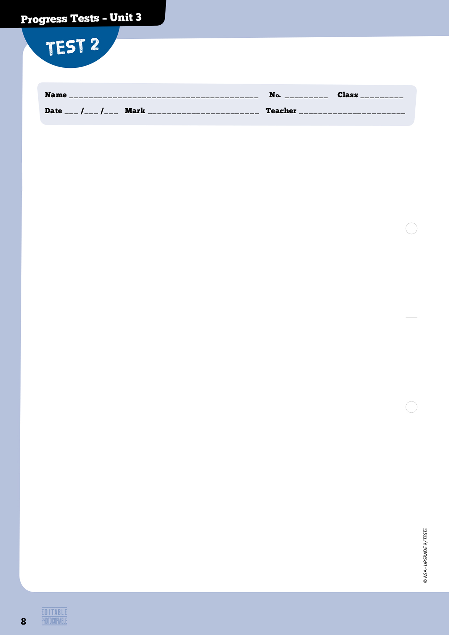

A – Listening 20 marks

1. Listen to a text about one of the world’s oddest jobs. Choose the correct option. 4 marks

1.1. Which food is mentioned in the text?

□a □b □c

2. You will listen to a man talking about why non-tech people should apply for jobs in technology.
Listen to part 1 and decide if each sentence is true or false. If it is true, put a tick () under YES.
If it is false, put a tick () under NO. 8 marks (4x2 marks)

Yes No
a. People who own electronic gadgets don’t know anything about the tech revolution. □ □
b. Anyone can apply for jobs related to technology. □ □
c. There aren’t many jobs available in the technology industry. □ □
d. People have to be intelligent and fast learners to work in technology. □ □

3. Now listen to part 2 and choose the correct option. 8 marks (4x2 marks)

3.1. How is most training done nowadays?
□ a. Informally. □ b. Formally. □ c. Through workshops.
3.2. In technology related jobs you learn the job by…
□ a. working, observing and helping other people.
□ b. observing, communicating with colleagues and taking part in projects.
□ c. listening, communicating with colleagues and taking part in projects.
3.3. One of the positions in which you can increase your skills is…
□ a. product developer. □ b. president. □ c. cleaner.
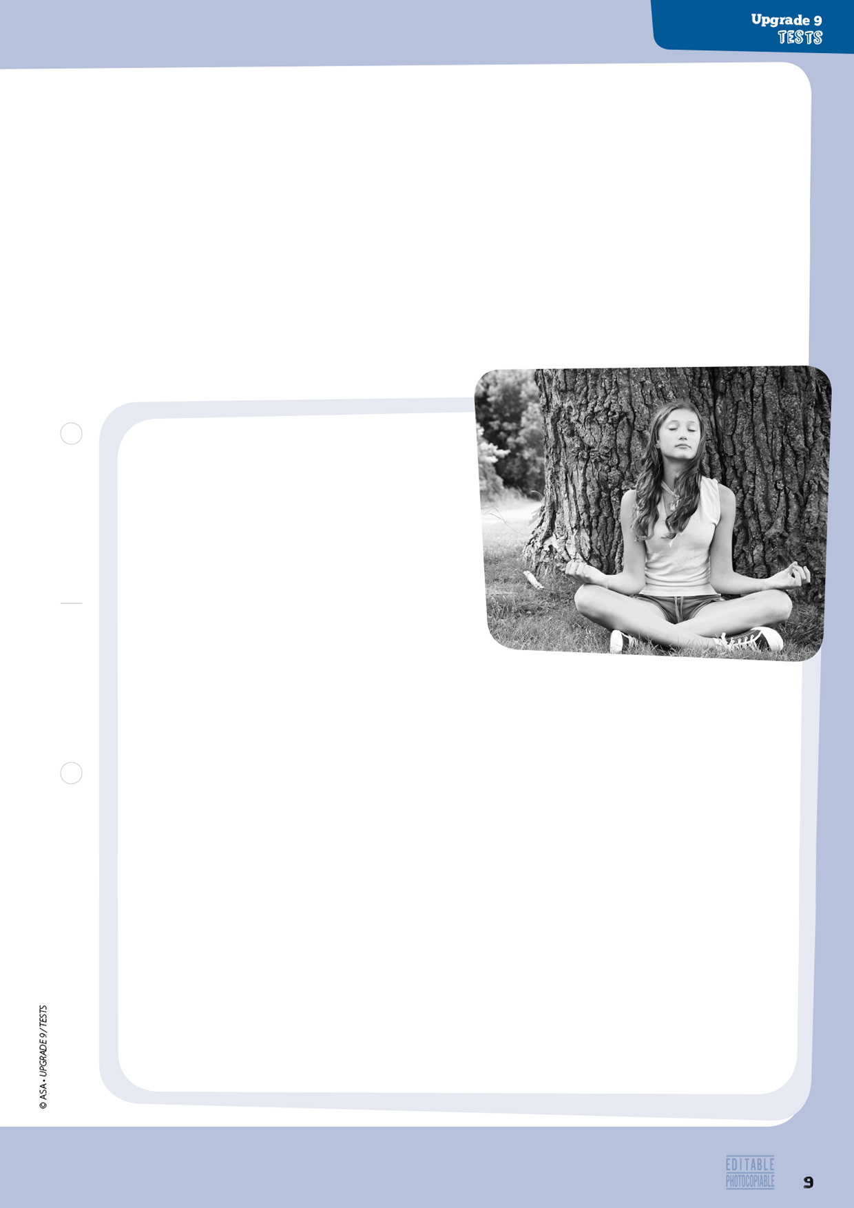

3.4. The greatest advantage of working in technology is…
□ a. the creation of products.
□ b. the creation of solutions.
□ c. the creation of products and solutions.

B – Reading 30 marks

1. Do you ever feel anxious about your school work and marks? Why/Why not? 5 marks
Answer the question in 15 - 20 words.

2. Read the text below.

How teens cope
with anxiety

Say your best friend tells you she’s going to the airport with her dad to learn to skydive. She’s totally excited. But just thinking of skydiving makes you very nervous. Your stomach hurts, your heart races, and you feel a lump in your throat when you try to swallow.
5
10
15
20
25

For teens or anyone else, anxiety is a normal reaction to stress. Things like tests, meeting new people, speaking in public, going on a date, and
competing in sports can make us feel apprehensive or upset. But some teens react much more strongly to stressful situations than others. Even thinking about the situations may cause them
great agony.

Anxiety can be a good thing when it helps you deal with a tense situation. For example, when you’re studying for a test, a little anxiety can make you want to study hard so you do well. But at other times, anxiety can be harmful, especially when it is excessive and irrational, and prevents
you from being able to focus.

Sometimes the anxiety can come between you and your friends, especially when you avoid
going out with them or calling them because you’re too panicked or tense. This level of anxiety is harmful and that’s when you need to do something to feel less anxious so you can fully enjoy your teenage life.

Many teens find ways to cope with the high anxiety they feel. Sometimes just admitting that a situation is stressful and being prepared to deal with it can reduce your anxiety. To reduce normal levels of anxiety, set aside a period of about 20 minutes each day to devote to relaxation. Remove distractions as much as possible. Turn off the sound on your computer and the ringer on your cell phone. Some silence will help you calm down and get ready for a stressful situation.

http://teens.webmd.com/anxiety-and-teens (adapted and abridged), accessed in December 2014
How teens cope
with anxiety
Say your best friend tells you she’s going to the airport with her dad to learn to skydive She’stotally excited. But just thinking of skydiving makes you very nervous. Your stomach hurts, your heart races, and you feel a lump in your throat when you try to swallow.

For teens or anyone else, anxiety is a normal reaction to stress. Things like tests, meeting new people, speaking in public, going on a date, and competing in sports can make us feel apprehensive or upset. But some teens react much more strongly to stressful situations than others. Even thinking about the situations may cause them great agony.

Anxiety can be a good thing when it helps you deal with a tense situation. For example, when you’re studying for a test, a little anxiety can make you want to study hard so you do well. But at other times, anxiety can be harmful, especially when it is excessive and irrational, and prevents you from being able to focus.

Sometimes the anxiety can come between you and your friends, especially when you avoid going out with them or calling them because you’re too panicked or tense. This level of anxiety is harmful and that’s when you need to do something to feel less anxious so you can fully enjoy your teenage life.

Many teens find ways to cope with the high anxiety they feel. Sometimes just admitting that a situation is stressful and being prepared to deal with it can reduce your anxiety. To reduce normal levels of anxiety, set aside a period of about 20 minutes each day to devote to relaxation. Remove distractions as much as possible. Turn off the sound on your computer and the ringer on your cell phone. Some silence will help you calm down and get ready for a stressful situation.

http://teens.webmd.com/anxiety-and-teens (adapted and abridged), accessed in December 2014
5

10

15

20

25

apprehensive (l. 10) a. 1. grief
agony (l. 12) b. 2. happiness
irrational (l. 15) c. 3. diminish
reduce (l. 22) d. 4. Nervous
5. unreasonable

10
3. Match the words from the text to their synonyms on the right. One isn’t used. 4 marks (4x1 mark)

4. Choose the correct option.
9 marks (3x3 marks)
4.1. What type of text is this?
□ a. An article.
□ b. An opinion text.
□ c. A blog post.

4.2. Anxiety is positive when it helps you...
□ a. deal with tense situations.
□ b. meet new people.
□ c. do your homework.

4.3. One of the disadvantages of anxiety is that...
□ a. it makes you work.
□ b. you lose your concentration.
□ c. you react irrationally.

5. Complete the sentences below. 12 marks (4x3 marks)
a. Anxiety is caused .
b. Not all teens react to .
c. You can reduce anxiety by .
d. Silence will both for a stressful situation .

C – Language 30 marks

1. Choose the best word for each space. 10 marks (5x2 marks)

One reason a. ………..……..…….…. society expects so much b. …………..…..………. teens and children is c. …………………. there are so many technological resources available. d. ……...……………. the advances in technology, young people e. use innovative resources to support their research and study.

 | 1. | 2. | 3. | 4.
a. | who | why | what | whose
b. | from | for | on | in
c. | which | who | that | whose
d. | Because | As a result of | However | Although
e. | can | must | could | shouldn’t

2. Choose the correct phrasal verb to complete the sentences. 10 marks (5x2 marks)

Different people choose different ways to a. take up / let off / back up steam. Some like to b. log in / pop up / hang out with their friends after school or after work. Others c. freeze up / take up / set up some sort of physical activity: going for a walk or exercising at the gym, for example. I myself like going for a walk every day after a day of study and work and it is so relaxing that I don’t think I’ll ever d. give up on / hack into / be into it. Even if I have to do some work when I get home, once I’m ready, I e. turn on / enrol in / switch off the computer and walk for one hour, enjoying the view and the quietness around.

3. Choose the correct option. 4 marks (4x1 mark)

If you a. didn’t / don’t relax, you b. will / would feel anxious and it c. will / would affect the quality of your work and your life unimaginably. But if you became a compulsive worker, your life d. will be / would be much more lonely than it is.

4. For each question, complete the second sentence so that it means the same as the first sentence.
Use no more than three words. 6 marks (4x1,5 marks)

a. Don’t pressurise your children or else they will become anxious.
……………………….. your children, they will become anxious.
b. Teenagers feel stressed. They don’t work or study.
If teens didn’t feel stressed, ……………………….. and study.
c. Because of social pressure, teens behave in certain ways.
If there was no social pressure, teens ……………………….. in certain ways.
d. Don’t put so much pressure on teenagers.
If ……………………….., I wouldn’t put so much pressure on teenagers.

D – Writing 20 marks

Write a blog entry about The best way to relax from school work.
Write about 80 words on your answer sheet.
11


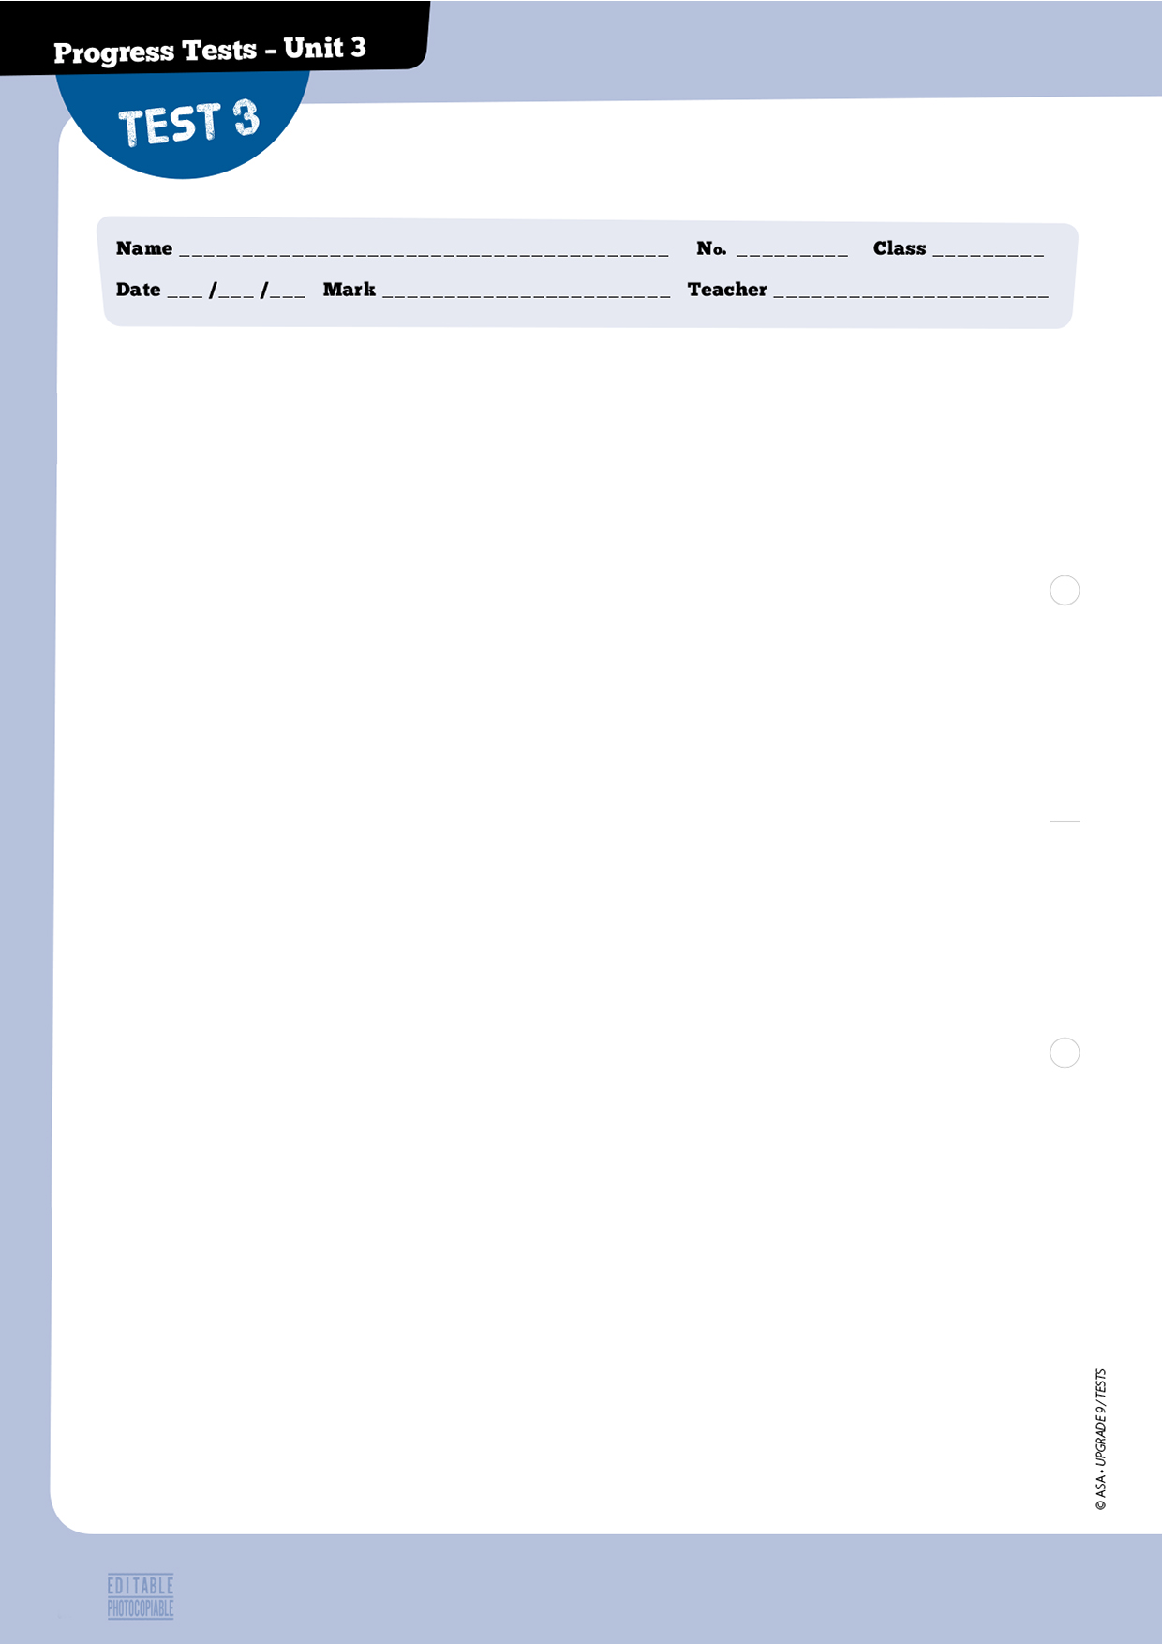
12
A – Listening 20 marks

1. You will listen to a text about one of the world’s oddest jobs. 4 marks
Choose the correct option.

1.1. What did Arnold have to polish?

□a. □b. □c.

2. You will listen to a woman talking about high school students. Decide if each sentence is true or false.
If it’s true, put a tick () under YES. If it is false, put a tick () under NO. 10 marks (5x2 marks)

Yes No
a. Anxiety disorder is considered to be very serious. □ □
b. Newport Academy is a local High School. □ □
c. Teens felt great pressure from different people. □ □
d. Annamarie cannot really point out the effects of stress. □ □
e. Jake was unable to identify the source of his fears. □ □

3. Listen to the text again and choose the correct option. 6 marks (3x2 marks)

3.1. What was Jake’s reason for anxiety?
□ a. Getting into a good High School.
□ b. Getting good marks.
□ c. Getting into the school’s football team.

3.2. If teens give up on normal activities, parents…
□ a. need not worry. □b. should call the doctor. □c. should worry.

3.3. Stress causes teens to refuse to do activities they…
□ a. enjoy. □b. fear. □c. dislike.


B – Reading 30 marks

1. How often do you use apps? Which do you prefer and why? 4 marks

2. Read the text.

A dummies’ guide to the new messaging apps

Just when I was feeling I’d generally got the hang of social tools like Facebook, Twitter, Skype and LinkedIn, I started hearing about a whole lot of new things with names like WhatsApp and SnapChat.
5
10
15
20
25
30
According to new research, the amount of time per day consumers spend using smartphones almost doubled between 2011 and 2013, from 98 minutes to 195 minutes. What are we doing? Well, we’re posting, tweeting, texting and snapping. And as we move from Facebook, Twitter and LinkedIn to Instagram, Skype and Vine, and on to WhatsApp, WeChat and SnapChat, each new app makes our actions faster and more interactive.
If your phone plan includes free data (or at least 3 gigabytes),
or you’re always connected with Wi-Fi, you’re sorted. This is the
power of these new apps. They all work through an internet connection.
The two main categories these apps can be separated into are social networking and messaging apps. This is a beginner’s guide to the two biggest messaging apps:
WhatsApp is one of the most popular messaging apps in the world with more than 600 million active monthly users. It’s the most popular mobile messaging App in India, Brazil and Mexico.
WhatsApp is like a drug. The app makes texting as fast as chatting, and it doesn’t matter where your friends are. You can make a group and open the conversation to as many friends
as you want. In this way you can receive a picture from your friend in Denmark, a comment
on it from another friend in Italy, and you can jump into the conversation whenever you want. There are simply no borders.
SnapChat was launched in September 2011 and soon became popular with young people.
It now has 100 million monthly active users, of which 71% are under 25 years old, sending
400 million snaps per day. You can snap a photo or a brief video, add a caption and send it to
a friend.
The number of messaging apps is growing all the time. With all these competing services, the power is as much in their networking abilities and size of their user base as in the
individual features they offer. It’s knowing who we can contact that keeps us hooked. But can communicating with friends really be an addiction?

http://www.bbc.co.uk/blogs/blogcollegeofjournalism/posts/WhatsApp-WeChat-or-Snapchat-A-dummies-guide-to-the-new-messaging-app (abridged and adapted), accessed in December 2014
5

10

15

20

25
got the hang (l. 1) a. 1. had no idea about
interactive (l. 11) b. 2. you’re OK
you’re sorted (l. 13) c. 3. knew how to handle
hooked (l. 31) d. 4. addicted
5. communicative with others

14
3. Match the words/expressions from the text to the words/expressions on the right.
One isn’t used. 8 marks (4x2 marks)

4. Choose the correct option. 8 marks (4x2 marks)

4.1. What does the text suggest about the writer and his take on technology?
□ a. He thinks he is updated.
□ b. He knows a lot about apps.
□ c. He believes he is outdated.

4.2. Why are people turning to the new apps?
□ a. They let you communicate more in less time.
□ b. They’re cheaper and quicker.
□ c. They’re more trendy and updated

4.3. The power of the new apps is that…
□ a. users are charged less than with regular networks.
□ b. they all use the internet.
□ c. users must use Wi-Fi to be connected.

4.4. What categories can apps be divided into?
□ a. Social networking and connecting apps.
□ b. Messaging apps and online accessing.
□ c. Social networking and messaging apps.

5. Complete the sentences below 10 marks (4x2,5 marks)
a. WhatsApp is widely used in …………………………..………… and .
b. SnapChat has been on the market .
c. People who want to share pictures and videos should .
d. It is suggested that people keep on using these apps because they know .

let off
hack into
switch off
take up
pop up
C – Language 30 marks

1. Choose the best word/expression for each space. 8 marks (4x2 marks)

Technology is one of the most important forces in our society today – we use it a. …………………….………… to connect and to save/waste time –, b. ……………...…………… we’re especially dependent on the professionals who make those tasks c. ………………………, powering and supporting our electronics and information systems. Employment numbers are d. …………………… high within the tech industry, but this is expected to be one of the fastest-growing job market between 2012 and 2022.

 | 1. | 2. | 3.
a. | both | and | too
b. | but | because | so
c. | effective | impossible | possiblet
d. | recently | already | lately

2. Complete the text with the correct form of the phrasal verb. One isn’t used. 10 marks (4x2,5 marks)

Surfing the net I find additional information about what I’m studying. My parents keep telling me I should a. ……………….. the computer so that I can focus better. I try to explain that the ads that keep b. ……………….. on screen do not disturb me and that it is a way of studying and c. ……………….. steam at the same time. I wish my parents would understand that the method of study I d. ……………….. is effective.

3. Choose the correct option. 4 marks (4x1 mark)

Nowadays if you a. use / used the internet, you b. will get / would get access to invaluable information and it c. will enrich / would enrich your life considerably. But if you become a compulsive user, you d. will be / would be much lonelier than you are now.

4. For each question, complete the second sentence so that it means the same as the first sentence.
Use no more than three words. 8 marks (2x4 marks)
a. You shouldn’t give up on high school.
If ………………….., I wouldn’t give up on high school.
b. Because of overwork, teenagers develop feelings of anxiety, fear and insecurity.
Teenagers wouldn’t develop feelings of anxiety, fear and insecurity…………………………….. not overwork.

D – Writing 20 marks

Write a blog entry about The best way to relax from school work.
Write about 80 words.

15






16

Reading • Part 1

Questions 1 – 4

Look at the text in each question.
What does it say?
Mark the correct letter A, B or C on your answer sheet.

1

What does this sign refer to?
A Electronic messages you should read before others.
B Electronic messages you have sent to others.
C Electronic messages which may be dangerous.

2

What is the purpose of the advert below?
A To tell people about ways they can avoid fraud.
B To teach people about ways to commit fraud.
C To warn people against becoming hackers.

3

A The laptop needs to be recharged tomorrow.
B The laptop is Jean’s.
C The laptop belongs to Dad.

4

A People cannot access the internet there.
B People have to pay to use the internet there.
C People must use their own internet device there.
16





A App Developer – The iPhone was introduced in 2007, the Android shortly after. Since then, more than a million apps have been put up for sale in Apple’s App Store and Android’s Google Play. This means fresh opportunity for programmers and developers to break into a booming market.

C User Experience Design – What is user experience design? Quite simply, experiences created and shaped through technology and how to make them happen. A user experience designer’s concern is how to create sounds from nature through technology. Would-be designers should be fluent in Photoshop, understand programming languages like CSS and HTML and feel comfortable taking an idea from its initial plan to the final product or experience.
B Educational or Admissions Consultants – When some parents watch their child stack his or her first set of blocks, more than enjoying a cute moment, they’re trying to work out if their child will get into the right pre-school. Admissions consultants may help with the process of interviewing and testing into schools from preschool to college. Admissions consultants can be paid thousands of dollars for their skills – which often include a very good knowledge of the schools and their achievements.

D Chief Listening Officer – Chief Listening Officers keep their ears (and eyes) on social channels and real life conversations to tell the company what their customers are saying. A Chief Listening Officer may spend his time monitoring people on Facebook, Twitter, message forums, YouTube, blogs, and elsewhere on the Web each day. Then that information is moved to the relevant department.
5 Richard, 18, is into technology and mobiles. Both his education and
professional experience have allowed him to develop skills which he
wants to use to create innovative Applications.
7 Ellen, 38, is an experienced educational psychologist who wants to work
with children and parents. She thinks that she can help and counsel
parents to avoid all the worry and stress involved in selecting a school
which will fit their children’s characters and the parents’ expectation.
6 Geoffrey is 23 and he is a real technology buff. He uses software from
Radian6 and PeopleBrowsr to find out what people’s interests are and
what they use technology for. He hopes to use his skills in his future job.
Reading • Part 2

Questions 5 – 7

The people below all want to find an innovative job. Below there are four jobs which have been
created during the past ten years to fit new needs and requirements. Decide which job would be
suitable for the following people.

For questions 5 – 7, mark the correct letter (A – D) on your answer sheet.

17


Reading • Part 3

Questions 8 – 12

Look at the sentences below about natural remedies for anxiety.
Read the text to decide if each sentence is correct or incorrect.
If it is correct, mark A on your answer sheet.
If it is not correct, mark B on your answer sheet.

8 Evidence shows that natural remedies may contribute to make someone less anxious.

9 If a person is fit, he is less likely to be relaxed and unworried.

10 It does not take a long exercise session to make someone less worried.

11 People’s diet has no effect on their levels of anxiety or stress.

12 There seems to be no natural solution for depression.

Natural remedies for anxiety

There are many safe natural remedies for anxiety, from
mind-body techniques to supplements to calming teas. Some start working right away, while others may help reduce anxiety over time.
Exercise – Exercise is safe, good for the brain and a powerful antidote to depression and anxiety, both immediately and in the long term. “If you exercise on a regular basis, you’ll have more self-esteem and feel healthier,” says Drew Ramsey, “One of the major causes of anxiety is worrying about illness and health, and that dissipates when you are fit.”
Hold your breath! – We’re not recommending that you turn blue, but yoga breathing has been shown to be effective in lowering stress and anxiety. One reason it works is that you can’t breathe deeply and be anxious at the same time. Exhale completely through your mouth, then inhale through your nose for a count of four. Hold your breath for a count of seven. Now let it out slowly through your mouth for a count of eight. Repeat at least twice a day.
The 21-minute cure – Twenty-one minutes. That’s about how long it takes for exercise to reliably reduce anxiety, studies show, give or take a minute.
“I generally ask my patients to spend 20 to 30 minutes on an activity that gets their heart rate up, whether it’s a treadmill or elliptical or stair stepping – anything you like. If you rowed in college, get back to rowing. If you don’t exercise, start taking quick walks.”

http://www.health.com/health/gallery/0,,2066937 (abridged and adapted), accessed in December 2014
18
41



Today’s workplace

Workers no longer need to be at their office; instead they can communicate effectively at home from a distant office or even from their car or on an airplane. Even though these new technologies offer a wide variety of services and opportunities, they seem united by a single factor: they are more efficient and could increase productivity. Indeed, companies have been quick to adopt many of these technologies, and talk about significant improvements in their work. However, as the physical office loses importance and workers are encouraged to work electronically from any place they choose, these physically isolated workers will inevitably lose their face-to-face skills and their relationships in the workplace will suffer.
Even though it has been the subject of immense media discussion and attention in the past few years, this technological revolution in the business world has occurred slowly but surely over the past few decades. It goes back to the invention of telegraphy in the 1850s. The invention of the telephone, fax machine, and more recent developments in wireless communications and
video-conferencing have offered businesses more flexibility and efficiency. And those who wanted to use these new technologies found they could survive and prosper more easily. The result is today’s heavily technical workplace, where skills with complex phone systems, fax machines, and often networked computers are basic essentials.

http://cs.stanford.edu/people/eroberts/cs201/projects/effect-on-interpersonal-skills/Work1.htm
(abridged and adapted), accessed in December 2014
19
Reading • Part 4

Questions 13 – 15

Read the text and the questions below.

For each question, mark the correct letter A, B, C or D on your answer sheet.

13 Modern workers
A can only work from home.
B have to work where they are told to work.
C take too long to get to work.
d do not need to work in the office anymore.

14 New technologies
A do not make any difference in the quality of people’s work.
B are not always beneficial.
C cost a lot of money and are not always effective.
D mean that people work more efficiently and productively.

15 Choose the statement that best summarises the last paragraph.

A – There have been a lot of transformations in the world of work in the last few decades. |  | B – Nothing has really changed for modern workers  during the past few decades.
C – Neither work nor working conditions will change  very much in the next few decades. |  | D – New jobs have appeared and some of the jobs  people used to do no longer exist.


20
Reading • Part 5

Questions 16 – 22

Read the text below and choose the correct word for each space.

For each question, mark the correct letter A, B, C or D on your answer sheet.

How to choose a career that’s best for you

(16) ………………… we all have different skills, interests, experiences and expectations, here’s what you (17) ………………… consider when thinking (18) ………………… the career you want to choose.
We all have natural talents, and certain tasks are easy for us. When we use our natural talents, time moves fast and we tend to receive compliments for our abilities. Knowing our talents is very important in choosing the right career. Of course we’re capable of (19) ………………… other things, (20) ………………… those other tasks usually feel more like work.
Some of us prefer to work under pressure, or take part in important projects. We like to be the person who has all the responsibility. People trust you and expect that you’ll deal well with the pressure. We all have different ways of dealing with stress. (21) ………………… you like being constantly pressurised, you (22) ………………… do well in a high-stress career.

http://money.usnews.com/money/blogs/outside-voices-careers/2010/12/06/how-to-choose-a-career-thats-best-for-you
(abridged and adapted), accessed in December 2014

16 A As B like C Even though D If

17 A will B would C should D shall

18 A on B about C off D for

19 A having B seeing C making D doing

20 A but B however C even though D if

21 A when B if C As D But

22 A have to B need to C should D will

21
Writing • Part 1

Questions 1 – 5

Here are some sentences about people and pressure.
For each question, complete the second sentence so that it means the same as the first sentence.
Use no more than three words.
Write only the missing words on your answer sheet.

1 Only people who aren’t very anxious can deal with the pressure.
You can only deal with the pressure …………………………….. aren’t very anxious.

2 The game was very relaxing.
The game caused …………………………….. stress.

3 Alice lives under a lot of stress.
Alice’s life is very ……………………………...

4 You should take 20 minutes to relax.
I would take 20 minutes to relax if …………………………….. you.

5 “Are you ready to work calmly?”
My friend asked me …………………………………….. ready to work calmly.

Writing • Part 2

Question 6

You have spent the week staying with some friends to relax after your exams.
Write them a card. In your card, you should:
• thank your friends for your stay;
• say how the week helped you overcome your stress;
• invite them to stay with you some time during the holidays.
Write 35 – 45 words on your answer sheet.

13 Modern workers
A can only work from home.
B have to work where they are told to work.
C take too long to get to work.
d do not need to work in the office anymore.

14 New technologies
A do not make any difference in the quality of people’s work.
B are not always beneficial.
C cost a lot of money and are not always effective.
D mean that people work more efficiently and productively.

15 Choose the statement that best summarises the last paragraph.

A – There have been a lot of transformations in the world of work in the last few decades. |  | B – Nothing has really changed for modern workers  during the past few decades.
C – Neither work nor working conditions will change  very much in the next few decades. |  | D – New jobs have appeared and some of the jobs  people used to do no longer exist.

22
Writing • Part 3

Write an answer to one of these questions (7 or 8) in this part.
Write an answer in about 100 words on your answer sheet.

Question 7

• This is part of a letter you received from your penfriend James.

In your next letter, please tell me about the career you are thinking of following.
Why would you like to follow that particular career?
Is there anyone in your family who may have influenced your decision?
Do you think you have any natural talents for this career? Which?

• Now write a letter, answering your penfriend’s questions.
• Write a letter in about 100 words.

Question 8

• Your teacher has asked you to write a story.
• This is the title of the story: The most stressful day at school

• Write your story in about 100 words on your answer sheet.





23
Listening • Part

Questions 1 – 4

There are four questions in this part.
For each question there are three pictures and a short recording.
Choose the correct answer (A, B or C)

1 What did Lucy lose?

A B C

2 Which did she decide to buy?

A B C

3 Which electronic gadget worries her?

A B C

4 How does she feel?

A B C

13 Modern workers
A can only work from home.
B have to work where they are told to work.
C take too long to get to work.
d do not need to work in the office anymore.

14 New technologies
A do not make any difference in the quality of people’s work.
B are not always beneficial.
C cost a lot of money and are not always effective.
D mean that people work more efficiently and productively.

15 Choose the statement that best summarises the last paragraph.

A – There have been a lot of transformations in the world of work in the last few decades. |  | B – Nothing has really changed for modern workers  during the past few decades.
C – Neither work nor working conditions will change  very much in the next few decades. |  | D – New jobs have appeared and some of the jobs  people used to do no longer exist.

24
Listening • Part 2

Questions 5 – 11

Listen to Ian talking to his friend, Linda, about his job.
For each question choose the correct answer A, B, or C.

5 Ian
A would like to work in that area of town.
B has been working there for one year.
C doesn’t work in the area yet.

6 He
A would like to do a different job.
B feels his job is very well paid.
C has always been interested in that area of work.

7 Web programmers
A do not socialise much.
B work from home.
C should have a large family.

8 Ian states
A he has no priorities.
B learning from books isn’t enough.
C technology doesn’t change much.

9 Ian’s been a programmer
A since he finished university
B ever since he left high school.
C for ten years.

10 Most of Ian’s friends
A are foreigners.
B work in programming.
C don’t go home to sleep.

11 A web programmer’s job
A involves a lot of stress.
B is very relaxed.
C is innovative.

Listening • Part 3

Questions 12 – 17

You will hear a radio programme in which young people are interviewed about their choice
of career. For each question fill in the missing information in the numbered spaces.

Listening • Part 4

Questions 18 – 23

Look at the six sentences for this part.
You will hear a radio programme in which young people who are smart and techy in their jobs
are interviewed.
Decide if each sentence is correct or incorrect.
If it is correct, choose the letter A for YES. If it is not correct, choose the letter B for NO.

YES NO

18 Alistair has been working as a game developer for three years. A B

19 His interest in games started when he was a young child. A B

20 He studied mathematics at university. A B

21 He didn’t want to start his own studio. A B

22 There is lot of activity and interest in games. A B

23 Dreams can be achieved without much effort. A B
Name: …………………………………………..
Age: (12) ……………………………
Career: ……………………………………
(13) ………………………………………….. generation of lawyers in the family.
Number of lawyers in the family: (14) …………………………………………..
Father and mother’s career: …………………………………………..
Subjects studied at school: (15) …………………………………………..
Older brother’s career: …………………………………………..
Going to university: (16) …………………………………………..
Some of her friends: not allowed to (17) …………………………………………..
Samantha Sunson
Lawer
Lawer
Doctor
25


• Where do you live/come from?
• Why did you start studying English?
• What career would you like to choose?
• Who would you ask for advice/help about
your career?
• Why is your choice of career important?
• Who has the most interesting career in
your family?
• What job wouldn’t you like to do? Why?
• Do you think English will be useful
when you go to university?
• Would you like to be a teacher?
• Would you ask your parents for advice
about a career?
• Is your choice of career important?
Why?
• Is there a job you don’t want to do in
the future? Which job?
Speaking • Part 1

(2 - 3 minutes)

Be prepared to say your names and spell them and answer questions about yourself, your daily
life, interests, etc. For example:

Speaking • Part 2

(2 - 3 minutes)
Talk to your partner about the following situation. The pictures below will help you.
26
You have been asked to identify what makes teens worried. Talk together and identify the three main causes of stress among teens. Here are some pictures with some ideas to help you.



27
Speaking • Part 3

(3 minutes)

Look at one of the following photographs and talk by yourself about what you see.

Speaking • Part 4

(3 minutes)

Talk to your partner about how you deal with situations of stress at home and at school.

Unit 3 – Progress tests and mock PET
Answer Key

Test 1

A – Listening
1.1. c.
2. a. No; b. Yes; c. No; d. Yes.
3.1. a; 3.2. b; 3.3. a; 3.4. c.

B – Reading
1. Open answer.
3. a. 4; b. 1; c. 5; d. 3.
4.1. a; 4.2. a; 4.3. b.
5. a. by stress; b. stress in the same way; c. relaxing daily for 20 minutes; d. help you calm down and get ready.

C – Language

1. a. 2; b. 1; c. 3; d. 2; e. 1.
2. a. let off; b. hang out; c. take up; d. give up on.
3. a. don’t; b. will; c. will; d. would be.
4. a. pressurise; b. would work; c. feel.

Test 2

A – Listening
1.1. c.
2. a. No; b. Yes; c. No; d.Yes.
3.1. a; 3.2. b; 3.3. a; 3.4. c.

B – Reading
1. Open answer.
3. a. 4; b. 1; c. 5; d. 3.
4.1. a; 4.2. a; 4.3. b.
5. a. by stress; b. stress in the same way; c. relaxing daily for 20 minutes; d. help you calm down and get ready.

C – Language
1. a. 2; b. 1; c. 3; d. 2; e. 1.
2. a. let off; b. hang out; c. take up; d. give up on; e. switch off.
3. a. don’t; b. will; c. will; d. would be.
4. a. If you pressurise; b. they would work; c. wouldn’t behave; d. I were you.

Test 3

A – Listening
1.1. b.
2. a. Yes; b. No; c. Yes; d. No; e. Yes.
3.1. b; 3.2. c; 3.3. b.

B – Reading
1. Open answer.
3. a. 3; b. 5; c. 2; d. 4.
4.1. c; 4.2. a; 4.3. b; 4.4. c.
5. a. Brazil, India, China… Mexico; b. for a considerable
amount of time; c. use SnapChat; d. who they can get in
touch with.

C – Language
1. a. 1; b. 3; c. 3; d. 2.
2. a. switch off; b. popping up; c. letting off; d. take up.
3. a. use; b. will get; c. will enrich; d. will be.
4. a. I were you; b. if they did.

Mock PET

READING
Part 1 – 1. C; 2. A; 3. B; 4. A.
Part 2 – 5. A; 6. D; 7. B.
Part 3 – 8. A; 9. B; 10. A; 11. B; 12. B.
Part 4 – 13. D; 14. B; 15. A.
Part 5 – 16. A; 17. C; 18. B; 19. D; 20. A; 21. B; 22. D.

WRITING
Part 1 – 1. if you; 2. no; 3. stressful; 4. I were; 5. if I was.
Part 2 – 6. Personal answer.
Part 3 – 7. and 8. Personal answers.

Listening
Part 1 – 1. A; 2. C; 3. B; 4. C.
Part 2 – 5. B; 6. C; 7. A; 8. B; 9. C; 10. B; 11. A.
Part 3 – 12. 19; 13. Third; 14. 10; 15. varied; 16. next year;
17. follow their hearts.
Part 4 – 18. A; 19. B; 20. A; 21. B; 22. A; 23. B.
AUDIO SCRIPTS

Tests 1 and 2

CD 4 – Track 30
Dog food tester – Manhattan, Kansas

Dog-food testing is not for people who get easily sick, because the best way to test it, claims Patricia Patterson, is to taste it. At the Sensory Analysis Center on the campus of Kansas State University, she analyses samples of dog food for flavour, of course, but also for texture. Typically, dog owners don’t like dog foods that make lots of crumbs. Nancy Rica Schiff/Caters News Agency.

http://www.theguardian.com/artanddesign/gallery/2013/nov/11/worlds-oddestjobs-in-pictures (abridged and adapted), accessed in December 2014

CD 4 – Tracks 31 and 32
Why should you apply for a job in technology?

[Part 1]
If you own a smartphone, tablet or even if you’re just glued to
your laptop, you’re aware of the tech revolution. But have you
ever thought about how it could impact your career?
Even non-tech people can successfully apply for tech jobs and
quickly develop tech skills. There are plenty of positions in the
technology industry in major cities around the country.
Tech is huge, and it isn’t going anywhere. Even if you don’t have a tech-related degree or any direct experience, if you are smart and a fast learner, you can learn technology skills and gain experience on the job.
Tech isn’t a mystery. Like any other skill, tech skills can be
learned on the job.

[Part 2]
These days, a lot of job training is done informally, through
observation, interactions with colleagues and practical projects.
In tech, you’ll get all three. Most tech companies are always
seeking candidates for positions in business intelligence, product developers or business analysts, which are great ways
to increase your current skills. The number one benefit of
working in technology is the ability to create products and
solutions that impact many people’s lives. Generally, tech is a
young industry.
If you’re extremely curious, interested in learning and ready to
work hard, you’re on your way to a job in technology.

http://mashable.com/2014/01/04/tech-jobs/ (abridged and adapted), accessed
in December 2014

Test 3

CD 4 – Track 33
Hotel polisher – San Francisco, California

The St Francis Hotel in San Francisco has been cleaning their
money for more than 50 years; and for 20 of those years, Arnold
Batliner was the man in charge. Every weekday morning,
Arnold went to work shining all the quarters, dimes, nickels,
and pennies by passing them through an old silverware polisher
borrowed from the kitchen. Arnold passed away several years
ago. All the old-timers at the hotel remember him as the real
treasure.

http://www.theguardian.com/artanddesign/gallery/2013/nov/11/worlds-oddestjobs-in-pictures (adapted and abridged), accessed in December 2014
28

Unit 3 – Progress tests and mock PET
CD 4 – Track 34
How anxiety rules the life of teens

One in eight children suffers from an anxiety disorder,
according to the Anxiety and Depression Association of
America. The problem is so severe that 10 percent of teens say
it affects their lives. High school students at Newport Academy, a behavioral treatment center, revealed what it was like to be overwhelmed by the stress they felt from parents, friends, and school.
“I would always have trouble breathing when I was feeling
anxious,” said 15-year-old Annamarie, who was a straight-A
student.
“There are a lot of fleeting thoughts in my head, a lot of fear,
but I don’t really know what I’m afraid of,” recalled 17-year-old Jake, a popular athlete.
“I didn’t see any other people in my life struggling with
anxiety, so I constantly felt like there was something wrong
with me,” Ariana said.
Some of the teens complained that social media has complicated their lives, forcing them to pretend they’re outgoing and having fun when the reality is very different. Many also said their parents added to their anxiety by constantly hovering around, arranging after-school activities and pressuring them to do well in class.
“From a really early age, I was exposed to the idea that if
you don’t get into a good university, you’re gonna amount to
nothing. And so I was really stressed out about getting good
grades,” Jake said.
While some anxiety in teens is normal, experts say
withdrawing from common activities is a major warning sign
that it has become a problem.
“Probably the biggest issue is one of avoidance. So teens who
are anxious tend to avoid things that they find frightening,
and this can be going to school, social relationships, or not
going to work,” said John Piacentini, director of the Child OCD, Anxiety, and Tic Disorders Program at UCLA’s Semel Institutefor Neuroscience and Human Behavior.
If you suspect your teen is feeling overly anxious, the American Academy of Child & Adolescent Psychiatry offers these tips:
• listen carefully and respectfully to their concerns;
• help them understand these feelings are natural parts of
adolescence;
• help them trace their anxiety to specific situations and
experiences;
• praise them when they take part in new situations in spite of
the uneasiness.

http://www.today.com/parents/i-was-really-stressed-out-anxiety-rules-secretlife-teens-1D80148616 (abridged and adapted), accessed in December 2014

Mock PET

Part 1

CD 4 – Track 35
1. What did Lucy lose?
Janice: Did you talk to Lucy? Today’s Wednesday and she
should have been at school to do her test.
Carly: No, I tried to call her but she didn’t answer. Then
Molly told me she lost her mobile phone. She said she was
really upset because last week someone took her tablet from
the classroom and she still doesn’t know who it was.
Janice: Yes, I know. And her cousin damaged her computer
at the weekend too!
Carly: Poor Lucy!

CD 4 – Track 36
2. Which did she choose?
Lucy: You can’t imagine how lucky I’ve been!
Molly: Did you find your mobile phone?
Lucy: No, I didn’t, unfortunately. But my aunt has just
arrived from the US and she offered to buy any gadget
I wanted.
I was so surprised I couldn’t decide if I should buy
a new tablet, an iPad or an iPhone! It was a very difficult
decision because I didn’t have much time and I didn’t want
to waste the opportunity. I couldn’t decide between the
iPhone and the iPad but in the end I chose the iPhone.

CD 4 – Track 37
3. Which electronic gadget worries her?
I really enjoy all the wonderful electronic gadgets that let
us access so much data and connect to people all around
the world in a very short space of time. Even though I use
my mobile phone a lot, the fact that I’m completely hooked
on my iPad really worries me. What if I can’t make proper
friends because I’ve got no face-to-face contact with anyone.
I know I have to make an effort to spend more time with
people, for example, doing things together with my friends,
without the company of my iPad.

CD 4 – Track 38
4. How does she feel?
Jonathan: Have you finished writing your essay?
Monica: No, I haven’t. I’ve had so much to do these last few days! I had the maths test on Monday, which meant I had to revise everything during the weekend. Then there’s the English presentation on Tuesday and the project for Moral Studies too! I hope the teacher will give me an extension!
I still have to do my audition for ballet school this evening.
I feel so stressed! I wish I could have a rest.

Part 2

CD 4 – Track 39

Linda: Hi, Ian.
Ian: Good to see you, Linda.
Linda: Do you work in this part of town?
Ian: Yeah, I do.
Linda: What do you do?
Ian: I started working around here about a year ago. I’m
a web programmer. I used to spend some of my time
experimenting scripting languages, HTML and JavaScript, for
example. Then I realised how much fun it would be to make
something that millions of people could potentially see.
I love what I do and don’t mind working long hours. Once
I start creating, I simply get lost in my work. Sometimes
I spend entire nights and weekends at work.
Linda: That must be very tiring!
Ian: Yes, it is. But I can try to recover once the work is done.
The main disadvantage is that there isn’t much time to meet
and talk to other people. It’s very hard if you have a family
of your own. It’s a very lonely job and you really have to love
it to accept giving up your social life! A web programmer’s
priority isn’t to hang out with his friends! What I like best
about the job is the fact that I can do things in my own way.
Like many programmers, I learn a lot while I’m at work and
we all have to be ready to develop and adapt our own work
to changes in technology. Learning from books really isn’t
enough and if you’re not dedicated you won’t become a good
programmer.
Linda: How long have you been a programmer?
Ian: It’s ten years since I started. I’ve had the opportunity
to work for a manufacturing company, an academic
institution, numerous web design firms and for myself.
Most of my friends work in the same field as me. This is very
important because we share experiences and discuss them
and that’s very important because we all learn from each
other’s experiences. That way we can use that knowledge
to meet the expectations and requirements of the people we
work for. A programmer has to deal with a lot of pressure.
Linda: It really sounds like a very hard job!
Ian: Not if you love it!

http://www.abeautifulsite.net/tips-for-the-aspiring-web-developer (abridged and adapted), accessed in December 2014

29
Unit 3 – Progress tests and mock PET
Part 3
CD 4 – Track 40
Hello, my name is Samantha and I’m nineteen. My choice of a career was a very easy decision to make. I’d always wanted to be a lawyer. I clearly remember being very young, about 3 or 4, and telling everyone who asked that I wanted to become a lawyer. I’m the third generation of my family to choose this career. My father and grandfather are both lawyers and so are most of my uncles and aunts. Two of my cousins are also studying at Law School. If I include myself, there are ten people in the family who took up Law. I can say that I was
never directly influenced to choose this career, but I think the
fact that my parents’ jobs always seemed to give them great
satisfaction and provide comfort for the family may have
influenced me during these years! Whenever the family got
together for celebrations, I clearly recall my cousins and I
would play “Courts”. Funnily enough none of us has shown any interest in becoming a judge.
My brothers and I were always told we had the freedom to
choose whichever career we wanted. At school Mum and Dad
encouraged us to choose a variety of subjects so that we could
more easily decide what area we wanted to work. One of my
favourite subjects was Biology. I truly enjoyed all the practical
work we did in the lab, but it was never an area I thought
I could work in. My older brother decided he wanted to become a doctor, much to the family’s surprise. For a moment my family thought I might follow him into Medicine, both because we’ve always been very close and also very good in sciences and maths.
I’m really excited about starting university next year. I’m sure it’s going to be the experience of a lifetime. I can’t begin to tell you how fortunate I feel for my parents and family’s support. Some of my friends have chosen the career their parents considered best or most “promising”. They weren’t allowed to follow their hearts. Some of them feel miserable about it, but there’s nothing they can do now. University is just round the corner.

Part 4
CD 4 – Track 41
Presenter: Hello Alistair, would you mind introducing yourself to the listeners?
Alistair: Hi there! I’m Alistair, and I’ve been working full
time as an independent game developer for the past three
years. I predominantly make games for iPhones and iPads.
I love getting people to physically interact over a tablet, get in
each other’s way, so it’s influenced a lot of my recent work!
Presenter: And why did you decide to enter the world of
independent gaming? How long have you actually been
creating games?
Alistair: I started out in 2001, when I was a teenager, learning
a language called Blitz Basic. I did that throughout high school,
working on bigger and bigger games, teaching myself as I went
along, learning by doing really. When I went to university
to study maths I got involved with the student game design
society, and that’s when I became really interested.
I met other enthusiastic game-makers, learnt new tools, had
exciting creative discussions and worked on group projects.
I really fell in love with game design, and exploring the form
went from a hobby to a life ambition.
Presenter: When did you decide making games could be your
career?
Alistair: As I was reaching the end of my degree, I began
wondering what I could do in the future. I knew making games
was my passion. But I wanted to do things my way, make my
own decisions, follow my own inspiration, explore the areas I
thought were most important. So it made sense to try to run an independent micro-studio. I’d have been sorry if I hadn’t!
Presenter: What about your thoughts on the current state
of gaming?
Alistair: We’re at an interesting point in time at the moment.
The best thing is that there’s more and more ways to make
games, more and more people getting involved in gamemaking,
and it’s never been easier to get your games out there
to players. But it’s hard to get your game noticed if you want
to make a living. Realistically you just have to make the best
of the opportunities that come your way. Making the games
you love all day long is an awesome dream career. No-one can
expect to live their dreams without having to fight for it.
Presenter: Thank you for talking to us about your choice of
career.

http://indiegames.com/2013/05/an_interview_with_indie_develo.html#more
(abridged and adapted), accessed in December 2014
30

31
© ASA • UPGRADE 9 / TESTS
Table of specifications
Progress Tests (Unit 4)

Skills | Contents |  | CEF competences | Types of items | Number  of items | Marks
Skills | Topics | Language
A – Listening | Respect your  neighbour  Happily different  Global classroom | Grammar  • Connectors  • Verb + to-infinitive  and verb + -ing form  • Relative pronouns  • Omission of relative Pronouns  Vocabulary  • Multiculturalism  • Different habits  and cultures | Linguistic  • lexical  • grammatical  • semantic  • orthographic  Pragmatic  • functional  • discoursive | • Multiple choice  • True/False  • Sequencing  • Short answer (blank  filling; sentence  completion;  rephrasing)  • Short answer  (text comprehension | 3 | 20
B – Reading  (200-300  words) |  |  |  |  | 4 | 30
C – Language |  |  |  |  | 4 | 30
D – Writing | Respect your  neighbour  Happily different  Global classroom |  |  | • Essay (80-100 words) | 1 | 20

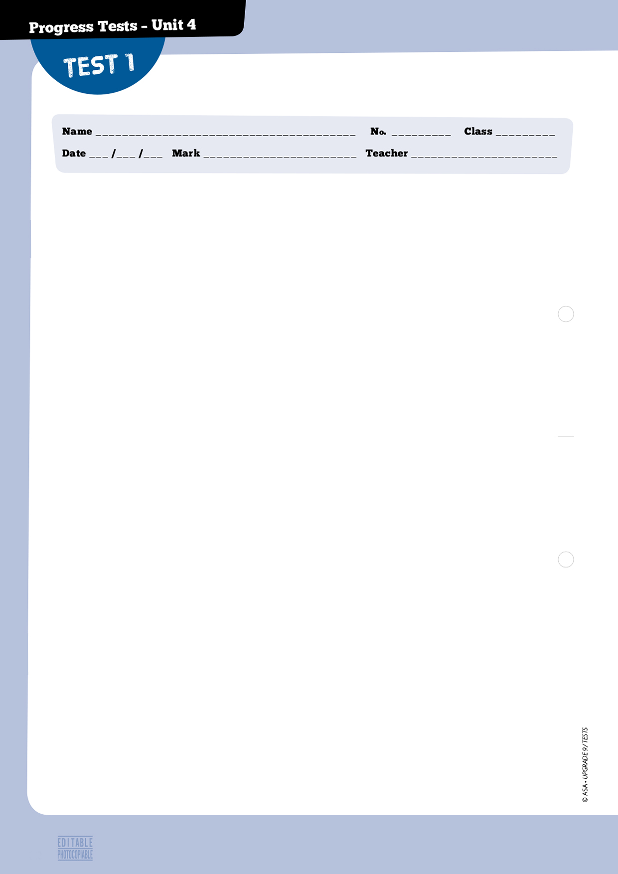
A – Listening 20 marks

1. Listen to two friends talking and answer the question. 5 marks

1.1. Who studies at the multilingual school?

□a. □b. □c.

2. You will hear Lynn talking to her friend Mary.
Decide if each sentence is true (T) or false (F).
10 marks (4x2,5 marks)
□ a. Lynn has plans for the summer.
□ b. Lynn and her friends will stay there for a whole month.
□ c. The visiting group of pupils will have to prepare a project.
□ d. Mary attends an international school.

3. Listen to Lynn and Mary again and choose the correct option. 5 marks (5x1 mark)

3.1. The school Lynn is visiting is in…
□ a. Portugal. □ b. India. □ c. the UK.
3.2. What type of school is it?
□ a. Multilingual. □ b. Multifunctional. □ c. Multicultural.
3.3. Which pupils will be on the visit?
□ a. Year 9. □ b. Year 8. □ c. Year 10.
3.4. The general feeling towards the experience is…
□ a. negative. □ b. positive. □ c. neutral.
3.5. The programme helps promote tolerance and…
□ a. understand differences. □ b. fight racism. □ c. encourage multiculturalism.

32


B – Reading 30 marks

1. Choose the correct definition for multiculturalism. 6 marks
□a. The belief that all members of a race possess characteristics, abilities, or qualities specific to that race, especially so as to distinguish it as inferior or superior to other races.
□b. Relating to or containing several cultural or ethnic groups within a society.
□c. The unjust or prejudicial treatment of different categories of people, especially on the grounds of race, age, or sex.

2. Read the text.

A multicultural window

I felt really proud and honoured to be a student in Finland and I have a
very good reason for saying that. Finland is among the best in the world for student success.
Last year, when I started my studies, I felt so great, so lucky and so enriched to be in an international programme. I was part of a group of 30 students who came from 12 different foreign backgrounds: Finland, England, Romania, India, Philippines, Nepal, Eritrea, Nigeria, Zambia, Kenya, Burundi, and
5

Zimbabwe, and for a few months there was also an exchange student from Germany in the group.
I strongly believe that multiculturalism affects social trust through discussions and descriptions
of each of our cultures, in order to get deeper understanding of differences in cultural backgrounds and to reduce culture shock. Because we were all foreign students in the same college, we got together on many occasions: we ate lunch, drank coffee, went to parties – some were organised by
us and others we were simply invited to go to – and we would also go out as a group.
10

The Finnish students were very open-minded and welcoming of the foreign students and I was very impressed by the motivation of students from Africa and Asia to understand Finnish society,
to learn the Finnish language and to bravely face the cold Finnish winter.
15

http://blogit.jamk.fi/studentsdiary/tag/multicultural-learning-environment/
(abridged and adapted), accessed in December 2014

3. Decide whether the sentences below are true (T) or false (F). 4 marks (4x1 mark)
□a. The writer was a student on an international programme.
□b. The total number of students in the programme is unknown.
□c. There were many different nationalities among the group.
□d. The students didn’t often get together.
33
33
33
© ASA • UPGRADE 9 / TESTS

honoured (l. 1) a. 1. origins and previous experiences
success (l. 3) b. 2. better because of an experience
enriched (l. 4) c. 3. proud to have a special opportunity
backgrounds (l. 6) d. 4. International
5. achievement
34
4. Match the words from the text to the words/expressions on the right.
One isn’t used. 10 marks (4x2,5 marks)

5. Answer the questions below. 10 marks (4x2,5 marks)

5.1. Was the author a member of the group of students?

5.2. Where did the author study?

5.3. When did she start studying there?

5.4. Who stayed only for some months?

C – Language 30 marks

1. Choose the best word for each space. 5 marks (5x1 mark)

a. ………………….. we are living in a global world, there are still people b. ………………….. discriminate against others based on ethnic or cultural differences. There is no logical explanation for this kind of behaviour c. ………………….. seems to want to turn the people d. ………………….. are discriminated against into victims. One of the obvious reactions should, e. ………………….., be to ignore them and not let such attitudes affect a person’s life.

 | 1. | 2. | 3. | 4.
a. | Even though | However | But | Since
b. | whose | which | whom | who
c. | whose | which | who | how
d. | who | which | whose | what
e. | even though | therefore | however | because

Even though people fight a.
discrimination,

New laws against racism are created b.

Both racial prejudice and stereotypes c.

Difference is easily accepted in my d.
country. Therefore,

Different people can live together. e.
However,

1. their cultures are not the same.
2. I think it is multicultural.
3. they can’t end it.
4. although I don’t know.
5. but people forget about them.
6. still exist.
2. Choose the correct option. 10 marks (4x2,5 marks)

In some countries people have a. multicultural / multilingual backgrounds, because they speak such diverse languages and are encouraged to celebrate the fact that they are b. multicultural / multicoloured. Some modern societies are considered a melting pot, because the population is both c. multinational / multiracial and
d. multiracial / multicoloured: their citizens come from so many distinct countries and belong to different racial groups.

3. Complete the text with the correct form of the verbs in brackets: 5 marks (5x1 mark)
to-infinitive -ing form.

Anthony keeps a. ……………………….. (make) fun of some of his classmates who forget
b. ……………………….. (bring) their gym clothes. When this happens, the P.E. teacher asks
the pupils c. ……………………….. (write) a detailed report of the class. If a pupil forgets
d. ……………………….. (hand) it at the end of the lesson, the teacher refuses
e. ……………………….. (accept) the report at a later time.

4. Match the clauses. One isn’t used. 10 marks (5x2 marks)

D – Writing 20 marks

Write an email to a friend about a bullying episode at school in about 80 words.

Do not forget to:
• write short sentences;
• organise your text in a logical way.
35
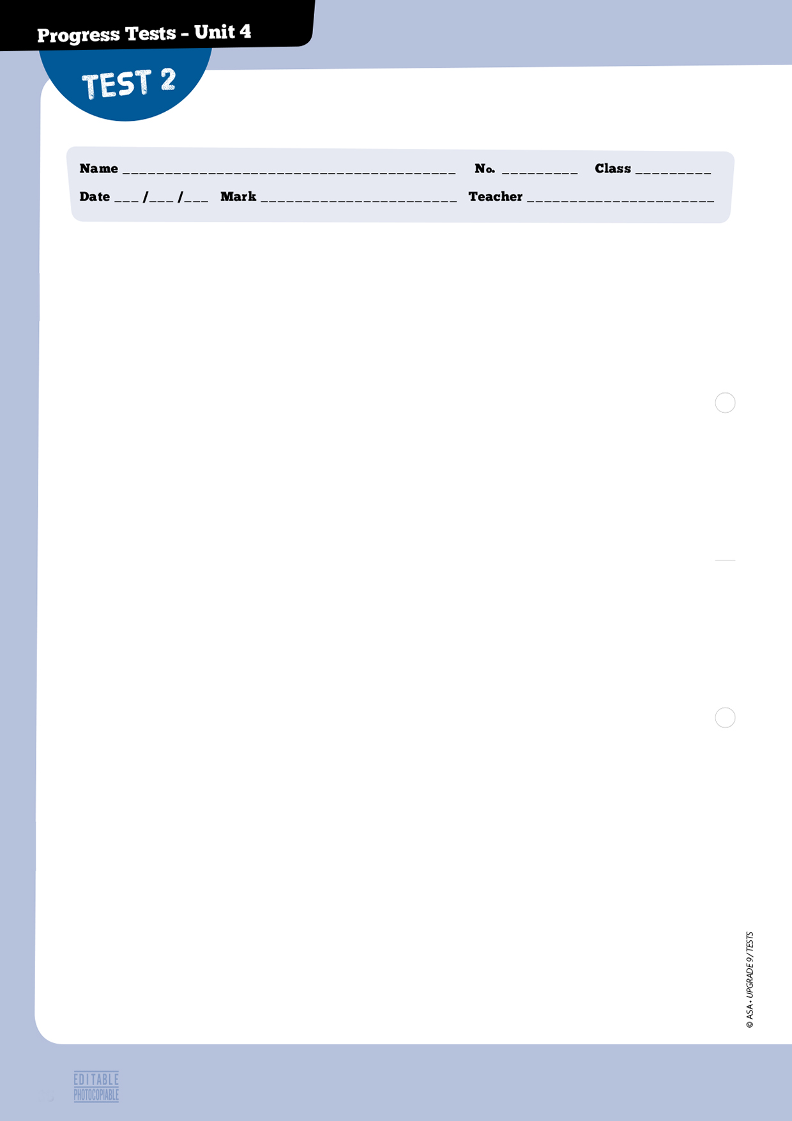
36
A — Listening 20 marks

1. Listen to two friends talking and answer the question. 5 marks

1.1. Who studies at the multilingual school?

□a. □b. □c.

2. You will hear Lynn talking to her friend Mary.
Decide if each sentence is true (T) or false (F).
10 marks (5x2 marks)
□ a. Lynn has plans for the summer.
□ b. Lynn and her friends will stay there for a whole month.
□ c. Pupils will learn about a diversity of topics.
□ d. The pupils will have to prepare a project.
□ e. Mary attends an international school.

3. Listen to Lynn and Mary again and choose the correct option. 5 marks (5x1 mark)

3.1. The school Lynn is visiting is in…
□ a. Portugal. □ b. India. □ c. the UK.
3.2. What type of school is it?
□ a. Multilingual. □ b. Multifunctional. □ c. Multicultural.
3.3. Which pupils will be on the visit?
□ a. Year 9. □ b. Year 8. □ c. Year 10.
3.4. The general feeling towards the experience is…
□ a. negative. □ b. positive. □ c. neutral.
3.5. The programme helps promote tolerance and…
□ a. understand differences. □ b. fight racism. □ c. encourage multiculturalism.


B – Reading 30 marks

1. Choose the correct definition for multiculturalism.
6 marks

□ a. The belief that all members of a race possess characteristics, abilities, or qualities specific to that race, especially so as to distinguish it as inferior or superior to other or races.

□ b. Relating to or containing several cultural or ethnic groups within a society.

□ c. The unjust or prejudicial treatment of different categories of people, especially on the grounds of race, age, or sex.

2. Read the text.

A multicultural window

I felt really proud and honoured to be a student in Finland and I have a very good reason for saying that. Finland is among the best in the world for student success.
Last year, when I started my studies, I felt so great, so lucky and so enriched
to be in an international programme. I was part of a group of 30 students who
came from 12 different foreign backgrounds: Finland, England, Romania,
India, Philippines, Nepal, Eritrea, Nigeria, Zambia, Kenya, Burundi, and Zimbabwe, and for a few months there was also an exchange student from Germany in the group.
5

10

15

20

I strongly believe that multiculturalism affects social trust through discussions and descriptions of each of our cultures, in order to get deeper understanding of differences in cultural backgrounds and
to reduce culture shock. Because we were all foreign students in the same college, we got together on many occasions: we ate lunch, drank coffee, went to parties – some were organised by us and others we were simply invited to go to – and we would also go out as a group.
The Finnish students were very open-minded and welcoming of the foreign students and I was
very impressed by the motivation of students from Africa and Asia to understand Finnish society, to
learn the Finnish language and to bravely face the cold Finnish winter.
I was impressed by their positivism, enjoyable simplicity and happy attitude towards life. We had
so many funny occasions together. We had such a great time! I think we really needed those moments when the dark gloomy Finnish autumn arrived and depressed people. It was all the laughing and the
good humour that saved us from sadness!

http://blogit.jamk.fi/studentsdiary/tag/multicultural-learning-environment/ (abridged and adapted), accessed in December 2014

3. Decide whether the sentences below are true (T) or false (F). 4 marks (4x1 mark)
□ a. The writer was a student on an international programme.
□ b. The total number of students in the programme is unknown.
□ c. There were many different nationalities among the group.
□ d. The students didn’t often get together.
37
37
4. Match the words from the text to the words/expressions on the right.
One isn’t used. 10 marks (4x2,5 marks)

5. Answer the questions below. 10 marks (4x2,5 marks)
5.1. Was the author a member of the group of students?

5.2. Where did the author study?

5.3. When did she start studying there?

5.4. Who stayed only for some months?

C – Language 30 marks

1. Choose the best word for each space. 5 marks (5x1 mark)

a. ………………….. we are living in a global world, there are still people b. ………………….. discriminate against others based on ethnic or cultural differences. There is no logical explanation for this kind of behaviour c. ………………….. seems to want to turn the people d. ………………….. are discriminated against into victims. One of the obvious reactions should, e. ………………….., be to ignore them and not let such attitudes affect a person’s life.

 | 1. | 2. | 3. | 4.
a. | Even though | However | But | Since
b. | whose | which | whom | who
c. | whose | which | who | how
d. | who | which | whose | what
e. | even though | therefore | however | because

honoured (l. 1) a. 1. origins and previous experiences
success (l. 3) b. 2. better because of an experience
enriched (l. 4) c. 3. proud to have a special opportunity
backgrounds (l. 6) d. 4. International
5. achievement
38

hand
make
accept
write
bring
2. Choose the correct option. 10 marks (4x2,5 marks)

In some countries people have a. multicultural / multilingual backgrounds, because they speak such diverse languages and are encouraged to celebrate the fact that they are b. multicultural / multicoloured. Some modern societies are considered a melting pot, because the population is both c. multinational / multiracial and
d. multiracial / multicoloured: their citizens come from so many distinct countries and belong to different racial groups.

3. Complete the text with the correct form of the verbs in the box: 5 marks (5x1 mark)
to-infinitive or -ing form.

Anthony keeps a. ……………….. fun of some of his classmates who forget b. ………..……….. their gym clothes. When this happens, the P.E. teacher asks the pupils c. ………………..…….. a detailed report of the class. If a pupil forgets d. ……………….. it at the end of the lesson, the teacher refuses e. ……………….. the report at a later time.

4. Join the sentences using the connector in brackets. 10 marks (4x2,5 marks)

a. The majority of people show tolerance towards difference in my country. I think it is truly multicultural. (therefore)

b. New laws are created and approved. Prejudice and stereotypes will not end. (even though)

c. People organise a lot of public protests against racism. It still exists everywhere. (but)

d. Prejudice and stereotypes cannot be overcome with laws. (neither… nor)

D – Writing 20 marks

Write a brief story in about 80 - 100 words on your answer sheet.
This is the title of the story: That was the worst day of my life.
Do not forget to:
• write short sentences;
• organise your story in a logical way.
39
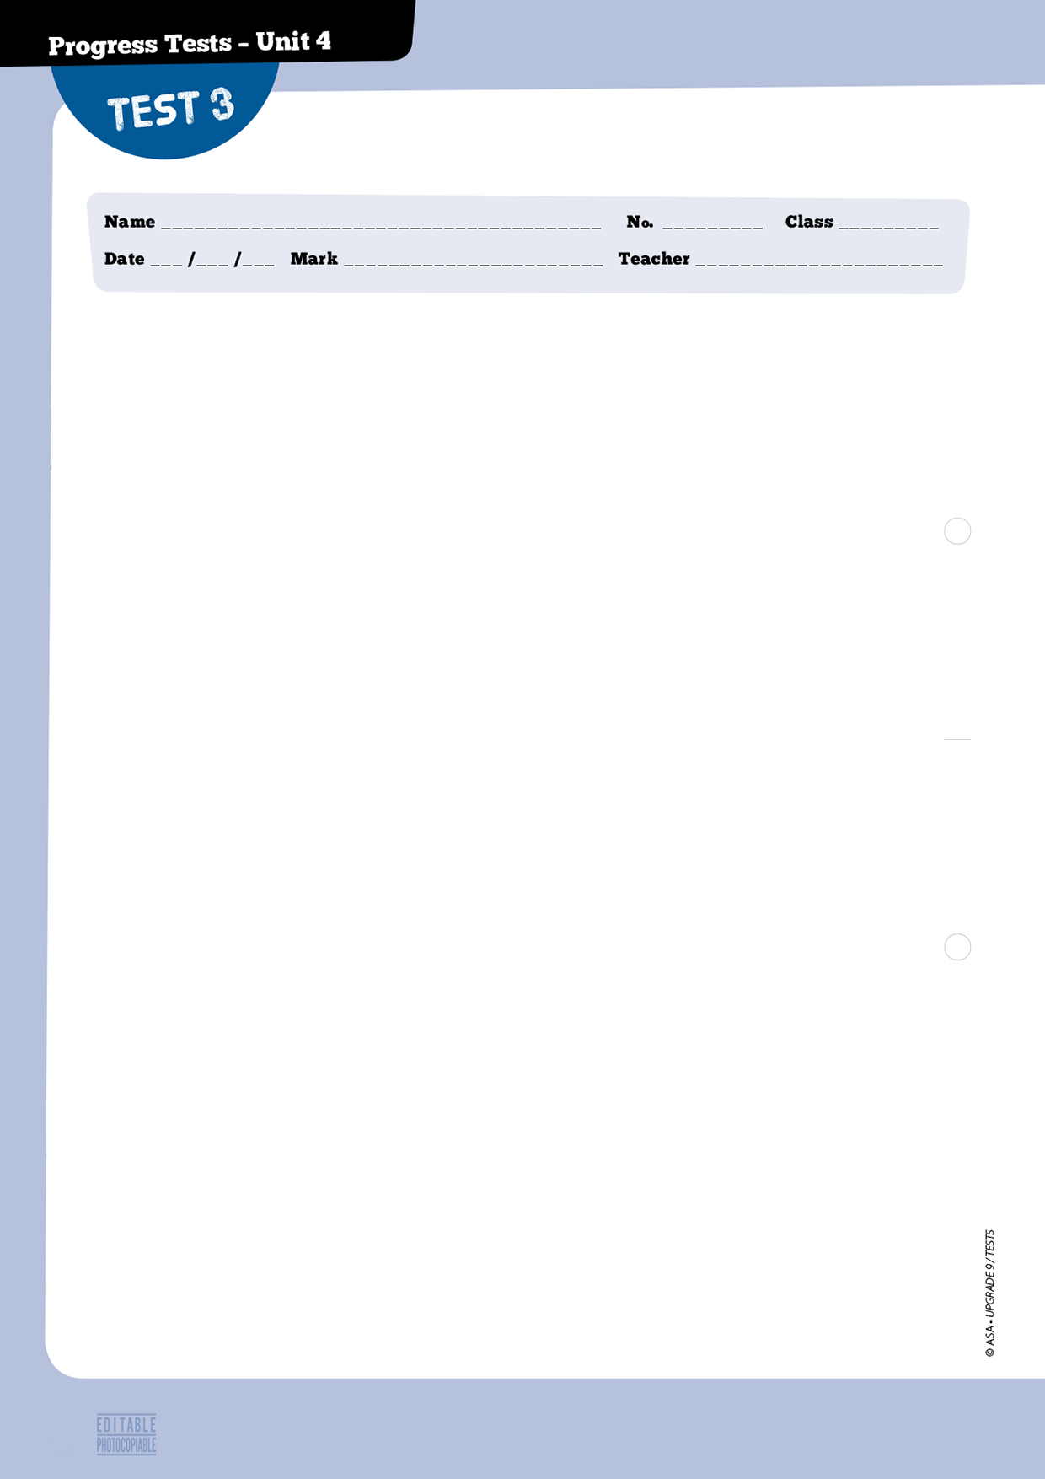
A – Listening 20 marks

1. Listen to two friends talking and choose the picture that answers the question. 5 marks

1.1. What is the girl wearing

□a. □b. □c.

2. You will hear a Chinese teen talking about her experience as a volunteer.
Listen to part 1 and decide if the sentences are true (T) or false (F).
10 marks (5x2 marks)
□ a. Grace is a migrant teenager who studies in Beijing.
□ b. The volunteers only teach Grade 5 students.
□ c. She’s working with a student who finds English vocabulary hard to learn.
□ d. Both Grace and the student have similar interests.
□ e. The girl wants to participate in another volunteering project.

3. Listen to part 2 and choose the correct option. 5 marks (5x1 mark)

3.1. Each volunteer teaches his student…
□ a. in the same way. □ b. differently. □ c. to speak Chinese..
3.2. Teachers at the migrant school…
□ a. get high salaries. □ b. feel unhappy. □ c. are volunteers.
3.3. Students at the migrant school…
□ a. could be successful. □ b. get very bad marks. □ c. want to go to university.
3.4. Grace feels volunteering…
□ a. makes no difference. □ b. changes someone’s life. □ c. should be paid.
3.5. The migrant kids…
□ a. visited the volunteers’ school. □ b. weren’t welcome. □ c. didn’t want to go there.
40


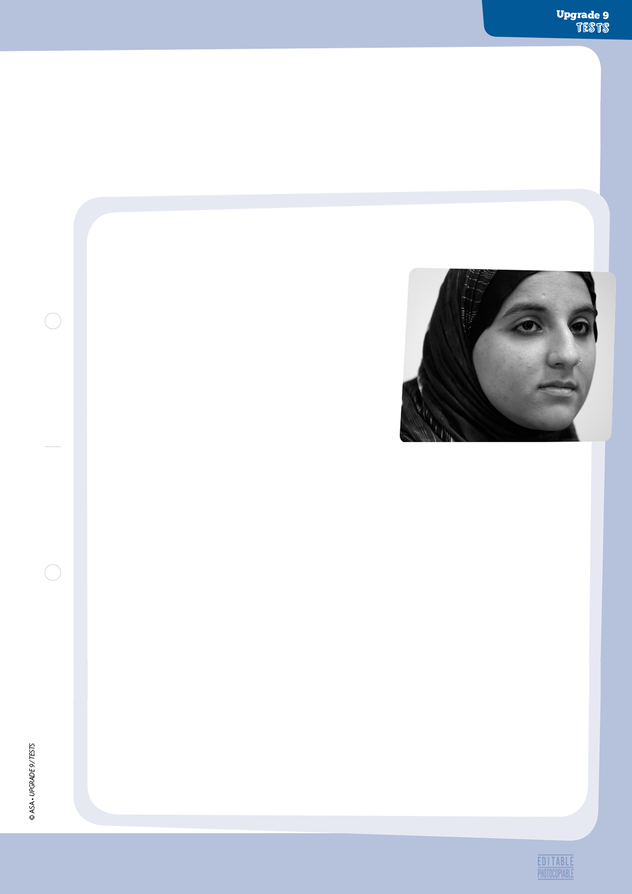

B – Reading 30 marks

1. How would you define discrimination? 5 marks

2. Read the text.

Abercrombie & Fitch worker
fired over head scarf

The Muslim teen worker who scored a legal victory in
an anti-discrimination case against Abercrombie & Fitch says the shop’s policy is “very unfair.”
A federal judge determined last week that Abercrombie & Fitch discriminated against Hani Khan, 18, when she was fired from its Hollister store in San Mateo, California, because she refused to remove her head scarf on the job.
5

10

15

20

25

30

Khan says she was approached by her manager after
four months on the job.
“She expressed concern about my scarf,” Khan told ABC News. “That’s when I felt like it was not appropriate, what they were saying.”
After refusing to remove the scarf while at work, she
was fired. The company offered her the job back 11 days later as long as she did not wear the
scarf, but she rejected the offer. “They just don’t feel like it fits in with their ‘Look Policy,’ which
I feel is very unfair,” Khan said.
The “Look Policy” includes a dress code guidebook for employees saying everything from
what they should wear to how they should style their hair while on the job, according to court documents.
In court, the trendy clothing company argued that the scarf, worn by Muslim women as a sign
of modesty, would negatively affect sales. But the judge said in writing “Abercrombie failed to
offer any evidence from those four months showing a decline in sales.”
“Abercrombie & Fitch does not discriminate based on religion and we allow freedom for
religious practice when reasonable,” a company representative told ABC News.
It’s not the first time the company has made headlines because of image-related issues.
Protesters gathered outside the stores after an interview Abercrombie’s CEO Mike Jeffries gave in 2006 reappeared on social media.
In the interview, Jeffries said the company’s clothing was marketed toward “cool, good-looking people. We don’t market to anyone other than that.” He later said he regretted the comments.
Khan hopes her case will lead to policy changes at Abercrombie & Fitch.
“I really hope that they look into their policies and practices,” she said, “and they’re able to
reflect some changes.”

http://abcnews.go.com/Business/muslim-fired-abercrombie-head-scarf-policy-unfair/story?id=20208124
(abridged and adapted), accessed in February 2015
41
33
33
© ASA • UPGRADE 9 / TESTS
3. Decide whether the sentences below are true (T) or false (F). 10 marks (5x2 marks)

□ a. The young woman was discriminated against because of the colour of her skin.
□ b. She was addressed by the manager of the shop.
□ c. The shop wanted her back after a month.
□ d. The company was able to prove there had been a reduction in their sales.
□ e. Abercrombie & Fitch have been in the news before.

4. Match the words to their synonyms on the right. One isn’t used. 5 marks (5x1 mark)

5. Answer the questions about the text. 10 marks (4x2,5 marks)

5.1. Why did Hani Khan say the company’s policy was unfair?

5.2. Where does the incident take place?

5.3. Who is Mike Jeffries?

5.4. What does Khan think of the whole situation?

C – Language 30 marks

1. Choose the best word/expression for each space. 5 marks (5x1 mark)

Bullying is being mean to another person over and over again. a. …………………………. pupils see bullying, they may not know what to do. They may be absent from school b. …………………………. they don’t feel safe. They may join in or stay silent so they won’t get bullied c. ………………………….. They may stand up to the bully. d. …………………………. the best thing to do is get an adult e. …………………………. will stop the bullying on the spot.

http://www.stopbullying.gov/kids/facts/ (abridged and adapted), accessed in January 2015
scored (l. 1) a. 1. reduction
appropriate (l. 11) b. 2. influence
affect (l. 21) c. 3. rational
decline (l. 22) d. 4. correct
reasonable (l. 24) e. 5. obtained
6. addressed

42
multiculturalism
multiracial
multinational
multilingual
multicoloured
multicultural
 | 1. | 2. | 3. | 4.
a. | But | Before | When | Even though
b. | because | therefore | so | as well
c. | them | their | they | themselves
d. | However | But | Even though | If
e. | who | which | whose | what

2. Complete the text with words from the box. 5 marks (5x1 mark)
One isn’t used. 5 marks (5x1 mark)

a. ………………… societies allow people who have b. ………………… backgrounds, because they speak such diverse languages, to preserve and celebrate their c. …………………. Many such societies can also be considered as d. …………………, as their citizens come from so many distinct countries, and e. …………………, because they belong to different racial groups.

3. Choose the correct option each time. 12 marks (6x2 marks)

3.1. Anthony keeps a. making / to make fun of some of his classmates who forget b. bringing / to bring their gym clothes. When this happens, the P.E. teacher asks the pupils c. to write / writing a detailed report of the class. If a pupil forgets the report at the end of the lesson, the teacher refuses d. to accept / accepting it at a later time.

3.2. Last week Anthony hid Mark’s gym clothes before the P.E. lesson. He intended a. to make / making Mark write the report of the class, but I spoke to Mark and suggested b. to tell / telling the teacher about it.

4. Join the sentences by using the connector in brackets. 8 marks (4x2 marks)

a. The country I live in is multicultural. Some people react to other cultures in an intolerant way.
(however)

b. Any form of discrimination is unacceptable. People are encouraged to accuse offenders. (therefore)

c. Prejudice and discrimination cannot be overcome by laws. (neither… nor)

d. Everyone claims they are not racist. Racism still exists everywhere. (even though)

D – Writing 20 marks

Write a brief story in about 80 - 100 words on your answer sheet.
This is the title of the story: That was the worst day of my life.
Do not forget: write short informal sentences; organise your text to the point.
43



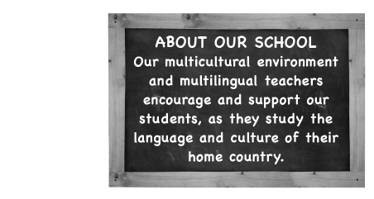

44

Reading • Part 1

Questions 1 – 4

Look at the text in each question.
What does it say?
Mark the correct letter A, B or C on your answer sheet.

1
A Students must not be tolerant and accept other people.
B Students mustn’t talk about religion and violence..
C Students who behave and act in an offensive or violent way will be punished.

2
A The school doesn’t accept students who speak foreign languages.
B The school welcomes students who have different cultural backgrounds.
C The school doesn’t have enough teachers to help foreign students with their work.

3
A Students in the school can study foreign languages if they want.
B Students will not be accepted in the school unless they speak three languages.
C Students in the school must study a specific number of languages.

4

A You mustn’t be tolerant.
B You should be open to other realities and lifestyles.
C If you don’t listen to other people, you’re rude.
16





A – IRCO’s mission is to promote the integration of refugees, immigrants, and the community at large into a self-sufficient, healthy, and inclusive multiethnic society.

http://www.irco.org/ (abridged and adapted), accessed in
December 2014

C – Paul Hamlyn Foundation – Paul Hamlyn’s aim: “Towards a better way”. That way is towards being a society that is fair, allows people to realise their potential, fights prejudice, encourages and assists participation in and enjoyment of the arts and learning, and understands the importance of the quality of life for all communities.

http://www.phf.org.uk/ (abridged and adapted), accessed in
December 2014

B – Get Kids Going! is a national charity which gives disabled children and young people – up to the age of 26 years – the opportunity of participating in sport by providing specially built sports’ wheelchairs.

htttp://www.getkidsgoing.com/ (abridged and adapted),
accessed in December 2014

D – The AIRE Centre is a specialist charity whose mission is to promote awareness of European law rights and help marginalized individuals and those in vulnerable circumstances to affirm those rights. We do this by: taking cases to the European Court of Human Rights, providing legal advice to individuals directly.

http://www.airecentre.org/ (abridged and adapted), accessed in December 2014
5 Joelle, 36, is a French lawyer. She has been doing voluntary work for an
association which helps people who have no families and no home. She
is looking for legal advice on the rights of one of her homeless clients.
7 John is 48 and he is a nurse. He has worked with refugees and illegal
immigrants in several African countries. He would like to go on his
work among people who come from other countries.
6 Lynn is 30 and she is a Physical Education teacher in a local school. She
is also a volunteer in a youth club for the disabled. One of the children
needs a wheelchair to take part in a competition.
Reading • Part 2

Questions 5 – 7

The people below all want to find an organisation that can help them fulfill their purpose.
Below there are four organisations based in different countries. Decide which organisation
would be suitable for the following people.

For questions 5 – 7, mark the correct letter (A – D) on your answer sheet.

45

46
Reading • Part 3

Questions 8 – 12

Look at the sentences below about culturally diverse cities in the world.
Read the text below to decide if each sentence is correct or incorrect.
If it is correct, mark A on your answer sheet. If it is not correct, mark B on your answer sheet.

8 As a result of immigration, world cities have become much more diverse.
9 The majority of children from Manchester can speak two languages.
10 What makes Manchester a well-known city is not just its football team.
11 A large percentage of people who live in New York City speak a language other than English.
12 All the other cities in England are as linguistically diverse as Manchester.

Top 10 culturally diverse cities in the world

Thanks to immigration, cities all over the world are transforming into baskets and melting pots of culture. The result is that there are about ten top culturally diverse cities in the world. More people can get to know the various cultural differences of different regions, delicious cuisine from various nations, and we are all reminded that even though there’s a lot of diversity, we still have many similarities as human beings.

1. New York City, USA
With a population of more than eight million residents, New York City remains one of the most exciting and diverse cities on the planet. Almost half of the city’s population is multi-lingual, about 47% and about three million speak a language other than English. Hispanics make up close to 23% of the population of the New York-Northern New Jersey-Long Island area, followed by African Americans at mover 16% and Asians at just under 10%. It is the city with the largest immigrant population in the world.

2. London, England
More than 300 different languages can be heard on the streets of Britain’s capital city. In this diverse city, it’s not surprising to find fish and chips sold next to a place that caters to those looking for some curry. Almost 8.2 million residents call London their home, and many of these residents come from various parts of the globe, including Ireland, India, Poland, Pakistani, and other Arab countries. The city is also home to 50 non-indigenous communities and number over 10,000.

3. Manchester, England
Manchester doesn’t just have a great football team, it is also considered the most diverse city in the world in terms of language given its size. The city’s residents of just 503,000 people speak a total of at least 153 various languages, compared to larger cities such as New York and Paris, whose population numbers in the millions. Some two-thirds of the city’s children are known to be bilingual, thanks to immigration and a growing number of foreign students in the city. Some of the languages spoken in Manchester include Chitrali, Konkani from India, as well as Uyghur, which is a dialect in the Northwestern section of China.

http://www.daynews.com/latest-news/2013/03/top-10-culturally-diverse-cities-in-the-world-15031
(abridged and adapted), accessed in December 2014


Reading • Part 4

Questions 13 – 15

Read the text and the questions below.
For each question, mark the correct letter A, B, C or D on your answer sheet.

For questions 5 – 7, mark the correct letter (A – D) on your answer sheet.

American diversity

America has traditionally been referred to as a “melting pot,” welcoming people from many different countries, races, and religions, all hoping to find freedom, new opportunities, and a better way of life.
American history began with waves of immigrants, bringing their own cultures and traditions to a vast new country. No other place in the world has such a diverse population. It is this diversity that makes America what it is and, at the same time, creates the challenges it faces.
Strictly speaking, the only indigenous Americans are the American Indians, who were living here long before the first waves of settlers came over from Europe. When Christopher Columbus discovered America in 1492, he called these natives “Indians” because he thought he had discovered a western route to India.

http://www.culturalsavvy.com/understanding_american_culture.htm (abridged and adapted), accessed in December 2014

13 What is this text about?
A The discovery of America.
B The Indigenous peoples of America.
C American history.
D The population of America.

14 Americans
A all share a common origin.
B are the richest people in the world, both culturally and ethnically.
C don’t like challenges.
D have never accepted the concept of the “melting pot”.

15 Indigenous Americans
A had been living in America before the Europeans arrived.
B arrived with the European settlers.
C came with Christopher Columbus.
D had been living in India before Columbus.

47
45
Reading • Part 5

Questions 16 – 22

Read the text below and choose the correct word for each space.

For each question, mark the correct letter A, B, C or D on your answer sheet.

The importance and benefits of diversity

Diversity (16) …………………. be defined as people coming together from different races, nationalities, religions and sexes to form a group, organisation or (17) …………………. . A diverse organisation is one that values the (18) …………………. in people. It is one that recognises that people with different (19) …………………., skills, attitudes and experiences bring fresh ideas and perceptions.
In society today, most people view diversity as a good thing because it gives people the chance to experience different things outside of what they are normally accustomed to. Diversity in America is openly viewed as (20) …………………. . Diversity is not always easy to use and understand
(21) …………………. it has both negative and positive effects on society such as education,
(22) …………………. and employment.

http://www.teenink.com/opinion/environment/article/465407/The-Importance-and-Benefits-of-Diversity/
(abridged and abridged), accessed in December 2014

16 A should B needs to C can D must

17 A family B team C nationality D club

18 A diversity B variety C similarity D difference

19 A backgrounds B lives C religions D faiths

20 A great B useful C beneficial D helpful

21 A so B therefore C but D because

22 A understanding B violence C tolerance D fighting

48

Writing • Part 1

Questions 1 – 5

Here are some sentences about multiculturalism.
For each question, complete the second sentence so that it means the same as the first sentence.
Use no more than three words.
Write only the missing words on your answer sheet.

1 That man’s daughter was discriminated against by some white boys.
That’s the man ………………………. was discriminated against by some white boys.
2 Carla told me about an interesting book called The Help.
The Help is ………………………. Carla told me about.
3 Linda studies at the International School.
Linda is the girl ………………………. the International School.
4 Freedom Writers is a film about students in a multiracial high school.
Freedom Writers is a ………………………. the story of students in a multiracial high school.
5 The English teacher in the film, Erin Gruwell, encourages them to become writers.
Erin Gruwell is the teacher ………………………. them to become writers.

Writing • Part 2

Question 6

You want to invite a friend to attend a cultural event in your school.
Write an email to Bryan. In your email, you should:
• explain what the event is;
• say why you would like him to be there;
• suggest a time and place to meet.
Write 35 – 45 words on your answer sheet.
49
50
Reading • Part 5

Write an answer to one of these questions (7 or 8) in this part.
Write an answer in about 100 words on your answer sheet.

Question 7

• This is part of a letter you received from your penfriend Kalil.

In your next letter, please tell me about your country’s most important
celebrations.
Are the most important dates you celebrate religious or cultural
occasions?
What is your favourite celebration and why?
Do you have any special responsibilities/role to play?

• Now write a letter, answering your penfriend’s questions.
• Write a letter in about 100 words.

Question 8

• Your teacher has asked you to write a story.
• This is the title of the story: That was the most unexpected situation I’ve ever experienced
• Write your story in about 100 words on your answer sheet.



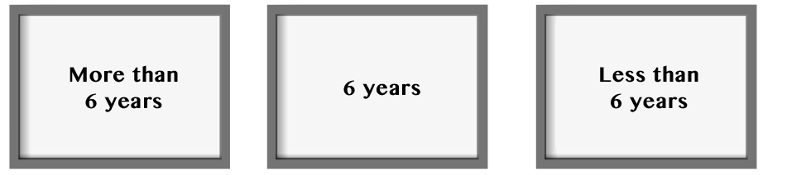

51
Listening • Part 1

Questions 1 – 4

There are four questions in this part.
For each questions there are three pictures and a short recording.
Choose the correct answer (A, B or C).

1 Which country is not mentioned?

A Romenia B Albania C Nigeria
2 How long have you been living here?

A B C
3 When are parents and children going to cook?

A B C
4 What’s the greatest problem?

A B C

52
Listening • Part 2

Questions 5 – 11

Listen to Jennifer talking to her friend Jessie about a cookery course.
For each question choose the correct answer A, B, or C.

5 Jennifer refuses Jessie’s invitation for coffee because
A she’s late.
B she doesn’t drink coffee.
C her lesson starts in a few minutes.

6 Jeniffer’s learning how to
A cook a specific type of food.
B prepare meals from very diverse countries and cultures.
C select the ingredients she will be using later.

7 One of the reasons why Jennifer chose the course was because
A it’s very cheap to cook such meals.
B it’s a very healthy diet.
C it’s an European type of food.

8 The course is expected to last for
A half a year.
B a whole year.
C six weeks.

9 She feels
A still very insecure about the course and her ability to cook such meals.
B she should have chosen a type of food that was easier to prepare.
C thrilled with the experience so far.

10 Jennifer’s family’s reaction
A was much worse than she expected, because they refused to eat her meals.
B wasn’t fully supportive initially, but they have surrendered to the new diet.
C doesn’t worry her. She only cooks for herself.

11 Jennifer
A promises to teach Jessie how to prepare a good meal.
B says she is going to cook for her friends.
C invited Jessie for dinner on Friday.

Listening • Part 3

Questions 12 – 17

You will hear a radio programme in which young people who have immigrated from different parts of the world are interviewed.
For each question fill in the missing information in the numbered spaces.

Listening • Part 4

Questions 18 – 23

Look at the six sentences for this part.
You will hear an interview with the presenter of the Tolerance Talk talking to Amanda Scofield, a pupil of a multicultural school.
Decide if each sentence is correct or incorrect.
If it is correct, choose the letter A for YES. If it is not correct, choose the letter B for NO.

YES NO

18 Amanda felt very confident from the beginning. A B

19 The atmosphere at the school was very positive and encouraging.. A B

20 One of the first activities they had to do was very difficult and uninteresting. A B

21 Going to a multicultural school had no impact on her. A B

22 The teachers were very supportive and helpful. A B

23 Amanda doesn’t consider it important for other schools to become multicultural. A B
Music Conservatory
Saint Petersburg, Russia
Danny Jones
Name: …………………………………………..
Age: (12) ……………………………
Lives in: ……………………………………
Living there for: (13) ………………………………………….. .
Studies at: …………………………………………..
Number of foreign students: (14) …………………………………………..
Students live in: (15) …………………………………………..
Difficult to adapt to: (16) …………………………………………..
Who he spent last Christmases with:: (17) …………………………………………..
53



• Where do you live/come from?
• What’s your favourite activity outside
school?

• Would you like to study in a foreign
country?

• Do you think English might be useful/
important if you moved to another
country?

• What’s the thing you enjoy most about
your country/region?
• Would you like to learn more about other
countries or cultures?

• Do you have a hobby?

• Which foreign country would you choose to
study in?

• What makes your country different from
all others?

• Which culture/country do you consider
interesting?
54
You have been asked to identify the form of disrespect you consider more serious. Talk together and identify the form of behaviour that causes greater social conflict.
Speaking • Part 1

(2 - 3 minutes)

Be prepared to say your names and spell them and answer questions about yourself, your daily
life, interests, etc. For example:

Speaking • Part 2

(2 - 3 minutes)
Talk to your partner about the following situation. The pictures below will help you.



55

Speaking • Part 3

(3 minutes)

Look at one of the following photographs and talk by yourself about what you see.

Speaking • Part 4

(3 minutes)

Talk to your partner about what needs to be done so that different people are integrated in
the global society.
Unit 4 – Progress tests and mock PET
Answer Key

Test 1

A – Listening
1. b.
2. a. T; b. F; c. T; d. F.
3.1. b; 3.2. c; 3.3. a; 3.4. b; 3.5. a.

B – Reading
1. b.
3. a. T; b. F; c. T; d. F. 4. a. 3; b. 5; c. 2; d. 1.
5.1. Yes, she was. 5.2. In Finland. 5.3. A year ago.
5.4. The German student.

C – Language
1. a. 1; b. 4; c. 2; d. 1; e. 2.
2. a. multilingual; b. multicultural; c. multinational;
d. multirracial.
3. a. making; b. to bring; c. to write; d. to hand; e. to accept.
4. a. 3; b. 5; c. 6; d. 2; e. 1.

Test 2

A – Listening
1.1. b.
2. a. T; b. F; c. T; d. T; e. F.
3.1. b; 3.2. c; 3.3. a; 3.4. b; 3.5. a.

B – Reading
1. b.
3. a. T; b. F; c. T; d. F.
4. a. 3; b. 5; c. 2; d. 1; e. 5.
5.1. Yes, she was.
5.2. In Finland.
5.3. A year ago.
5.4. The German student.

C – Language
1. a. 1; b. 4; c. 2; d. 1; e. 2.
2. a. multilingual; b. multicultural; c. multinational;
d. multiracial.
3. a. making; b. to bring; c. to write;
d. to hand; e. to accept.
4. a. The majority of people show tolerance towards difference in my country, therefore I think it is truly multicultural. b. Even though new laws are created and approved, prejudice and stereotypes will not end.
c. People organise a lot of public protests against racism, but it still exists everywhere. d. Neither prejudice nor stereotypes can be overcome by laws.

Test 3

A – Listening
1.1. a.
2. a. F; b. F; c. F; d. T; e. T.
3.1. b; 3.2. c; 3.3. a; 3.4. b; 3.5. a.

B – Reading
1. Personal answer.
3. a. F; b. T; c. F; d. F; e. T.
4. a. 5; b. 4; c. 2; d. 1; e. 3.
5.1. Because she wasn’t allowed to wear a scarf while she was at work.
5.2. In one of Abercrombie & Fitch’s shops, in
California.
5.3. The CEO of the company.
5.4. She thinks it is unfair, but hopes the company will change some of their policies and practices.

C – Language
1. a. 3; b. 1; c. 4; d. 2; e. 1.
2. a. multicultural; b. multilingual; c. multiculturalism;
d. multinational; e. multiracial.
3.1. a. making; b. to bring; c. to write; d. to accept. 3.2. a. to
make; b. telling.
4. a. The country I live in is multicultural. However, some people react to other cultures in an intolerant way. b. Any form of discrimination is unacceptable therefore people are encouraged to accuse offenders. c. Neither prejudice nor discrimination can be overcome by laws. d. Even though everyone claims they are not racist, racism still exists everywhere.

Mock PET

READING
Part 1 – 1. C; 2. B; 3. C; 4. B.
Part 2 – 5. D; 6. B; 7. A.
Part 3 – 8. A; 9. A; 10. A; 11. A; 12. B.
Part 4 – 13. D; 14. B; 15. A.
Part 5 – 16. C; 17. B; 18. D; 19. A; 20. C; 21. D; 22. B.

WRITING
Part 1 – 1. whose daughter; 2. the interesting book; 3. who studies at; 4. film that tells; 5. that encourages.
Part 2 – 6. Personal answer.
Part 3 – 7. or 8. Personal answer.

Listening
Part 1 – 1. B; 2. A; 3. B; 4. C.
Part 2 – 5. C; 6. A; 7. B; 8. A; 9. C; 10. B; 11. C.
Part 3 – 12. 19 years; 13. 18 months; 14. 250; 15. a Student
Residence; 16. lifestyle and climate; 17. his parents and
brothers.
Part 4 – 18. B; 19. A; 20. B; 21. B; 22. A; 23. B.

AUDIO SCRIPTS

Tests 1 and 2

CD 4 – Track 42
Lizzie: Do you remember my friend Kelly?
Nikky: Yes, I do. I haven’t seen her at school lately.
Lizzie: Her family moved to Cape Verde two months ago. She’s studying at the Cape Verde Multilingual School. Jessica and Larry used to study there, but their parents moved to Ghana last month.

CD 4 – Track 43
Mary: That sounds wonderful!
Lynn: Yes, it is. We spend time at the school learning about their culture and their way of life. We’ll also find out about their religion and the different gods they worship. At the same time we have to start preparing a project to be presented in one of our classes when we come back.
Mary: What’s the name of the school you’re visiting?
Lynn: It’s the Multicultural School of Mumbai. Pupils from our school have been going there for ten years. Every year the visit is a tremendous success. The projects the pupils prepare are normally presented to the whole school at the end of the term.
There’re always lots of photos to be shown and everyone is very enthusiastic about the experience.
Mary: That sounds fun! It’ll be like a holiday, but you’ll be working too.
Lynn: Yes, it’s a chance to get to know other people and other cultures. I think this is the best way to promote tolerance and understand differences. It’s a wonderful opportunity to start to understand other people’s way of life and customs. And then, as soon as the new school year begins, the Indian pupils will come and visit our school.
Mary: I wish my school was like yours!
Lynn: It’s a lot of hard work, really. We’ve had to prepare all the activities we’ll be doing when the Indian boys and girls come over with their teachers. But it’s worth it!

56
Unit 4 – Progress tests and mock PET
Test 3

CD 4 – Track 44
Jill: Why is that girl wearing a scarf over her head?
Megan: Muslim girls have to keep their heads covered after a certain age.
Jill: So they can’t wear a cap or a hat?
Megan: No, not if they want to respect Muslim tradition and culture.

CD 4 – Tracks 45-46
Lighting a fire: Grace Wang and her volunteering experiences

[Part 1]
Fourteen-year-old Grace Wang does it all. This Beijing native
sings, plays volleyball, is a member of student council at her
school, and volunteers with several charities. For the past year,
she has been teaching English to migrant kids for the Migrant
Children’s Foundation (MCF), one of her school’s charities.
“At MCF we plan our own English lessons and go to the
migrant school in Beijing. The students can’t go to local
schools, so they attend our lessons. The students we teach are
mainly in Grade 4 and 5.
We’re usually always with the same student. We try to
concentrate on one student so we can help him or her make
good progress. The student I have right now is called Li Che
and he’s in Grade 4. I’ve only taught him twice, but he’s pretty
smart; he probably learns English vocabulary faster than
Ido. We have similar interests. For example, we both like this
Korean teen pop group called Exo. He taught me a game during a lesson and I started to enjoy it as well.
This year my classmates and I decided to restart a project
called Give a Hope. We want to visit a Chinese orphanage with
a group of five to ten people to spend some time and help out.
We also go to visit old people every week. We just talk to them
and have fun.

[Part 2]
When we teach the kids we sit down and chat with them to see
what they’re like. We use the resources that we prepared and
teach them. Each person has a different way of teaching.
These migrant kids don’t have as many opportunities as we do.
Their families might have money problems. They don’t have a
proper education. Their teachers are volunteers. But all children deserve an equal chance and just because they face these challenges doesn’t mean they can’t be successful in the future.
I get a lot of joy and happiness out of volunteering. When
I finish a lesson and go over the words to see how much a kid
has learned, I feel like I’ve achieved a lot and helped someone
else. It makes me part of something meaningful and it gives
me purpose. And it has changed someone else’s life.
The most rewarding experience I had as a volunteer was when
we invited the MCF kids to our school’s Sports Day. At first
some of my colleagues didn’t really know how to talk to them,
but in the end we all had fun together.”

http://www.beijing-kids.com/magazine/2014/12/09/ (abridged and adapted),
accessed in March 2015

Mock PET – Unit 4

CD 4 – Track 47
1. Which country is not mentioned?
Girl: Do you live in a community with different nationalities?
Boy: Yes, I do. There are people from different ethnic
groups and countries. The Pans, who live opposite my
house, are Chinese. Mrs Agabi, who lives down the street,
comes from Nigeria. There’s also the Djokovichs, who come
from Romania. We all meet at school and at sports and
community events.

CD 4 – Track 48
2. How long have you been living here?
Woman: What do you like most about living in this town?
Girl: I like the fact that it is very open, very friendly and
open-minded. My family and I have been living here for more than six years and there’s never been any problem. When we first moved here I was afraid that we might have to face discrimination and prejudice. But everyone’s always shown respect and acceptance towards our culture and lifestyle.

CD 4 – Track 49
3. When are parents and children going to cook?
The Festival of Multiculturalism will be taking place during the next few days. Today the teachers and pupils in the Art Department are going to organise an exhibition of the pupils” best works which is going to be opened on Tuesday. It can be visited by anyone who is interested. On Wednesday there will be a workshop for students on multiculturalism. Thursday will be multicultural food day. Parents and their children will be cooking simple meals typical of their country or culture.
Finally, on Friday some people will come and tell stories from different cultures to the children, in the library.

CD 4 – Track 50
4. What is the greatest obstacle?
Man: What’s this new project you’re involved in?
Woman: It’s a community project. We want to support
people who have no family and no friends and encourage
them to get integrated in society. Some of these people live
on the streets and are victims of discrimination.
Man: Do you think you’ll succeed?
Woman: I do hope so. Right now the greatest problem we face is that some of these people have different ethnic backgrounds.

Part 2
CD 4 – Track 51
Jennifer: Hi Jessie!
Jessie: Jennifer! It’s really good to see you.
Jennifer: You too!
Jessie: Let’s have a cup coffee together, shall we?
Jennifer: I’m afraid I can’t. My class starts in less than five minutes.
Jill: Really? What course are you doing?
Jennifer: I’m doing a cookery course. You know I’ve always enjoyed cooking and when I heard about this course for people who are interested in cooking Mediterranean food I couldn’t resist it. Nutritionists say the Mediterranean diet is one of the most healthy and I knew so little about it!
Jessie: How long is the course?
Jennifer: It’s six months. This is my third month and I‘ve learnt so much! What I find most amazing is that there is such a diversity of ingredients that are used! Sometimes I even think that the different ingredients they use match their national characters and identities.
Jessie: You sound really enthusiastic!
Jennifer: Oh yes! At first I felt a bit insecure because everything was so new to me. And even though I’d learnt about several different national foods, they all seemed to have something in common with one another. Mediterranean cuisine was a real cooking challenge!
Jessie: Have you tried preparing some Mediterranean meals for your family?
Jennifer: Of course I have! Initially they felt a little suspicious. They’ve confessed that they thought there were too many vegetables and lots of fish too. But now they truly appreciate the variety and the difference. I suppose you get used to this “new way of life.”
Jessie: So, you’re saying your family has accepted the new change in their diet?
Jennifer: Yes, absolutely! Now they themselves ask me to cook meals which include Mediterranean ingredients. Well,
I have to go now. Why don’t you and Jack have dinner with us on Friday? You can try it yourselves.
Jessie: I’d love to.
Jennifer: Lovely! Eight o’clock?
Jessie: Great! See you on Friday.

57
Unit 4 – Progress tests and mock PET
Part 3
CD 4 –Track 52
Hello, my name is Danny Jones and I am nineteen. I have
lived in St Petersburg, Russia, for 18 months now. I go to the
Music Conservatory and I’m in year two. I’m really interested
in playing the piano, but I find Russian language very hard.
I’m good at languages and I’ve already learnt a lot since I’m
here. There are about 250 foreign students, who come from 38
different countries. There’s a lot of diversity and differences
among us. But the fact that we were all so far way from our
homes brought us closer together. International students live in a Student Residence, which is about 30 minutes away, so
I have to take the bus to the Conservatory every day. At first it
was difficult to adapt to a totally different lifestyle and climate.
Winter is very hard. Being a student at the conservatory is a
lot of hard work and even when I’m at the residence, I use the
practice room to study. A pianist has to practice as much as
he possibly can! I normally fly back home once a year, during
the summer holidays. I had to get used to spending Christmas
and New Year’s Eve away from home, simply because Russian
tradition and the Russian calendar are different from our own
and Christmas and the New Year are celebrated in January. My
parents and brothers visited me over the last two Christmases.
It was great to be able to celebrate together.

Part 4
CD 4 –Track 53
Interviewer: What was it like to study in a multicultural school?
Amanda: Well, it was a very unique experience. At first I felt
a bit frightened because I thought I might not be able to make
many friends because everyone was so different. But even
though pupils had very different cultural backgrounds and
spoke many different languages, the atmosphere was very
friendly and were all able to communicate with one another.
Interviewer: That sounds wonderful!
Amanda: Yes, it was. One of the first activities we had to do
was to prepare a short presentation about our country, its
culture, traditions and costumes, food and religion. Then we
were encouraged to ask questions about any aspects we didn’t
understand or felt curious about. Everyone was a bit nervous at
first, but the result was much better than anyone had anticipated.
I think all of us are now more open to difference, because we
understand that different people live in different ways. I think
I feel more tolerant towards other religions and cultures.
Interviewer: And how did you communicate with each other?
Amanda: We could only speak in English at school. That was
the language teachers used in the classes. All our tests were
written in English too. And at the end of the course we all
wrote our exams in English.
Interviewer: That sounds like hard work!
Amanda: Yes, it was. But we got a lot of support from the
teachers. In the future we can choose to go on studying in any
other country in the world. I think that’s very important.
Interviewer: Do you think all schools can do the same?
Amanda: I hope that more schools will become multicultural
in the future. It’s very important that young people are taught
to accept other perspectives by learning what other cultures
and languages are like.
Interviewer: Thank you for talking to us, Amanda.
Amanda: Thank you.
58
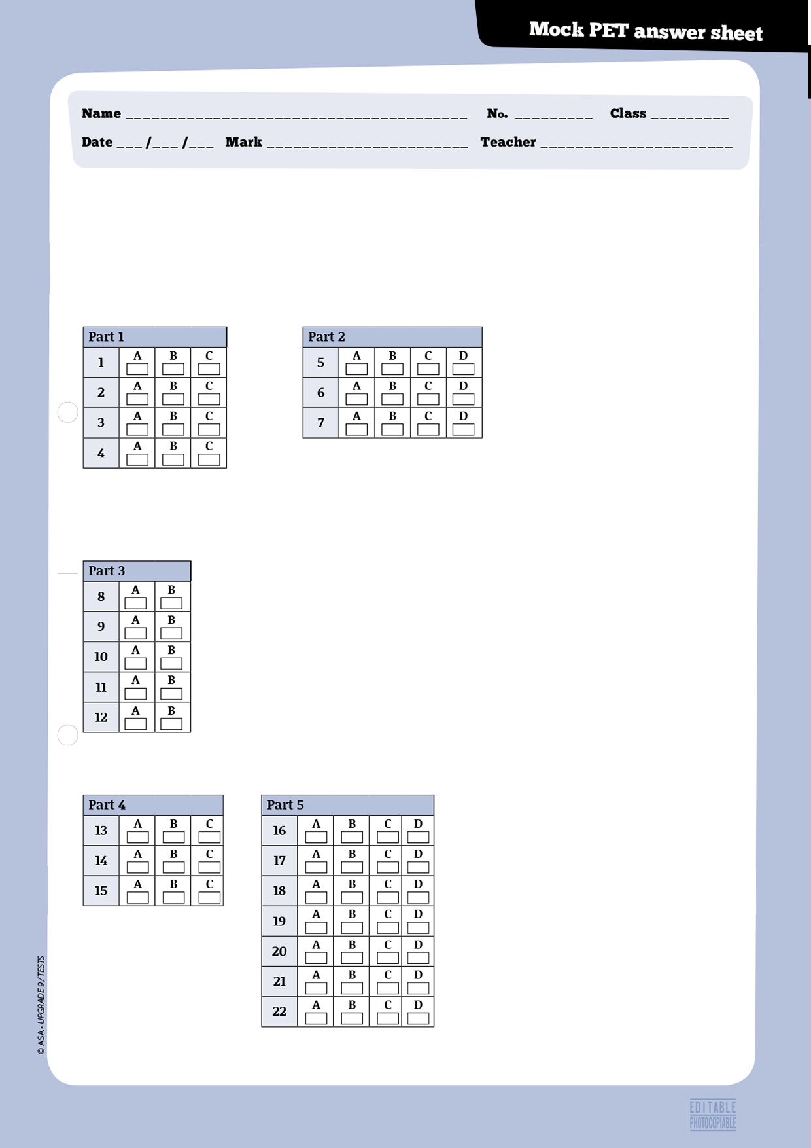
59
Reading

Instructions
For parts 1, 2, 3, 4, and 5, mark ONE letter for each question.

7
8
Writing

Instructions

For parts 1, 2 and 3, write your answers in the spaces provided.

Part 1: write your answer below.
1
2
3
4
5

Part 2 (Question 6): write your answer below.

Part 3: mark the number of the question you are answering here: →
write your answer below.

60
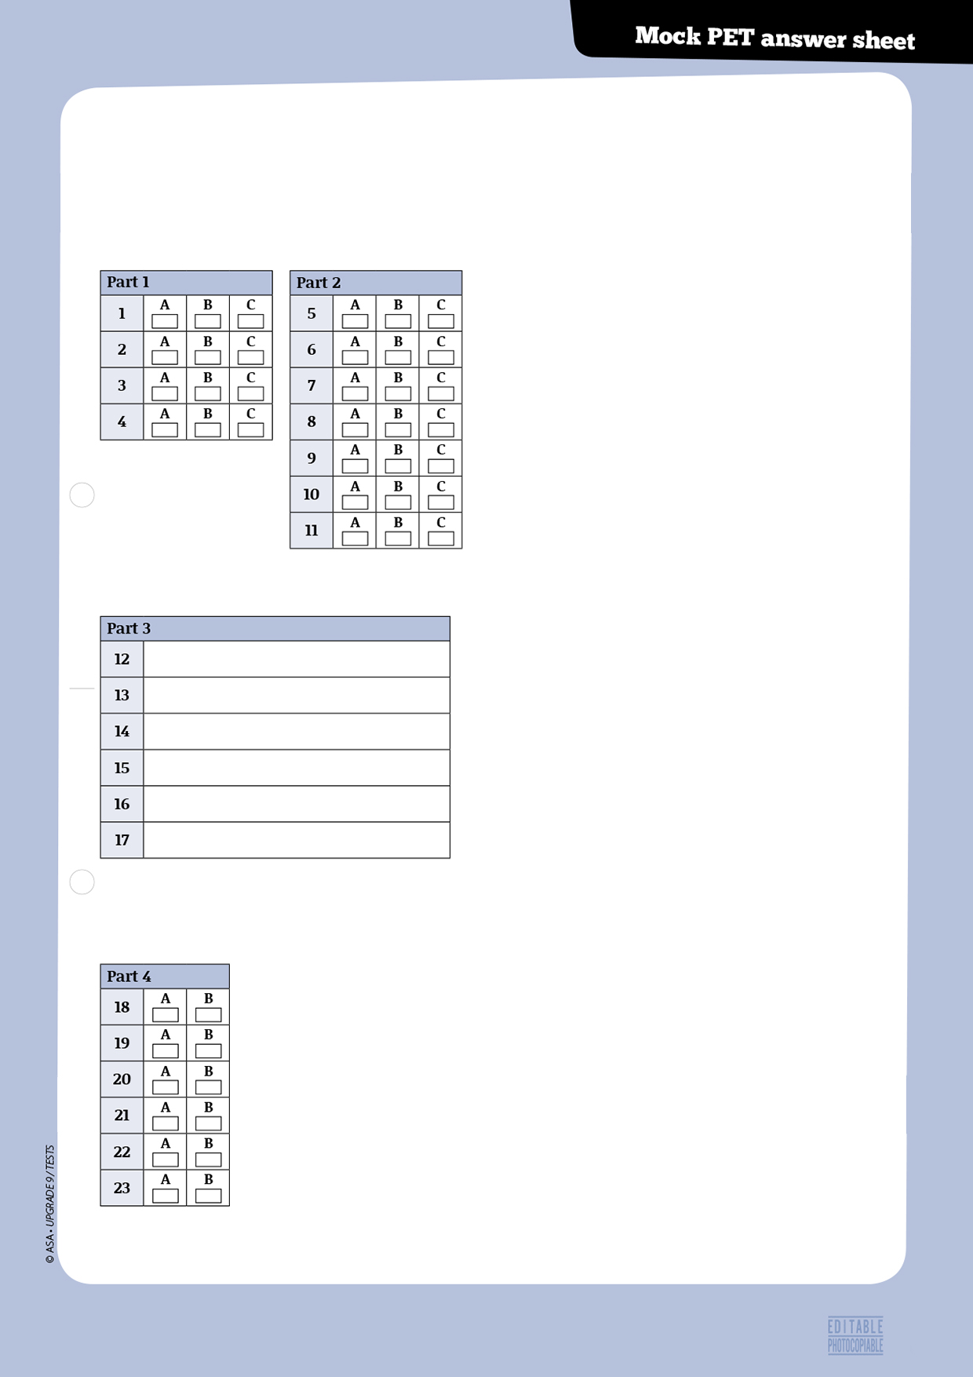

Listening

Instructions

For parts 1 and 2 mark ONE letter for each question.

Instructions
For part 3, write your answers clearly next to the numbers.

Instructions
For part 4, mark ONE letter for each question.
61
62
Progress Tests Correction Criteria
Type of items | Criteria
• Multiple choice  • True / false  • Matching  • Sequencing  • Short answer (blank filling) | • Correct/incorrect  - Sequencing items will only be given marks if the whole sequence is correct  - One mark off in true/false items for each incorrect quotation from the text, when applicable  - One mark off in true/false items for each incorrect answer, if quotation from the text is correct, when applicable
• Short answer (sentence completion;  rephrasing) | • One mark less for each language mistake, up to a maximum of 3 marks  • Incomprehensible or decontextualised answers will be marked wrong
• Short answer (text comprehension) | • One mark less for language mistakes, up to a maximum of 3 marks
• Essay | 17 to 20: The student shows excellent writing skills; totally respects the topic or text type; presents his own ideas about the topic, contextualises and develops them; uses appropriate and varied cohesive devices; organises the text in a coherent manner; mistakes (structure or spelling) are irrelevant for the comprehension of message.
• Essay | 13 to 16: The student shows reasonable writing skills; respects the topic or the text type; presents some ideas about the topic and contextualises them; uses simple cohesive devices to text but not always sucessefully; choice of words is good; makes few mistakes (structure or spelling) which hardly affect message.
• Essay | 9 to 12: The student shows some writing skills; respects the topic or the text type; presents some ideas about the topic and tries to contextualise them; uses some cohesive devices but the text is slightly disorganised; choice of words is reasonable; makes some mistakes (structure or spelling) which sometimes make message slightly confusing.
• Essay | 5 to 8: The student shows poor writing skills; mostly respects the topic or the text type; presents some ideas about the topic but the text is slightly confused; uses few cohesive devices but the text is not well organised; choice of words is poor; makes some mistakes (structure or spelling) which sometimes impede meaning.
• Essay | 0 to 4: The student shows very poor writing skills; doesn’t fully respect the topic or the text type; ideas are scarce and mostly decontextualised; uses few cohesive devices and the text is disorganised; choice of words is very poor; makes many mistakes (structure or spelling) which sometimes make message incomprehensible or illegible.  Note: the student will get 0 marks if the topic or text type is not respected, or if the whole text is incomprehensible or illegible.


74
© ASA • UPGRADE 9 / TESTS
63
 |  | A - Listening |  |  |  | B - Reading |  |  |  |  | C - Language |  |  |  |  | D - Writing |  | Total | Mark
 |  | 1 | 2 | 3 | Total | 1 | 2 | 3 | 4 | Total | 1 | 2 | 3 | 4 | Total | 1 | Total | Total | Mark
No. | Name |  |  |  | 20 |  |  |  |  | 30 |  |  |  |  | 30 |  | 20 | 100
1
2
3
4
5
6
7
8
9
10
11
12
13
14
15
16
17
18
19
20
21
22
23
24
25
26
27
28
29
30

