


Progress Tests

Unit 5 – Time to move
Table of specifications 4
Test 1 5
Test 2 9
Test 3 13
Mock PET for Schools Test 17

Answer key / Audio scripts 29
Mock PET answer sheet 32
Progress tests correction criteria 35
Progress tests correction grid 36

Mini-Tests
Mini-Test 1 38
Mini-Test 2 39
Mini-Test 3 40
Mini-Test 4 41
Mini-Test 5 42
Mini-Test 6 43
Mini-Test 7 44

Answer Key 45

Provas de Equivalência à
Frequência
Table of specifications 47
Prova 1 48
Prova 2 53

Answer key 58
Provas de Equivalência à Frequência
correction criteria 59
Provas de Equivalência à Frequência
correction grid 60

Extensive Reading Test
Test 62
Answer key 64

3
Introduction

As well as three placement tests and Mock PET for Schools Test for Unit 5, this book also includes a set of 7 mini-tests wich aim to offer more opportunities for teachers to assess their students’ development and identify areas of strength and/or weakness with regard to the specific language items taught in each unit. It is expected that the use of these grammar tests will inform both the teacher and the learner of the areas which need to be further explored or recycled.
The book also includes two Provas de Equivalência à Frequência created to help prepare students to face the assessment challenge they will encounter, allowing them to understand better the structure of this kind of exam. Each test is divided into two parts: the first evaluates Reading, Language and Writing skills and the second provides resources to evaluate Speaking (Prova oral).
Finally, we provided materials for formal formative assessment of Extensive Reading in order to help teachers asssess their students’ comprehension skills, as well as their progress in writing.
We hope all these materials and resources will help you get the best from your students.

The Team
Isabel Filipe
M.ª Adelaide Rabaça
Paula Simões

4
© ASA • UPGRADE 9 / TESTS
Table of specifications
Progress Tests (Unit 5)

Skills | Contents |  | CEF competences | Types of items | Number  of items | Marks
Skills | Topics | Language
A – Listening | Swapping  families  Xtreme holidays  Working fun | Grammar  • Reported spech  • Reported questions  • Reporting verbs  Vocabulary  • Exchange  programmes  • Extreme sports  • Voluntary work | Linguistic  • lexical  • grammatical  • semantic  • orthographic  Pragmatic  • functional  • discoursive | • Multiple choice  • Sequencing  • Matching  • Short answer (blank  filling; sentence  completion;  rephrasing)  • Short answer  (text comprehension) | 3 | 20
B – Reading  (200-300  words) |  |  |  |  | 4 | 30
C – Language |  |  |  |  | 4 | 30
D – Writing | Swapping  families  Xtreme holidays  Working fun |  |  | • Essay (80-100 words) | 1 | 20


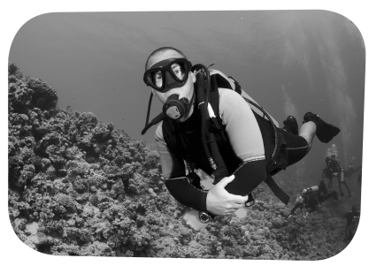
5
A – Listening 20 marks

1. You will listen to a man talking about an extreme holiday.
Listen to him and choose the right option. 5 marks

1.1. What does he mention?
□ a. The cost.
□ b. The highlights.
□ c. The group of tourists.

2. For each question, tick () the correct answer. 10 marks (4x2,5 marks)

2.1. The first part of the tour is based…
□ a. in the South. □ b. in the North. □ c. in the West.
2.2. There you’ll…
□ a. go scuba diving. □ b. meet local people. □ c. visit places.
2.3. The next place you’ll go to is a resort…
□ a. at the beach. □ b. in the city. □ c. in the mountains.
2.4. You’ll get help from…
□ a. experienced local people. □ b. a professional guide. □ c. other tourists.

3. Listen to the text again and decide if each sentence is true or false.
If is correct, put a tick () in the box under A for YES.
If it is not correct, put a tick () under B for NO. 5 marks (5x1 mark)

A B
a. In the first part of the tour you will get the opportunity to visit some cities. □ □
b. After this, you’ll visit the mountains. □ □
c. There will be an opportunity for a beach holiday. □ □
d. During the tour you won’t be able to do any extreme sports. □ □
e. The tour can be adapted to your preferences and interests. □ □


B – Reading 30 marks

1. What is the text about? Choose the right option. 6 marks
□ a. A project for Portuguese volunteers abroad.
□ b. The profile required for volunteers in South Africa.
□ c. People who want to help South African children.
□ d. Several projects for teens who want to volunteer.

2. Read the text.

Project overview


Volunteer with Gap Year South Africa assisting the local community of
Masiphumelele in South Africa. Our Community Development project is mainly
targeted at assisting people with few resources through community development programmes such as: HIV Prevention, Performing Arts and Sports Coaching
programmes. We design a personalised volunteer schedule for people, based on their particular area of interest and knowledge. Volunteers will have an opportunity to make
a meaningful contribution through supporting a number of community development activities.
5
10
15
20
25

1. HIV Prevention Programme
The Youth Centre aims to encourage young people to avoid a lifestyle that has led to a high number of HIV/AIDS cases in Masiphumelele. The Youth Centre provides activities, such as journalism classes, as well as support in ITC skills (such as typing, internet use and setting-up emails).

2. Performing Arts Programme
The Performing Arts Programme offers volunteers an opportunity to support existing projects, and to initiate their own programme which they will run while volunteering with Gap Year South Africa. The programme is based on the volunteer’s specific area of interest, encouraging children to get involved in activities such as music, dance and drama.

3. Sports Coaching Programme
Our volunteers have successfully introduced a number of new sports to enthusiastic groups of school children. These activities have certainly kept the children off the streets and assisted in preventing them from getting involved in anti-social behaviour.

http://gapyearsouthafrica.com/projects/community-development/
(abridged and adapted), accessed in December 2014
6
5

10

15
apprehensive (l. 6) a. 1. grief
agony (l. 9) b. 2. happiness
irrational (l. 12) c. 3. diminish
reduce (l. 14) d. 4. Nervo
5. unreasonable

3. Match the young people below with the programmes (1 to 3) best suited for them. 6 marks (3x2 marks)

□ a. Stephen is 21 and he loves sports. He worked as a football coach for a team of young teens.
He would prefer to work in a voluntary project with youngsters.

□ b. Monica, 19, has very good computer skills and she would like to participate in a voluntary
programme where she can teach others to work with computers.

□ c. Linda is 20 and she wants to become a singer and an actress. She is looking for an
opportunity to work with children who share her interests.

4. Decide if each sentence is true (T) or false (F). 6 marks (3x2 marks)

□ a. If a person volunteers with Gap Year South Africa, he will help the community.
□ b. There is not much volunteers can do to encourage children to do sports.
□ c. The activities in the project are not related to the volunteers’ abilities or interests.

5. Answer the questions about the text. 12 marks (3x4 marks)

5.1. What is the first goal of the Gap Year South Africa project?

5.2. How can volunteers gain with this experience?

5.3. Why is the HIV Prevention Programme important?

C – Language 30 marks

1. Choose the best word/expression for each space. 4 marks (4x1 mark)

“I’m on a 3 months a. …………………. programme at the moment in France and I’d just like to tell everyone that it’s the b. ………………. amazing experience I’ve ever had! My language is slowly c. ……...…..…. surely progressing. My school friends call it ‘Franglais’. I think that, even d. …………………. you have been learning French for years before arriving here, it is still a shock to start off with.”
http://studentexchange.org.au/about-us/testimonials/ (abridged), accessed in December 2014

 | 1. | 2. | 3. | 4.
a. | change | exchanged | exchange | chance
b. | more | many | much | most
c. | but | because | as a result | so
d. | when | if | where | as


2. Choose the correct option (1, 2, 3 or 4). 6 marks (6x1 mark)

2.1. I’m going home next week.” Paul said he a. ……………… home the b. ………………
a. 1. will go 2. is going 3. was going 4. would go
b. 1. next week 2. following week 3. week before 4. previous week

2.2. “These are my friends.” Kim said a. ……………… were b. ……………… friends.
a. 1. these 2. that 3. this 4. those
b. 1. her 2. his 3. their 4. Our

2.3. “I don’t know where to go.” Lee said she a. ……………… where to go.
a. 1. doesn’t know 2. didn’t know 3. hasn’t known 4. won’t know

2.4. “I’ll stay here.” Julia said she would stay a. ……………….
a. 1. here 2. where 3. there 4. When

3. Choose the correct option. 10 marks (5x2 marks)

a. Hannah explained / suggested / told that her friend Maya had returned from a gap year in South Africa a week after / a week before / past week.

b. Maya said / stated / told her friends about her experience during the year after / following year / previous year. The organisers asked / suggested / told her if she would like to go back to South Africa.

4. For each question, complete the second sentence so that it means the same as the first. 10 marks (4x2,5 marks)
Use no more than three words.

a. “I’m going to Brazil,” James said.
James said he ………………………… going to Brazil.
b. “You’ve done very well,” his host mother said.
His host mother told ………………………… had done very well.
c. “Did you enjoy the exchange programme, Paul?”
Sue asked ………………………… had enjoyed the exchange programme.
d. “I want to work in an animal refuge,” Jenna said.
Jenna said she ………………………… work in an animal refuge.

D – Writing 20 marks

You have just returned from an exchange programme abroad.
Write your host family an email in about 80 words.
You should:
• thank them for your stay;
• say how important their help was during your period away from home.
8

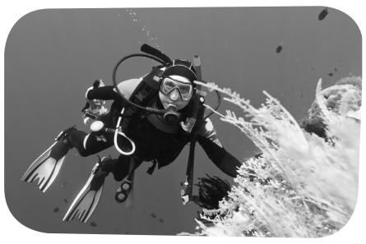
5
9
A – Listening 20 marks

1. You will listen to a man talking about an extreme holiday.
Listen to him and choose the right option. 5 marks

1.1. What does he mention?
□ a. The cost.
□ b. The highlights.
□ c. The group of tourists.

2. For each question, tick () the correct answer. 10 marks (4x2,5 marks)

2.1. The first part of the tour is based…
□ a. in the South. □ b. in the North. □ c. in the West.
2.2. There you’ll…
□ a. go scuba diving. □ b. meet local people. □ c. visit places.
2.3. The next place you’ll go to is a resort…
□ a. at the beach. □ b. in the city. □ c. in the mountains.
2.4. You’ll get help from…
□ a. experienced local people. □ b. a professional guide. □ c. other tourists.

3. Listen to the text again and decide if each sentence is true or false.
If is correct, put a tick () in the box under A for YES.
If it is not correct, put a tick () under B for NO. 5 marks (5x1 mark)

A B
a. In the first part of the tour you will get the opportunity to visit some cities. □ □
b. After this, you’ll visit the mountains. □ □
c. There will be an opportunity for a beach holiday. □ □
d. During the tour you won’t be able to do any extreme sports. □ □
e. The tour can be adapted to your preferences and interests. □ □


B – Reading 30 marks

1. What is the text about? Choose the right option. 4 marks
□ a. A project for Portuguese volunteers abroad.
□ b. The profile required for volunteers in South Africa.
□ c. People who want to help South African children.
□ c. Several projects for teens who want to volunteer.

2. Read the text.

Project overview

Volunteer with Gap Year South Africa assisting the local community of Masiphumelele in South Africa. Our Community Development project is mainly
targeted at assisting people with few resources through community development programmes such as: School Support, HIV Prevention, Performing Arts and Sports Coaching programmes. We design a personalised volunteer schedule for people,
based on their particular area of interest and knowledge. Volunteers will have an opportunity to make a meaningful contribution through supporting a number of community development activities.

1. School Support Programme
Volunteers support various activities at our partner primary school, including
activities such as the after school homework club, environmental awareness, general improvement of the school grounds and classroom facilities. Your presence in the
school will help in providing greater individual attention and encouragement to all children as well as assisting those children who may require additional lessons.

2. HIV Prevention Programme
The Youth Centre aims to encourage young people to avoid a lifestyle that has led
to a high number of HIV/AIDS cases in Masiphumelele. The Youth Centre provides activities, such as journalism classes, as well as support in ITC skills (such as typing, internet use and setting-up emails).

3. Performing Arts Programme
The Performing Arts Programme offers volunteers an opportunity to support existing projects, and to initiate their own programme which they will run while volunteering
with Gap Year South Africa. The programme is based on the volunteer’s specific area
of interest, encouraging children to get involved in activities such as music, dance and drama.

4. Sports Coaching Programme
Our volunteers have successfully introduced a number of new sports to enthusiastic groups of school children. These activities have certainly kept the children off the
streets and assisted in preventing them from getting involved in anti-social behaviour.

http://gapyearsouthafrica.com/projects/community-development/
(abridged and adapted), accessed in December 2014
10

25

20

15

10

5

How teens cope
with anxiety
Say your best friend tells you she’s going to the airport with her dad to learn to skydive She’stotally excited. But just thinking of skydiving makes you very nervous. Your stomach hurts, your heart races, and you feel a lump in your throat when you try to swallow.

For teens or anyone else, anxiety is a normal reaction to stress. Things like tests, meeting new people, speaking in public, going on a date, and competing in sports can make us feel apprehensive or upset. But some teens react much more strongly to stressful situations than others. Even thinking about the situations may cause them great agony.

Anxiety can be a good thing when it helps you deal with a tense situation. For example, when you’re studying for a test, a little anxiety can make you want to study hard so you do well. But at other times, anxiety can be harmful, especially when it is excessive and irrational, and prevents you from being able to focus.

Sometimes the anxiety can come between you and your friends, especially when you avoid going out with them or calling them because you’re too panicked or tense. This level of anxiety is harmful and that’s when you need to do something to feel less anxious so you can fully enjoy your teenage life.

Many teens find ways to cope with the high anxiety they feel. Sometimes just admitting that a situation is stressful and being prepared to deal with it can reduce your anxiety. To reduce normal levels of anxiety, set aside a period of about 20 minutes each day to devote to relaxation. Remove distractions as much as possible. Turn off the sound on your computer and the ringer on your cell phone. Some silence will help you calm down and get ready for a stressful situation.

http://teens.webmd.com/anxiety-and-teens (adapted and abridged), accessed in December 2014

3. Match the young people below with the programmes (1 to 4) best suited for them. 10 marks (4x2,5 marks)

□ a. Linda is 20 and she wants to become a singer and an actress. She is looking for an opportunity to work with children who share her interests.

□ b. Monica, 19, has very good computer skills and she would like to participate in a voluntary programme where she can teach others to work with computers.

□ c. Zoe, 20, wants to be a volunteer in a school because she thinks education is very important.
She is willing to work directly with children or help rebuild the school.

□ d. Stephen is 21 and he loves sports. He worked as a football coach for a team of young teens.
He would prefer to work in a voluntary project with youngsters.

4. Decide if each sentence is true (T) or false (F). 4 marks (4x1 mark)

□ a. If a person volunteers with Gap Year South Africa, he will help the community.
□ b. The activities in the project are not related to the volunteers’ abilities or interests.
□ c. Voluntary work in the primary school could involve giving children more lessons.
□ d. The Performing Arts Programme allows children to develop their criativity.

5. Answer the questions about the text. 12 marks (3x4 marks)

5.1. What does the Community Development project expect to do?

5.2. In what ways will School Support Programme volunteers help children?

5.3. What is the goal of the HIV Prevention Programme?

C – Language
30 marks
1. Choose the best word/expression for each space. 4 marks (4x1 mark)
“I’m on a 3 months a. ………………… programme at the moment in France and I’d just like to tell everyone that it’s the b. ………………… amazing experience I’ve ever had! My language is slowly c. ………………… surely progressing. My school friends call it ‘Franglais’. I think that, even d. ………………… you have been learning French for years before arriving here, it is still a shock to start off with.”

http://studentexchange.org.au/about-us/testimonials/ (abridged), accessed in December 2014

 | 1. | 2. | 3. | 4.
a. | change | changing | exchange | exchanging
b. | more | many | much | most
c. | but | however | though | Even though
d. | when | if | that | now

11

2. Choose the correct option (1, 2, 3 or 4). 6 marks (6x1 mark)

2.1. I’m going home next week.” Paul said he a. ……………… home the b. ………………
a. 1. will go 2. is going 3. was going 4. would go
b. 1. next week 2. following week 3. week before 4. previous week

2.2. “These are my friends.” Kim said a. ……………… were b. ……………… friends.
a. 1. these 2. that 3. this 4. those
b. 1. her 2. his 3. their 4. Our

2.3. “I don’t know where to go.” Lee said she a. ……………… where to go.
a. 1. doesn’t know 2. didn’t know 3. hasn’t known 4. won’t know

2.4. “I’ll stay here.” Julia said she would stay a. ……………….
a. 1. here 2. there 3. where 4. When

3. Choose the correct option. 10 marks (5x2 marks)

a. Hannah explained / suggested / told that her friend Maya had returned from a gap year in South Africa a week after / a week before / last week.

b. Maya said / stated / told her friends about her experience during the year after / following year / previous year. They asked / suggested / told her if she would like to go back to South Africa.

4. For each question, complete the second sentence so that it means the same as the first.
Use no more than three words. 10 marks (4x2,5 marks)
a. “I’m going to Brazil,” James said.
James said he ………………………… to Brazil.
b. You’ve done very well,” his host mother said.
His host mother told ………………………… done very well.
c. “Did you enjoy the exchange programme, Paul?”
Sue asked ………………………… enjoyed the exchange programme.
d. “I want to work in an animal refuge,” Jenna said.
Jenna said she ………………………… work in an animal refuge.

D – Writing 20 marks

You have just returned from an exchange programme abroad.
Write your host family an email in 80 - 100 words.
You should:
• thank them for your stay;
• say how important their help and support were during your period away from home.
12

A – Listening 20 marks

1. You will listen to a man talking about an extreme holiday.
Listen to part 1 and choose the right answer. 4 marks

1.1. What exactly does he say?
□ a. He explains why the holiday is so expensive.
□ b. He calls people’s attention to safety regulations.
□ c. He describes the holiday in detail.

2. Listen to part 2 of the text and tick () the correct answer. 6 marks (2x3 marks)

2.1. If you go on the tour, you’ll…
□ a. walk through unchanged polar territory.
□ b. feel very tired.
□ c. have to wear warm clothes.
2.2. This tour is…
□ a. organised by local people.
□ b. very expensive.
□ c. a real expedition.

3. Listen to a man talking about the east coast of Greenland.
Decide if each sentence is true or false.
If the sentence is correct, put a tick () in the box under A for YES.
If is not correct, put a tick () under B for NO. 10 marks (4x2,5 mark)

A B
a. None of Greenland’s population lives on the east coast. □ □
b. There are no mountains on the east coast. □ □
c. The first explorers of Liverpool Land believed it was an island. □ □
d. There are few animal species in Greenland. □ □

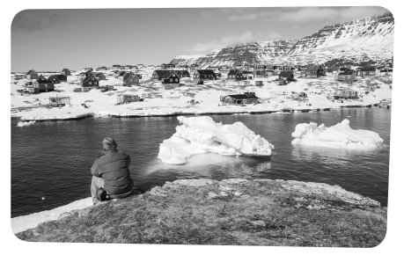
13

25
20
15
10
5
B – Reading 30 marks

1. What is the text about? Choose the right option. 4 marks
□ a. Opportunities to go on an exchange programme during a gap year.
□ b. People who want to help those in need.
□ c. How people can make donations to help South African children.
□ d. Opportunities to do voluntary work abroad.

2. Read the text.

Community development in Cape Town

Volunteers will support numerous community development initiatives in the local community of Masiphumelele in Cape Town, South Africa. Masiphumelele is a township of approximately 38,000 people near Cape Town. Most residents are migrants from the rural
areas of the Eastern Cape. They settle here looking for work, better education and other facilities. Social and health deprivation together with poverty and poor living conditions make life tough for residents – only 30% have regular work and life expectancy is 50 years of age.

1. Student tutoring and mentoring
This programme involves after school tutoring and mentoring of students who need help with schoolwork. Your role as a volunteer involves not only helping the students with their work, but also providing support and encouragement, and building relationships with the students. Volunteers indicate their subject areas of interest, and find a group that needs help with that subject.

2. Women’s Club Programme
The Women’s Club provides an environment for teenage girls to talk openly about issues they face in their daily lives: relationships, diet, self-image and peer-pressure. This club has been incredibly popular, as it encourages an open dialogue between volunteers and young
girls. The support and advice that you as a volunteer can provide mean a lot to young women who often don’t get enough support at home.

3. Edu-care Support Programme
The Edu-Care Support Programme assists local child care centres in becoming registered centres. In order to do that – and receive financial support – centres need to meet certain standards related to meals and safety. Volunteers will assist teachers in looking after the young children by playing and interacting with them, sorting donated resources, and planning nutritious meals for the children.

4. Life Exchange Programme
Life Exchange offers volunteers the opportunity to work in a safe and supportive environment with young people who are working to change their lives. Life Exchange offers academic tutoring, classes and mentoring to support young adults who have faced huge challenges in life, from pressure to join gangs and drug addiction to delinquency.

http://gapyearsouthafrica.com/projects/community-development/ (abridged and adapted), accessed in December 2014
14
3. Match the young people below with the programmes (1 to 4) best suited for them. 8 marks (4x2 marks)

□ a. Linda is 20 and she would like to work with disabled children. She has some experience
as a babysitter.

□ b. John, 19, has always been a very good student and thinks he can use his skills and
knowledge to help children and young people with their education.

□ c. Phillip, 20, has considerable experience working with and monitoring teens in summer
camps. He would prefer to work in a voluntary project with youngsters.

□ d. Victoria, 19, would like to take part in a volunteer programme involving young girls.
She thinks she will be able to provide help, advice and support in many important areas.

4. Decide if the sentences are true (T), false (F) or not mentioned (NM). 6 marks (4x1,5 marks)

□ a. The students in the community do not need any help with their schoolwork.
□ b. There are young people in the community who have not finished high school.
□ c. Girls get all the help and advice they need from their parents.
□ d. Volunteers in the Life Exchange Programme will help in different areas.

5. Answer the questions about the text. 12 marks (3x4 marks)

5.1. Where do the people in the community of Masiphumelele come from?

5.2Why is residents’ life so difficult in this community?

5.3. Who will volunteers be working with?

C – Language 30 marks

1. Choose the correct option (1, 2, 3 or 4) to complete the sentences. 5 marks (5x1 mark)

1.1. “I’m going home next week.” Paul said he a. …………….. home the b. ……………...
a. 1. will go 2. is going 3. was going 4. would go
b. 1. next week 2. following week 3. week before 4. previous week
1.2. “These are my friends.” Kim said a. …………….. were b. …………….. friends.
a. 1. these 2. that 3. this 4. those
b. 1. her 2. his 3. Their 4. our
1.3. “I don’t know where to go.” Lee said she a. …………….. where to go.
a. 1. doesn’t know 2. didn’t know 3. hasn’t known 4. won’t know

15

2. Choose the correct option. 5 marks (5x1 mark)

a. Hannah went on a 3 months exchange trip to France. She suggested / asked / told everyone that it was the most amazing experience she had ever had!

b. Hannah explained / suggested / told that it had been really scary because nothing had prepared her for what she was going to do but she also told / asked / said that she had made many great friends.

c. Hannah’s friend, Jill, explained / asked / told her what the benefits were. Hannah suggested / told / said Jill that her language had improved immensely.

3. For each question, complete the second sentence so that it means the same as the first.
Use no more than three words. 10 marks (4x2,5 marks)

a. My friend asked, “Have you ever participated in an exchange programme?”
My friend asked ……………………. ever participated in an exchange programme.
b. James asked, “Is he leaving now?”
James asked if he ……………………..
c. “I’m flying to France tomorrow,” she said.
She said she was flying to France the ……………………..
d. “Mary didn’t enjoy her stay in Italy,” Carol said.
Carol said Mary ……………………. her stay in Italy.

4. Choose the best word for each space. 10 marks (4x2,5 marks)

“Living away a. …………………. home, on the other side of the world, has changed me in ways that will stay with me for life. b. ………………. visiting Denmark, I have come out of my shell, so to say; I’m much less shy! I’ve become more independent, and have more confidence in c. ……………. and the choices I make, and I’ve learned to take everything as it comes, and not judge things by their appearance, d. ……………. I didn’t necessarily do this before my trip.”

http://studentexchange.org.au/about-us/testimonials/ (abridged and adapted), accessed in December 2014

 | 1. | 2. | 3. | 4.
a. | from | off | of | out
b. | For | Because | Since | Then
c. | me | myself | my | mine
d. | although | who | whose | but

D – Writing 20 marks

You have just returned from an exchange programme abroad.
Write your host family an email in 80 - 100 words. You should:
• thank them for your stay and say how important their help and support were during that period;
• invite them to visit you and your family.
16


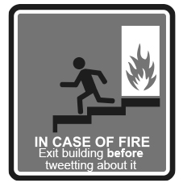

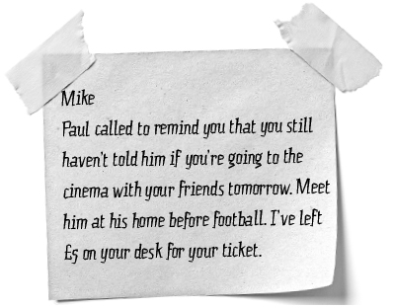
What does Mike have to do?
A Meet his friends at school.
B Decide if he’s going to the cinema.
C Play rugby with Paul.
What does Mike have to do?
A Meet his friends at school.
B Decide if he’s going to the cinema.
C Play rugby with Paul.

What does Mike have to do?
A Meet his friends at school.
B Decide if he’s going to the cinema.
C Play rugby with Paul.

17
Reading • Part 1

Questions 1 – 4

Look at the text in each question.
What does it say?
Mark the correct letter A, B or C on your answer sheet.

1

A People who want to write graffiti should call the police.
B People witnessing graffiti should call the police.
C The police want people to write graffiti on the wall.

2

A People must tweet about the fire and leave.
B Tweeting is forbiden if a fire breaks out.
C People can only tweet after getting out if there is a fire.

3
What can parents do?
A Get information on the main school events.
B Take part in the main school events.
C Access the school calendar by paying a small amount
of money.

4


18




A North Pole cruise in the Arctic –
This journey combines the ship with the use of helicopter flights for aerial viewing. Reaching the “top of the world”, the experience of standing where all directions are south is incomparable. There will be time to explore remote Franz Josef Land. With its massive flat-topped islands and basalt cliffs, this archipelago is a birdwatcher’s paradise.

C Gobi desert tour in Mongolia – The motorbike is a fine way to discover Mongolia. Riding off-road for hundreds of kilometres across the vast open steppe and mountains of the Gobi, you will experience the ride of a lifetime and observe an ancient culture that has changed little in centuries.

B Galapagos Islands holiday – Extended trekking on the island of Isabela in the remote Galapagos archipelago is a rare privilege. As well as five major volcanoes, Isabela is also one of the last remaining habitats of the giant Galapagos tortoise.

D Kilimanjaro climb, Rongai route – With its sense of unspoilt wilderness, the Rongai Route approaches Kilimanjaro from the north and is less crowded than the most popular trails. We trek through farmlands, forest and alpine moorlands as we approach the beautiful summit cone.

http://www.responsibletravel.com/holiday/ (adapted and abridged), accessed in December 2014

Reading • Part 2

Questions 5 – 7

The people below all want to go on an extreme holiday. Below there are four extreme holiday
suggestions in different parts of the world.

Decide which three would best suit the following people.

For questions 5 – 7, mark the correct letter (A – D) on your answer sheet.

5 Patrick, 40, works in banking. He is looking for an opportunity
to escape from everyday life and enjoy real freedom and adventure.
He is especially keen on photography and enjoys riding a motorbike.
7 Ron, is 39 and he is a geologist. He always picks extreme destinations
for his holidays. Besides adventure, he chooses to visit places where he
can find out more about different types of rocks.
6 Maria is 58 and she is a teacher. She is extremely adventurous and likes
to go on adventurous trips and visit unusual, exciting places.
Maria is also a nature-friendly tourist and a keen bird-watcher.


19
Reading • Part 3

Questions 8 – 12

Look at the sentences below about hosting exchange programme students experiences.
Read the text to decide if each sentence is correct or incorrect.
If it is correct, mark A on your answer sheet.
If it is not correct, mark B on your answer sheet.

8 The Marsh family learnt a lot from their exchange student.

9 The hosting experience was so positive that one of the families keeps in touch with their
“daughter”.

10 One of the exchange students refused to participate in the family’s daily routine.

11 The two girls got along very well and found out they had things in common.

12 One of the host families did not have any children.

Exchange programmes

Some Australian families hosted a student in their home. These are a few testimonials.

1. “It’s been a great experience so far... It’s been great having an older brother for our young kids. Simon has been a great role model and he helps around the house a lot. One of the first things he asked us during the first couple of days he was here was what his chores were. I was delighted to hear him say that.” – Victoria, host Mum

2. “We have visited many places and seen Australia through Charlotte’s eyes. We have also been able to learn about Charlotte’s family, their culture and her school experiences in Belgium. Hosting Charlotte has been a rewarding experience for us all, better than we thought possible. She very quickly became a part of our family and we will all have happy memories for the rest of our lives”. Having
a Belgian sister is a new experience for Grace too. She says, ‘Being the youngest and the only one left at home I was looking forward to having another teenager in the house. While Charlotte helps me with my French I help her with her English lessons and I have taught her many Aussie words and sayings. We both love to shop and shop and shop...’” – The Marsh family

3. “Francesca was like the third daughter that we never had. We couldn’t believe how well she slipped right on into our family and we almost didn’t realise she was there. Our lives have been very much enriched by Francy’s short stay with us in Australia. We are always in contact and we can see
in the future that we will catch up again with her. We have fond and long lasting memories of whole
big bunches of fun.” – The Cope Family

http://studentexchange.org.au/host-a-student/testimonial (adapted and abridged), accessed in December 2014


20
Reading • Part 4

Questions 13 – 15

Read the text and the questions below.
For each question, mark the correct letter A, B, C or D on your answer sheet.

Welcome a foreign student into your home!

Volunteer host families are asked to provide students with meals and room and board during their stay in America. Although not a large sum of money, the Department of State does appreciate your dedication to international exchange and so host families can claim $50 per month tax deduction for each month they host in the following tax year.
Your International Cultural Exchange Services (ICES) Area Representative will provide support for you and your student and prepare you and your family before the student’s arrival.
Throughout the year, your Area Representative will be available to help your student through monthly phone calls, face to face, informal meetings, or student/host family group activities. Your ICES Area Representative will also maintain contact with the local high school your student attends, ensuring academic progress.
Additionally, ICES provides a full-time support team trained in the field of international exchange. Bonnie Gunter and her team in our Virginia office have over 20 years of experience in international exchange and are responsible for helping the student, host family, and Area Representatives resolve any adjustment challenges and answer questions.

http://www.icesusa.org/host-families/ (abridged and adapted), accessed in December 2014

13 What is this text about?
A The holiday experience.
B The hosting experience.
C The travelling experience.
d The student exchange experience.

14 The Area Representative
A will prepare the student before his arrival.
B will provide the family with some money.
C will inform the family before the student arrives.
D will help both the family and the student.

15 The support team
A are extremely experienced.
B have been trained recently.
C will not support the family, just the student.
D give host families $50 to help with expenses.
21
Reading • Part 5

Questions 16 – 22

Read the text below and choose the correct word for each space.
For each question, mark the correct letter A, B, C or D on your answer sheet.

Renovating schools in Tanzania
with Global Citizens Network (GCN)

We need (16) ……………….…… help working with the Pare people of Kilomeni, Tanzania to rehabilitate and expand the elementary and secondary school buildings. (17) ……….……………children have had to leave the village in order to (18) …………….………education elsewhere.
You will live and work with a community high in the Pare Mountains. GCN has been helping to build and renovate classrooms and expand the staff housing at the Kilomeni Primary School.
Since 2008, GCN has been in partnership with Mr Smart Baitani, founder and Executive Director
(19) ………….………… COSAD (Community Solutions) for Africa’s Development to build a
(20) ………….………… education centre designed to provide training classes, promote small-scale economic initiatives, and work space for womens’ (21) ……….……………You will stay with the Bahaya people in the village of Bukoba and be absorbed into their rich culture and daily (22) ………….…………

http://www.universalgiving.org/ (abridged and adapted), accessed in December 2014

16 A your B their C our D her
17 A Some B Few C No D Many
18 A finish B continue C get D avoid
19 A from B of C in D to
20 A population B group C society D community
21 A classes B activities C businesses D groups
22 A routine B tasks C experience D works


22
Writing • Part 1

Questions 1 – 5

Here are some sentences about volunteering.
For each question, complete the second sentence so that it means the same as the first sentence.
Use no more than three words.
Write only the missing words on your answer sheet.

1 Sally said, “Don’t volunteer for that programme.”
Sally told me _ _ _ _ _ _ _ _ _ _ _ _ _ _ _ _ _ _ _ _ _ _ _ _ volunteer for that programme.

2 Carla said, “I‘ve been a volunteer since 2010.”
Carla told me _ _ _ _ _ _ _ _ _ _ _ _ _ _ _ _ _ _ _ _ _ _ _ _ been a volunteer since 2010.

3 Peter said, “I’m going to Tanzania next week.”
Peter said he was going to Tanzania _ _ _ _ _ _ _ _ _ _ _ _ _ _ _ _ _ _ _ _ _ _ _ _.

4 Mary wanted to know whether they lived in the shelter.
Mary asked “ _ _ _ _ _ _ _ _ _ _ _ _ _ _ _ _ _ _ _ _ _ _ _ _ in the shelter?”

5 Paul advised them to leave then.
Paul said “You _ _ _ _ _ _ _ _ _ _ _ _ _ _ _ _ _ _ _ _ _ _ _ _.”

Writing • Part 2

Question 6

You want to invite your host family to attend your graduation ceremony.
Write the family an email. In your email, you should:
• explain when and where the event is taking place;
• say why you would like them to be there;
• suggest they stay with you and your family.
Write 35 – 45 words on your answer sheet.
23
Writing • Part 3

Write an answer to one of these questions (7 or 8) in this part.
Write an answer in about 100 words on your answer sheet.

Question 7
• This is part of a letter you received from your penfriend Reese.

In your next letter, please tell me about your student exchange experience.
What were some of the most important benefits for you as a person and as
a student?
What was your favourite time and why?
Did you have any special responsibilities/role to play around the host home?

• Now write a letter, answering your penfriend’s questions.
• Write a letter in about 100 words on your answer sheet.

Question 8
• Your teacher has asked you to write a story.
• This is the title of the story: The experience of a lifetime
• Write your story in about 100 words on your answer sheet.




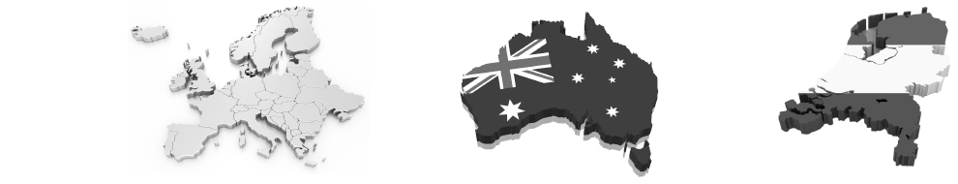
24
Listening • Part 1

Questions 1 – 4

There are four questions in this part.
For each question there are three pictures/answers and a short recording.
Choose the correct answer (A, B or C).

1 Where is she planning to go?

A Europe B Australia C Holland

2 Where hasn’t he lived?

A B C

3 Where does she want to live in the future?

A B C

4 What countries is she planning to visit?

A B C

25
Listening • Part 2

Questions 5 – 11

Listen to Carla talking about herself and her experiences.
For each question, choose the correct answer A, B, or C.

5 Carla studies in
A San Marino.
B Forlí.
C Bologna.

6 The university she studies in
A hasn’t built many new facilities.
B is very old.
C organises many international conferences.

7 She’s been an Erasmus student
A since 2014.
B for six months.
C for six weeks.

8 Carla’s favourite activity(ies) is(are)
A playing music, travelling and doing voluntary work.
B playing the piano and the guitar.
C playing the keyboard in a band.

9 Carla
A used to be an athlete.
B never really enjoyed sports.
C would like to compete in the Olympic Games.

10 She
A would like to visit Congo.
B would like to send some money to help a mission in Congo.
C has already been to Congo.

11 In the future she hopes to
A volunteer in Tanzania.
B go back to Africa and work for an NGO.
C go back to Africa and work in a Catholic mission.

Listening • Part 3

Questions 12 – 17

You will hear a radio programme in which Jill Hennessy, who provides support and
encouragement to volunteers at GCN – Global Citizens Network–, is interviewed.
For each question, fill in the missing information in the numbered spaces.

Listening • Part 4

Questions 18 – 23

Look at the six sentences for this part.
Decide if each sentence is correct or incorrect.
If it is correct, choose the letter A for YES. If it is not correct, choose the letter B for NO.

YES NO

18 Sue’s family wish Tiffany could stay longer. A B

19 Amy had some reservations about becoming a host. A B

20 Sue admits there were minor difficulties. A B

21 Tiffany had to adapt to a new system of education. A B

22 There were not many benefits for them as a family. A B

23 Sue is sure they will keep in touch in the future. A B
Name: Jill Hennessy
Works for: ………………………………..
Project: (12) ………………………………..
Who it will help: ………………………………..
How many people it will serve: (13) ………………………………..
People of Odienya: ………………………………..
How they refer to President Obama: (14) ………………………………..
The people maintain a life of: ………………………………..
Website: ………………………………..
Programme cost covers: ……………………………..……………………………..
Skills needed: (15) ………………………………..
Who will contribute with expertise: (16) ………………………………..
Odienya location: (17) ………………………………..
Global Citizens Network
the community
nearly 2,000
subsistence farming
www.globalcitizens.org
one-site accommodations and in-country travel
26
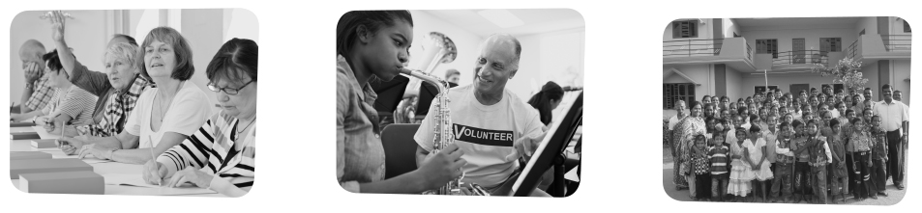

• Where do you live/come from?

• Would you like to study more foreign
languages?

• Would you like to study in a foreign
country? Why/Why not?

• Would you like to study or volunteer
abroad? Why/Why not?

• What’s the thing you enjoy most about
your country/region?
• What type of voluntary work would you
choose?

• What country would you choose
to volunteer in?

• What is your favourite type of holiday?
• What language do you use to
communicate?

• What types of activities do you like doing?

• What are the benefits of travelling?
You have been asked to choose two key volunteering projects. Talk together about how important these projects are and decide which two projects you think are the most important.
Speaking • Part 1

(2 - 3 minutes)

Be prepared to say your names, spell your surname and answer questions about yourself, your daily life, interests, etc. For example:

Speaking • Part 2

(2 - 3 minutes)
Talk to your partner about the following situation. The pictures below will help you.
27

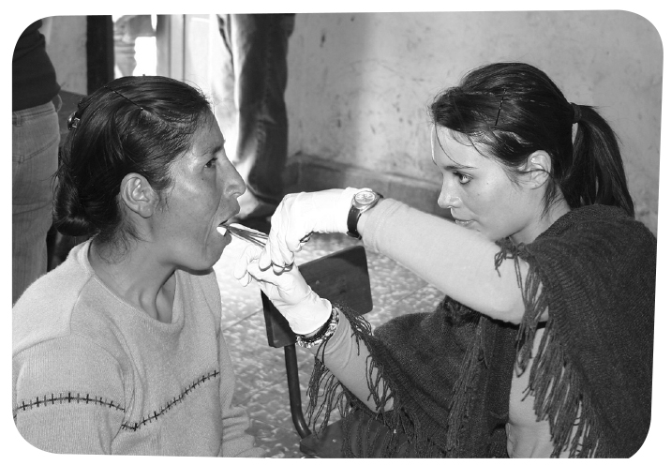
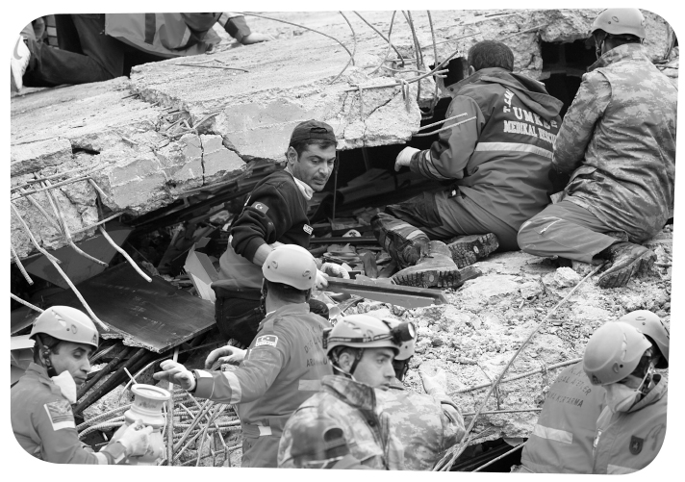
28
Speaking • Part 3

(3 minutes)

Look at one of the following photographs and talk by yourself about what you can see.

Speaking • Part 4

(3 minutes)

Talk to your partner about volunteering, if you think this is a good idea and what voluntary
work you would like to do and where.

Unit 5 – Progress tests and mock PET
Answer Key

Test 1

A – Listening
1.1. b.
2.1. b; 2.2. c; 2.3. a; 2.4. b.
3. a. A; b. B; c. A; d. B; e. A.

B – Reading
1. d.
3. a. 3; b. 1; c. 2.
4. a. T; b. F; c. F.
5.1. The first goal is to assist people with few resources through community development programmes.
5.2. With a personalised schedule based on their area of interest and knowledge.
5.3. It encourages young people to avoid a lifestyle that has led to a high number of HIV/AIDS cases.

C – Language
1. a. 3; b. 4; c. 1; d. 2.
2.1. a. 3; b. 2. 2.2. a. 4; b. 1. 2.3. a. 2; 2.4. a. 3.
3. a. explained… a week before; b. told… previous year
asked.
4. a. was; b. him he; c. Paul if/whether he; d. wanted to.

Test 2

A – Listening
1.1. b.
2.1. b; 2.2. c; 2.3. a; 2.4. b.
3. a. A; b. B; c. A; d. B; e. A.

B – Reading
1. d.
3. a. 3; b. 2; c. 1; d. 4.
4. a. T; b. F; c. T; d. T.
5.1. The Community Development project expects to help people improve their situation.
5.2. They will give children more attention and encouragement, as well as help the ones who need extra lessons.
5.3. The goal is to encourage young people to avoid a lifestyle that has led to a high number of HIV/AIDS cases.

C – Language
1. a. 3; b. 4; c. 1; d. 2.
2.1. a. 3; b. 2. 2.2. a. 4; b. 1; 2.3. a. 2; 2.4. a. 2.
3. a. explained… a week before; b. told… previous year… asked.
4. a. was going; b. him he had; c. Paul if/whether he;
d. wanted to.

Test 3

A - Listening
1.1. c.
2.1. a; 2.2. c.
3. a. B; b. B; c. A; d. B.
B - Reading
1. d.
3. a. 3; b. 1; c. 4; d. 2.
4. a. F; b. NM; c. F; d. T.
5.1. The people in the community of Masiphumelele come from rural areas of the Eastern Cape.
5.2. It’s difficult because the majority of people in the community lack social and health support and live in poor conditions.
5.3. Volunteers will be working with poor and unhealthy people.

C – Language
1.1. a. 3; b. 2. 1.2. a. 4; b. 1. 1.3. a. 2.
2. a. told; b. explained… said; c. asked… told.
3. a. if/whether I had; b. was leaving then;
c. following/next day; d. hadn’t enjoyed.
4. a. 1; b. 3; c. 2; d. 1.

Mock PET

READING
Part 1 – 1. B; 2. C; 3. A; 4. B.
Part 2 – 5. C; 6. A; 7. B.
Part 3 – 8. A; 9. A; 10. B; 11. A; 12. B.
Part 4 – 13. B; 14. D; 15. A.
Part 5 – 16. A; 17. D; 18. C; 19. B; 20. D; 21. C; 22. A.

WRITING
Part 1 – 1. not to; 2. she had; 3. the following week/the week
after; 4. Do you live; 5. should leave now.
Part 2 – 6. Personal answer.
Part 3 – 7. or 8. Personal answer.

Listening
Part 1 – 1. B; 2. C; 3. A; 4. B.
Part 2 – 5. B; 6. C; 7. B; 8. A; 9. A; 10. C; 11. B.
Part 3 – 12. construct a health clinic; 13. about 10,000 people;
14. their American President; 15. no specific skills required;
16. the local community; 17. in southwestern Kenya.
Part 4 – 18. A; 19. B; 20. A; 21. A; 22. B; 23. A.

AUDIO SCRIPTS

Progress tests 1 and 2

CD 4 – Track 54
Diving and mountain biking in Vietnam
Some of the highlights of this holiday are adventure travel off the beaten track, mountain biking, kayaking, colourful ethnic culture, exotic scenery, remote ethnic markets, homestays in stilt houses, boat cruises, and scuba diving. The first part of this tour is based in the North, where you’ll visit Hanoi, Ha Long Bay and Sapa.
From there, you travel to Nha Trang, where you’ll find a small,
secluded beach resort for diving and a beach holiday. The active elements of the tour include biking, kayaking and scuba diving.
Where necessary, you’ll have an experienced professional guide, and interact with Vietnamese people in cities and towns, and ethnic minority communities in Sapa. If you wish, the tour can easily be extended to include trekking, more time in Ho Chi Minh City, or any other interests you may have.

http://www.responsibletravel.com/holiday/2474/diving-and-mountain-biking-in-vietnam (abridged and adapted), accessed in December 2014

29

Progress tests 3

CD 4 – Tracks 55 and 56
Polar explorers

[Part 1]
This holiday is a north to south skiing expedition of Liverpool
Land – a little peninsula on the east coast of Greenland.
Over 15 days we will trek approximately 75 miles and experience the Arctic in all its raw natural beauty. Along the way we will enjoy the mountain range of Liverpool Land and views to the west of Hurry Fjord and Jameson Land. We will start at the frozen coastline and travel over sea ice, glaciers and valleys. It will be a physically and mentally challenging expedition and will instill a fantastic sense of achievement. Travel to the start of the trek will be via skidoo and at the end we will experience an exhilarating helicopter flight with stunning views over sea ice, mountains and the distant ice cap.

[Part 2]
Expedition highlights include:
– trekking over 70 miles through remote polar wilderness;
– experiencing living and travelling in polar conditions;
– being part of a real expedition with an objective.
Greenland is the largest island in the world and the interior is
one large ice sheet similar to that of Antarctica. This expedition
offers the chance to explore a true polar landscape, to travel over sea ice and to master the day-to-day skills necessary to survive in this remote wilderness.

www.highandwild.co.uk (abridged and adapted), accessed in December 2014

CD 4 – Track 57
Liverpool Land
The east coast of Greenland is sparsely populated by Inuits and
has the world’s largest system of fjords (inlets), which are a stark contrast to the mountainous terrain rising steeply up from them.
Until relatively recently Liverpool Land was believed to be an
island, as pioneering explorers of the area believed Hurry Inlet
formed a channel with Carlsberg Fjord.
Greenland has eight species of whale around its coastal waters,
over two million seals, reindeers, walruses, polar bears, arctic
hares, wolves and a large variety of sea birds.
We may see any of these animals during the expedition.

www.highandwild.co.uk (abridged and adapted), accessed in December 2014

Mock PET

Part 1

CD 4 – Track 58
1. Where is she planning to go?
I’m Angelique, and I’m 21. I’m taking a degree in Media and
Communication at Rotterdam University, Holland. I really
like studying there because people are very open-minded and
Rotterdam is a very beautiful multicultural city, with a lot
of music festivals and shopping centres. I’ve already visited
almost all the countries in Europe, but I have never been
outside Europe. In two years I’m going with a friend
of mine backpacking in Australia to see kangaroos, and
I really can’t wait.

CD 4 – Track 59
2. Where hasn’t he lived?
I’m Bob, I was born in Almere in the Netherlands but
I didn’t go to university there because I moved with my family to Sweden when I was 17. After that I lived in London for two years, where I finished high school and began my Social Psychology studies at university. However,
I didn’t finish my degree, as in the last year I moved back to
Sweden where my family was living. I also lived in New York for three months, where I took a general course of English.
That experience was amazing because not only did I improve
my English, but I also lived in Manhattan, the real centre of
New York. There I met an incredible number of people.

http://www.du.se/en/Student-Services/Study-Abroad/Interviews-with-Exchange-Students-at-Dalarna-University/ (abridged and adapted), accessed in December 2014

CD 4 – Track 60
3. Where does she want to live in the future?
I’m Anna and I’m from Bologna, Italy. I came to Falun,
Sweden, to attend the master programme in African Studies,
and also because I’ve always loved Sweden. I really like its cold climate, the beautiful scenery, and the many lakes.
I really enjoy living in a place with a lot of rivers and lakes,
because when I’m close to water I feel at home. I also like
Swedish music, and the post rock bands. I would like to move here in the future, but it’s very difficult to find a job here if you don’t know the language.

CD 4 – Track 61
4. What countries is she planning to visit?
I’m Jasmine and I‘m 23 years old. I’m doing a master’s degree in Education in Hamburg, training to be a Spanish and
German teacher in German secondary-schools.
I came to Sweden because I wanted to visit the country and
because I have some relatives in Gothenburg. I really enjoy
living in such a small, friendly town, and I don’t think it’s
very different from Hamburg. This isn’t my first time living
away from home: I lived in Lima for one year when I was 15
as an exchange student to improve my Spanish. I also went to
Namibia, Botswana and South Africa, and now I’m planning
to visit Norway and Finland as well.

http://www.du.se/en/Student-Services/Study-Abroad/Interviews-with-Exchange-Students-at-Dalarna-University/ (abridged and adapted), accessed in January 2015
Part 2

CD 4 – Track 62
Carla’s experiences abroad
I am Carla and I’m 22. I was born in the Republic of San Marino, a small nation surrounded by Italy. I am studying International Relations in Forlí, which is a part of the University of Bologna.
In Forlí there is the best university in Italy for International
Relations; the city is quite small and there are not too many
inhabitants, and we can say that the city lives thanks to
the students. The city is becoming bigger thanks to the
university which is building new facilities and organising an
increasing number of conferences with important people at the
international political and economic level.
I came to Sweden as an Erasmus student, but even after 6 months I can’t say that I’ve met a lot of Swedish people.
I feel that there is a big distance between Swedish students and
international students.
I like playing music, travelling and doing voluntary work.
I played piano for 10 years and guitar for three, and now
I play the keyboard in a band. We send the money that we get
when we play to a mission in Congo. I was there for 20 days
to live together with native people. It was a trip based on the
language of music, because I think that music can help with
communication between people from very different cultures.
I have always been involved with sports. I was an athlete for
many years, and I also went to England and Germany for
competitions. I had to quit when I decided to come to Sweden.
I would like to work for an NGO or at the international level,
because I’m interested in cooperation and development. The
best experience of my life has been the month that I spent in
Tanzania as a volunteer in a Catholic mission. There I helped
organise the medical dispensary and I took care of children in the kindergarten. I remember on the first day they asked me to draw the alphabet with pictures, and I had to draw an elephant even if at that time the only elephant I had ever seen was in a picture!
My main aim is to return to Africa to work there for an NGO.

http://www.du.se/en/Student-Services/Study-Abroad/Interviews-with-Exchange-Studentsat-Dalarna-University/ (abridged and adapted), accessed in January 2015

Unit 5 – Progress tests and mock PET
30

16
31
Unit 5 – Progress tests and mock PET

Part 3

CD 4 – Track 63
Partnership with the Luo people of Odienya
Hello, my name is Jill Hennessy and I provide support to young people who hope to participate in an international volunteer programme. Global Citizens Network needs your help to build a health clinic for the Luo people of Odienya, who were hit hard by outbreaks of malaria and cholera. The construction of this health center will greatly help the community and will serve about 10,000 people within the 4 km radius. The majority of the nearly 2,000 people of Odienya belong to the Luo tribe.
President Barack Obama’s father is a Luo from this area, and the local people proudly refer to President Obama as their “American President”.
The people live a life of subsistence farming, balancing their rich traditions while developing a modern lifestyle focusing on health and education.
You will help construct the health center with a committee who oversees the project and has worked with GCN and community volunteers since January 2000.
The current programme cost for the three week trip to Kenya is listed on the website at www.globalcitizens.org. Programme cost covers on-site accommodation (lodging and meals) and
in-country travel. No specific skills are required, only a willingness to appreciate and accept other cultures. We believe everyone has skills – some yet to be discovered. Each volunteer contributes what she or he can. If any expertise is needed for a project, the local community will provide these skills.
Odienya is a Luo village in southwestern Kenya. It is just west of Kenya’s capital, Nairobi, beautifully situated near beautiful Lake Victoria and a short drive to the foot of Mount Kilimanjaro. This area is rich in breathtaking scenery, abundant wildlife and tribal culture.

www.globalcitizens.org/where-we-go/ (abridged and adapted), accessed in January 2015
Part 4

CD 4 – Track 64
A fantastic experience with Tiffany
Interviewer: What motivated you and your family to volunteer
to host?
Sue: It was Amy’s idea to become a host family. Amy was
interested in knowing more about exchange programmes and
when an opportunity came up to become a coordinator nearly
two years ago I jumped at the chance so that we could learn
more first hand. We thought that 6 months would be quite long
enough but now that the time for Tiffany to leave is getting
closer we wish she could stay longer. Tiffany has become a
member of our family, a second daughter and a sister, and we
love having her with us.
Interviewer: Did you have any reservations?
Sue: Amy was very excited once we made the decision to take on our student but I did have a few reservations. I was concerned about the reaction that a student and her family might have about having a single parent host family. Also, my working full time means that our day-to-day lives are very busy and I was concerned that it would be difficult to spend enough time with our new family member. Because Amy is an only child, I did wonder how I would cope if our student and Amy didn’t get on or had totally different interests. Silly me! None of my concerns have caused a major problem. Life is still busy, and I am still a ingle parent but our guest has fitted right in and copes with our family life as if she has been with us forever.
Interviewer: Any major challenges or difficulties?
Sue: There really haven’t been many. I think my role as
coordinator provided me with a good understanding of what to
expect. Ensuring that I had some support systems in place was
important. Planning ahead was the key I believe. For Tiff, the
biggest challenge has been getting used to school because the
system is so different here.
Interviewer: What benefits have you gained from hosting?
Tell us about the good stuff!
Sue: The benefits... where do I begin? I’m sure every host
family would talk about the benefits of exposure to another
culture but we didn’t realise how much we would enjoy
sharing our lives with an overseas student. The benefits have
not just been for Amy and me, but for everyone around us.
Amy is an only child so the obvious benefit for her has been
that she has enjoyed having a sister at last and they have
become very close. They talk about visiting one another in the
future and Tiff has indicated that she wants to come back to
Australia to live for a while. Tiff’s father has even invited Amy
to come and stay with them in France for several months. It
seems that our relationship with Tiff will not end when her
stay with us is over and I look forward to meeting her parents
at some time and visiting her home in France. I think she will
always be part of our family now.
Interviewer: Thank you for talking to us, Sue.
Sue: Thank you.

http://studentexchange.org.au/ (abridged and adapted), accessed in January 2015

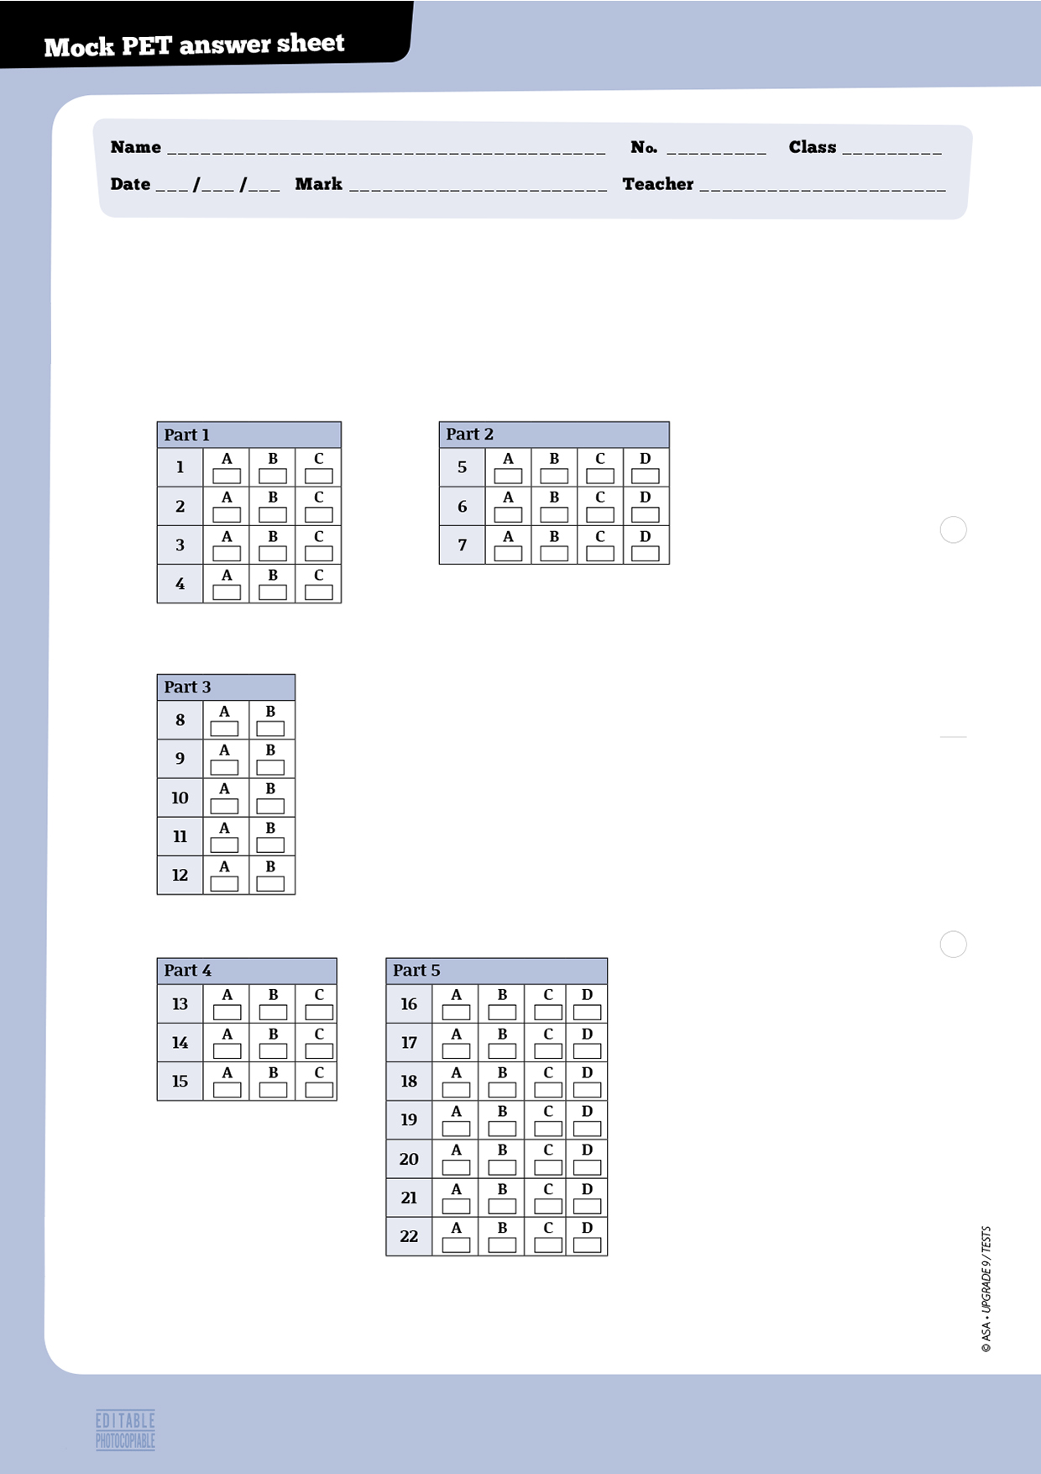

32
Reading

Instructions
For parts 1, 2, 3, 4, and 5, mark ONE letter for each question.
19

7
8
33
Writing

Instructions

For parts 1, 2 and 3, write your answers in the spaces provided.

Part 1: write your answer below.
1
2
3
4
5

Part 2 (Question 6): write your answer below.

Part 3: mark the number of the question you are answering here: →
write your answer below.

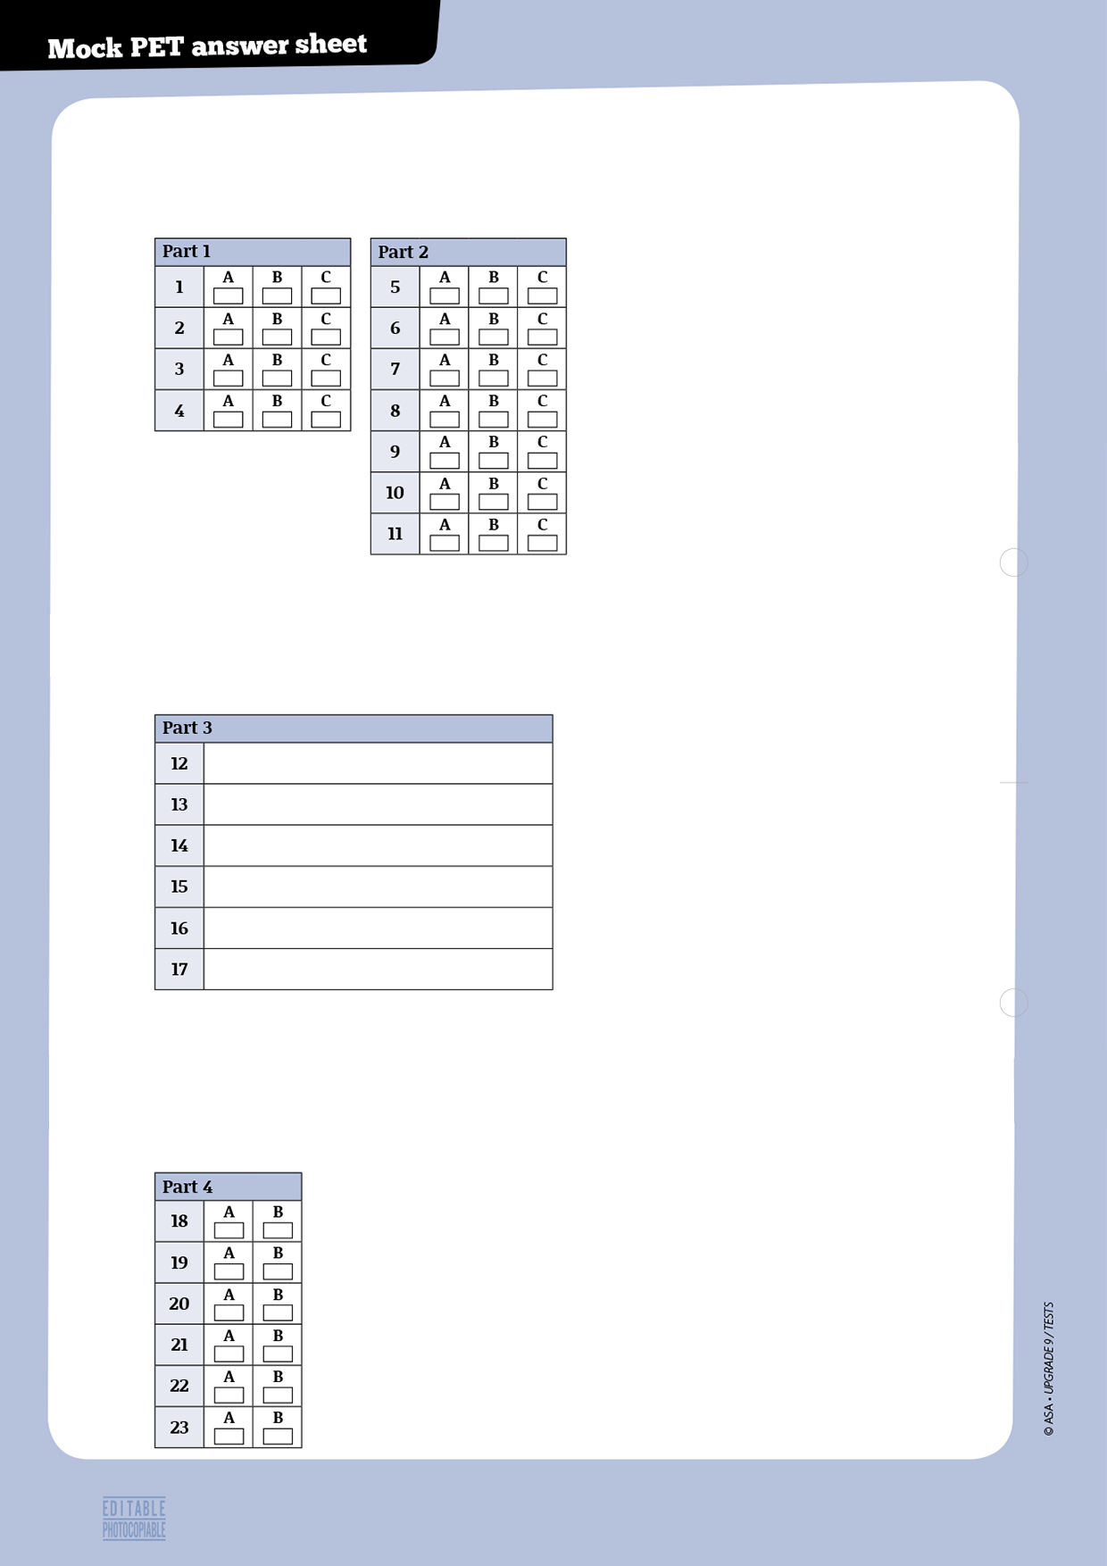
Listening

Instructions

For parts 1 and 2 mark ONE letter for each question.

Instructions
For part 3, write your answers clearly next to the numbers.

Instructions
For part 4, mark ONE letter for each question.
34
Progress Tests Correction Criteria
Type of items | Criteria
• Multiple choice  • True / false  • Matching  • Sequencing  • Short answer (blank filling) | • Correct/incorrect  - Sequencing items will only be given marks if the whole sequence is correct  - One mark off in true/false items for each incorrect quotation from the text, when applicable  - One mark off in true/false items for each incorrect answer, if quotation from the text is correct, when applicable
• Short answer (sentence completion;  rephrasing) | • One mark less for each language mistake, up to a maximum of 3 marks  • Incomprehensible or decontextualised answers will be marked wrong
• Short answer (text comprehension) | • One mark less for language mistakes, up to a maximum of 3 marks
• Essay | 17 to 20: The student shows excellent writing skills; totally respects the topic or text type; presents his own ideas about the topic, contextualises and develops them; uses appropriate and varied cohesive devices; organises the text in a coherent manner; mistakes (structure or spelling) are irrelevant for the comprehension of message.
• Essay | 13 to 16: The student shows reasonable writing skills; respects the topic or the text type; presents some ideas about the topic and contextualises them; uses simple cohesive devices to text but not always sucessefully; choice of words is good; makes few mistakes (structure or spelling) which hardly affect message.
• Essay | 9 to 12: The student shows some writing skills; respects the topic or the text type; presents some ideas about the topic and tries to contextualise them; uses some cohesive devices but the text is slightly disorganised; choice of words is reasonable; makes some mistakes (structure or spelling) which sometimes make message slightly confusing.
• Essay | 5 to 8: The student shows poor writing skills; mostly respects the topic or the text type; presents some ideas about the topic but the text is slightly confused; uses few cohesive devices but the text is not well organised; choice of words is poor; makes some mistakes (structure or spelling) which sometimes impede meaning.
• Essay | 0 to 4: The student shows very poor writing skills; doesn’t fully respect the topic or the text type; ideas are scarce and mostly decontextualised; uses few cohesive devices and the text is disorganised; choice of words is very poor; makes many mistakes (structure or spelling) which sometimes make message incomprehensible or illegible.  Note: the student will get 0 marks if the topic or text type is not respected, or if the whole text is incomprehensible or illegible.

35


74
© ASA • UPGRADE 9 / TESTS
36
 |  | A - Listening |  |  |  | B - Reading |  |  |  |  | C - Language |  |  |  |  | D - Writing |  | Total | Mark
 |  | 1 | 2 | 3 | Total | 1 | 2 | 3 | 4 | Total | 1 | 2 | 3 | 4 | Total | 1 | Total | Total | Mark
No. | Name |  |  |  | 20 |  |  |  |  | 30 |  |  |  |  | 30 |  | 20 | 100
1
2
3
4
5
6
7
8
9
10
11
12
13
14
15
16
17
18
19
20
21
22
23
24
25
26
27
28
29
30


37
Mini-Tests

awards
performing
participated
film
role
audiences
director
actor
1. Complete the text with the words on the right. Two aren’t used.

Robin Williams

The American a. _ _ _ _ _ _ _ _ _ _ _ _ _ _ _ _ _ _ _ _ _ _ _ _ Robin Williams walked the red carpet on more than one occasion during his b. _ _ _ _ _ _ _ _ _ _ _ _ _ _ _ _ _ _ _ _ _ _ _ _ career. The most interesting c. _ _ _ _ _ _ _ _ _ _ _ _ _ he d. _ _ _ _ _ _ _ _ _ _ _ _ _ _ _ _ _ _ _ _ _ _ _ _ _ _ _ _ _ _ in was Dead Poets Society, in the late 1980s. He played the e. _ _ _ _ _ _ _ _ _ _ _ _ _ _ _ _ _ _ _ _ _ _ _ _ of a teacher who had a new perspective on education and the way teachers and students could get along. The film received several f. _ _ _ _ _ _ _ _ _ _ _ _ _ _ _ _ _ _ _ _ _ _ _ _.

2. Complete the sentences with the past simple or past continuous of the verbs in brackets.

a. Robin Williams _ _ _ _ _ _ _ _ _ _ _ _ __ _ _ _ _ _ _ _ (die) on 11th November 2014. When his death _ _ _ _ _ _ _ _ _ _ _ _ _ _ _ _ _ _ (occur) he _ _ _ _ _ _ _ _ _ _ _ _ _ _ _ _ _ _ (work) in a new American comedy film, Night at the Museum: Secret of the Tomb, in which he _ _ _ _ _ _ _ _ _ _ _ _ _ _ _ _ _ (play) the part of Theodore Roosevelt. The film _ _ _ _ _ _ _ _ _ _ _ _ _ _ _ _ _ (be) released in December 2014.

b. He was a very busy actor and performer. Whenever he _ _ _ _ _ _ _ _ _ _ _ _ _ _ _ _ _ _ _ _ _ _ _ _ (not work) on a film,
he _ _ _ _ _ _ _ __ _ _ _ _ _ _ _ (take part) in television series or programmes.

c. Williams _ _ _ _ _ _ _ _ _ _ _ _ _ _ _ _ (act) in a lot of different types of films and it _ _ _ __ _ __ _ _ _ _ _ _ _ _ _ _ _ _ _ _ (be) this versatility that _ _ _ _ _ _ _ __ _ __ _ _ _ _ _ _ _ (make) him very well known in Hollywood.

http://www.theguardian.com/film/2014/aug/11/robin-williams-found-dead-suicide and
http://edition.cnn.com/2014/08/11/showbiz/robin-williams-dead/ (abridged and adapted), accessed in December 2014

3. Choose the correct form of the verb: past simple or present perfect.

Brainy teenager

A Stockport whizz kid a. has become / became one of the best in the world in a global English competition. Rebecca Moore b. spent / has spent 10 days competing against 12,000 other students across the world in an 80-hour online challenge last August. The student c. has become / became the best in Britain in the Education Perfect World Series competition after finishing eighth in the world. She d. has entered / entered the competition, which quizzes youngsters in writing skills, because she e. always enjoyed / has always enjoyed an extra challenge. As well as answering online questions, Rebecca f. has had / had to prepare by studying various classic works, for example Shakespeare’s Romeo and Juliet.

http://www.manchestereveningnews.co.uk/ (abridged and adapted), accessed in December 2014
38

publications
articles
adaptation
hits
career
novel
released
39
1. Fill in the gaps with the words on the right. Two aren’t used.

The author of If I stay

Gayle Forman began her a. _ _ _ _ _ _ _ _ _ _ _ _ _ _ _ _ writing for Seventeen Magazine in which most of her b. _ _ _ _ _ _ _ _ _ _ _ _ _ _ _ _ focused on young people and social concerns. Later she became a freelance journalist for c. _ _ _ _ _ _ _ _ _ _ _ _ _ _ _ _ like Details Magazine, Jane Magazine, Glamour Magazine, The Nation, Elle Magazine, and Cosmopolitan Magazine. In 2009, Forman d. _ _ _ _ _ _ _ _ _ _ _ _ _ _ _ _ _ _ _ If I Stay, about a 17 year old girl named Mia who has been involved in a tragic car accident. The e. _ _ _ _ _ _ _ _ _ __ _ _ _ _ _ follows Mia’s experience as she lies in a coma.

http://en.wikipedia.org/wiki/Gayle_Forman (abridged and adapted), accessed in February 2015

2. Complete the text with the past simple of the verbs in brackets.

How to become a writer

There is no recipe on how to become a successful writer. While some writers admit they a. _ _ _ _ __ _ _ _ _ _ _ _ __ _ _ _ _ (not have) access to books at home when they b. _ _ _ _ _ _ _ _ __ _ _ _ _ _ _ (be) very young, others confess they c. _ _ _ _ _ _ _ _ __ _ _ _ _ _ _ (know) they d. _ _ _ _ _ __ _ _ _ _ _ _ _ _ _ (want) to become writers at a very early age. Still others say their parents e. _ _ _ _ _ __ _ _ _ _ _ _ _ _ _ (prefer) books about the sea or about a variety of different topics but they f. _ _ _ _ _ _ __ _ _ _ _ _ _ _ _ (not show) any interest in the types of books they write. Most of their families never g. _ _ _ _ _ __ _ _ _ _ _ _ _ _ _ (go) into libraries. In addition, bookshops h. _ _ _ _ _ _ _ _ _ _ _ __ _ __ _ __ _ _ _ (not exist) in the small villages where many i. _ _ _ _ _ _ _ _ _ _ _ __ _ _ _ (grow) up.

3. Complete the second sentence so that it means the same as the first sentence.
Use no more than three words.

a. It’s three years since he wrote his last book.
He _ _ _ _ _ _ _ _ _ _ _ _ _ a book for three years.

b. His first novel was published in 2004.
He has been a writer _ _ _ _ _ _ _ _ _ _ _ _ _ .

c. No other novel has won as many awards as this one over the last few years.
This is the novel that _ _ _ _ _ _ _ _ _ _ _ _ _ most awards over the last few years.


be a couch potato
a piece of cake
break from
cup of tea
healthy foods
noodle
a smart cookie
40
1. Rewrite each sentence below and replace the highlighted phrase with one of the expressions in the box. Two aren’t used.

a. Normally when I get home, my friend Paul is already cooking a vegetarian dish for dinner. He’s really into cooking and says preparing a meal is very easy.

b. The best thing about Paul’s love of cooking is that when I get home I can have a pause from my daily routine.

c. While Paul really enjoys spending his time in the kitchen, I have to admit that cooking is not my favourite activity.

d. Paul keeps telling me all I have to do to become a good cook is to use my intelligence. I doubt it very much. I don’t even like the kitchen environment.

e. The truth is that I’ve never felt confident in the kitchen. Paul says I would succeed if I tried harder because I’m such an intelligent girl.

2. Complete the sentences with the correct question tag.

a. Let’s try that new vegetarian restaurant down the street, _ _ _ _ _ _ _ _ _ _ _ _ _?
b. They have been vegetarians for years, _ _ _ _ _ _ _ _ _ _ _ _ _?
c. Jonathan cooks delicious healthy food, _ _ _ _ _ _ _ _ _ _ _ _ _?
d. You wouldn’t like to try this new vegan dish, _ _ _ _ _ _ _ _ _ _ _ _ _?
e. They gave up on dairy products, _ _ _ _ _ _ _ _ _ _ _ _ _?
f. I’m a good cook, _ _ _ _ _ _ _ _ _ _ _ _ _?

3. Complete the sentences with the correct verb forms: past simple or past perfect.

Yesterday was one of those days when everything seems to go wrong.
When I a. _ _ _ _ _ _ _ _ _ _ _ _ _ (get) home from the gym, my friends b. _ _ _ _ _ _ _ _ _ _ _ _ _ (already / have) dinner because it c. _ _ _ _ _ _ _ _ _ _ _ _ _ (be) so late although I d. _ _ _ _ _ _ _ _ _ _ _ _ _ (promise) to be early.
They e. _ _ _ _ _ _ _ _ _ _ _ _ _ (be) upset because I f. _ _ _ _ _ _ _ _ _ _ _ _ _ (not call) to tell them.

1. Choose the correct phrasal verb to complete the sentences below.

a. Nowadays people are into / enroll in / take part in mobile phones. Wherever they go, people use their mobile phones constantly to switch on / log in / set up to a network server and send out / log in / freeze up electronic messages. Often they even forget to hack into / print out / switch off their phones.

b. These days children learn to take up / turn on / log out electronic devices from a very early age. Because they are so familiar with technology, some teens are even capable of backing up / plugging in / hacking into other people’s computers.

2. Choose the correct verb form to complete the conditional sentences below.

a. If you choose / chose a job you like, you felt / will feel happy.
b. Children will be / would be negatively affected if they will watch / watch too much television.
c. Some medical advances wouldn’t be / would be possible if technology don’t support / didn’t support them.
d. If mobile phones don’t exist / didn’t exist, communication wouldn’t be / would be so fast.
e. People’s lives wouldn’t be / aren’t so rich if technology developed / will develop more slowly.

3. Complete the second sentence so that it means the same as the first.
Use no more than three words.

a. People can’t relax unless they stop working for a while.
_ _ _ _ _ _ _ _ _ _ _ _ _ working for a while, they can relax .

b. You have to find a method that suits you to be able to relax.
If you can’t find a method that suits you, you _ _ _ _ _ _ _ _ _ _ _ _ _ able to relax.

c. Teens need to take some time off in order to reduce stress.
Teens won’t reduce stress if _ _ _ _ _ _ _ _ _ _ _ _ _ take some time off.

d. You won’t have a stressful life if you don’t worry a lot.
If you worry too much, you _ _ _ _ _ _ _ _ _ _ _ _ _ a stressful life.

e. The number of stressed teenagers won’t reduce until people stop pressurising them.
If people _ _ _ _ _ _ _ _ _ _ _ _ _ pressurising them, the number of stressed teenagers will reduce.
41

a big cheese
call the shots
sweat blood
dead end job
be tired
to call it a day
learn the ropes
42
1. Rewrite the sentences below and replace the highlighted expressions with one of the idioms
in the box. Two aren’t used.

a. When Sally abandoned school she never imagined she would end up in a job with no future.

b. It’ll take the new workers some time to understand how to do their job properly.

c. By 9 pm the boss decided we could all stop work and go home.

d. Sally is very capable. She’s the right person to make the important decisions.

e. Sam has become one the most important and influential workers in the company.

2. Choose the correct verb form to complete the conditional sentences below.

a. If you choose / chose a job as a software engineer, you will work / worked with computers
every day.
b. Computers work / worked better when they will be / are updated.
c. If you use / will use a webcam, you could talk / can talk to your family face-to-face.
d. You saw / can see your friends if you log / will log in to Skype.
e. If someone hacked / hacks into your computer, they will steal / stole all your data.

3. Complete the second sentence so that it means the same as the first.
Use no more than three words.

a. Young people feel anxious when their parents and teachers’ expectations are too high.
If their parents and teachers’ expectations _ _ _ _ _ _ _ _ _ _ _ _ _ so high, teens wouldn’t feel anxious.

b. Parents pressurise their children about their grades and they get stressed.
Children wouldn’t get stressed if their parents _ _ _ _ _ _ _ _ _ _ _ _ _ them about their grades.

c. You shouldn’t worry too much about your social image.
I wouldn’t worry so much about your social image if _ _ _ _ _ _ _ _ _ _ _ _ _ you.

43
1. Choose the correct option.

a. Either / Neither his uncle nor / or his aunt want to go to the party.

b. When Monica arrived at the new school, she was bullied. “Feel free to talk to neither / either myself or the head teacher if anyone tries to discriminate against you again,” Miss Albertson told her.

2. Complete the text with the correct form of the verb: to-infinitive or -ing form.

It’s not easy to live in this neighbourhood. It seems a. _ _ _ _ _ _ _ _ _ _ _ _ _ (be) very peaceful and tolerant to anyone who doesn’t live here. Outsiders normally enjoy b. (visit) the park, c. _ _ _ _ _ _ _ _ _ _ _ _ _ (shop) at the local market or simply d. _ _ _ _ _ _ _ _ _ _ _ _ _ (walk) the streets. Those who chose e. _ _ _ _ _ _ _ _ _ _ _ _ _ (live) here have a different opinion. They refuse f. _ _ _ _ _ _ _ _ _ _ _ _ _ (agree) with the opinions of the outsiders. They keep g. _ _ _ _ _ _ _ _ _ _ _ _ _ (remember) the riots that happened at weekends, when teens from different racial groups fought each other.

3. Complete the second sentence so that it means the same as the first.
Use no more than three words.

a. The city Annie lives in is multicultural but discrimination still exists.
_ _ _ _ _ _ _ _ _ _ _ _ _ Annie lives in a multicultural city, discrimination still exists.

b. Lynn was bulied because she has got dark skin.
Lynn’s got dark skin, _ _ _ _ _ _ _ _ _ _ _ _ _ she was bulied.

c. My neighbour is a foreigner but he is well integrated into the community.
My neighbour is a foreigner. _ _ _ _ _ _ _ _ _ _ _ _ _ he is well integrated into the community.

d. It was raining heavily but the protesters kept demonstrating in the street.
The protesters kept demonstrating in the street _ _ _ _ _ _ _ _ _ _ _ _ _ it was raining heavily.

4. Join the sentences using the relative pronoun in brackets.

a. Fatima is a Muslim woman. She is in favour of multiculturalism. (who)

b. Wivika believes religious diversity should be celebrated. Religious diversity should be celebrated if it brings people together. (which)

c. Kathrin is very proud of her country. Its culture makes it unique. (whose)




The cost of the trip to Iceland was so low a.
that we decided to
My holidays this year were b.
You can’t pick an exotic destination
if you want to c.
Fiona says her dream holiday would be d.
1. travel on a shoe string.
2. make hay while the sun shines.
3. off the beaten track.
4. a busman’s holiday.
cooperate
volunteer
foundation
worthy
humanitarian
charity
fundraising
1. Complete the sentences with the words on the right. One isn’t used.

You don’t have to go abroad to participate in a a. _ _ _ _ _ _ _ _ _ _ _ _ _ project. You can simply organise a b. _ _ _ _ _ _ _ _ _ _ _ _ _ _ _ _ _ event at your school. The important thing is to make sure everyone agrees to c. _ _ _ _ _ _ _ _ _ _ _ _ _ It is a good idea to partner with a local d. _ _ _ _ _ _ _ _ _ _ _ _ _ to support them. You can also work with a e. _ _ _ _ _ _ _ _ _ _ _ _ _ which supports a f. _ _ _ _ _ _ _ _ _ _ _ _ _ cause.

2. Match the sentence halves.

3. Choose the best option.

a. “I visited Nepal last year,” he said.
He says / said he had visited / visited Nepal last year / the previous year.

b. “My last visit to Paris was ten years ago,” Mary explained.
Mary explained / explains her last visit to Paris had been / was ten years early / before.

c. “Why don’t you apply to do voluntary work abroad?” Mary asked.
Mary asks / asked why she doesn’t / didn’t apply to do voluntary work abroad.

4. Complete the second sentence so that it means the same as the first.
Use no more than three words.

a. My friend asked, “Do you want to go on an extreme holiday?”
My friend asked me _ _ _ _ _ _ _ _ _ _ _ _ _ to go on an extreme holiday.

b. Paul asked, “Where did you go on holiday this year?”
Paul asked me_ _ _ _ _ _ _ _ _ _ _ _ _ gone on holiday that year.

c. “Will your parents agree with the exchange programme?”
Mark wanted to know whether _ _ _ _ _ _ _ _ _ _ _ _ _ agree with the exchange programme.
44
Answer key

Mini-test 1 (Unit 1)

1. a. actor; b. performing; c. film; d. participated; e. role;
f. awards.
2. a. died… occurred… was working… played… was; b. wasn’t working… was taking part; c. acted… was… made.
3. a. has become; b. spent; c. became; d. entered; e. has
always enjoyed; f. had.

Mini-test 2 (Unit 1)

1. a. career; b. articles; c. publications; d. released; e. novel.
2. a. didn’t have; b. were; c. knew; d. wanted; e. preferred;
f. didn’t show; g. went; h. didn’t exist; i. grew.
3. a. hasn’t written; b. since 2004; c. has won.

Mini-test 3 (Unit 2)

1. a. a piece of cake; b. break from; c. cup of tea; d. noodle;
e. a smart cookie.
2. a. shall we; b. haven’t they; c. doesn’t he; d. would you;
e. didn’t they; f. aren’t I.
3. a. got; b. had already had; c. was; d. had promised; e.
were; f. hadn’t called.

Mini-test 4 (Unit 3)

1. a. are into… log in… send out… switch off; b. turn on…
hacking into.
2. a. choose… will feel; b. will be… watch; c. wouldn’t be… didn’t support; d. didn’t exist… wouldn’t be; e. wouldn’t be… developed.
3. a. If people stop; b. won’t be; c. they don’t; d. will have;
e. stop.

Mini-test 5 (Unit 3)

1. a. dead end job; b. learn the ropes; c. to call it a day;
d. call the shots; e. a big cheese.
2. a. choose… will work; b. work… are; c. use… can talk; d.
can see… log; e. hacks… will steal.
3. a. weren’t; b. didn’t pressurise; c. I were.

Mini-test 6 (Unit 4)

1. a. Neither… nor; b. either.
2. a. to be; b. visiting; c. shopping; d. walking; e. to live;
f. to agree; g. remembering.
3. Even though/Although; b. therefore/so; c. However; d. even though/although.
4. a. Fatima is a Muslim woman who is in favour of
multiculturalism. b. Wivika believes religious diversity
which brings people together should be celebrated.
c. Kathrin is very proud of her country whose culture
makes it unique.

Mini-test 7 (Unit 5)

1. a. humanitarian; b. fundraising; c. cooperate; d. charity;
e. foundation; f. worthy.
2. a. 2; b. 4; c. 1; d. 3.
3. a. said… had visited… the previous year; b. explained…
had been… before; c. asked… didn’t.
4. a. If I wanted; b. where I had; c. my parents would.

45

Provas de Equivalência
à Frequência
46

Table of specifications
Provas de Equivalência à Frequência

Skills | Contents |  | CEF competences | Types of items | Number  of items | Marks
Skills | Topics | Language
A – Readi | Volunteering  Discrimination | • Connectors  • Relative pronouns  • Conditional  sentences  • Reported speech  • Modal verbs | Linguistic  • lexical  • grammatical  • semantic  • orthographic  Pragmatic  • functional  • discoursive | • True / false  • Matching  • Short answer (blank  filling; sentence  completion;  rephrasing)  • Short answer  (text comprehension) | 4 | 40
B – Language |  |  |  |  | 4 | 40
D – Writing | Volunteering  Discrimination |  |  | • Essay (80-100 words) | 1 | 20

47
© ASA • UPGRADE 9 / TESTS
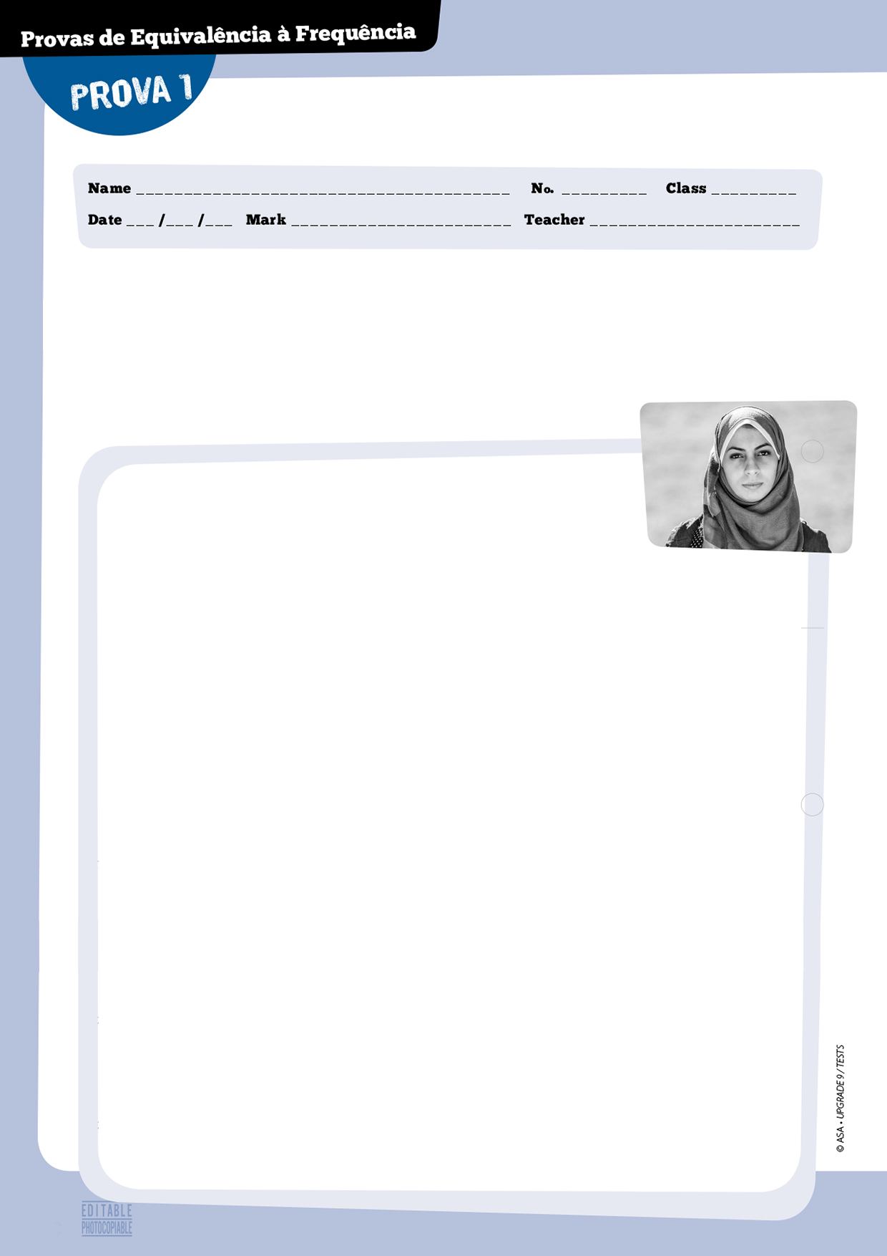

A — Reading 40 marks

1. What factor(s) is/are important when choosing a job? 5 marks

2. Read the text.

Eman Mohamed: the courage
to tell a hidden story
48

When I turned 19, I started my career as the first female photojournalist in the Gaza Strip, Palestine. My work as a woman photographer was considered a serious insult to local traditions,
and created a problem for me and my family. The male-dominated field made my presence unwelcome by all possible means. They made it clear that a woman must not do a man’s job.
Photo agencies in Gaza refused to train me because I was a woman. The “no” sign was pretty clear. Three of my colleagues went as far as to drive me to an open air strike area where the sounds of explosion were the only thing I could hear. Dust was flying in the air, and the ground was shaking under my feet. I only realised we weren’t there to document the event when the three of them
got back into the armored Jeep and drove away, waving and laughing, leaving me behind. For a moment I felt terrified, humiliated, and sorry for myself but my colleagues’ action is not the only death threat I have received, although it was the most dangerous one.
10

5

Women in Gaza are seen as passive creatures, a lot of women were not allowed to work or have
an education. With two conflicts in their lives, namely the war and social restrictions on their
lives, the bright stories women had to tell were fading away. To men, women’s stories were seen as insignificant.
15

Then I started paying closer attention to women’s lives in Gaza. I had access to worlds where
my male colleagues were forbidden. Beyond the obvious pain and struggle, there was a healthy dose of laughter and accomplishment. In front of a police compound in Gaza City during the first war
in Gaza, an Israeli air raid managed to destroy the compound and break my nose. For a moment,
all I saw was white, bright white, like these lights. I thought to myself, “Either I’m blind or I’m in heaven.” By the time I managed to open my eyes, I had documented this moment.
20

My work is not meant to hide the scars of war, but to show the unseen stories of Gazans. As a Palestinian female photographer, the journey of struggle, survival and everyday life has inspired
me to overcome the community taboo and see a different side of war and its consequences. I have become a witness with a choice: to run away or stand still.
25

https://www.ted.com/talks/eman_mohammed_the_courage_to_tell_a_hidden_story/transcript?language=en
(adapted and abridged), accessed in January 2015

or
therefore
even though
either
however
3. Say whether the sentences below are true (T) or false (F). 10 marks

□ a. Eman’s choice of career has had negative consequences for herself and her family.
□ b. Her colleagues showed great respect towards her.
□ c. When her colleagues took her out in the jeep, Eman thought they were going out on work.
□ d. She is one of the few women journalists whose life is not at risk.
□ e. Eman realises there are both positive and negative aspects of the lives of women in the Gaza Strip.

4. Find words/expressions to match the synonyms below in paragraph 2. 10 marks

a. inactive
b. forbidden
c. wars
d. limitations
e. interesting

5. Answer the questions about the text. 15 marks

5.1. What does the title of the text suggest about Eman?

5.2. What does Eman mean by “With two conflicts in their lives (…)” (l. 13)?

5.3. Do you think that Eman’s career as a journalist is worthwhile? Explain.

B – Language 40 marks

1. Choose the best word for each space. One isn’t used. 10 marks

Unfortunately, discrimination is still a reality in many societies.
Women, for example, are a. …………….…… not allowed to go to school
b. …………….…… unable to get a promotion at work.
Other people have cultural traditions which are different from those of the country they live in and c. …………….…… they are not accepted in society.
Some communities are becoming more tolerant and open-minded;
d. …………….……, it takes time to change people’s mentality.
49

2. Choose the correct option. 8 marks

2.1. Layla, ………………………. is Moroccan, wants to be a mechanic engineer.
a. which b. whose c. who
2.2. Imelda is the girl ………………………. wasn’t allowed to go to university.
a. whose b. which c. that
2.3. Nick, ………………………. background is Chinese, hopes to study in the US.
a. that b. who c. whose
2.4. Jennifer is an Afro-American ………………………. wants to live in a multicultural community.
a. which b. that c. whose

3. Complete the sentences with the correct verb forms. 10 marks

a. If a woman chooses a “man’s job” in a traditional society, she …………………..………. (risk) not being accepted.
b. If more women follow Eman Mohamed’s example, the number of female journalists ………..…… ………..…… (increase).
c. If I …………………..…… (be) Eman, I’d be very frightened.
d. She …………………..…… (go) on being a journalist if she had to choose.

4. Complete the second sentence so that it means the same as the first.
Use more than three words. 12 marks

a. “Did you know about her choice of profession?” Eman’s father asked her brother.
Eman’s father asked her brother …………………..…… about her choice of profession.

b. “Why did you become a journalist?” her mother wanted to know.
Her mother wanted to know why she …………………..…… a journalist.

c. “I first heard about gender discrimination seven years ago,” Anne said.
Anne said she had first heard about gender discrimination seven years …………………..…….

d. “This is the right moment to show what we’re capable of,” Eman explained.
Eman explained …………………..…… right moment to show what they were capable of.

C – Writing

20 marks
Write a story in 80 - 100 words.
This is the title of the story: “That was the most frightening experience of my life.”
Do not forget to:
• write short sentences using descriptive language;
• organise your text logically.
50

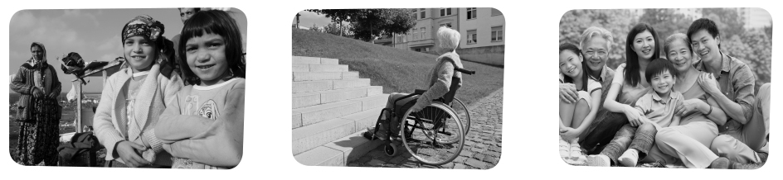
You have been asked to identify groups of people who are victims of discrimination.
Talk together and decide who is most discriminated against in Europe.
• Where do you live/come from?
• Why did you start studying English?
• What is your favourite subject at school?
• What job do you think you’d like to do in
the future?
• Why would you like to have that career?
• What is your father’s/mother’s job?
• Do you live in…?
• Do you think English will be useful in the
future?
• Do you have a hobby?
Prova Oral

Part 1 (2 - 3 minutes)

Be prepared to say your names and spell your surname, then answer questions about yourself,
your daily life, interests, etc. For example:

Part 2 (2 - 3 minutes)
Talk to your partner about the following situation. The pictures below will help you.
51



Part 3 (3 - 4 minutes)

Look at one of the following photographs and talk on your own about what you see.

Part 4 (3 - 4 minutes)

Talk to your partner about what the benefits of a multicultural society or community are.
52


A — Reading 40 marks

1. How important do you think volunteering is? 5 marks

2. Read the text.

Dubai runner completes SEVEN
ultramarathons on seven continents

Dubai-based charity founder Maria Conceição has received official confirmation of her double world record success from The Guinness Book of Records after conquering the 777 Ultramarathon Challenge. The Ultramarathon is seven 50 km runs completed across the seven continents in seven weeks. Not only did Conceição complete the challenge, she did so in just six weeks. This native of Portugal secured her second record for the fastest average time to complete an ultramarathon on
seven continents.
5

The first Portuguese woman to climb Mount Everest, Conceição has faced a number of other challenges in the past, all aimed at raising awareness and funds for her charity, the Maria Cristina Foundation (MCF), which helps educate children in Dhaka, Bangladesh, in an attempt to free them from poverty. The MCF currently supports over 200 children from the poor areas of Dhaka, in primary, secondary and college education programmes. The group sends children with the most promising potential to schools in Dhaka that provide higher quality education and which could give the children the best possible opportunity to break free of poverty.
10

The 777 Ultramarathon Challenge has certainly raised awareness for the Foundation and its work, but the charity remains in urgent need of funds to help more children stay in school and continue
their education. Appealing for help to support the cause, Maria said, “The Foundation is hugely grateful for donations from generous individuals who have been our saviours, but we really need
more corporate partners to support our work. There are a lot of companies who can be partners, and we appeal to them to consider working with us.”
20

15

“We know that many people also believe that education is the best way to eradicate poverty. Education gives children hope and the tools to dream bigger and achieve more, not only for themselves but for their families and the communities they live in. MCF has the experience and knowledge required to provide the maximum social impact from any financial support from a
partner, so we do hope you consider placing your trust in us. I hope my effort will show people how serious I am. I hope this opens new doors and leads to new opportunities, whether it be speaking
at events, or endorsing brands as a humanitarian or as an athlete. I have now completed several extreme challenges and have many more planned.”
25

http://sport360.com/article/athletics/22651/maria-conceicao-receives-two-guinness-world-records-ultramarathon-effortsand http://whatson.ae/dubai/knowledge/13955/maria-conceicao-777-ultramarathon-challenge/ (abridged and adapted), accessed in January 2015

can
might
could
must
should
couldn’t
3. Say whether the sentences below are true (T) or false (F). 10 marks

□ a. Maria Cristina was the person who set up MCF.
□ b. Conceição was born in Dubai and works in Bangladesh.
□ c. She was the fastest runner in the ultramarathon.
□ d. This was the first time she participated in a sports event.
□ e. Conceição was the first Portuguese woman to reach the top of the Everest.

4. Find words/expressions to match the definitions below in paragraphs 1 and 2. 10 marks

a. difficult sports competitions ……………………………………………..
b. get to the top ……………………………………………………………..
c. knowlegde of a situation or fact ………………………………………….
d. ability that can be developed …………………………………………….
e. escape from negative situation/condition ………………………………

5. Answer the questions about the text. 15 marks

5.1. What arguments does Maria use to try and get support from new partners?

5.2. What reason(s) does Maria present to justify her participation in sports competitions?

5.3. What types of new opportunities does Maria refer to?

B – Language 40 marks

1. Complete the text below with the words on the right. One isn’t used. 10 marks

I never thought I a. …………………….…… be a runner – the idea was purely to raise funds for the foundation. I’d read and heard you b. ………………..………… make people take notice of your cause if you did something phenomenal. That’s when I decided I c. …………………… do something that very few would do or have done. This is not a childhood fantasy or dream nor is it for enthusiasm or adventure. I kept telling myself,
“I d. …………………… do this so that I e. …………………… keep the promise I made nine years back to the children and families under the MCF banner to lift them out of poverty.”

http://sport360.com/article/athletics/19081/maria-conceicao-dubai-expat-run-underprivileged-kids
(abridged and adapted), accessed in January 2015
54
55
2. Complete the text with the correct form of the verbs in the box. 6 marks

The reporter a. ……………………. Nathalie Haddad, Founder of The Right Bite Nutrition, if she was enjoying working with such a determined individual.
Haddad b. ……………………. they were thrilled to be given this opportunity to work with Maria Conceição, and make a difference in people’s lives.
She c. ……………………. the reporter that they are passionate about empowering individuals to make positive changes to their overall well-being.

http://sport360.com/article/health-and-fitness/20310/rite-bites-healthy-meal-plan-helping-dubai-expats-charity-dreams
(abridged and adapted), accessed in January 2015

3. Rewrite the sentences below. 12 marks

a. Unless Maria gets ……………………. funds, MCF won’t be able to help Bangladeshi children.
If Maria funds, MCF won’t be able to help Bangladeshi children.
b. The more opportunities Maria gets, the more money she will raise.
She won’t raise much money ……………………. get many opportunities.
c. You shouldn’t run such long, difficult marathons.
If I ……………………. you, I wouldn’t run such long, difficult marathons.

4. Join the two sentences using the word in brackets. 12 marks

a. Maria Conceição is the founder of the MCF. She ran the 777 Challenge. (who)

b. She completed a very difficult task. This task allowed her to continue the work she started with
the children of Dhaka. (that)

c. Maria admitted she thought of those children and families. She wants to change their lives. (whose)

C – Writing 20 marks

This is part of a letter you received from the Maria Cristina Foundation.

Why would you like to become a volunteer in our foundation?
How long do you plan to stay with us?What specific skills and competences
do you have? What types of activities can you do with the children
and/or their families?

Now write a letter, in about 100 words, answering the questions.
say
tell
ask


• Where do you live/come from?
• What do you usually do during the
holidays?
• Have you ever done any voluntary work?
• Would you like to go abroad as a volunteer?
• What type of programme would you
choose?
• Do you live in…?
• What’s your favourite holiday activity?
• Do you think volunteering is important?
Why?/Why not?
• What country would you like to be a
volunteer in?
• Would you like to work with animals?
You have been asked to select three relevant volunteering project for young volunteers.
Decide which are the most significant and have most impact on the community.
56
Prova Oral

Part 1 (2 - 3 minutes)

Be prepared to say your names and spell your surname, then answer questions about yourself,
your daily life, interests, etc. For example:

Part 2 (3 - 4 minutes)
Talk to your partner about the following situation. The pictures below will help you.

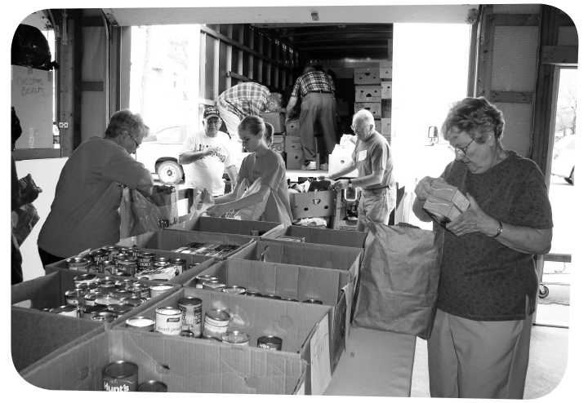

57
Part 3 (3 - 4 minutes)

Look at one of the following photographs and talk on your own about what you see.

Part 4 (3 - 4 minutes)

Talk to your partner about what the advantages and disadvantages of being a volunteer.
Answer key
58
Prova de Equivalência à Frequência 1

A – Reading

1. Personal answer.
3. a. T; b. F; c. T; d. F; e. T.
4. a. passive (l. 12); b. not allowed (l. 12);
c. conflicts (l. 13); d. restrictions (l. 13); e. bright (l. 14).
5.1. It suggest that Eman lives in a very traditional society where women are not expected to take certain jobs.
So it took a lot of bravery to tell her story as a woman journalist who was threatened for choosing a career she was not supposed to.
5.2. This refers to the fact that there are two conflicts
taking place: the armed conflict in Gaza and the battle against women by refusing to give them opportunities to obtain a more important status in society.
5.3. Her struggle and effort as a journalist have taught
her not to worry so much about what others think
and be more focused on what’s really happening and the consequences. She’s been able to make her own choices.

B – Language

1. a. either; b. or; c. therefore; d. however.
2.1. who; 2.2. that; 2.3. whose; 2.4. that.
3. a. risks; b. will increase; c. were; d. would go.
4. a. if he knew; b. had become; c. before; d. that was the.
Prova de Equivalência à Frequência 2

A – Reading

1. Personal answer.
3. a. T; b. F; c. T; d. F, e. T.
4. a. challenge (l. 3); b. climb (l. 7); c. awareness (l. 8);
d. potential (l. 12); e. break free of (l. 13).
5.1. She claims that the Foundation’s experience
and knowledge will guarantee the success of the
partnership.
5.2. She states she hopes that people will realise how
much she wants to go on helping those in need.
5.3. Maria is ready to speak at events, to support
brands and to go on participating in difficult sports
competitions.

B – Language

1. a. might; b. could; c. should; d. must; e. can.
2. a. asked; b. said; c. told.
3. a. doesn’t get; b. if she doesn’t; c. were.
4. a. Maria Conceição, who is the founder of the MCF,
ran the 777 Challenge. / Maria da Conceição, who ran the 777 Challenge, is the founder of the MFC.
b. She completed a very difficult task that allowed her to continue the work she started with the children of Dhaka. c. Maria admitted she thought of those children and families whose lives she wants to change.

16

Provas de Equivalência à Frequência
Correction Criteria

Part A | Criteria
1. 5 marks | N2 appropriate answer to question = 5 marks
1. 5 marks | N1 partially appropriate answer to question = 2 marks
3. 10 marks | N3 4-5 correct = 10 marks
3. 10 marks | N2 2-3 correct = 6 marks
3. 10 marks | N1 1 correct = 2 marks
4. 10 marks | N3 4-5 correct = 10 marks  N2 2-3 correct = 6 marks  N1 1 correct = 2 marks
5. 15 marks | N3 3 correct = 15 marks
5. 15 marks | N2 2 correct / 3 partially correct = 9 marks
5. 15 marks | N1 1 correct / 2 partially correct = 4 marks
Part B | Criteria
1. 10 marks | N3 3-4 correct = 10 marks  N2 2 correct = 5 marks  N1 1 correct = 2 marks | N3 4-5 correct = 10 marks  N2 2-3 correct = 5 marks  N1 1 correct = 2 marks
2. 8 marks /  6 marks | N3 3-4 correct = 8 marks  N2 2 correct = 4 marks  N1 1 correct = 2 marks | N3 3 correct = 6 marks  N2 2 correct = 4 marks  N1 1 correct = 2 marks
3. 10 / 12  marks | N3 4 correct = 10 marks  N2 3 correct = 5 marks  N1 2 correct = 2 marks | N3 3 correct = 12 marks  N2 2 correct = 8 marks  N1 1 correct = 4 marks
4. 12 marks | N3 3-4 correct = 12 marks  N2 1-3 correct = 8 marks  N1 1 correct = 4 marks | N3 3 correct = 12 marks  N2 2 correct = 8 marks  N1 1 correct = 4 marks
20 marks | 20-marks – The student shows excellent writing skills; totally respects the topic or the text type; presents his own ideas about the topic, contextualises and develops them; uses appropriate and varied cohesive devices; organises the text in a coherent manner; mistakes (structure or spelling) are irrelevant for the comprehension of message.
20 marks | 16 marks – The student shows reasonable writing skills; respects the topic or the text type; presents some ideas about the topic and contextualises them; uses simple cohesive devices to organise the text, but not always successfully; choice of words is good; makes few mistakes (structure or spelling) which hardly affect message.
20 marks | 12 marks – The student shows some writing skills; respects the topic or the text type; presents some ideas about the topic and tries to contextualise them; uses some cohesive devices but the text is slightly disorganised; choice of words is reasonable; makes some mistakes (structure or spelling) which sometimes make message slightly confusing.
20 marks | 8 marks – The student shows poor writing skills; mostly respects the topic or the text type; presents some ideas about the topic but the text is slightly confused; uses few cohesive devices but the text is not well organised; choice of words is poor; makes many mistakes (structure or spelling) which sometimes impede meaning.
20 marks | 4 marks – The student shows very poor writing skills; doesn’t fully respect the topic or the text type; ideas are scarce and mostly decontextualised; uses few cohesive devices and the text is disorganised; choice of words is very poor; makes many mistakes (structure or spelling) which sometimes make message incomprehensible.  Note: the student will get 0 marks if the topic or the text type is not respected, or if the whole text is incomprehensible or illegible.

59

74
 |  | A - Reading |  |  |  |  | B - Language |  |  |  |  | C - Writing |  | Total | Mark
 |  | 1 | 2 | 3 | 4 | Total | 1 | 2 | 3 | 4 | Total | 1 | Total | Total | Mark
No. | Name |  |  |  |  | 40 |  |  |  |  | 40 |  | 20 | 100
1
2
3
4
5
6
7
8
9
10
11
12
13
14
15
16
17
18
19
20
21
22
23
24
25
26
27
28
29
30

© ASA • UPGRADE 9 / TESTS
60

61
Extensive Reading
Test


10

5

The story takes place a. 1. plays the drums.
Mia’s brother, Teddy, b. 2. at Juilliard School.
Mia has cello lessons c. 3. in a February morning.
Mia’s Gran wants her to go d. 4. with a private music teacher.
5. during a music concert.
6. to Juilliard School.

- What do you know about the story? Tick () the correct statements.

□ a. Mia lives with her parents and little brother, Teddy.
□ b. Mia attends Juilliard School.
□ c. Her boyfriend Adam is the manager of a rock band.
□ d. Mia goes to hospital and is in a coma.
□ e. The first person she sees when she wakes up is Adam.

2. Match the sentence halves according to the story. Two do not apply.

3. Read this excerpt from the story.

It didn’t start out so smoothly with Adam and me. I think I had this notion that love conquers
all. And by the time he dropped me off from the Yo-Yo Ma concert, I think we were both aware
that we were falling in love. I thought that getting to this part was the challenge. In books and
movies, the stories always end when the two people finally have their romantic kiss. The happily-
ever-after part is just assumed. I dreaded going to shows with Adam. It wasn’t that I was jealous.
Or that I wasn’t into his kind of music. I loved to watch him play. When he was onstage, it was like the guitar was a natural extension of his body. Once the fans would descend, I’d skitter off to the sidelines. Adam would try to draw me back, to wrap an arm around my waist, but I’d disentangle myself and head back to the shadows. “Don’t you like me anymore?” Adam chided me after one show. He was kidding, but I could hear the hurt behind the offhand question. “I don’t know if
I should keep coming to your shows,” I said. “Why not?” he asked. This time he didn’t try to
disguise the hurt. “I feel like I keep you from basking in it all. I don’t want you to have to worry
about me.” Adam said that he didn’t mind worrying about me, but I could tell that part of him did.

Forman, Gayle (2009). If I stay. New York: Penguin Books (abridged and adapted)
62


4. Choose the correct option.

4.1. Mia and Adam
□ a. didn’t want to fall in love.
□ b. realised they were in love after a music gig.
□ c. fell in love at first sight.

4.2. Mia thinks
□a. Adam is a great musician. □b. Adam’s music is terrible. □c. Adam is jealous of her.

4.3. The thing that bothered Mia was
□a. the manager. □b. the fans. □c. the darkness.

4.4. Mia doesn’t want to go to Adam’s concerts anymore because
□a. she doesn’t have time.
□b. she has her own concerts to go to.
□c. she doesn’t want him to worry about her.

5. Choose the best option to complete the excerpt from the story.

I lean my head against the car window, a. …………………………………………. the scenery zip by,
a tableau of dark green trees dotted with snow, wispy strands of white fog, and heavy gray storm clouds up above. It’s so b. ………….……………. in the car that the windows keep fogging up, and I c. ………………………. little squiggles in the condensation. When the news is d. ……………………………., we turn to the classical station.
I hear the first e. ………………………..……. bars of Beethoven’s Cello Sonata no. 3, which was the very piece
I was supposed to be working f. ……………………………………. this afternoon. It feels like some kind of cosmic coincidence. I g. …………………..……. on the notes, imagining myself playing (…). I close my eyes.

 | 1. | 2. | 3. | 4.
a. | watching | making | hearing | catching
b. | cold | bland | warm | mild
c. | build | design | draw | see
d. | over | out | on | off
e. | little | long | short | few
f. | out | on | from | from
g. | work | play | concentrate | make

6. What do you think of this story? Did you enjoy reading it? Why?
What are, in your opinion, the best and worst parts of the story?
Write an opinion text (80 – 100 words) in which you answer the previous questions.
You may add other elements that are also important for you.
63
Extensive Reading Test

1. a; d; e.
2. a. 3; b. 1; c. 4; d. 6.
4.1. b; 4.2. A; 4.3. C; 4.4. C.
5. a. 1; b. 3; c. 3; d. 1; e. 4; f. 2; g. 3.
Answer key

