TEST UNIT 1 On The Move
Name __________________________________________ No. ___________ Class __________
Date _____/_____/_____ Mark ___________________ Teacher __________________________

LISTENING

Wonder
A. Listen to the song and choose the right option. (10 x 1 = 10 points)
I wonder if I'm being ¹royal / real  Do I speak my ²truth / youth or do I filter how I feel?  I wonder, wouldn't it be ³right / nice  To live inside a ⁴world / word that isn't black and white?  I wonder what it's like to be my ⁵trends / friends  Hope that they don't ⁶shrink / think I'll forget about them  I wonder  I wonder  Right before I close my ⁷eyes / lies  The only thing that's on my ⁸mile / mind  Been ⁹dreamin' / streamin’ that you feel it too  I wonder what it's ¹⁰hike / like to be loved by you  Yeah  I wonder what it's like  I wonder what it's like to be loved by | 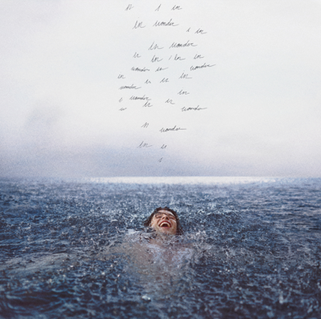  Shawn Mendes, “Wonder” (abridged)  https://www.youtube.com/watch?v=fHeQemJJQII

B. Listen to a podcast about Shawn Mendes and complete the text with the missing words. (5 x 2 = 10 points)
Miami has played a vital role in the story of the new Shawn Mendes and in the creation of his new album, Wonder. After years of being the handsome and famous singer who ¹____________________ the world and never turned down a selfie, Shawn had to stay at home. The coronavirus meant he was no longer going from hotel room to hotel room, destination to ²____________________. He spent three months living with his partner, the singer Camila Cabello, and her family and finally got to live the ³____________________ he’d never got to have before: he cooked dinner, he did laundry. “I was able to have a ⁴____________________, watch a movie with the family, do the dishes, things that sound pretty mundane, but actually... when you’re living in a ⁵____________________ room, you never do laundry.”
https://www.gq-magazine.co.uk/culture/article/shawn-mendes-wonder (abridged and adapted)

TEST UNIT 1 On The Move
Name __________________________________________ No. ___________ Class __________
Date _____/_____/_____ Mark ___________________ Teacher __________________________

VOCABULARY

Quick-fire travel questions with Shawn Mendes


A. Complete the interview with the missing words. The first letter of each word has been given. (10 x 2 = 20 points)
CNT: If you could only pack one thing, what would it be?
SM: I’d pack my guitar if I could fit it in my ¹s_______________.

CNT: Internet or book?
SM: I’d rather be ²s_______________ the net, I must confess.

CNT: Scroll through Instagram or turn off your phone?
SM: I’ll turn my phone off. But it’ll be hard.

CNT: Netflix or podcasts?
SM: I’m actually really into podcasts at the ³m_______________.

CNT: Ocean or ⁴s_______________ pool?
SM: Pool. Because I’m terrified of sharks.

CNT: What’s your favourite ⁵c_______________ in the world?
SM: Amsterdam. It’s very magical. I think if wizards existed, they’d be in Amsterdam. The people are really fun, and it’s always an ⁶e_______________ place. There are always things happening and people riding their ⁷b_______________ past you. All the canals and the bridges – it’s just like a dream world.

CNT: What’s your favourite ⁸b_______________ in the world?
SM: Bondi Beach. Or the beach in Port Antonio, Jamaica.

CNT: Where would you take your mum on a ⁹h_______________?
SM: I’d take my mother to Jamaica because she loves hot weather.

CNT: Home or on the road?
SM: I am addicted to travelling. As much as I love home, I’m there for five days and then I can’t wait to get ¹⁰a_______________ again.

https://www.cntraveller.com/article/shawn-mendes-interview (abridged and adapted)

TEST UNIT 1 On The Move
Name __________________________________________ No. ___________ Class __________
Date _____/_____/_____ Mark ___________________ Teacher __________________________

READING

A. Read the following interview with Shawn Mendes.

Shawn Mendes' favourite places in LA, Jamaica and Toronto

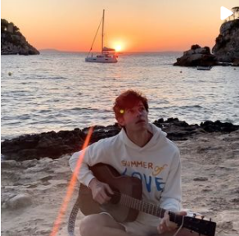
The LA-based star - who became the youngest singer to ever nab a number one album - gives us the low-down on his favourite view, the brunch spot he can't get enough of, and how travel inspires his songwriting

Where in the world inspires your songwriting?
I get most of my ideas on very busy weeks when I’m travelling through Europe or South America – that's where my inspiration comes from. I just write my ideas down and bring them with me to LA.
Describe your perfect day in LA.
I’d start at King’s Road Café for breakfast. Then I’d have to go for a hike with my friends. I’d go to Runyon Canyon, as classic as that is.

Where can you get the best view of the city?
I would go back to the studio where I recorded my album, for the view at The Woodshed in Malibu. It has one of my favourite views in the whole world. You’re up on a mountain, and you can see the whole cliff down the Pacific Coast Highway and all the way into the city.

Where else in the world do you find inspiration to record songs?
We recorded this album for three or four months. Most of that was in LA and Malibu, but we were in Jamaica for about 10 days. We stayed at a villa, Cocosan, which is a studio that’s part of Geejam Studios in Port Antonio.

Describe your perfect day in Jamaica.
It’s very hard to get any work done in Jamaica. It's way too relaxed. There was an amazing view outside the villa where we stayed, right by the beach. A step outside would turn into three hours outside. My perfect day in Port Antonio would just be sunbathing on the beach.

What's the best way to staycation in Canada, where you grew up?
Go to Vancouver, with some friends, and rent a boat. All you need is a driving licence, and you can rent a boat for 75 dollars. Take it out to the Indian River. There are all these waterfalls, and you can climb them. Depending on the time of year, there are hundreds of jelly fish and the water is so fresh.

https://www.cntraveller.com/article/shawn-mendes-interview (abridged and adapted)

B. Answer the following questions on the text. (5 x 3 = 15 points)
1. Where does Shawn’s inspiration come from?
____________________________________________________________________________
2. What is Shawn’s perfect day in LA like?
____________________________________________________________________________
3. Why is the view at The Woodshed in Malibu one of his favourite views in the whole world?
____________________________________________________________________________
4. Where did he record his album Wonder?
____________________________________________________________________________
5. What can you do in Vancouver if you want to have some fun?
____________________________________________________________________________

C. Match the words with their definitions. (5 x 1 = 5 points)
1. nab _____  2. the low-down _____  3. brunch _____  4. villa _____  5. staycation _____ |  | a. a combination of breakfast and lunch  b. a house where people stay on holiday  c. a holiday that you spend at or near your home  d. get  e. the true facts about someone/ something

GRAMMAR

A. Complete the paragraph with the past simple or continuous. (8 x 1 = 8 points)
Shawn ¹____________________ (sleep) when Camila ²____________________ (call). He ³____________________ (stay) at a wonderful villa in Port Antonio. He ⁴____________________ (record) his new album there. Camila ⁵____________________ (not be) calm at all because it was the hurricane season in Jamaica, and authorities ⁶____________________ (shut) down airports and cancelling flights. Shawn was worried, too, but he couldn’t simply leave Jamaica in a hurry. How ⁷____________________ (Camila/ feel) about it? Terribly nervous, but Shawn ⁸____________________ (have) to finish his album…

B. Write sentences with either… or/ neither… nor/ both… and. (3 x 2 = 6 points)
1. Camila was terribly nervous. Shawn’s mother was terribly nervous too.
____________________________________________________________________________
2. After dinner, Shawn can go out for a drink; or he can stay at home listening to Bob Marley.
After dinner, Shawn can _________________________________________________________

3. Shawn didn’t go to Navy Island. He didn’t go to Winnifred Beach either.
Shawn ______________________________________________________________________

C. Correct the following sentences. (3 x 2 = 6 points)
1. Shawn use to rent a boat and took it to the Indian River when he was in Vancouver.
____________________________________________________________________________
2. He try always to learn some things about the culture of any country he visits.
____________________________________________________________________________
3. He didn’t used to travel so much when he is younger.
____________________________________________________________________________

WRITING

A. Imagine that you are at a summer camp in Port Antonio, Jamaica. Yesterday, you were at the beach and you met Shawn Mendes. Write an email to your friends telling them about your latest news (90-100 words). (20 points)

TEST UNIT 1 On The Move
Name __________________________________________ No. ___________ Class __________
Date _____/_____/_____ Mark ___________________ Teacher __________________________

SPEAKING

The speaking test lasts about 10 to 12 minutes and will be divided into four parts. You take the test with another student.

PART 1
2-3 minutes
In this part of the test, you will be asked personal questions.
Suggested questions:
1. Have you ever attended a summer camp?
2. If you were going to attend one, which type would you choose?
3. Which activities would you like to try?
4. Have you ever participated in a school exchange?
5. If so, what was it like? / If not, where would you like to go?

PART 2
2-3 minutes
Imagine the following situation. You are thinking about going on a 2-week school exchange to Vancouver Film School. Talk together about the different things you can do there. Here is some information to help you.
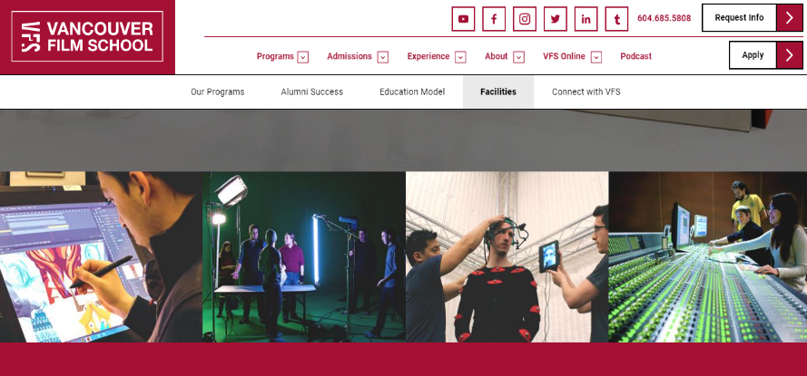 | Courses:  Film Production  Acting for Film and Television  Game Design  Animation & Visual Effects  Writing for Film, Television and Games  English for Creative Arts

PART 3

3 minutes
In this part of the test, you’ll be asked to talk on your own about a picture. Describe your picture in detail. Say who/ what you can see, what they look like, what they are doing, etc.

 | Name:  - Lee Wang  Destination:  - Port Antonio, Jamaica  Purpose of the trip:  - summer camp experience

 | Name:  - Kate Rodriguez  Destination:  - Vancouver, Canada  Purpose of the trip:  - 2-week school exchange

PART 4
3 minutes
Your photographs show a teenage boy and a teenage girl who are about to have two different experiences abroad. Talk together about the experience you would choose for yourself.

