TEST UNIT 3 Technology is great!
Name ______________________________________________ No. _________ Class ________
Date _____/_____/_____ Mark _________________ Teacher ____________________________

LISTENING

Ready to use Snapchat’s Harry Potter voice lens?

A. Listen to the first part of a podcast about Snapchat’s Harry Potter voice lens and mark the following sentences T (true) or F (false). (7 x 2 = 14 points)


1. Potterheads will be transported to Hogwarts by a Snapchat Express Train. ____

2. Snapchat decided to create a new voice lens to celebrate the anniversary of the last Harry Potter film. ____

3. Snapchat is using augmented reality technology. ____

4. Snapchat AR lens lets you support the Hogwarts house you want to win the tournament. ____

5. The Hogwarts voice lens will be available throughout the duration of the tournament. ____

6. Hart Woolery, Snapchat lens creator, was inspired by the way Harry Potter and his friends use modern technological devices in Harry Potter series. ____

7. It will be difficult to download Snapchat now because many Potterheads are using it. ____

B. Listen to the second part of the podcast and order the instructions. (6 x 1 = 6 points)
Here’s how to use the Harry Potter Hogwarts voice lens to channel your inner witch or wizard:
____ Hit the phrase “Take a Snap” to get the perfect shot.
____ Sit back and watch the fun happen as your backdrop changes to the colors of your house. You’ll also see your house outfit and face paint change to your house selection.
____ Hit the phrase above your head that says “Tap to Change House,” and activate which house you want by using the voice command “Go, Go Gryffindor” or “Go, Go Hufflepuff.” If you’re a Slytherin or a Ravenclaw, use the same prompt.
____ Open the Snapchat Camera and scroll through the Lens Carousel. Or take a pic of the Harry Potter Snapcode to activate the lens.
____ Tap on the microphone button on the screen to enable voice commands.
____ Once you find the Hogwarts Lens, simply tap on it.

How To Use Snapchat's 'Harry Potter' Hogwarts Voice Lens To Rep Your House (elitedaily.com) (NAmE; abridged and adapted)

TEST UNIT 3 Technology is great!
Name ______________________________________________ No. _________ Class ________
Date _____/_____/_____ Mark _________________ Teacher ____________________________

VOCABULARY

Harry Potter: Why Wizards Don’t Use Technological Devices

A. Learn why there aren’t technological devices and gadgets in Harry Potter’s Wizarding World. First, match the sentence halves. (8 x 1 = 8 points)
1. Harry Potter’s Wizarding World ____  2. It’s very different from the human world, ____  3. Those who inhabit it don’t use any technological devices, and in ____  4. Hogwarts students write with quills, consult books for their homework, ____  5. One of the most popular explanations for it is that ____  6. Wizards aren’t really users of electricity, ____  7. With no electricity, wizards can’t use ____  8. What does J. K. Rowling say about ____ | a. preferring candles and other magic to provide light instead.  b. send owls with their messages, and more.  c. is a fascinating place.  d. phones, computers, and other devices like Muggles do.  e. with its magical objects and animals.  f. that sense, they seem to be stuck in the past.  g. magic interferes with electricity.  h. the absence of technological devices in the wizarding world?

B. Now, complete the paragraphs using the words in the box. (6 x 2 = 12 points)
computers | Google | technology | devices | trains | internet

J. K. Rowling has already explained the topic of ^{1.}_______________ and its absence in the wizarding world. Rowling explained that when you can summon any object with just one word, communicate through fire, owls, and more, and your newspaper has moving images, Muggle stuff like the ^{2.}_______________ “does not seem like a particularly exciting place”. Besides that, according to Rowling, the magical community takes pride in not needing most Muggle ^{3.}______________.

Although wizards in Harry Potter don’t use cellphones, ^{4.}_______________, and more, there are some exceptions on this matter as they do use cars, motorbikes, and ^{5.}_______________, as seen when Ron and Harry flew to Hogwarts in Mr. Weasley’s car, Hagrid moving around in a motorbike, and the famous Hogwarts Express. I wonder how much they could benefit from communicating through cellphones, doing some research on ^{6.}_______________, and typing that tedious homework on a computer…
Harry Potter: Why Wizards Don't Use Technology | Screen Rant (NAmE; abridged and adapted)

TEST UNIT 3 Technology is great!
Name ______________________________________________ No. _________ Class ________
Date _____/_____/_____ Mark _________________ Teacher ____________________________

READING

What if Harry Potter lived in the world of cloud technologies?

A. Read the text carefully.
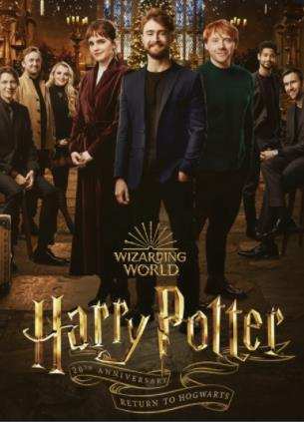
We know that in Harry Potter universe, magic interferes with “muggle” technology - or as Arthur Weasley says, “eckeltricity”. But, what if it didn’t? What if Harry and his friends could integrate their magic with the benefits of modern technologies? Would our young heroes have a slightly easier life?

Faster (and better) communication
Sending letters via owls? With a smartphone and internet connection, Harry could be in constant touch with his friends. He could be instant messaging Ron and Hermione all day. Or making video calls, group chats, sharing memes, and more.

Prophecies kept safe online
Sadly, delicate crystal balls are not really the best protection for dangerous prophecies. Prophecies could be uploaded on a secure cloud server that is password-protected, with encryption, multiple layers of firewalls and backup, and security protocols.

Better audience access to the Wizard Games
Just as our muggle sports are televised, live-streamed, promoted on social media and via marketing broadcast campaigns, why not extend the same courtesy to wizard sports? All wizards would be able to watch the Quidditch cup and Triwizard Tournament live!

It’s interesting to see how our favourite wizards would live in the world of modern technology - with the same tools that make our everyday lives so much easier.

Reimagining The Wizarding World of Harry Potter With The Cloud (acefone.com) (abridged and adapted)

B. Complete the sentences according to the text. (5 x 3 = 15 points)
1. Would Harry Potter and his friends have a slightly easier life if they could …
___________________________________________________________________________?
2. Harry could make video calls to his friends if he had …
___________________________________________________________________________.
3. Delicate crystal balls are not the best protection for dangerous prophecies, so they should …
___________________________________________________________________________.
4. If the Quidditch Cup and Triwizard Tournament were live-streamed, …
___________________________________________________________________________.
5. Modern technological devices make …
___________________________________________________________________________.

C. Find in the text the words that match these definitions. (5 x 1 = 5 points)
1. a little (1st paragraph) ___________
2. images, videos, pieces of text, etc. that are passed very quickly from one internet user to another, often with small changes that make it humorous (2nd paragraph) ___________
3. statements that something will happen in the future (3rd paragraph) ___________
4. the act of putting information into a special code (3rd paragraph) ___________
5. broadcasted live over the internet (4th paragraph) ___________

GRAMMAR

A. Circle the correct alternative. (5 x 1 = 5 points)
1. Harry Potter has decided return / to return / returning to Hogwarts.
2. Harry’s idea of meet / to meet / meeting with other wizards is great.
3. Hermione is anxious to learn / learning / learn new spells.
4. Ron can to help / help / helping reform the Ministry of Magic.
5. Harry is very good at play / to play / playing Quidditch.

B. Complete the sentences with the correct tense of the verbs in brackets. (5 x 1 = 5 points)
1. If Harry had a smartphone, he ____________________ (create) a group chat on WhatsApp.
2. If prophecies ____________________ (be) uploaded on a secure cloud server they would be protected.

3. If Hogwarts offers online classes, Portuguese wizards ____________________ (learn) more about magic.
4. Unless Hermione has internet connection, she ____________________ (not be able) to send Ron a text message.
5. If you ____________________ (meet) Harry Potter, would you ask him to teach you a spell?

C. The underlined parts of the sentences are wrong. Rewrite them correctly. (5 x 2 = 10 points)
1. When Harry Potter reads Hogwarts Acceptance Letter, he was extremely happy.
__________________________________________________________________________
2. If Hermione has some time next week, she would go shopping for a new wand.
__________________________________________________________________________
3. Hermione will buy a computer if she had enough money.
__________________________________________________________________________
4. If Ron creates a blog, it would be about his adventures in the World of Wizardry.
__________________________________________________________________________
5. Wizards at Hogwarts can use computers if magic didn’t interfere with electricity.
__________________________________________________________________________

WRITING

A. You are going to write an article for your school online magazine. The title is “WOW! There’s Internet at Hogwarts!”. Write about 90-100 words. (20 points)
____________________________________________________________________________
____________________________________________________________________________
____________________________________________________________________________
____________________________________________________________________________
____________________________________________________________________________
____________________________________________________________________________
____________________________________________________________________________
____________________________________________________________________________

TEST UNIT 3 Technology is great!
Name ______________________________________________ No. _________ Class ________
Date _____/_____/_____ Mark _________________ Teacher ____________________________

SPEAKING

The speaking test lasts about 10 to 12 minutes and will be divided into four parts. You will take the test with another student.

PART 1
2-3 minutes
In this part of the test, you will be asked some personal questions.
Suggested questions:
1. What is your favourite technological device? Why?
2. Do you have a mobile phone? What do you use it for?
3. What is your favourite app? Why?
4. Do you think social networks are positive? Why?
5. What are the disadvantages of excessive internet use?

PART 2
2-3 minutes
Student A has some plans for the afternoon and will call Student B on her / his mobile phone to invite Student B to join her / him. Follow the instructions below.

STUDENT A |  | STUDENT B
- Greet B.  - Talk about your plans for the afternoon (stay at home and watch Harry Potter 20th Anniversary: Return to Hogwarts) and invite your friend to join you.  - Make another suggestion.  - Make a suggestion.  - Reply. |  | - Greet A.  - Refuse the invitation and give a reason.  - Accept the invitation. Ask about the time to meet.  - Agree with your friend. Say you’ll bring popcorn. Finish the conversation.

PART 3
3 minutes
In this part of the test, you’ll be asked to talk on your own about a photo. Describe your photo in detail. Say who/ what you can see, what they look like, what they are doing, etc.

STUDENT A  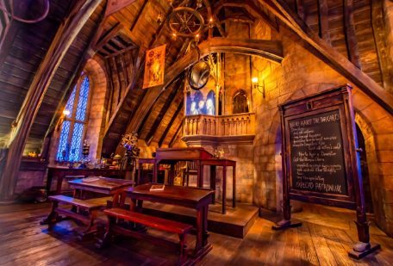 |  | STUDENT B  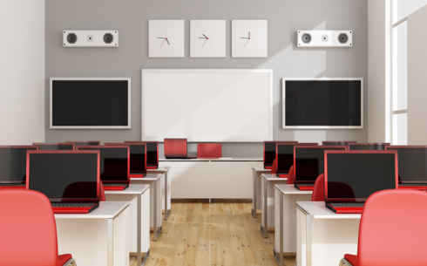

PART 4
3 minutes
The second photograph shows the use of technological devices at school. Talk together about the advantages and disadvantages of using technological devices in the classroom. Here are some tips to help you.

STUDENT A  (advantages) |  | STUDENT B  (disadvantages)
Creative ways of learning  Students’ motivation  Online research  Easy access to information  IT skills  Communication in foreign languages  Preparation for the future |  | Distraction  Isolation from the rest of the class  Fake information  Cheating  Physical and mental health problems  Limited internet access  Cost

