TEST 2 | UNIT 2 – A QUESTION OF ART
Name:_____________________________________________________ No.:______ Class:_____
Date: ____/____/____ Mark: ________________________ Teacher: _______________________
LISTENING
PART 1
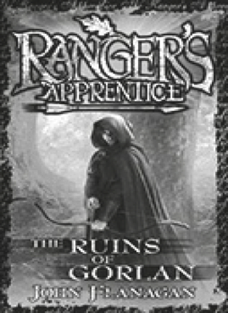
- You will hear a girl called Megan describing her reading preferences. Complete each gap with
My favourite teen ⁽¹⁾ ______________ is called Ranger’s
Apprentice because it has all of the items in a
⁽²⁾ ______________ book that I like. It has action, romance, and ⁽³⁾ ______________ (until someone reveals the truth and solves the mystery), and of course, ⁽⁴⁾ ______________. I particularly like it because its main themes are
⁽⁵⁾ _____________, ⁽⁶⁾ _____________, endurance and
⁽⁷⁾ ______________. I often prefer to read intriguing books over playing video ⁽⁸⁾ _____________________.
I also choose ⁽⁹⁾ ______________ books only because I am not able to use an ⁽¹⁰⁾ ______________ all the time.

PART 2
1. You will hear four young people discussing their film preferences. For each sentence, tick () correct (C) or incorrect (I). C I
a) Rob is a film addict. ___ ___
b) The film Rick saw last month was an Academy-Award winner. ___ ___
c) Grace agrees that the film has good actors and amazing special effects. ___ ___
d) Rob is keen on romantic comedies. ___ ___
e) Grace agrees with Rob’s opinion about romantic comedies completely. ___ ___
f) Naomi prefers tragicomedies because their ending is often predictable. ___ ___

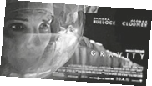
2. Fill in the missing information in the spaces below. Pay attention to Rick’s description of the film he saw.
Film title: | a)
Stars: | b)
Their characters: | c)
Their mission: | d)
Type of film: | e)

TEST 2A | UNIT 2 – A QUESTION OF ART
Name:_____________________________________________________ No.:______ Class:_____
Date: ____/____/____ Mark: ________________________ Teacher: _______________________

READING AND USE OF LANGUAGE

PART 1
1. What music-related words are being described?
a) Modern music popular with young people. P ___ ___
b) Serious music by people like Mozart and Stravinsky. C ___ ___ ___ ___ ___ ___ ___ ___
c) Someone who plays a musical instrument, often as a job. M ___ ___ ___ ___ ___ ___ ___
d) A group of musicians who play modern music together. B ___ ___ ___
e) Loud, modern music often played with electric guitars and drums. R ___ ___ ___
f) A series of performances, usually over a few days. F ___ ___ ___ ___ ___ ___ ___
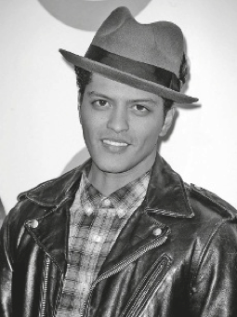
2. Read the text and circle the correct letter – A, B, C or D.
Bruno Mars: the new Michael Jackson?
I was already a fan of the Bruno Mars’ hit song Grenade, but it
wasn’t until I saw him ⁽¹⁾ ________ it live that I really appreciated
his soulful ⁽²⁾ ________ voice.
This young American singer has already been compared
⁽³⁾ ________ the late Michael Jackson, and it is easy to understand
why. With vocal chords that echo the ⁽⁴⁾ ________ days of The
King of Pop and an immense talent for writing songs with
meaning and an instant hook, Bruno Mars is well on his way to
bridging the gap between star and superstar.
His first album Doo-Wops and Hooligans has already been a ⁽⁵⁾ _______ international success, topping the music ⁽⁶⁾ ________ worldwide. His second album, Unorthodox Jukebox, promises continued success!

Bruno Mars: the new Michael Jackson?
I was already a fan of the Bruno Mars’ hit song Grenade, but it
wasn’t until I saw him ⁽¹⁾ ________ it live that I really appreciated
his soulful ⁽²⁾ ________ voice.
This young American singer has already been compared
⁽³⁾ ________ the late Michael Jackson, and it is easy to understand
why. With vocal chords that echo the ⁽⁴⁾ ________ days of The
King of Pop and an immense talent for writing songs with
meaning and an instant hook, Bruno Mars is well on his way to
bridging the gap between star and superstar.
His first album Doo-Wops and Hooligans has already been a ⁽⁵⁾ _______ international success, topping the music ⁽⁶⁾ ________ worldwide. His second album, Unorthodox Jukebox, promises continued success!
1. A perform B compose C write D blow
2. A singer B singing C sing D blowing
3. A at B from C on D to
4. A best B bad C worse D worst
5. A monstrous B small C immense D huge
6. A sales B discos C charts D lists

PART 2
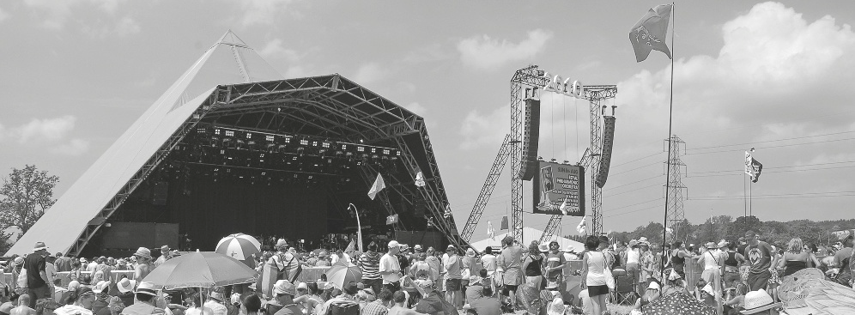
Read the text.
1. Decide whether these sentences are correct (C) or incorrect (I). Copy the information from the text that justifies the incorrect ones. C I
Glastonbury Festival
Glastonbury Festival is a five-day music festival that takes place near Pilton, Glastonbury. Glastonbury is a historic town in Somerset, a county in south-west England. It is also one of the largest and most famous outdoor music and performing arts events in the world. It has more than 15 stages, each with over 12 hours a day of live music. Every musical taste is catered for: pop, dance, jazz, folk, and music from around the world. And if you’re into music, it’s out of this world!
Leading pop and rock artists have headlined, alongside thousands of others appearing on smaller stages and performance areas. Films and albums recorded at Glastonbury have been released, and the festival receives extensive television and newspaper coverage.
But there’s more than music. There are cinemas, circuses, theatre and cabaret acts. You can join a dance or craft workshop, learn about the many charities the festival supports, dance until dawn with drummers and didgeridoo players.
This festival is now attended by around 175,000 people, requiring extensive infrastructure in terms of security, transport, water, and electricity supply. The majority of staff are volunteers, helping the festival to raise millions of pounds for good causes. Some of the profits from the festival are usually donated to charity, and organizations such as Oxfam and Greenpeace have all benefited in the past.
Glastonbury is a festival with a conscience. It showcases solar-powered hot showers, and eco-friendly toilets. The ‘Greenfields’ are a large part of the site, dedicated to educating people about the environment and how to protect it. Also, unlike many festivals, Glastonbury is very family-friendly, with lots of entertainment for children. The festival usually takes place on the last weekend of June, which is the time when either an early heat wave can happen, or when rainy periods are still quite common. General advice to visitors is to bring a good pair of wellies and a waterproof jacket.
http://en.wikipedia.org/wiki/Glastonbury_Festival (adapted)

a) Glastonbury Festival lasts for a week.
___________________________________________________________________ ___ ___
b) Festival-goers can listen to a great variety of music.
___________________________________________________________________ ___ ___
c) Only well-known musicians perform at the festival.
___________________________________________________________________ ___ ___
d) The festival offers different performing arts.
___________________________________________________________________ ___ ___
e) All the people working for the festival organization are well paid.
___________________________________________________________________ ___ ___
f) The festival is held at the end of the summer.
___________________________________________________________________ ___ ___
2. Complete the sentences according to the information given in the text.
a) Glastonbury festival is held _____________________________________________________.
b) They donate some of the profits from the festival ____________________________________.
c) The ‘Greenfields’ are aimed at ___________________________________________________.
d) The festival offers ____________________________________________________ to children.
e) As the weather is unpredictable, visitors should ______________________________________.
PART 3
1. Put the verbs in brackets into the past simple or past perfect.
a) My favourite band ________________________________ (begin) playing before we arrived.
b) I _______________ (not feel) good at the festival because I had stayed up late the night before.
2. Complete the second sentence so that it means the same as the first. Use no more than three words.
a) The last time Finn went to a music festival was three years ago.
Finn ______________________ to a music festival for three years.
b) He hasn’t seen a pop band play live for two years.
The last time ______________________ a pop band play live was two years ago.
c) He watched one music concert online this Friday and one this Sunday.
He ______________________ two concerts so far this week.
d) It was the first time Finn invited Betty to see a concert with him.
Finn ______________________ Betty to see a concert with him before.
e) He had never enjoyed watching a music concert before.
It was the first time ______________________ watching a music concert.
WRITING
PART 4
Imagine you went to a music festival last summer. Write a letter to a friend telling him/her about it. You may refer to:
• the people you went with
• how long the festival lasted
• the site where it took place and the facilities it offered
• the names of your favourite bands/singers and songs
• what you liked/disliked about the festival.

Write about 100 words.
______________________________
_____________________________
___________________________________________________________________________
____________________________________________________________________________________
____________________________________________________________________________________
____________________________________________________________________________________
____________________________________________________________________________________
____________________________________________________________________________________
____________________________________________________________________________________
____________________________________________________________________________________
______________________________
______________________________

______________________________
______________________________
___________________________________________________________________________
____________________________________________________________________________________
____________________________________________________________________________________
____________________________________________________________________________________
____________________________________________________________________________________
____________________________________________________________________________________
____________________________________________________________________________________
____________________________________________________________________________________
______________________________
______________________________

TEST 2B | UNIT 2 – A QUESTION OF ART
Name:_____________________________________________________ No.:______ Class:_____
Date: ____/____/____ Mark: ________________________ Teacher: _______________________
READING AND USE OF LANGUAGE

PART 1
1. What types of films are being described?
a) A film that tries to make the audience laugh. C ___ ___ ___ ___ ___
b) A film which tries to make the audience very frightened. H ___ ___ ___ ___ ___
c) A short humorous film in which the characters are drawn. C ___ ___ ___ ___ ___ ___
d) A film with a very exciting story that often involves a crime. T ___ ___ ___ ___ ___ ___ ___

2. Read the text and circle the correct letter – A, B, C or D.
Emma Stone was born in Scottsdale, Arizona, to Krista
Yeager), a homemaker, and Jeffrey Stone, a contracting
company founder. She is of Swedish (from ⁽¹⁾ __________
paternal grandfather), English, German, Scottish, and Irish
descent. Stone began ⁽²⁾ __________ as a child as a member
of the Valley Youth Theatre in Phoenix, Arizona. She
⁽³⁾ _____________ in many productions through her early
teens until, at the age of 15, she decided that she wanted
⁽⁴⁾ __________ acting her career.
The official story is that she made a PowerPoint presentation,
backed by Madonna’s “Hollywood” and itself entitled “Project Hollywood”, in an ⁽⁵⁾ __________ to persuade her parents to allow her to drop out of school and move to Los Angeles. The pitch was successful and she moved with her mother to LA, having completed her schooling at home while she spent her days auditioning.
Her film debut was as Jules in Superbad (2007) and, after a string of successful performances, her leading role as Olive in the film Easy A (2010) ⁽⁶⁾ __________ her as a star.
http://www.imdb.com/name/nm1297015/bio?ref_=nm_ov_bio_sm (abridged)

Emma Stone was born in Scottsdale, Arizona, to Krista
Yeager), a homemaker, and Jeffrey Stone, a contracting
company founder. She is of Swedish (from ⁽¹⁾ __________
paternal grandfather), English, German, Scottish, and Irish
descent. Stone began ⁽²⁾ __________ as a child as a member
of the Valley Youth Theatre in Phoenix, Arizona. She
⁽³⁾ _____________ in many productions through her early
teens until, at the age of 15, she decided that she wanted
⁽⁴⁾ __________ acting her career.
The official story is that she made a PowerPoint presentation,
backed by Madonna’s “Hollywood” and itself entitled “Project Hollywood”, in an ⁽⁵⁾ __________ to persuade her parents to allow her to drop out of school and move to Los Angeles. The pitch was successful and she moved with her mother to LA, having completed her schooling at home while she spent her days auditioning.
Her film debut was as Jules in Superbad (2007) and, after a string of successful performances, her leading role as Olive in the film Easy A (2010) ⁽⁶⁾ __________ her as a star.
http://www.imdb.com/name/nm1297015/bio?ref_=nm_ov_bio_sm (abridged)
1. A their B his C her D its
2. A act B actor C actress D acting
3. A appeared B appear C seemed D arose
4. A do B to do C make D to make
5. A try B challenge C attempt D effort
6. A made B put C got D established
PART 2
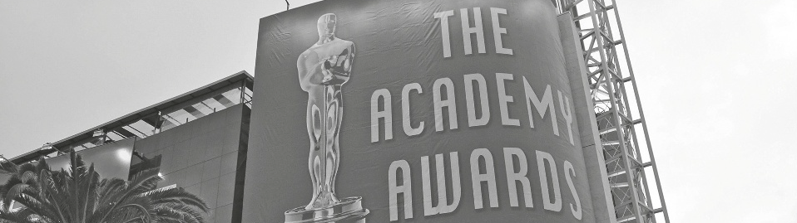
Read the text.

And the winner is…
The Academy Awards, also known as the Oscars, is an annual presentation held by the US film industry. The event is run by the Academy of Motion Picture Arts and Sciences, which has to maintain strict security over who has won what until the winners are announced. The first presentation took place on 16th May, 1929, at a private dinner at the Hollywood Roosevelt Hotel with an audience of about 270 people. The event has grown into a worldwide extravaganza over the years.
The awards ceremony was first televised in 1953. Millions of people tune in each year to see whether their favourite film, director or actor has picked up the top award. The gold statuette prize, called an Oscar, is the highest honour in the film industry. It can turn an actor into a legend or a film into a classic. It also turns Hollywood into a party and paparazzi paradise. The stars turn out looking like a million dollars in their designer dresses and suits. A tuxedo (American English for black tie dress) is the most common outfit for men, although fashion may dictate not wearing a bow-tie, and musical performers sometimes do not adhere to this.
The voting for the Academy Awards is very strict and is conducted under the tightest secrecy. A top international accounting firm has counted the votes for the past few decades. Only the most talented people in the film industry can become members of the Academy and vote. Membership is by invitation only. This is to make sure the top professionals in the business decide on the winners.
There are up to 24 categories up for grabs, and up to five nominations can be made in each. Film fans in more than 200 countries watch on television as the famous envelopes are opened with the words, “And the winner is…”
http://en.wikipedia.org/wiki/Academy_Awards (adapted)

1. Identify the paragraphs where you can find information about the following:
a) Description of the Academy Awards ceremony ______________________________________
b) The way they choose the winners ________________________________________________
c) Date of the first Academy Awards presentation ______________________________________
d) Number of categories eligible for the Oscars ________________________________________
2. Decide whether these sentences are correct (C) or incorrect (I). Copy the information from the text that justifies the incorrect ones.
C I
a) The Academy Awards ceremony takes place every year.
___________________________________________________________________ ___ ___
b) People know who the winners are before the event.
___________________________________________________________________ ___ ___
c) The first awards ceremony was held after World War II.
___________________________________________________________________ ___ ___
d) The Oscars are considered to be the most prestigious cinema awards.
___________________________________________________________________ ___ ___
3. Complete the sentences according to the information given in the text.
a) The first awards ceremony was broadcast on TV ____________________________________.
b) Millions of people are curious to know _____________________________________________.
c) Not all male stars wear _________________________________________________________.
d) Only the best professionals in the movie industry can _________________________________.
PART 3
1. Put the verbs in brackets into the past simple or past perfect.
a) When I turned the TV on, the awards ceremony ______________________ (already / begin).
b) He ____________ (scream) and ____________ (jump) off the sofa when he ____________ (see) his favourite film star walking on the red carpet of the Oscars.
c) ______________________ (he / never / watch) the Oscars on TV before?
2. Complete the second sentence so that it means the same as the first. Use no more than three words.
a) It was the first time I saw the Oscars on TV.
I __________________________ the Oscars on TV before.
b) We haven’t watched such a good televised event for a long time.
It’s a long time since __________________________ such a good televised event.
c) Are you interested in that sort of TV programme?
Do __________________________ that sort of TV programme?
d) The last time that singer wore a tuxedo was a year ago.
That singer __________________________ a tuxedo since last year.
e) Do you know the name of that actress in red?
What __________________________ of that actress in red?
WRITING

PART 4
1. Your class has won a video competition. Write a letter to a friend inviting him/her to the award ceremony. In your letter, you should give him/her information about:

• the day and the time it starts
• the place where it will be held
• the clothes he/she may wear.
Write about 100 words.

______________________________
______________________________
___________________________________________________________________________
____________________________________________________________________________________
____________________________________________________________________________________
____________________________________________________________________________________
____________________________________________________________________________________
____________________________________________________________________________________
____________________________________________________________________________________
____________________________________________________________________________________
______________________________
______________________________

______________________________
______________________________
___________________________________________________________________________
____________________________________________________________________________________
____________________________________________________________________________________
____________________________________________________________________________________
____________________________________________________________________________________
____________________________________________________________________________________
____________________________________________________________________________________
____________________________________________________________________________________
______________________________
______________________________

TEST 2

SPEAKING
The speaking test lasts about 10 to 12 minutes and will be divided into four parts. You take the test with another student.
PART 1
2/3 minutes
In this part of the test, you will be asked personal questions.
Student A Student B
• Do you like going to the cinema? • Do you like listening to music?Why?/Why not?
Why?/Why not?
• How often do you go to the cinema? • How often do you listen to music?
• Who is your favourite film star? • Who is your favourite singer?
• How do you write it? • How do you spell it?
• What is your favourite type of film ? Why? • Which do you prefer, listening to music or reading a book? Why?
PART 2
2/3 minutes
I am going to describe a situation to you.
Your class is going on a day trip. Talk together about the different places you could visit and decide which places you would enjoy most. Here are a few pictures to help you.
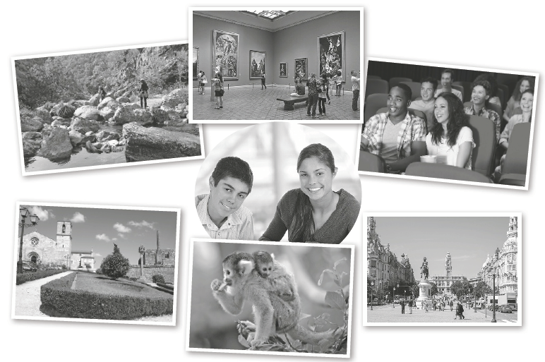
PART 3
3 minutes
In this part of the test, you’ll be asked to talk on your own about a picture/photo.
Student A: Describe your photo in detail. Say who/what you can see, what type of clothes the people are wearing, etc.
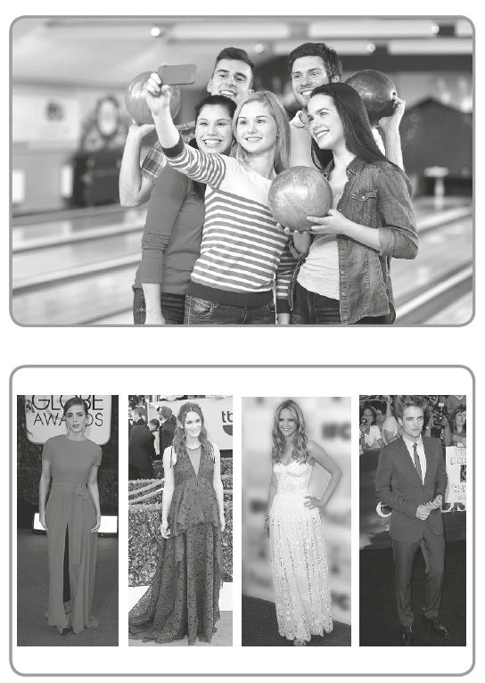
Student B: Do the same.
PART 4
3 minutes
Your photographs showed people wearing different types of clothes. Talk together about the sort of clothes you’d prefer to wear for different occasions and your favourite colours.
CRITÉRIOS ESPECÍFICOS DE CLASSIFICAÇÃO TEST 2
LISTENING TEST 2 – PART 1
1. | N5 | Escreve 9 ou 10 palavras corretamente.  Chave:  (1) series; (2) fantasy; (3) secrets; (4) suspense; (5) loyalty; (6) bravery;  (7) friendship; (8) games: (9) print; (10) e-book | 40
1. | N4 | Escreve 7 ou 8 palavras corretamente. | 30
1. | N3 | Escreve 5 ou 6 palavras corretamente. | 20
1. | N2 | Escreve 3 ou 4 palavras corretamente. | 15
1. | N1 | Escreve apenas 1 ou 2 palavras corretamente. Erra ou omite as restantes palavras. | 5
PART 2
1. | N5 | Identifica as 6 opções corretamente.  Chave:  a) I; b) C; c) C; d) I; e) I; f) I | 30
1. | N4 | Identifica 5 opções corretamente. | 24
1. | N3 | Identifica 4 opções corretamente. | 18
1. | N2 | Identifica 3 opções corretamente. | 12
1. | N1 | Identifica 2 opções corretamente. Erra ou omite as outras respostas. | 6
2. | N5 | Completa as 5 entradas corretamente. Pode escrever com incorreções linguísticas não impeditivas da compreensão.  Chave: a) Gravity; b) Sandra Bullock and George Clooney; c) astronauts; d) (the mid-orbit) destruction of a space shuttle (and their attempt to return to Earth); e) science fiction (epic) | 30
2. | N4 | Completa 4 entradas corretamente. Pode escrever com incorreções linguísticas não impeditivas da compreensão. | 24
2. | N3 | Completa 3 entradas corretamente. Pode escrever com incorreções linguísticas não impeditivas da compreensão. | 18
2. | N2 | Completa 2 entradas corretamente. Pode escrever com incorreções linguísticas não impeditivas da compreensão. | 12
2. | N1 | Completa 1 entrada corretamente. Erra ou omite as outras informações. | 6
READING AND WRITING – TEST 2A – PART 1
1. | N5 | Escreve as 6 palavras corretamente.  Chave: a) pop; b) classical; c) musician; d) band; e) rock; f) festival | 12
1. | N4 |  | 10
1. | N3 | Escreve 4 palavras corretamente. | 8
1. | N2 |  | 6
1. | N1 | Escreve apenas 2 palavras corretamente. Omite ou erra as restantes. | 4
2. | N5 | Escolhe as 6 opções corretas.  Chave: 1. A; 2. B; 3. D; 4. A; 5. D; 6. C | 12
 | N4 | Escolhe 5 opções corretas. | 10
 | N3 | Escolhe 4 opções corretas. | 8
 | N2 | Escolhe 3 opções corretas. | 6
 | N1 | Escolhe apenas 2 opções corretas. Erra ou omite o restante. | 4

PART 2
1. | N5 | Distingue todas as frases corretas das incorretas e identifica a informação no texto para justificar as 4 frases incorretas.  Chave:  a) I – “Glastonbury Festival is a five-day music festival…” ; b) C  c) I – “Leading pop and rock artists have headlined, alongside thousands of others…”; d) C  e) I – “The majority of staff are volunteers…”  f) I – “The festival usually takes place on the last weekend of June…” | 12
1. | N4 |  | 10
1. | N3 | Distingue 4 frases corretamente e identifica a informação no texto para justificar a(s) frase(s) falsa(s), se aplicável. | 8
1. | N2 |  | 6
1. | N1 | Distingue apenas 2 frases corretamente e identifica a informação no texto para justificar a(s) frase(s) falsa(s), se aplicável. | 4
2. | N5 | Completa as 5 frases corretamente. Pode escrever com incorreções linguísticas não impeditivas da compreensão.  Chave:  a) … near Pilton, Glastonbury, Somerset, England.  b) … to charity.  c) … educating people about the environment and how to protect it.  d) … lots of entertainment…  e) … bring good rubber boots and a waterproof jacket. | 15
2. | N4 |  | 12
2. | N3 | Completa 3 frases corretamente. Pode escrever com incorreções linguísticas não impeditivas da compreensão. | 9
2. | N2 |  | 6
2. | N1 | Completa 1 frase corretamente. Pode escrever com incorreções linguísticas não impeditivas da compreensão. Omite ou erra a restante informação. | 3

PART 3
1. | N2 | Completa os 2 espaços corretamente.  Chave: a) had begun; b) didn’t feel | 4
1. | N1 | Completa 1 espaço corretamente. | 2
2. | N5 | Completa as 5 frases corretamente.  Chave: a) hasn’t been; b) he saw; c) has watched; d) had never invited; e) he enjoyed | 15
2. | N4 |  | 12
2. | N3 | Completa 3 frases corretamente. | 9
2. | N2 |  | 6
2. | N1 | Completa 1 frase corretamente. Pode escrever com incorreções linguísticas não impeditivas da compreensão. Erra ou omite as outras informações. | 3
PART 4
Competência Pragmática
 | N5 | Escreve uma carta, respeitando as instruções dadas, fornecendo pormenores e destacando aspetos relevantes.  Utiliza um número ainda limitado de mecanismos de coesão, mas articula as ideias de forma adequada num texto organizado, claro e coerente.  Respeita o limite de palavras indicado. | 15
 | N4 |  | 12
 | N3 | Escreve uma carta simples, respeitando as instruções dadas e destacando alguns aspetos relevantes.  Utiliza conectores simples, articulando as ideias num texto coeso embora ainda constituído por uma sequência linear de informações.  Pode não respeitar o limite de palavras indicado. | 9
 | N2 |  | 6
 | N1 | Escreve uma carta simples, abordando o tema de forma genérica e recorrendo a repetições e pormenores pouco relevantes.  Utiliza conectores simples para ligar frases elementares, mas estrutura deficientemente o texto.  Pode não respeitar o limite de palavras indicado. | 3

Competência Linguística*
 | N5 | Escreve um texto razoavelmente elaborado, utilizando recursos linguísticos adequados que lhe permitem transmitir a informação de forma precisa. Pode ainda revelar alguma influência da língua materna.  Utiliza vocabulário suficiente para se exprimir, podendo suprir algumas lacunas com a ajuda de circunlocuções. Pode ocorrer alguma confusão e escolha incorreta de palavras.  Revela, geralmente, bom domínio das estruturas e formas gramaticais, não cometendo erros gramaticais que possam causar incompreensão.  A ortografia é razoavelmente precisa.  A pontuação é geralmente adequada. | 15
 | N4 |  | 12
 | N3 | Escreve um texto simples, utilizando recursos linguísticos adequados ao que pretende transmitir.  Pode ainda revelar alguma influência da língua materna.  Utiliza vocabulário suficiente para se exprimir com a ajuda de circunlocuções. Revela bom domínio do vocabulário elementar, cometendo erros graves apenas quando exprime um pensamento mais complexo.  Utiliza, com correção, estruturas simples, não cometendo erros gramaticais elementares de forma sistemática.  A ortografia é suficientemente precisa para não afetar a inteligibilidade do texto.  A pontuação é geralmente adequada. | 9
 | N2 |  | 6
 | N1 | Escreve um texto simples, utilizando padrões frásicos elementares.  Utiliza vocabulário elementar suficiente para se exprimir com a ajuda de circunlocuções.  Utiliza, com correção, estruturas simples, mas ainda comete alguns erros gramaticais elementares de forma sistemática, sem que isso impeça a compreensão global da mensagem.  Revela algum conhecimento das convenções ortográficas.  A pontuação nem sempre é adequada. | 3
READING AND WRITING – TEST 2B – PART 1
1. | N4 | Escreve as 4 palavras corretamente.  Chave: a) comedy; b) horror; c) cartoon; d) thriller | 8
1. | N3 | Escreve 3 palavras corretamente. | 6
1. | N2 | Escreve 2 palavras corretamente. | 4
1. | N1 | Escreve apenas 1 palavra corretamente. Omite ou erra as restantes. | 2
2. | N5 | Escolhe as 6 opções corretas.  Chave: 1. C; 2. D; 3. A; 4. D; 5. C; 6. D | 12
2. | N4 | Escolhe 5 opções corretas. | 10
2. | N3 | Escolhe 4 opções corretas. | 8
2. | N2 | Escolhe 3 opções corretas. | 6
2. | N1 | Escolhe apenas 2 opções corretas. Erra ou omite as restantes. | 4
PART 2
1. | N4 | Identifica corretamente a informação nos 4 parágrafos.  Chave:  a) 2nd paragraph; b) 3rd paragraph  c) 1st paragraph; d) 4th paragraph | 8
1. | N3 | Identifica corretamente a informação em 3 parágrafos. | 6
1. | N2 | Identifica corretamente a informação em 2 parágrafos. | 4
1. | N1 | Identifica corretamente a informação apenas num parágrafo. Erra ou omite as outras informações. | 2
2. | N4 | Distingue todas as frases corretas das incorretas e identifica a informação no texto para justificar a(s) resposta(s) errada(s).  Chave:  a) C  b) I – “… which has to maintain strict security over who has won what until the winners are announced.”  c) I – “The first presentation took place on 16th May, 1929…”  d) C | 12
2. | N3 | Distingue 3 frases corretamente. Identifica a informação no texto para justificar a(s) resposta(s) errada(s). | 9
2. | N2 |  | 6
2. | N1 | Identifica 1 frase corretamente. Pode escrever com incorreções linguísticas não impeditivas da compreensão. Omite ou erra a restante informação. | 3
3. | N4 | Completa corretamente as 4 frases.  Chave: a) in 1953; b) who has won what; c) a bow tie; d) vote | 10
3. | N3
3. | N2 | Completa corretamente 2 frases. | 5
3. | N1 | Completa corretamente 1 frase. | 2

PART 3
1. | N5 | Completa os 5 espaços corretamente.  Chave: a) had already begun; b) screamed… jumped… saw…  c) Had he never watched | 10
1. | N4 |  | 8
1. | N3 | Completa 3 espaços corretamente. | 6
1. | N2 |  | 4
1. | N1 | Completa 1 espaço corretamente. | 2
2. | N5 | Completa as 5 frases corretamente.  Chave: a) had never seen; b) we have watched; c) you like; d) hasn’t worn;  e) is the name | 10
2. | N4 |  | 8
2. | N3 | Completa 3 frases corretamente. | 6
2. | N2 |  | 4
2. | N1 | Completa apenas 1 frase corretamente. Pode escrever com incorreções linguísticas não impeditivas da compreensão. Erra ou omite as outras informações. | 2
PART 4 (1/2) (VER TESTE 2A)
 |  | Competência Pragmática | 15
 |  | Competência Linguística * | 15

* A competência linguística só será avaliada se o aluno tiver tratado o tema proposto, situando-se o seu texto, pelo menos, no nível 1 da competência pragmática.
SPEAKING TEST 2 (Suggestions)

PART 1
Student A
- Yes, I like going to the cinema because I can see the latest films, normally with my friends.
- I go to the cinema on school holidays.
- My favourite film star is (Jennifer Lawrence)
- J- E-N-N-I F-E-R L-A-W-R-E-N-C-E
- I like watching adventure films because the plot is always exciting.

Student B
- Yes, I like listening to music because it makes me feel good.
- I normally listen to music every day.
- My favourite singer is Adele because her songs are rhythmic and melodic.
- A-D-E-L-E
- It depends on the sort of music and type of book. Both are enjoyable ways of spending free time.

PART 2
Student A: In my opinion, we could go to a museum and look at those wonderful pictures on the wall. Some of us really like art.
Student B: Well, only if it is free entry. And some might find it boring. Why don’t we go to the city centre? Usually the historical part of the city has unique architecture. We could arrange a guided tour.
Student A: Hmm, I don’t think they would like to walk for so long. I was thinking that there’s a great film on… Why don’t we go to the cinema? And you know how much they love popcorn!
Student B: But the weather is too nice to be inside a dark room. Besides, it’s only about 2 hours. We could go to the Zoo and see those funny little monkeys. Most of us really like animals and wildlife.
Student A: Or we could go to the mountains and try some extreme sports like mountaineering or abseiling.
Student B: Well… Don’t you think that’s too dangerous? Some of the parents will object to that.
Student A: You’re right. Let’s go to the Zoo, then. I think we will all enjoy that!

PART 3
Student A: I can see a group of young people, two boys and three girls. They are in the bowling alley together and one of the girls is taking a selfie of the group. It seems they are having fun together. They are wearing informal and light clothes: T-shirts and jeans.
Student B: The photograph shows three well-known actresses and an actor. All of them are wearing formal clothes. Their dresses are long and of different colours. It looks like they are walking the red carpet of the Oscars. The actor is also wearing a in a formal way since he’s wearing a tuxedo, a shirt and a tie.
Student B: The photograph shows three well-known actresses and an actor. All of them are wearing formal clothes. Their dresses are long and of different colours. It looks like they are walking the red carpet of the Oscars. The actor is also wearing a in a formal way since he’s wearing a tuxedo, a shirt and a tie.

PART 4
Student A: I prefer wearing informal clothes, like T-shirts and jeans.
Student B: So, do I. That’s the type of clothes people our age wear every day.
Student A: When I go to a wedding, for example, my mum makes me wear more formal clothes, but that’s only for a day, so I don’t mind.
Student B: That’s exactly what happens with me. But I don’t feel very comfortable wearing this stuff.
Student A: As for colours, my favourites are blue or black.
Student B: I also like these colours, but my favourite is green. Green means hope and I always hope for the best. I sometimes buy designer clothes, but clothes brands names aren’t very important to me.
Student A: Well… most of these clothes are very fashionable, but they are also expensive, so I can’t afford to buy them.

