TEST 3 | UNIT 3 – TECHNOLOGY IS GREAT!
Name:______________________________________________________ No.:______ Class:_____
Date: ____/____/____ Mark: ________________________ Teacher: ________________________
LISTENING

PART 1
1. You will hear a voice message. Fill in the missing information in the table.
Who’s speaking? | ⁽¹⁾ _________________________________
To whom? | ⁽²⁾ _________________________________
Message: | Everyone’s coming to ⁽³⁾ __________________. Match starts ⁽⁴⁾ ________________.  Bring some (5) ___________________________________and ^{(6) __________________________}_______________.  Pass ⁽⁷⁾ __________________________.

PART 2
1. You will hear an interview with three teenagers talking about selfies.
Who says what? Answer each question with a name.
a) On average, I take about forty selfies
a week! – ________________.
b) Normally I take about one or
two. – ________________.
c) I would take selfies at concerts or
possibly at parties with my friends. – ________________.
d) I like selfies, but I don’t take them very often. – ________________.
e) People who take a lot of selfies are a bit vain, most of the time. – ________________.
2. Complete the sentences according to what you hear. Write 2-4 words for each sentence.
a) People are obsessed with taking selfies because they’re ______________________________.
b) You update your social media with ________________________________________________.
c) People take selfies because they don’t want to be different _____________________________.
d) Celebrities take a lot of selfies, so their fans ________________________________________.
e) Martha got upset with a rude comment on a photo she ________________________________.
f) The rude comment didn’t stop her from _____________________________________________.
g) If you are not being judged by anyone, taking selfies __________________________________.
TEST 3A | UNIT 3 – TECHNOLOGY IS GREAT!
Name:_____________________________________________________ No.:______ Class:_____
Date: ____/____/____ Mark: ________________________ Teacher: _______________________

READING AND USE OF LANGUAGE

PART 1
1. Why has Julie sent this text message? Circle the correct answer (A, B or C).
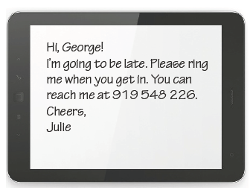
A To tell George she’ll phone him later.
B To check if he’s going to get back home late.
C To ask George to call her when he arrives.

2. Complete this phone call (1 – 7) with the questions/expressions in the box (A – H). One letter is not needed.
A When?
Luca: You sound a bit down. ⁽¹⁾ _______________
Eva: Nothing. I’m just a bit tired.
Luca: ⁽²⁾ __________________
Eva: Not a lot. ⁽³⁾ __________________
Luca: Not much. ⁽⁴⁾ __________________
Eva: Yeah, that sounds good.
⁽⁵⁾ ________________________
Luca: How about Saturday afternoon?
Eva: Good idea. ⁽⁶⁾ __________________
Luca: Excellent.
Eva: ⁽⁷⁾ ____________________
at Leicester Square outside the tube station.
Luca: Great. See you there!

Luca: You sound a bit down. ⁽¹⁾ _______________
Eva: Nothing. I’m just a bit tired.
Luca: ⁽²⁾ __________________
Eva: Not a lot. ⁽³⁾ __________________
Luca: Not much. ⁽⁴⁾ __________________
Eva: Yeah, that sounds good. ⁽⁵⁾ _____________
Luca: How about Saturday afternoon?
Eva: Good idea. ⁽⁶⁾ __________________
Luca: Excellent.
Eva: ⁽⁷⁾ ____________________
at Leicester Square outside the tube station.
Luca: Great. See you there!
B Let’s meet
C What about you?
D What’s up?
E I’m really sorry. Can
I call you later?
F Shall we meet at
3 p.m.?
G Do you fancy going
for an ice cream?
H What are you up to
this weekend?

PART 2
Read the text.

Can’t it wait until later?
Once again I am interrupted when I hear a noisy song coming from a girl’s Smartphone. She opens her bag, picks up her phone and answers, “Hello? Yeah, I’ll be home in about an hour... No, I don’t feel like cooking. Maybe I’ll pick up some pizza on the way. I’ve gotta go. See you soon.” Why the call about dinner was so important, I do not know.
Mobile phones (or Smartphones) – who doesn’t have one? Whether used for safety reasons or social purposes, it seems that I can go nowhere these days without being bothered by someone who just simply cannot wait until later to talk. It is almost as if every call is vital.
Don’t get me wrong, I recognize that mobile phones can be helpful. When someone’s car breaks down, they bring quick help. Teens with loving parents can go out at the weekend with a way to check in and satisfy their parents’ wish of knowing where they are. Mobile phones keep people safe and enable the communication lines to remain open 24 hours a day. However, when safety and frivolity clash, we run into problems.
My question is, where do we draw the line between necessary talk and obvious rudeness? How many times have you been in a cinema, restaurant, or shopping centre when a mobile phone started ringing? It is likely that the call could have waited. I think life should be simple, not complicated with thousands of conversations happening at the same time with the constant use of mobile phones. These phones are just infuriating sometimes, when people don’t see what’s happening around them. All I am asking is for mobile phone users to be safe, have some respect for others overhearing their chats, and to realize that sometimes it’s better to keep conversations private. Caroline R., Hull, MA, www.teenink.com (abridged and adapted)

Can’t it wait until later?
Once again I am interrupted when I hear a noisy song coming from a girl’s Smartphone. She opens her bag, picks up her phone and answers, “Hello?… Yeah, I’ll be home in about an hour... No, I don’t feel like cooking. Maybe I’ll pick up some pizza on the way. I’ve gotta go. See you soon.” Why the call about dinner was so important, I do not know.
Mobile phones (or Smartphones) – who doesn’t have one? Whether used for safety reasons or social purposes, it seems that I can go nowhere these days without being bothered by someone who just simply cannot wait until later to talk. It is almost as if every call is vital.
Don’t get me wrong, I recognize that mobile phones can be helpful. When someone’s car breaks down, they bring quick help. Teens with loving parents can go out at the weekend with a way to check in and satisfy their parents’ wish of knowing where they are. Mobile phones keep people safe and enable the communication lines to remain open 24 hours a day. However, when safety and frivolity clash, we run into problems.
My question is, where do we draw the line between necessary talk and obvious rudeness? How many times have you been in a cinema, restaurant, or shopping centre when a mobile phone started ringing? It is likely that the call could have waited. I think life should be simple, not complicated with thousands of conversations happening at the same time with the constant use of mobile phones. These phones are just infuriating sometimes, when people don’t see what’s happening around them. All I am asking is for mobile phone users to be safe, have some respect for others overhearing their chats, and to realize that sometimes it’s better to keep conversations private.
Caroline R., Hull, MA, www.teenink.com (abridged and adapted)

1. In note form, complete the table with information from the text.
Mobile phones/Smartphones
Advantages | Disadvantages
a) | c)
b) | d)
2. Choose the correct ending to the sentences.
1. Caroline was interrupted when ______________.
a) a boy started playing a noisy song
b) a mobile phone started ringing
c) a girl answered her mobile phone
2. The telephone conversation Caroline overheard was about ______________.
a) an emergency
b) a serious matter
c) an unimportant subject
3. Mobile phones are used ______________.
a) only for safety reasons
b) for various purposes
c) only for important conversations
4. Caroline thinks mobile phones are ______________.
a) useful in some situations
b) indispensable to daily life
c) something we can live without
3. Find words in the three first paragraphs that mean the following:
a) intentions or reasons ________________________ c) useful ________________________
b) essential to life ____________________________ d) allow _________________________
4. What does Caroline ask mobile phone users to do?
PART 3
1. Put the verbs into the correct tense.
a) If he needs to concentrate, he always ________________________ (turn off) his Smartphone.
b) Give me a call if your car ________________________ (break) down.
c) If you didn’t phone your parents, they ________________________ (not know) where you are.
2. Complete the second sentence so that it means the same as the first. Use no more than three words.
a) I use an old mobile phone, but I don’t mind.
I don’t mind ________________________________ mobile phone.
b) You should save your pocket money to buy a Smartphone.
I suggest ________________________________ money to buy a Smartphone.
c) Do you want to see my new selfies?
Would ________________________________ see my new selfies?
d) I’m really sorry, but I didn’t mean to interrupt you.
I’m really sorry ________________________________ you.
WRITING

PART 4
1. You have been invited to a party that you don’t want to go to. Phone up and leave a message. You should:
• thank the person for the invitation
• give an excuse why you can’t go
• say when you’ll give the person your birthday present.
Write 35-45 words.

2. Read the question below and write a blog comment, giving your opinion.
Write 60-70 words.
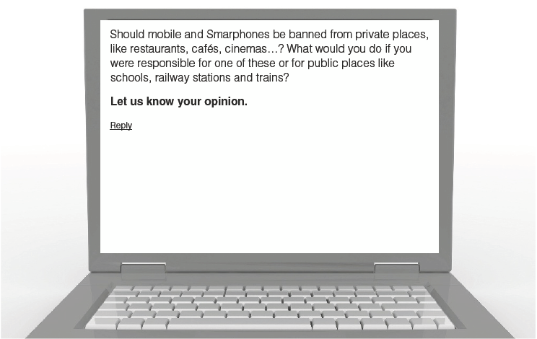

TEST 3B | UNIT 3 – TECHNOLOGY IS GREAT!
Name:_____________________________________________________ No.:______ Class:_____
Date: ____/____/____ Mark: ________________________ Teacher: _______________________

READING AND USE OF LANGUAGE

PART 1


Two friends, Ray and Kristen, are chatting online. What does Kristen say to Ray? Match the numbers (1 – 7) with the right letters (A – J). Three letters are not needed.
A Oh, I’m sorry I forgot.
B That’s a pity.
C Oh, no, Ray!
D OK. What time shall we meet?
E Great!
F Don’t worry. You’ll be fine.
G Well… I’m not.
H Jill and I went to that new club, Ego.
I It’s fantastic. They’ve got a brilliant DJ. We danced a lot.
J That’s fine for me. I’ll be there by then.

A Oh, I’m sorry I forgot.
B That’s a pity.
C Oh, no, Ray!
D OK. What time shall we meet?
E Great!
F Don’t worry. You’ll be fine.
G Well… I’m not.
H Jill and I went to that new club, Ego.
I It’s fantastic. They’ve got a brilliant DJ. We danced a lot.
J That’s fine for me. I’ll be there by then.
TEEN CHAT

Ray: Hey, Kristen! How are things?
Kristen: ⁽¹⁾ ________________
Ray: Did you do anything interesting at the weekend?
Kristen: ⁽²⁾ ________________
Ray: What’s it like?
Kristen: ⁽³⁾ ________________
Ray: You haven’t forgotten about tomorrow afternoon, have you?
Kristen: ⁽⁴⁾ ________________
Ray: Kristen! We’re going to finish our English project.
Don’t you remember?
Kristen: ⁽⁵⁾ ________________
Ray: Well… but I really need some help. I can’t do it alone.
Kristen: ⁽⁶⁾ ________________
Ray: What about 3 o’clock in the school library?
Kristen: ⁽⁷⁾ ________________

TEEN CHAT

Ray: Hey, Kristen! How are things?
Kristen: ⁽¹⁾ ________________
Ray: Did you do anything interesting at the weekend?
Kristen: ⁽²⁾ ________________
Ray: What’s it like?
Kristen: ⁽³⁾ ________________
Ray: You haven’t forgotten about tomorrow afternoon, have you?
Kristen: ⁽⁴⁾ ________________
Ray: Kristen! We’re going to finish our English project.
Don’t you remember?
Kristen: ⁽⁵⁾ ________________
Ray: Well… but I really need some help. I can’t do it alone.
Kristen: ⁽⁶⁾ ________________
Ray: What about 3 o’clock in the school library?
Kristen: ⁽⁷⁾ ________________

PART 2
Read the texts.

The online world
Some psychologists say obsessive use of computers to surf the web, join social sites and chat room discussions, and play video games is a real addiction.
In recent years, people have started to use the computer and the Internet like they used to watch TV. It is, in fact, very comfortable and relaxing just to sit down and have a chat with somebody from Canada about ice hockey and lacrosse.
If we are hungry, we simply order a pizza through the Internet. While we are waiting for the food, we check our Facebook messages, upload photos and change our profile pictures and even leave a message on our friends’ Facebook walls.
So, we just don’t have much time for communication with people anymore. Besides, there is so much information available that when we start surfing the Internet, we spend a long time in front of the screen. There are a lot of people who are addicted to TV and watch it 5 to 7 hours a day, and I believe using the computer is becoming an addiction, too.
Karen, Wales


It always starts the same way. A friend tells you about social networks and their chat rooms. Why should I chat? Usually you have some free time left and you are curious and want to try.
Sometimes you meet your friends in the chat room instead of giving them a call. Later, you get more interested in other anonymous chatterers. After seeing for a while the same nickname, you want to know more about them. You want to meet them each day to talk and laugh together.
You start to stay on while your friends go out for dinner and have fun. Maybe you won’t have time to prepare a meal for yourself and eat only fast food. If you stay online all night long, you won’t get enough sleep. Finally, you can say that you are addicted to chat rooms and social networks. This will be a serious problem in our society in the future.
Sean, Ireland

1. In note form, write three computer uses mentioned in the texts.
Computer uses | a)
Computer uses | b)
Computer uses | c)
2. Are these sentences correct (C) or incorrect (I)? Correct the wrong ones.
C I
a) People are becoming addicted to computers.
___________________________________________________________________ ___ ___
b) People like chatting via the Internet because it’s cheaper.
___________________________________________________________________ ___ ___
c) We can’t order food through the Internet.
___________________________________________________________________ ___ ___
d) People spend so much time online that they don’t talk face to face to
other people very often.
___________________________________________________________________ ___ ___
e) Young people start chatting online because it’s fun.
___________________________________________________________________ ___ ___
f) They prefer to talk to their friends in the chat rooms.
___________________________________________________________________ ___ ___
3. Find the words in the first text that mean the following:
a) informal conversation __________________________________________________________
b) to copy or move information or pictures to the Internet _________________________________
c) able to be used _______________________________________________________________
4. What do the two teens think about people’s use of the computer?
PART 3
1. Put the verbs into the correct tense. Use different modal verbs where appropriate (will, may…).
a) Don’t surf the web for hours if you ____________________ (not want) to waste time.
b) Unless you tell me so, I ____________________ (not send) you the English assignment.
c) If you trust your online friends, you ____________________ (get) into trouble.
d) Peter would be healthier if he __________________ (not spend) so much time in front of screens.
2. Complete the second sentence so that it means the same as the first. Use no more than three words.
a) Avoid spending too much time online.
You shouldn’t _________________________ time online.
b) Are you interested in joining a social networking site?
Do you want _________________________ a social networking site?
c) I think it would be a good idea to design a class website.
I suggest _________________________ website.

WRITING

PART 4
1. You want a friend to go shopping with you. Phone up and leave a message. You should:

• invite him/her to go shopping with you
• tell him/her the day and time
• suggest a place to meet.
Write 35-45 words.


2. Read the question below and write a reply, giving your opinion. Write 60-70 words.
Discussion Forum
Should parents limit teens’ time online?
Share your opinion here.
Reply

TEST 3

SPEAKING
The speaking test lasts about 10 to 12 minutes and will be divided into four parts. You take the test with another student.
PART 1
2/3 minutes
In this part of the test you will be asked personal questions.
Student A Student B
• Do you have a mobile phone/Smartphone? • Do you like surfing the web? Why/Why not?
• How often do you use it? • How often do you go online?
• What do you use it for? • Do you have a Facebook account? Why/Why not ?
• How many games do you have on your phone? • What can you do on social networks like Facebook?
• Could you live without your phone? • Who many ‘virtual friends’ do you have?
PART 2
2/3 minutes
I am going to describe a situation to you.
A boy in your class is going to give a birthday party and has invited all his classmates. Your class wants to give him a birthday present. You know he’s keen on technological gadgets. Talk together about the different presents you could give him and then decide which would be best. Here are a few pictures to help you.
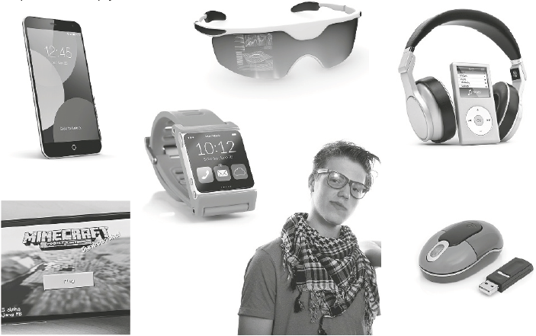
PART 3
3 minutes
In this part of the test, you’ll be asked to talk on your own about a picture/photo.
Student A: Describe your photo in detail. Say who/what you can see, what the people are doing, if you do the same, etc.
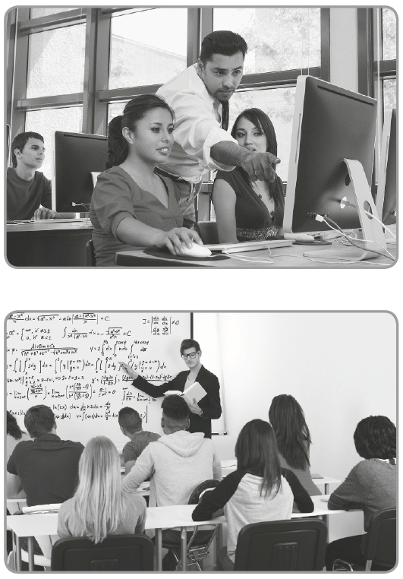
Student B: Do the same.
PART 4
3 minutes
Your photographs showed two different classrooms. Talk together about the types of lessons the students are having, how they are behaving and the importance of technology in class. Then, say which of the classrooms above you would choose and why.
LISTENING TEST 3 - PART 1

1. | N5 | Completa os 7 espaços corretamente. Pode escrever com incorreções linguísticas não impeditivas da compreensão.  Chave:  (1) Sally; (2) Jeremy; (3) my place tonight; (4) at 6.30; (5) crisps; (6) fruit juice; (7) it on | 30
1. | N4 | Completa 5 ou 6 espaços corretamente. Pode escrever com incorreções linguísticas não impeditivas da compreensão. | 24
1. | N3 | Completa 4 espaços corretamente. Pode escrever com incorreções linguísticas não impeditivas da compreensão. | 18
1. | N2 | Completa 3 espaços corretamente. Pode escrever com incorreções linguísticas não impeditivas da compreensão. | 12
1. | N1 | Completa 1 ou 2 espaços corretamente. Erra ou omite as restantes palavras. | 6
PART 2
2. | N5 | Identifica 5 nomes corretamente. Pode escrever com incorreções linguísticas.  Chave: a) Martha; b) Louise; c) Martha; d) Jordan; e) Louise | 25
2. | N4 | Identifica 4 nomes corretamente. Pode escrever com incorreções linguísticas. | 20
2. | N3 | Identifica 3 nomes corretamente. Pode escrever com incorreções linguísticas. | 15
2. | N2 | Identifica 2 nomes corretamente. Pode escrever com incorreções linguísticas | 10
2. | N1 | Identifica apenas 1 nome corretamente. Erra ou omite as outras respostas. | 5
3. | N5 | Completa as 7 frases corretamente. Pode escrever com incorreções linguísticas não impeditivas da compreensão.  Chave:  a) … a lot of fun; b) … the selfies you take; c) … from their friends; d) … take them too; e) … posted on Facebook; f) … posting anymore selfies; g) … is fun | 45
3. | N4 | Completa 6 frases corretamente. Pode escrever com incorreções linguísticas não impeditivas da compreensão. | 40
3. | N3 | Completa 4 ou 5 frases corretamente. Pode escrever com incorreções linguísticas não impeditivas da compreensão. | 30
3. | N2 | Completa 3 frases corretamente. Pode escrever com incorreções linguísticas não impeditivas da compreensão. | 20
3. | N1 | Completa 1 ou 2 frases corretamente. Erra ou omite as outras informações. | 10

READING AND WRITING – TEST 3A – PART 1
1. | N1 | Seleciona a opção correta.  Chave: C) | 5
2. | N5 | Escolhe as 7 opções corretas.  Chave: 1. D; 2. H; 3. C; 4. G; 5. A; 6. F; 7. B | 14
2. | N4 | Escolhe 5 opções corretas. | 10
2. | N3 | Escolhe 4 opções corretas. | 8
2. | N2 | Escolhe 3 opções corretas. | 6
2. | N1 | Escolhe apenas 2 opções corretas. Erra ou omite o restante. | 2
PART 2
1. | N5 | Identifica as 4 informações. Pode escrever com erros linguísticos não impeditivos da comunicação.  Chave:  Advantages: a) safety;  b) communication at any time  Disadvantages: c) lack of privacy;  d) lack of respect for the people around | 12
1. | N3 | Identifica 3 informações. Pode escrever com erros linguísticos não impeditivos da comunicação. | 9
1. | N2 | Identifica 2 informações. Pode escrever com erros linguísticos não impeditivos da comunicação. | 6
1. | N1 | Identifica apenas 1 informação. Erra ou omite as restantes. | 3
2. | N4 | Seleciona as 4 opções corretas.  Chave:  1. c; 2. c; 3. b; 4. a | 6
2. | N3 | Seleciona 3 opções corretas. | 4
2. | N2 | Seleciona 2 opções corretas. | 2
2. | N1 | Seleciona apenas 1 opção correta; erra ou omite as restantes opções. | 3
3. | N4 | Indica os 4 sinónimos corretamente.  Chave: a) purposes; b) vital; c) helpful; d) enable | 8
3. | N3 | Indica 3 sinónimos corretamente. | 6
3. | N2 | Indica 2 sinónimos corretamente. | 4
3. | N1 | Indica 1 sinónimo corretamente. | 2
4. | N3 | Identifica a informação correta para responder à pergunta. Pode escrever com erros linguísticos não impeditivos da comunicação.  Chave:  To be safe, have some respect for others overhearing their chats, and to keep conversations private. | 8
4. | N2 |  | 4
4. | N1 | Responde à pergunta omitindo informação e cometendo alguns erros linguísticos básicos. | 2

PART 3
1. | N3 | Completa os 3 espaços corretamente.  Chave: a) turns off; b) breaks; c) wouldn’t know | 9
1. | N2 | Completa 2 espaços corretamente.
1. | N1 | Completa 1 espaço corretamente. | 3
2. | N4 | Completa as 4 frases corretamente.  Chave: a) using an old; b) saving your pocket; c) you like to; d) for interrupting | 12
2. | N3 | Completa 3 frases corretamente. | 9
2. | N2 | Completa 2 frases corretamente. | 6
2. | N1 | Completa 1 frase corretamente. Pode escrever com incorreções linguísticas não impeditivas da compreensão. Erra ou omite as outras informações. | 3
PART 4 (1/2)
 |  | Competência Pragmática
 | N3 | Escreve um texto respeitando o tipo de enunciado pedido e as instruções dadas.  Utiliza um número ainda limitado de mecanismos de coesão, mas articula as ideias de forma adequada num texto organizado, claro e coerente.  Respeita o limite de palavras indicado. | Task 1  5  Task 2  11
 | N2 |  | Task 1  4  Task 2  7
 | N1 | Escreve um texto simples, não respeitando o tipo de enunciado pedido e as instruções dadas.  Utiliza conectores simples para ligar frases elementares, mas estrutura deficientemente o texto.  Pode não respeitar o limite de palavras indicado. | Task 1  2  Task 2  3
 |  | Competência linguística*
 | N3 | Escreve um texto razoavelmente elaborado, utilizando recursos linguísticos adequados que lhe permitem transmitir a informação de forma precisa. Pode ainda revelar alguma influência da língua materna.  Utiliza vocabulário suficiente para se exprimir, podendo suprir algumas lacunas com a ajuda de circunlocuções. Pode ocorrer alguma confusão e escolha incorreta de palavras.  Revela geralmente bom domínio das estruturas e formas gramaticais, não cometendo erros gramaticais que possam causar incompreensão.  A ortografia é razoavelmente precisa.  A pontuação é geralmente adequada. | Task 1  5  Task 2  11
 | N2 |  | Task 1  4  Task 2  7
 | N1 | Escreve um texto simples, utilizando padrões frásicos elementares.  Utiliza vocabulário elementar suficiente para se exprimir com a ajuda de circunlocuções.  Utiliza, com correção, estruturas simples, mas ainda comete alguns erros gramaticais elementares de forma sistemática, sem que isso impeça a compreensão global da mensagem.  Revela algum conhecimento das convenções ortográficas.  A pontuação nem sempre é adequada. | Task 1  2  Task 2  3
READING AND WRITING – TEST 3B – PART 1
1. | N5 | Seleciona as 7 opções corretas.  Chave: 1. E; 2. H; 3. I; 4. C; 5. A; 6. D; 7. J | 14
1. | N4 | Seleciona 5 ou 6 opções corretas. | 11
1. | N3 | Seleciona 4 opções corretas. | 8
1. | N2 | Seleciona 3 opções corretas. | 6
1. | N1 | Seleciona apenas 2 opções corretas. Erra ou omite as restantes. | 4
PART 2
1. | N3 | Identifica as 3 informações. Pode escrever com erros linguísticos não impeditivos da comunicação.  Chave:  a) have a chat; b) order a pizza through the Internet; c) check our Facebook accounts | 9
1. | N2 | Identifica 2 informações. Pode escrever com erros linguísticos não impeditivos da comunicação. | 6
1. | N1 | Identifica apenas 1 informação. Erra ou omite as restantes. | 3
2. | N5 | Distingue todas as frases corretas das incorretas e corrige as 3 frases incorretas.  Chave:  a) C  b) I – It’s comfortable and relaxing to sit down and have a chat.  c) I – We can order food, like a pizza, through the Internet.  d) C  e) I – A friend tells them about chat rooms and they are curious and want to try.  f) C | 18
2. | N4 |  | 15
2. | N3 | Distingue 4 frases corretas das incorretas e identifica a informação no texto para justificar as frases falsas. | 12

PART 2
 | N2 |  | 8
 | N1 | Distingue apenas 2 frases corretas das incorretas e identifica a informação no texto para justificar 1 frase falsa, se aplicável. | 4
3. | N3 | Identifica as 3 palavras corretamente.  Chave:  a) chat; b) upload; c) available | 6
3. | N2 | Identifica 2 palavras corretamente. | 4
3. | N1 | Identifica 1 palavra corretamente. Omite ou erra as restantes. | 2
4. | N1 | Responde corretamente à pergunta.  Exemplo:  Both teens think that computer use is becoming an addiction. | 4
PART 3
1. | N4 | Completa os 4 espaços corretamente.  Chave: a) don’t want; b) won’t send; c) may get; d) didn’t spend | 8
1. | N3 | Completa 3 espaços corretamente. | 6
1. | N2 | Completa 2 espaços corretamente. | 4
1. | N1 | Completa 1 espaço corretamente. | 2
2. | N3 | Completa as 3 frases corretamente.  Chave: a) spend so much; b) to join; c) designing a class | 9
2. | N2 | Completa 2 frases corretamente. | 6
2. | N1 | Completa 1 frase corretamente. Pode escrever com incorreções linguísticas não impeditivas da compreensão. Erra ou omite as outras informações. | 3
PART 4 (VER TEST 3A)
1. |  | Competência Pragmática | 5
1. |  | Competência Linguística* | 5
2. |  | Competência Pragmática | 11
2. |  | Competência Linguística* | 11

* A competência linguística só será avaliada se o aluno tiver tratado o tema proposto, situando-se o seu texto, pelo menos, no nível 1 da competência pragmática.

SPEAKING TEST 3 (Suggestions)

PART 1
Student A
– Yes, I do. I have a mobile/Smartphone.
– I use it every day.
– I use it to send text messages, phone my parents and my friends, play games (and access the Net).
– I have a few games.
– It would be difficult since I’m used to it, but it wouldn’t be impossible.

Student B
– Yes, I do. Because I can use it for a lot of things.
– I go online almost every day.
– Yes, I have a Facebook account because all my friends have one too.
– Lots of things, like playing games, chatting, uploading videos, songs, photos, etc.
– Not many. Most of my friends are ‘real friends’ that also use social networks.

PART 2
Student A: I think we could give him a Smartphone.
Student B: I’m afraid I don’t agree with you. He’s already got one.
Student A: What about a mouse and a pen drive?
Student B: That’s not a good idea. He doesn’t use this stuff. He prefers his smartphone.
Student A: How about a Smartwatch?
Student B: Do you know how much it costs? We wouldn’t have enough money for that.
Student A: You’re right. I saw a pair of high-tech sunglasses that are really cool.
Student B: What does he need the glasses for? He never goes out in the sun! They’re not useful. But he might like a video game.
Student A: He can play games on his phone. I think he likes listening to music. How about giving him a pair of good headphones?
Student B: OK, that’s a good idea. Let’s do that.

PART 3
Student A: I can see a group of students in a computer room. It looks like they are having an ICT lesson because the teacher is standing behind them, looking at what they are doing. There’s another student behind the teacher looking at the computer. The students must be about eighteen, to twenty, so they are probably in higher education. The teacher is young and good-looking. There are a lot of window on the left of the room.

Student B: The picture shows some students in a classroom. The teacher is very young and standing in front of the blackboard, giving the lesson. It might be a maths class since we can see a lot of numbers and formulas written on the board. It seems that the students are paying attention to the lesson.

PART 4
Student A: In my picture, the students are using computers. It can be an ICT lesson or any other lesson where they are looking for information on the Internet or even doing exercises online.
Student B: My picture shows a traditional classroom, where the teacher uses the white board and the students use books and pens or pencils to write.
Student A: The first classroom is equipped with technology and the students are interested in the lesson.
Student B: As I said before, in my picture the students seem to be involved in classroom activities, too. But I think, may conclude that technology is important for students nowadays.
Student A: I agree with you. Looking back at the pictures, I can say that I’d prefer to have lessons in the first classroom. Students can do practical activities on computers whenever they need to.
Student B: I’d also prefer the first classroom, but I think we should also have lessons where the teacher explains the subjects and uses the board.

