TEST 4 | UNIT 4 – HEALTH AND FITNESS
Name:_____________________________________________________ No.:______ Class:_____
Date: ____/____/____ Mark: ________________________ Teacher: _______________________
LISTENING
You will hear an article about how The Biggest Loser is tackling childhood obesity.
PART 1
- Complete each gap with a word according to what you hear. PART 2
The Biggest Loser is a reality ⁽¹⁾ _____________ show which started in the US in 2004. The show centers on ⁽²⁾ ___________ contestants attempting to lose the most weight and to ⁽³⁾ ___________ for a cash prize. The person who ⁽⁴⁾ ___________ the highest percentage of weight becomes The Biggest Loser.
When The Biggest Loser ⁽⁵⁾ _______________ to NBC on Sunday, the country will be watching as three ⁽⁶⁾ _______ fight to lose weight and gain ⁽⁷⁾ ___________ while the hit weight-loss show tackles the epidemic of childhood
⁽⁸⁾ ___________ for the first time.

The Biggest Loser is a reality ⁽¹⁾ _____________ show which started in the US in 2004. The show centers on
⁽²⁾ ___________ contestants attempting to lose the most weight and to ⁽³⁾ ___________ for a cash prize. The person who ⁽⁴⁾ ___________ the highest percentage of weight becomes The Biggest Loser.
When The Biggest Loser ⁽⁵⁾ _______________ to NBC on Sunday, the country will be watching as three ⁽⁶⁾ _______ fight to lose weight and gain ⁽⁷⁾ ___________ while the hit weight-loss show tackles the epidemic of childhood
⁽⁸⁾ ___________ for the first time.

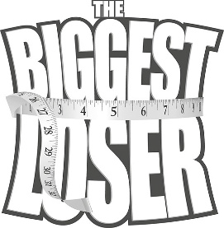
1. For each sentence circle the right answer (a, b or c).
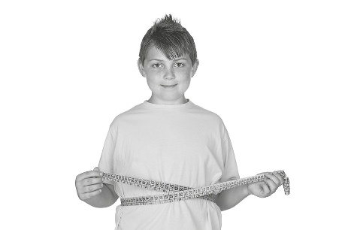
1. The first The Biggest Loser with children includes ___________.
a) 3 children
b) 13 children
c) 30 children
2. One of their final goals is to _________________.
a) return to the show
b) get into a beautiful prom dress
c) win a lot of money
3. Another reason teenagers give to lose weight is ________________.
a) people laughing at you
b) not having any friends
c) not having fun
2. Which type of activities will there be? Tick (✓) the right answers.
a) weigh-ins ___ d) fun activities ___
b) ball games ___ e) lessons on healthy eating ___
c) elimination games ___ f) work out ___

TEST 4A | UNIT 4 – HEALTH AND FITNESS
Name:_____________________________________________________ No.:______ Class:_____
Date: ____/____/____ Mark: ________________________ Teacher: _______________________
READING AND USE OF LANGUAGE

PART 1
1. Read the text below and choose the correct word for each space. For each question, mark the letter A, B or C.
Facts about overweight and obesity
Overweight and obesity are leading ⁽¹⁾ ________ for global deaths. Around 3.4 million adults die each year as a result of being ⁽²⁾ _________ or obese. In addition, they are the ⁽³⁾ _________ of many diseases such as diabetes, ischaemic heart disease and certain cancers.
⁽⁴⁾_______ to the WHO (World Health Organisation) estimates, in 2013, 42 ⁽⁵⁾ _______ children under the age of 5 were also overweight or obese. Once considered a high-income ⁽⁶⁾ _______ problem, overweight and obesity are now on the ⁽⁷⁾ ________ in low- and middle-income countries, particularly in urban settings. ⁽⁸⁾________ developing countries with emerging economies, the rate of increase of childhood overweight and obesity has been more than 30% ⁽⁹⁾_________ than that of developed countries.
Overweight and obesity are linked to more deaths worldwide than ⁽¹⁰⁾ ________.
http://www.who.int/mediacentre/factsheets/fs311/en/ (abridged)

Facts about overweight and obesity
Overweight and obesity are leading ⁽¹⁾________ for global deaths. Around 3.4 million adults die each year as a result of being ⁽²⁾_________ or obese. In addition, they are the ⁽³⁾_________ of many diseases such as diabetes, ischaemic heart disease and certain cancers.
⁽⁴⁾_______ to the WHO (World Health Organisation) estimates, in 2013, 42 ⁽⁵⁾_______ children under the age of 5 were also overweight or obese. Once considered a high-income ⁽⁶⁾_______ problem, overweight and obesity are now on the ⁽⁷⁾________ in low- and middle-income countries, particularly in urban settings. ⁽⁸⁾________ developing countries with emerging economies, the rate of increase of childhood overweight and obesity has been more than 30% ⁽⁹⁾_________ than that of developed countries.
Overweight and obesity are linked to more deaths worldwide than ⁽¹⁰⁾________.
http://www.who.int/mediacentre/factsheets/fs311/en/ (abridged)

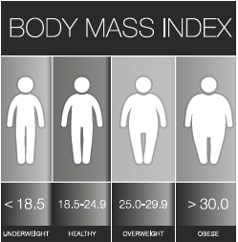
1. A risks B problems C situations
2. A sick B old C overweight
3. A result B consequence C cause
4. A According B Because C Due
5. A thousand B million C billion
6. A continent B country C city
7. A decrease B growth C rise
8. A On B In C At
9. A taller B bigger C higher
10. A underweight B heavyweight C middleweight
2. Match the verbs with their objects to find solutions for the reduction of obesity.
1. make ___ a) fats and sugar
2. limit ___ b) physical activity
3. consume ___ c) healthy choices
4. do ___ d) fruit and vegetables
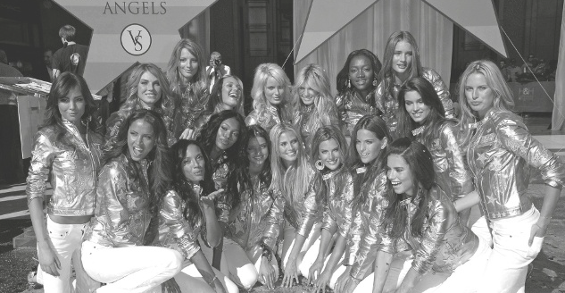
PART 2
Read the following text.

How the Victoria’s Secret Angels are getting fit for the runway
Forget Christmas; the most exciting event of December is undoubtedly the Victoria’s Secret Fashion Show. All of our favorite Angels will be stomping down the runway on Dec. 9 at 10/9C⁽¹⁾ on CBS. Getting filmed at every angle during the show can be intimidating, but these supermodels have no fear – they prepare for the show all year long. Before the winged babes make their debut, they’re training extra hard to stay healthy and toned. Check out how all of the Angels are keeping fit before their big day.
Adriana Lima
This tough beauty loves to hit the gym hard and works with trainers to make sure her body stays strong and toned. Check out the full-body and core workout she’s been taking on leading up to the show.
Doutzen Kroes
Doutzen has been taking ballet classes that focus on toning her body and giving her a long and lean look. Of course she’s wearing Victoria’s Secret Sport gear while working up a sweat!
Alessandra Ambrosio
Like Doutzen, Alessandra is also a fan of ballet. Over the last few months, we’ve also seen her heading to pilates, yoga, and SoulCycle.
Lily Aldridge
Lily is focusing on eating healthy. The model showed off her meal of steak, sweet potatoes, and green tea.
Karlie Kloss
The model loves to work in a good stretch after a long workout at the gym. Karlie keeps her workouts varied by doing a mix of running, strength training, and barre.
http://www.popsugar.com/celebrity-fitness (American English)
⁽¹⁾10/9C – Because of USA different time zones, schedules may give more than one time for a programme listing. (10 eastern time/9 central time).

How the Victoria’s Secret Angels are getting fit for the runway
Forget Christmas; the most exciting event of December is undoubtedly the Victoria’s Secret Fashion Show. All of our favorite Angels will be stomping down the runway on Dec. 9 at 10/9C⁽¹⁾ on CBS. Getting filmed at every angle during the show can be intimidating, but these supermodels have no fear – they prepare for the show all year long. Before the winged babes make their debut, they’re training extra hard to stay healthy and toned. Check out how all of the Angels are keeping fit before their big day.
Adriana Lima
This tough beauty loves to hit the gym hard and works with trainers to make sure her body stays strong and toned. Check out the full-body and core workout she’s been taking on leading up to the show.
Doutzen Kroes
Doutzen has been taking ballet classes that focus on toning her body and giving her a long and lean look. Of course she’s wearing Victoria’s Secret Sport gear while working up a sweat!
Alessandra Ambrosio
Like Doutzen, Alessandra is also a fan of ballet. Over the last few months, we’ve also seen her heading to pilates, yoga, and SoulCycle.
Lily Aldridge
Lily is focusing on eating healthy. The model showed off her meal of steak, sweet potatoes, and green tea.
Karlie Kloss
The model loves to work in a good stretch after a long workout at the gym. Karlie keeps her workouts varied by doing a mix of running, strength training, and barre.
http://www.popsugar.com/celebrity-fitness (American English)
⁽¹⁾10/9C – Because of USA different time zones, schedules may give more than one time for a programme listing. (10 eastern time/9 central time).

1. Complete the following sentences according to the introduction.
a) The best event in December is __________________________________________________.
b) The models are filmed _________________________________________________________.
c) They feel calm because ________________________________________________________.
d) To be prepared for the show, they ________________________________________________.
2. In note form, complete the table with information from the text.
 | Model’s name | How do they keep fit?
a)
b)
c)
d)
e)
PART 3
- Complete the second sentence so that it means the same as the first.

1. Victoria Secret’s Angels are required to be in shape.
Victoria Secret’s Angels ________________ be in shape.
2. It’s possible that overweight and obesity cause serious diseases.
Overweight and obesity ________________ cause serious diseases.
3. She wants to start a healthy diet.
She ________________ like to start a healthy diet.
4. I advise you to see a doctor before changing your diet.
You ________________ see a doctor before changing your diet.
5. In the past the rate of obesity was higher in rich countries, but now it is higher in developing countries.
Although ______________________________________________________________________.
6. She eats a lot of sweets, but she is very thin.
_____________________________________; however, ________________________________.
7. People suffer from obesity because they consume too much fat and sugar.
_____________________________________, therefore ________________________________.
8. The consequence of unhealthy eating is obesity.
People don’t eat healthily, ________________ they are obese.
9. People are overweight. They tend to be discriminated against.
People ________________ are overweight tend to be discriminated against.
10. Developing countries have a higher rate of obesity.
Developing countries are the ones ________________ rate of obesity is higher.
11. I am doing some exercises. They are important to keep fit.
The exercises ________________ I am doing are important to keep fit.

WRITING

PART 4
Your school newspaper has opened a writing contest. You have decided to participate.
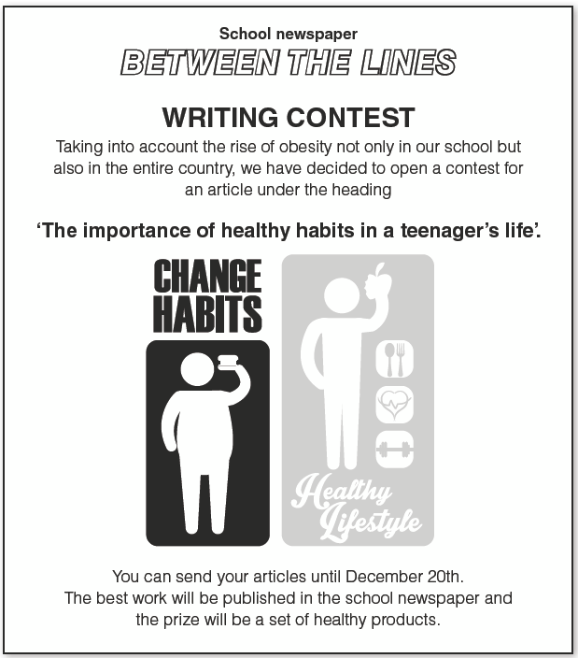
Read the ad below and write a text in about 80-100 words.

______________________________________________________________________________
______________________________________________________________________________
______________________________________________________________________________
______________________________________________________________________________
______________________________________________________________________________
_____________________________________________________________________________
TEST 4B | UNIT 4 – HEALTH AND FITNESS
Name:_____________________________________________________ No.:______ Class:_____
Date: ____/____/____ Mark: ________________________ Teacher: _______________________

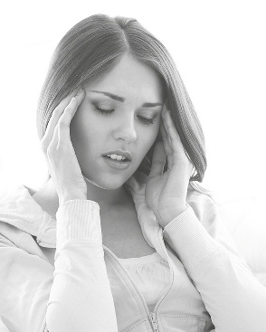
READING AND USE OF LANGUAGE

PART 1
1. Complete the sentences with a physical condition.
a) My back hurts. I have a _______________________________.
b) My tooth hurts. I have a _______________________________.
c) My head hurts. I have a ______________________________.
d) My stomach hurts. I have a ___________________________.
e) My ear hurts. I have an _______________________________.
f) My shoulder hurts. I have a ___________________________.
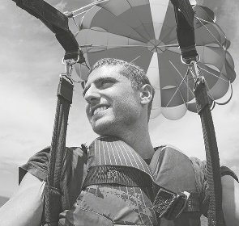
2. Read the text and circle the best answer (A, B or C) on the next page.
Extreme sports
Extreme sports are about exhilaration, skill
and ⁽¹⁾___________. They do not normally
involve teams and there are very ⁽²⁾___________
rules. People who take part use their ⁽³⁾___________
and experience to control the risks. Some of the
extreme sports most ⁽⁴⁾___________ in Britain are:
Kitesurfing, a thrilling combination of kite, board and
⁽⁵⁾___________. These kites can be up to 17 metres
long and you never know if you’re going to go up in
the air, so you are full of adrenaline.
Coasteering, which is exploring the coastline without worrying ⁽⁶⁾___________ a coastal path or finding a rocky cliffy cove blocking your route. You climb, ⁽⁷⁾___________, swim and clamber from A to B.
Skydiving, which is ⁽⁸⁾___________ from a plane and listening to your heart pounding as you hurtle towards Earth before you open your parachute at the ⁽⁹⁾___________ moment.
Mountain biking, which has been around so long that bikers are no longer satisfied with just going up and down a mountain. Nowadays thrill seeking mountain bikers want a big slope to go down very, very ⁽¹⁰⁾___________.
http://www.bbc.co.uk/worldservice/learningenglish/newsenglish/britain/extreme_sports.shtml (abridged)

Extreme sports
Extreme sports are about exhilaration, skill
and ⁽¹⁾___________. They do not normally
involve teams and there are very ⁽²⁾___________
rules. People who take part use their ⁽³⁾___________
and experience to control the risks. Some of the
extreme sports most ⁽⁴⁾___________ in Britain are:
Kitesurfing, a thrilling combination of kite, board and
⁽⁵⁾___________. These kites can be up to 17 metres
long and you never know if you’re going to go up in
the air, so you are full of adrenaline.
Coasteering, which is exploring the coastline without worrying ⁽⁶⁾___________ a coastal path or finding a rocky cliffy cove blocking your route. You climb, ⁽⁷⁾___________, swim and clamber from A to B.
Skydiving, which is ⁽⁸⁾___________ from a plane and listening to your heart pounding as you hurtle towards Earth before you open your parachute at the ⁽⁹⁾___________ moment.
Mountain biking, which has been around so long that bikers are no longer satisfied with just going up and down a mountain. Nowadays thrill seeking mountain bikers want a big slope to go down very, very ⁽¹⁰⁾___________.
http://www.bbc.co.uk/worldservice/learningenglish/newsenglish/britain/extreme_sports.shtml (abridged)

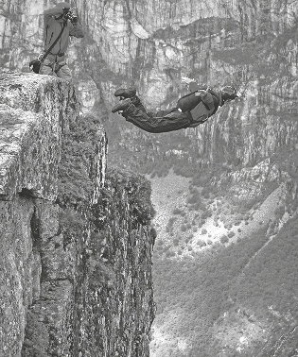
1. A danger B endangered C dangerous
2. A many B some C few
3. A qualities B skills C qualifications
4. A popular B populous C popularity
5. A sea B water C waves
6. A for B with C about
7. A dive B walk C run
8. A leaving B jumping C falling
9. A first B next C last
10. A fast B slow C leisurely
3. Put the following words into the most suitable column.
• football • swimming • cycling • volleyball • car racing
• gymnastics • basketball • golf • wrestling • table tennis

• football • swimming • cycling • volleyball • car racing
• gymnastics • basketball • golf • wrestling • table tennis

a) Indoor sports | b) Outdoor sports
•  •  •  •  •  • | •  •  •  •

PART 2
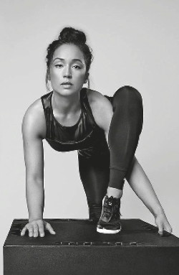
Read the following text.
Up close with Madonna’s trainer Nicole Winhoffer
Shape: The question on everyone’s mind: how does someone
become Madonna’s personal trainer?
Nicole: I have been a dancer all my life. I trained in classical dance,
modern, jazz, and musical theater and I performed in three Broadway
shows: 42nd St, Bombay Dreams, and Wicked. Madonna’s previous
trainer was recruiting professional dancers for the dance cardio portion
of her fitness training. I was brought on board to assist her on her last
tour and I continued to train her.
Shape: What about you: How do you stay fit and healthy with such
a busy schedule?
Nicole: I’ve learned that making time for myself is key: rest,
massage, and staying inspired. When my body is recharged,
I perform my best! I train with two to four clients every week day, and I try to take Saturdays off. I’ll go to yoga, ballet class, or work in the studio with my friends. We choreograph together and test new concepts and ideas.
Shape: What about diet? Any specific guidelines you stick to?
Nicole: I stay away from fried foods. I listen to my body and see what it craves. If I’m craving a lot of sugar/carbohydrates, it usually means that I need rest – my body is craving the glucose for energy. I love tofu, vegetables, and whole grains like quinoa and brown rice.
Shape: What’s your best advice for people who want to get in shape or achieve any fitness goal?
Nicole: Commit to change. Ask yourself if you’re living at your highest potential: physically, mentally, and spiritually. If the honest answer is no, ask why. Why haven’t you given back to yourself first? Then start to accomplish one new change every day. Start a morning on the treadmill, give up soda, plan and pack your meals for the day, take a group fitness class. Once you commit to a change, there is no failing.
http://www.shape.com/celebrities/star-trainers/close-madonnas-trainer-nicole-winhoffer (abridged)

Up close with Madonna’s trainer Nicole Winhoffer
Shape: The question on everyone’s mind: how does someone
become Madonna’s personal trainer?
Nicole: I have been a dancer all my life. I trained in classical dance,
modern, jazz, and musical theater and I performed in three Broadway
shows: 42nd St, Bombay Dreams, and Wicked. Madonna’s previous
trainer was recruiting professional dancers for the dance cardio portion
of her fitness training. I was brought on board to assist her on her last
tour and I continued to train her.
Shape: What about you: How do you stay fit and healthy with such
a busy schedule?
Nicole: I’ve learned that making time for myself is key: rest,
massage, and staying inspired. When my body is recharged,
I perform my best! I train with two to four clients every week day, and I try to take Saturdays off. I’ll go to yoga, ballet class, or work in the studio with my friends. We choreograph together and test new concepts and ideas.
Shape: What about diet? Any specific guidelines you stick to?
Nicole: I stay away from fried foods. I listen to my body and see what it craves. If I’m craving a lot of sugar/carbohydrates, it usually means that I need rest – my body is craving the glucose for energy. I love tofu, vegetables, and whole grains like quinoa and brown rice.
Shape: What’s your best advice for people who want to get in shape or achieve any fitness goal?
Nicole: Commit to change. Ask yourself if you’re living at your highest potential: physically, mentally, and spiritually. If the honest answer is no, ask why. Why haven’t you given back to yourself first? Then start to accomplish one new change every day. Start a morning on the treadmill, give up soda, plan and pack your meals for the day, take a group fitness class. Once you commit to a change, there is no failing.
http://www.shape.com/celebrities/star-trainers/close-madonnas-trainer-nicole-winhoffer (abridged)
1. For each sentence write correct (C) or incorrect (I). C I
a) Nicole Winhoffer has always been Madonna’s trainer. ___ ___
b) She is a professional dancer with a lot of experience. ___ ___
c) To stay fit and healthy, she not only trains but also rests to ‘recharge batteries’. ___ ___
d) She works every day of the week. ___ ___
e) She avoids fried foods and excess sugar in her diet. ___ ___
f) If you want to get in shape, you must change your lifestyle overnight. ___ ___
g) If you put your mind to it, you will succeed. ___ ___
PART 3
For each question, complete the second sentence so that it means the same as the first.
1. I advise you to eat only home-made food.
You __________________ eat only home-made food.
2. You don’t have permission to be here. Please leave.
You ________________________ stay here.
3. It was so dark that it was impossible for me to see anything.
It was so dark that I ________________________ see anything.
4. Nicole was a dancer, but she became Madonna’s personal trainer.
Even though ___________________________________________________________________.
5. She wants to lose some pounds but she doesn’t commit to it.
________________________________; however, ________________________________.
6. Although she is overweight, she is a happy girl.
________________________________ but ________________________________.
7. She got diabetes in consequence of her bad eating habits.
She had bad eating habits, ___________________ she got diabetes.
8. He has lost some pounds because he has been doing physical exercise.
________________________________, so ________________________________.
9. That’s the documentary. It is about health and fitness.
That’s the documentary _________________ is about health and fitness.
10. The models were in great shape. They participated in the fashion show.
The models _________________ participated in the fashion show were in great shape.
11. That model won the contest. She was in a white dress.
The model _________________ dress was white won the contest.
WRITING

PART 4
1. Imagine that you write for Shape magazine advice column and you receive the following email. Answer it in about 60 words.
Hello.
I am 14 years old and I feel very unhappy. I’ve been overweight since I was a child and I am often discriminated against and laughed at due to my weight. I’ve tried some diets but, after losing some pounds, I always get back to the way I was before.
Please, help me get down to my ideal weight.

Hello.
I am 14 years old and I feel very unhappy. I’ve been overweight since I was a child and I am often discriminated against and laughed at due to my weight. I’ve tried some diets but, after losing some pounds, I always get back to the way I was before.
Please, help me get down to my ideal weight.
____________________________________________________________________________________________________________________________________________________________
______________________________________________________________________________

TEST 4 | UNIT 4 – HEALTH AND FITNESS
Name:_____________________________________________________ No.:______ Class:_____
Date: ____/____/____ Mark: ________________________ Teacher: _______________________

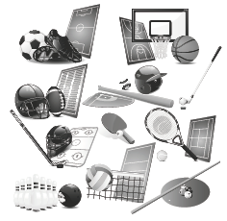
SPEAKING
The speaking test lasts about 10 to 12 minutes and will be
divided into four parts. You take the test with another student.
PART 1
2/3 minutes
In this part of the test, you will be asked personal questions.

Student A Student B
a) What’s your favourite sport? a) What do you like about doing sports?
b) Do you practise any sport? If so,
how often do you practise it? b) Do you think that people should go to a gym?
c) How important are sports for a
healthy life? c) How often do you visit a doctor for a check-up?
d) What type of diseases can we
avoid by doing physical exercise? d) Do you usually skip meals?

e) Are you a healthy teenager?
Why/Why not? e) What do you eat for breakfast?
PART 2
2/3 minutes
I am going to describe a situation to you.
You are going out for dinner and you have
to choose a restaurant.
Student A wants to go to a fast-food restaurant.
Student B wants to go to a home-made food
restaurant.
Talk together about the advantages of each
restaurant and decide which would be the best.

PART 3
3 minutes
In this part part of the test, you’ll be asked to talk on your own about a photograph.
Student A: Describe your photograph in detail. Say what you see and the consequences of such behaviour.
Student B: Do the same.
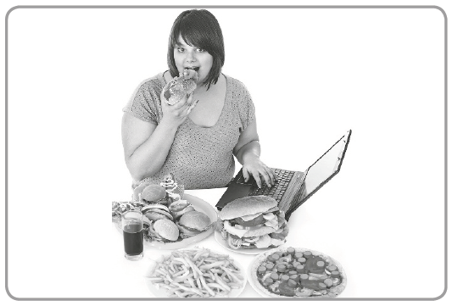
Student A
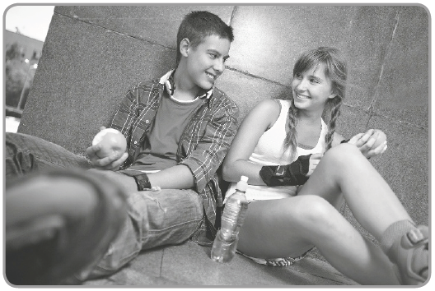
Student B
PART 4
3 minutes
Your photographs showed two different lifestyles. Talk together about the different habits these people have. Then, say which of the behaviours above you identify with.

CRITÉRIOS ESPECÍFICOS DE CLASSIFICAÇÃO TEST 4
LISTENING TEST 4 – PART 1
1. | N5 | Completa o texto com 8 palavras corretas. Pode fazê-lo com incorreções linguísticas não impeditivas da compreensão.  Chave:  1. television; 2. overweight; 3. fight  4. loses; 5. returns; 6. teens;  7. self-esteem; 8. obesity | 40
1. | N4 |  | 32
1. | N3 | Completa o texto com 5 palavras corretas. Pode fazê-lo com incorreções linguísticas não impeditivas da compreensão. Erra ou omite as restantes palavras. | 24
1. | N2 |  | 16
1. | N1 | Completa o texto com 1 ou 2 palavras corretas. Pode fazê-lo com incorreções linguísticas não impeditivas da compreensão. Erra ou omite as restantes palavras. | 8
PART 2
1. | N3 | Identifica as 3 opções corretas. Pode fazê-lo com incorreções linguísticas não impeditivas da compreensão.  Chave: 1. a); 2. b); 3. a) | 30
1. | N2 |  | 20
1. | N1 | Identifica 1 opção correta. Pode fazê-lo com incorreções linguísticas não impeditivas da compreensão. Erra ou omite as outras informações. | 10
2. | N3 | Identifica as 4 opções corretas.  Chave: b); d); e); f) | 30
2. | N2 |  | 20
2. | N1 | Identifica 1 opção correta. Erra ou omite as outras informações. | 10
READING AND WRITING – TEST 4A – PART 1
1 | N3 | Indica as 10 informações corretas. Pode escrever com incorreções linguísticas não impeditivas da compreensão.  Chave: 1. A); 2. C); 3. C); 4. A); 5. B); 6. B); 7. C); 8. B); 9. C); 10. A) | 20
1 | N2 |  | 14
1 | N1 | Indica 1 ou 2 informações corretas. Pode escrever com incorreções linguísticas não impeditivas da compreensão. Erra ou omite as outras informações. | 6
2. | N3 | Faz corresponder as 4 opções corretamente.  Chave: 1. c); 2. a); 3. d); 4. b) | 10
2. | N2 |  | 6
2. | N1 | Faz corresponder 1 opção corretamente. Erra ou omite as outras informações. | 2

PART 2
1 | N3 | Completa as 4 frases corretamente. Pode escrever com incorreções linguísticas não impeditivas da compreensão.  Chave:  a) … the Victoria’s Secret Fashion Show.  b) … at every angle during the show.  c) … they prepare for the show all year long.  d) … train extra hard. | 10
1 | N2 |  | 6
1 | N1 | Completa 1 frase corretamente. Pode escrever com incorreções linguísticas não impeditivas da compreensão. Erra ou omite as outras informações. | 2
2. | N3 | Completa as 4/5 informações da tabela em forma de nota corretamente. Pode escrever com incorreções linguísticas não impeditivas da compreensão.  Chave:  a) Adriana Lima – workout with trainers in the gym  b) Doutzen Kroes – ballet classes  c) Alessandra Ambrosio – ballet, pilates, yoga and SoulCycle  d) Lily Aldridge – healthy eating  e) Karlie Kloss – varied workout in the gym | 10
2. | N2 |  | 6
2. | N1 | Completa 1 informação da tabela em forma de nota corretamente. Pode escrever com incorreções linguísticas não impeditivas da compreensão.  Erra ou omite as outras informações. | 2
PART 3
1. | N5 | Completa as 11 frases corretamente.  Chave:  1. have to/must  2. may/can  3. would  4. should  5. Although in the past the rate of obesity was higher in rich countries, now it is higher in developing countries.  6. She eats a lot of sweets; however, she is very thin.  7. People consume too much fat and sugar, therefore they suffer from obesity.  8. so/therefore  9. who/that  10. whose  11. which/that | 20
1. | N4 |  | 18
1. | N3 | Completa 6 ou 7 frases corretamente. Erra ou omite as outras informações. | 15
1. | N2 |  | 10
1. | N1 | Completa 1 ou 2 frases corretamente. Erra ou omite as outras informações. | 5

PART 4
Competência Pragmática
 | N5 | Escreve um texto, respeitando as instruções dadas, fornecendo pormenores e destacando aspetos relevantes.  Utiliza um número ainda limitado de mecanismos de coesão, mas articula as ideias de forma adequada num texto organizado, claro e coerente.  Respeita o limite de palavras indicado. | 15
 | N4 |  | 12
 | N3 | Escreve um texto simples, respeitando as instruções dadas e destacando alguns aspetos relevantes.  Utiliza conectores simples, articulando as ideias num texto coeso embora ainda constituído por uma sequência linear de informações.  Pode não respeitar o limite de palavras indicado. | 9
 | N2 |  | 6
 | N1 | Escreve um texto simples, abordando o tema de forma genérica e recorrendo a repetições e pormenores pouco relevantes.  Utiliza conectores simples para ligar frases elementares, mas estrutura deficientemente o texto.  Pode não respeitar o limite de palavras indicado. | 3
 |  | Competência Linguística*
 | N5 | Escreve um texto razoavelmente elaborado, utilizando recursos linguísticos adequados que lhe permitem transmitir a informação de forma precisa. Pode ainda revelar alguma influência da língua materna.  Utiliza vocabulário suficiente para se exprimir, podendo suprir algumas lacunas com a ajuda de circunlocuções. Pode ocorrer alguma confusão e escolha incorreta de palavras.  Revela geralmente bom domínio das estruturas e formas gramaticais, não cometendo erros gramaticais que possam causar incompreensão.  A ortografia é razoavelmente precisa.  A pontuação é geralmente adequada. | 15
 | N4 |  | 12
 | N3 | Escreve um texto simples, utilizando recursos linguísticos adequados ao que pretende transmitir.  Pode ainda revelar alguma influência da língua materna.  Utiliza vocabulário suficiente para se exprimir com a ajuda de circunlocuções. Revela bom domínio do vocabulário el pensamento mais complexo.  Utiliza, com correção, estruturas simples, não cometendo erros gramaticais elementares de forma sistemática.  A ortografia é suficientemente precisa para não afetar a inteligibilidade do texto.  A pontuação é geralmente adequada. | 9
 | N2 |  | 6
 | N1 | Escreve um texto simples, utilizando padrões frásicos elementares.  Utiliza vocabulário elementar suficiente para se exprimir com a ajuda de circunlocuções.  Utiliza, com correção, estruturas simples, mas ainda comete alguns erros gramaticais elementares de forma sistemática, sem que isso impeça a compreensão global da mensagem.  Revela algum conhecimento das convenções ortográficas.  A pontuação nem sempre é adequada. | 3
READING/WRITING TEST 4B – PART 1
1. | N3 | Indica as 6 informações corretas. Pode escrever com incorreções de grafia que não impliquem competência gramatical.  Chave:  a) backache  b) toothache  c) headache  d) stomachache  e) earache  f) pain in my shoulder | 10
1. | N2 |  | 6
1. | N1 | Indica 1 informação correta. Pode escrever com incorreções de grafia que não impliquem competência gramatical. | 2
2. | N5 | Indica as 10 informações corretas.  Chave:  1. A; 2. C; 3. B; 4. A; 5. C; 6. C; 7. A;  8. B; 9. C; 10. A | 10
2. | N4 |  | 8
2. | N3 | Indica 5 ou 6 informações corretas. Erra ou omite as outras informações. | 6
2. | N2 |  | 4
2. | N1 | Indica 1 ou 2 informações corretas. Erra ou omite as outras informações. | 2
3. | N5 | Indica as 10 informações corretas.  Chave:  a) swimming / volleyball / gymnastics / basketball / wrestling / table tennis  b) football / cycling / car racing / golf | 10
3. | N4 |  | 8
3. | N3 | Indica 5 ou 6 informações corretas. Erra ou omite as outras informações. | 6
3. | N2 |  | 4
3. | N1 | Indica 1 ou 2 informações corretas. Erra ou omite as outras informações. | 2
PART 2
1. | N3 | Classifica 7 frases corretamente.  Chave:  a) I; b) C; c) C; d) I; e) C; f) I; g) C | 15
1. | N2 |  | 8
1. | N1 | Classifica 1 frase corretamente. Erra ou omite as restantes informações. | 3

PART 3
1. | N5 | Completa as 11 frases corretamente.  Chave:  1. should  2. can’t/mustn’t  3. couldn’t  4. Even though Nicole was a dancer, she became Madonna’s personal trainer.  5. She wants to lose some pounds; however, she doesn’t commit to it.  6. She is overweight but she is a happy girl.  7. so/therefore  8. He has been doing physical exercise, so he has lost some pounds.  9. which/that  10. who/that  11. whose | 25
1. | N4 |  | 20
1. | N3 | Completa entre 6 ou 7 frases corretamente. Erra ou omite as outras informações. | 15
1. | N2 |  | 10
1. | N1 | Completa 1 ou 2 frases corretamente. Erra ou omite as outras informações. | 5
PART 4 (VER TEST 4A)
 |  | Competência Pragmática | 15
 |  | Competência Linguística* | 15

SPEAKING TEST 4 (Suggestions)

PART 1

Student A

- My favourite sport is (football, swimming…).
- Yes, I do it (once/twice three times a week).
- They are very important to keep fit and healthy because they prevent certain diseases.
- You can avoid diseases like diabetes, heart problems and others.
- Yes, I am. I practise sports and have a healthy diet. / No, I’m not. I do little exercise and eat a lot of fat and sugar.

Student B
- What do you like about doing sports?
- Do you think that people should go to a gym?
- How often do you visit a doctor for a check-up?
- Do you usually skip meals?
- What do you eat for breakfast?

PART 2
Student A: I would like to go to a fast-food restaurant because the food is cheap and fast; I could eat a tasty hamburger.

Student B: I prefer going to a home-made food restaurant because the food is more varied, you can choose meat or fish or vegetarian and there are always fresh vegetables. The food is healthier and not necessarily more expensive.

PART 3
Student A: This girl is overweight because she eats all types of junk food, like hot dogs, hamburgers and chips with sauces like ketchup and mayonnaise. She drinks soda, which is also a source of sugar. She leads a sedentary life. She probably spends her free time in front of her computer. She should get more exercise.

Student B: These teens are in shape and they look healthy. They do sports (inline skating), and they probably have a healthy diet because they are eating apples and we can also see a bottle of water. Fruit and plain water are important in a healthy diet and it is a good idea to get plenty of exercise.

PART 4
Student A: My picture showed a fat girl eating all kind of fast food. In my opinion, we should avoid that kind of food because it doesn’t help you to keep fit and healthy. If you want to avoid diseases, you should include a variety of fruit and vegetables in your meals. Usually I eat healthy food. I always have vegetable soup, a portion of protein and carbohydrates and when I feel like eating dessert I prefer fruit. It’s not difficult to have a healthy diet if you like feeling good.
Student B: My picture showed two healthy teenagers and it seems that they love sports and have good eating habits. In my opinion, of course, eating healthy food is important to be in shape, to feel good with your body and mind, but sometimes it’s so difficult to follow the rules that I feel like giving up then, usually the only thing I can think about is a hamburger and chips full of ketchup. I eat it once in a while but I know I must respect my body.

