TEST 1 UNIT 1 On The Move

Name ____________________________________________________ No. ___________ Class __________
Date _____/_____/_____ Mark ___________________ Teacher ___________________________________

LISTENING

A. Listen to the song “Fame” and fill in the gaps with the missing words. (10 x 1 = 10 points)

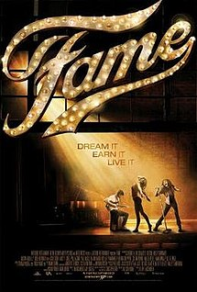
Baby, look at me
And tell me what you (1)……………………………
You ain't seen the (2)…………………………… of me yet
Give me time
I'll make you (3)…………………………… the rest
I got more in me
And you can set it (4)……………………………
I can catch the moon in my (5)……………………………
Don't you know who I am
Remember my name, fame
I'm gonna live (6)……………………………
I'm gonna learn how to fly, high
I feel it comin' (7)……………………………
People will see me and cry, fame
I'm gonna make it to (8)……………………………
Light up the sky like a flame, (9)……………………………
I'm gonna live forever
Baby, remember my (10)……………………………
Remember, remember, remember, remember
Remember, remember, remember, remember

Naturi Naughton, Fame (cover)
https://www.youtube.com/watch?v=5B1QTEGL3t0

B. Listen and complete the paragraph. Use the words in the box. (10 x 1 = 10 points)
talented cover students pop dance film artist photography year song

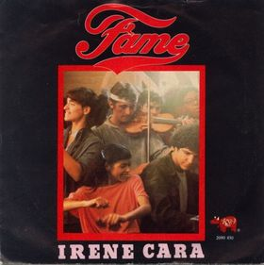
“Fame” is a (1)…………………………… song released in 1980. It achieved chart success as the theme (2)…………………………… of the film and TV series Fame, which follows (3)…………………………… high school (4)…………………………… who study music, (5)……………………………, drama and (6)…………………………… at The High School of Performing Arts in New York City. The song was first performed by Irene Cara, leading the (7)…………………………… to stardom. It won the Academy Award for Best Original song in 1980, and the Golden Globe Award the same (8)……………………………. In 2009, a remake of the (9)…………………………… would allow Naturi Naughton to be equally successful with her (10)…………………………… of the song.
https://en.wikipedia.org/wiki/Fame_(Irene_Cara_song)

TEST 1 UNIT 1 On The Move

Name ____________________________________________________ No. ___________ Class __________
Date _____/_____/_____ Mark ___________________ Teacher ___________________________________

VOCABULARY

A. Complete the text using the words in the box. (10 x 1 = 10 points)
teenagers training performances dancers School departments talent actress lives electronic


Fame is a 1980 American teen musical drama. Set in New York City, it chronicles the (1)…………………………… and problems of students attending the High (2)…………………………… of Performing Arts (known today as Fiorello H. LaGuardia High School). These students get specialized (3)…………………………… so that they later become successful actors, singers, (4)……………………………, etc. After the auditions, the (5)…………………………… are sorted into three different (6)……………………………: Drama, Music, and Dance. Accepted in the Drama department are Doris Finsecker, a shy girl who wants to be a famous (7)……………………………, Ralph Garci and Montgomery MacNeil, two other students who want to be famous actors. In the Music department, Bruno Martelli is an aspiring keyboardist whose (8)…………………………… equipment horrifies Mr. Shorofsky, a conservative music teacher. Leroy Johnson, a very talented student, and Lisa Monroe are accepted in the Dance department. Coco Hernandez is accepted in all three departments because of her all-around (9)…………………………… These students must study hard the academic topics as well as deliver great (10)…………………………….
https://en.wikipedia.org/wiki/Fame_(1980_film) (abridged and adapted)

B. Complete the following definitions. (5 x 2 = 10 points)
Destination: New York City

1. The place where you go when you arrive at the airport and where you show your ticket before you get onto the plane is the c……………………………. d……………………………..

2. A b……………………………. p……………………………. is the printed card which allows you to get onto a plane.

3. A shop in an airport where you don’t have to pay taxes on the goods you buy is a d……………………………. s……………………………..

4. Small bags or cases which passengers carry with them onto the plane are called h……………………………. l……………………………..

5. The area where you pick up your luggage after a flight is called b……………………………. r……………………………..

TEST 1 UNIT 1 On The Move

Name ____________________________________________________ No. ___________ Class __________
Date _____/_____/_____ Mark ___________________ Teacher ___________________________________

READING

Two incredible weeks @LAGUARDIA ARTS


When our Arts teacher told us our class had been chosen for an exchange programme in New York City, we simply couldn’t believe the news! It was too good to be true! Our class projects had been awarded the first prize in an International contest and we were going to spend two weeks in New York City, attending classes at Fiorello H. LaGuardia High School of Music & Art and Performing Arts.
This school offers specialised teaching in arts and allows students to explore their talents in music, art and the performing arts. Students are accepted based on auditions (Dance, Drama, Instrumental Music, Vocal Music and Technical Theatre) and portfolios (Art and Technical Theatre) and can benefit from scholarships and special programs.
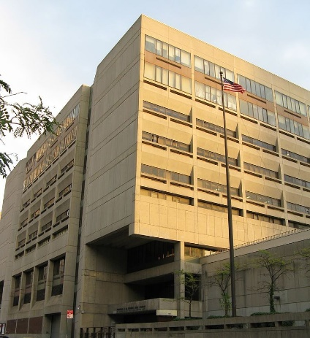
My schoolmates and I could choose the classes we wanted to have. Some students worked on drawing from observation, learning colour theory, and the principles of design. Gabriel and Thomas had Computer Graphics and Photography classes. Paul and Tracy had Drama classes. Betty and I attended Music Theory and History classes and we played different musical instruments. We composed two original songs and performed them in front of the class. Isn’t that amazing?! The school also presents an annual musical. Beauty and the Beast was being produced, and we were allowed to see the rehearsals.
After these two weeks, I think we are ready for a remake of the famous TV series Fame! We would be the new actresses and actors, of course!

https://en.wikipedia.org/wiki/Fiorello_H._LaGuardia_High_School (abridged and adapted)
A. Complete the following sentences according to the text. (5 x 3 = 15 points)
1. Nicole’s class was chosen ………………………………………………………………………………………………………………………
because the projects of her class received …………………………………………………………………………………………………

2. The students had classes at ……………………………………………………………………………………………………………….…

3. At LaGuardia High School, teenagers can study ……………………………………………………………………………….……

4. Gabriel and Thomas ……………………………………………………………………………………………………………………..………;
Paul and Tracy ………………………………………………………………………………………………………………………….………………

5. Nicole and Betty played …………………………………………………………..……………………………………………………………; they …………………………….………………………………………… and ………………….…………………………..…………………………

B. Match the words with their definitions. (5 x 1 = 5 points)
1. scholarship ……………  2. remake ……………  3. talents ……………  4. auditions ……………  5. rehearsal …………… |  | a. natural abilities or skills  b. short performances people give when they are trying to get a job/role as an actor, a dancer, singer or musician  c. a payment made to support a student’s education  d. the preparation and practice of a play or other work for later public performance  e. a new series/film that has a story and title similar to the original one

GRAMMAR

A. Complete the paragraph with the past simple or the past continuous. (8 x 1 = 8 points)
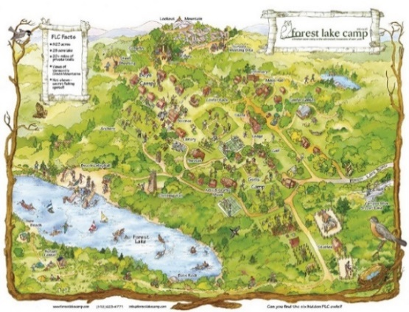
Nicole and her friends (1)……………….……………… (decide) to spend a weekend at Forest Lake Camp, one of America's great sleep away camps. When they (2)……………….……………… (arrive) there, some teenagers (3)……………….……………… (swim) in the lake and others (4)……………….……………… (participate) in boating activities. Others (5)……………….……………… (play) tennis and basketball and riding horses. Nicole and her friends (6)……………….……………… (go) on a whitewater rafting trip, (7)……………….……………… (take) part in a performing arts program, and much more. It (8)……………….…………… (be) a healthy, life-shaping experience for them.

https://www.newyorksummercamps.com/ (abridged and adapted)

B. Rewrite the following sentences. Start as suggested. (3 x 2 = 6 points)
1. The music teacher wasn’t in the classroom. The exchange students weren’t there either.
Neither ………………………………………………………….………………………………………………………………………….………………
2. Later, the students can go to a party or they can go to a pub.
Later, the students can either …………………………………………………………………………………………………………………….
3. Nicole missed the sightseeing bus. Betty missed the sightseeing bus too.
Both ………………………………………………………………………………………………………………………………………….………………

C. Each sentence has one mistake. Underline the mistakes and correct them. (3 x 2 = 6 points)
1. Nicole use to get homesick when she travelled abroad. ………………..……..
2. Betty’s parents misses her a lot when she is away. ………………..……..
3. There didn’t used to be school exchange programmes when Nicole’s parents were young. ………………..……..

WRITING
A. In your opinion what are the main advantages of school exchange programmes? Write about 90-100 words. (20 points)

TEST 1 UNIT 1 On The Move

Name ____________________________________________________ No. ___________ Class __________
Date _____/_____/_____ Mark ___________________ Teacher ___________________________________

SPEAKING

The speaking test lasts about 10 to 12 minutes and will be divided into four parts. You take the test with another student.

PART 1
2-3 minutes
In this part of the test, you will be asked personal questions.
Suggested questions:
1. What’s your name?
2. Have you ever been to a summer camp?
3. If you had the chance to go to a summer camp next summer, what type of camp would you choose?
4. Which activities would you like to try?
5. Have you ever been on a school exchange programme?
6. If so, what was it like? / If not, where would you like to go?

PART 2
2-3 minutes
I am going to describe a situation to you. You are thinking about going to Forest Lake Camp next summer.
Talk together about the different things you can do there. Here are a few pictures from the Camp’s website (https://forestlakecamp.com/about-flc/flc-summer-photos/) to help you.
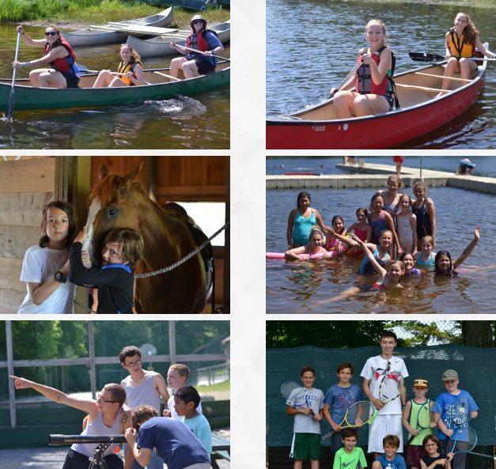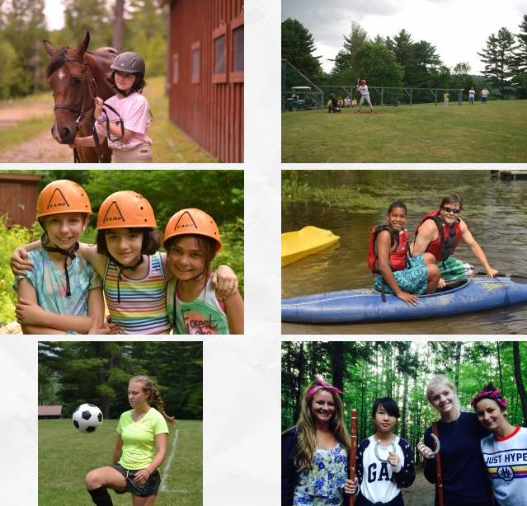

PART 3

3 minutes
In this part of the test, you’ll be asked to talk on your own about a picture/ photo. Describe your photo in detail. Say who/ what you can see, what they look like, what they are doing, etc.

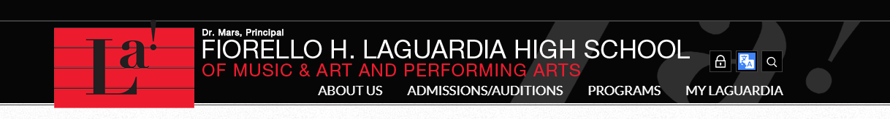
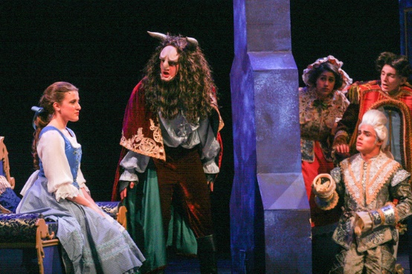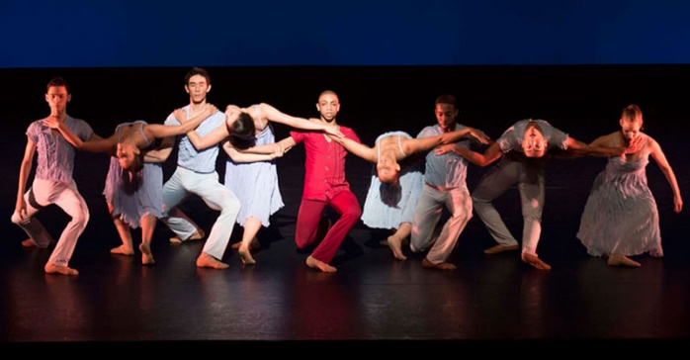
https://www.laguardiahs.org/apps/album/#!&s=0

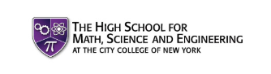
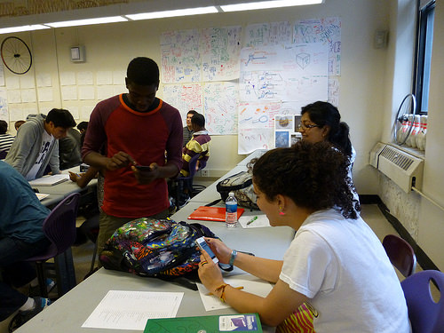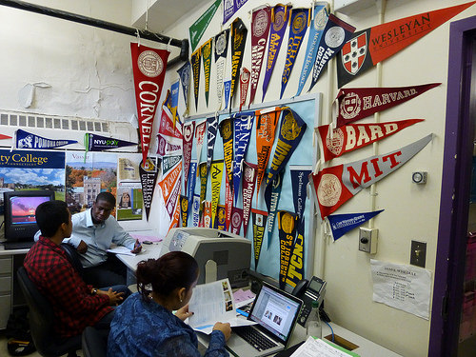
https://insideschools.org/school/05M692

PART 4
3 minutes
Your photographs show two different types of schools. Talk together about the one you would like to go to on a school exchange programme.

